MILES ANNOUNCES DEBUT EP NEVER HAVE I EVER, OUT JULY 15
FEATURING TRAVIS BARKER ON THE TITLE TRACK
NEW SINGLE “WHEN YOU’RE SOBER” & MUSIC VIDEO OUT TODAY
PRE-SAVE NEVER HAVE I EVER HERE
PHOTO CREDIT: Jacqueline Day
DOWNLOAD HI-RES IMAGE HERE | PRESS ASSETS HERE
(June 17, 2022) – LOS ANGELES, CA – LA-based singer/songwriter and rapper MILES today announced the release of his debut EP NEVER HAVE I EVER, out on Friday, July 15 via Elektra Records. It was also revealed today that legendary multi-platinum and GRAMMY® Award-nominated musician Travis Barker will be featured on the title track, along with serving as its primary producer. The forthcoming EP is available to pre-save HERE.
Ahead of the new effort, MILES also shared standout track “WHEN YOU’RE SOBER,” the third-released single from the EP. Complete with a chantable chorus and a falsetto-inflected bridge, the song highlights MILES’ dynamic range. Directed by Nicholas Jandora (24kgoldn, Lil Skies), the accompany music video is also out now, which follows the artist through a chaotic series of events, encountering various characters along the way. “WHEN YOU’RE SOBER” is available on all streaming services, with the visual available to watch HERE.
Of the new song, MILES mined inspiration from “the trials, tribulations, and heartbreak of moving to one of the craziest cities in America (Los Angeles).” He explained, “It’s also about forming an instant connection with someone, but the next day, nothing is the same.”
“One night, my team and I went through all the songs on the EP, and we felt like the project needed more live instrumentation,” MILES added. “‘NEVER HAVE I EVER’ still needed some production work, and it seemed like the perfect song to record live drums on. I was so excited when word came back that Travis was going to hop on the track. I can’t wait for everyone to hear this new project and am thankful for everyone involved in it.”
MILES creates big, high-energy tracks that people can relate to when navigating life, relationships, and dating in the modern era. Early Rising called “MISS INDEPENDENT,” MILES’ first single from the EP, a “brilliant feel-good track that continues his exciting trajectory to becoming a household name,” while SHEESH Media hailed his follow-up single “THE INTERNET” (ft. LØLØ) a “summer anthem.”
MILES bobs and weaves past genre lines with an unpredictable and undeniable style of his own, fusing breezy hip-hop, earthshaking pop, and grimy rock. Slowly, but surely, MILES developed a following online in 2020 before cooking up “WHAT IN TARNATION” back home in his native St. Louis. Beyond inspiring thousands of TikTok videos, it raked in millions of streams as he inked a deal with Elektra Records. He maintained his momentum with the captivating, high-energy follow up singles “DESPERADOS” and “MOSH PIT.” MILES’ debut EP NEVER HAVE I EVER kickstarts an exciting new era.
NEVER HAVE I EVER
1. MISS INDEPENDENT
2. THE INTERNET (feat. LØLØ)
3. WHEN YOU’RE SOBER
4. HOLLYWOOD
5. NEVER HAVE I EVER (feat. Travis Barker)
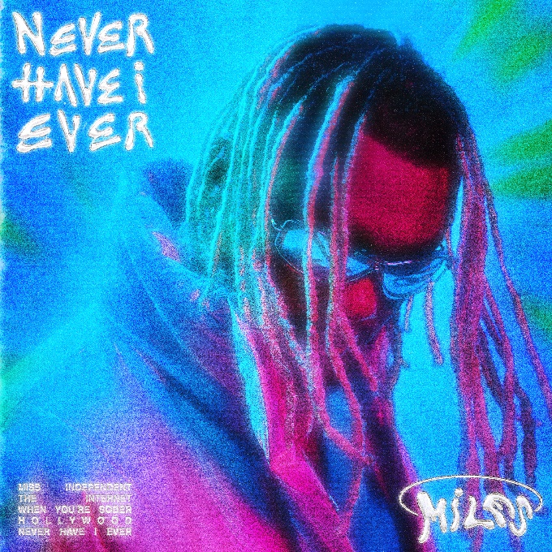
HI-RES ARTWORK HERE
MILES
“WHEN YOU’RE SOBER”
AVAILABLE HERE
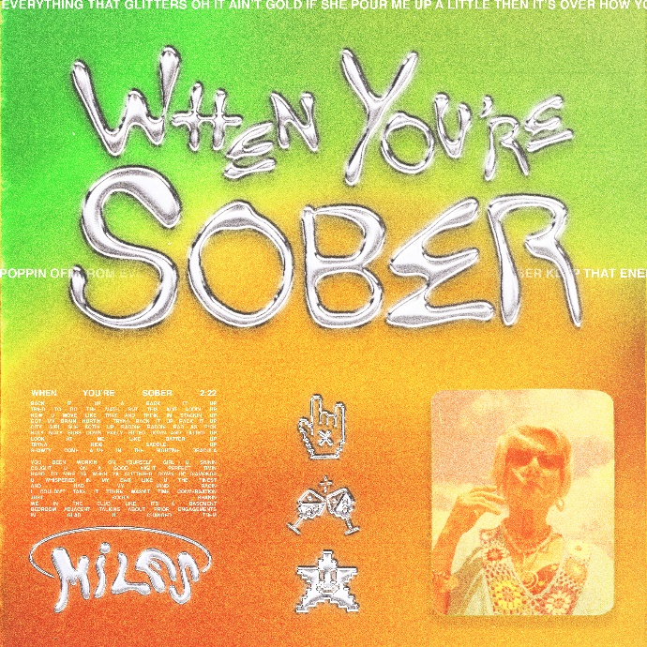
DOWNLOAD HI-RES ARTWORK HERE
FOLLOW MILES:
Instagram
Twitter
YouTube
TikTok
# # #
PRESS CONTACT FOR MILES:
Nathalie Rubin
NathalieRubin@elektra.com
