MOTIONLESS IN WHITE
RELEASE ANOTHER LIFE / ETERNALLY YOURS: MOTION PICTURE COLLECTION EP

“ANOTHER LIFE: MOTION PICTURE COLLECTION” (FEAT. KERLI) OFFICIAL VIDEO STREAMING NOW

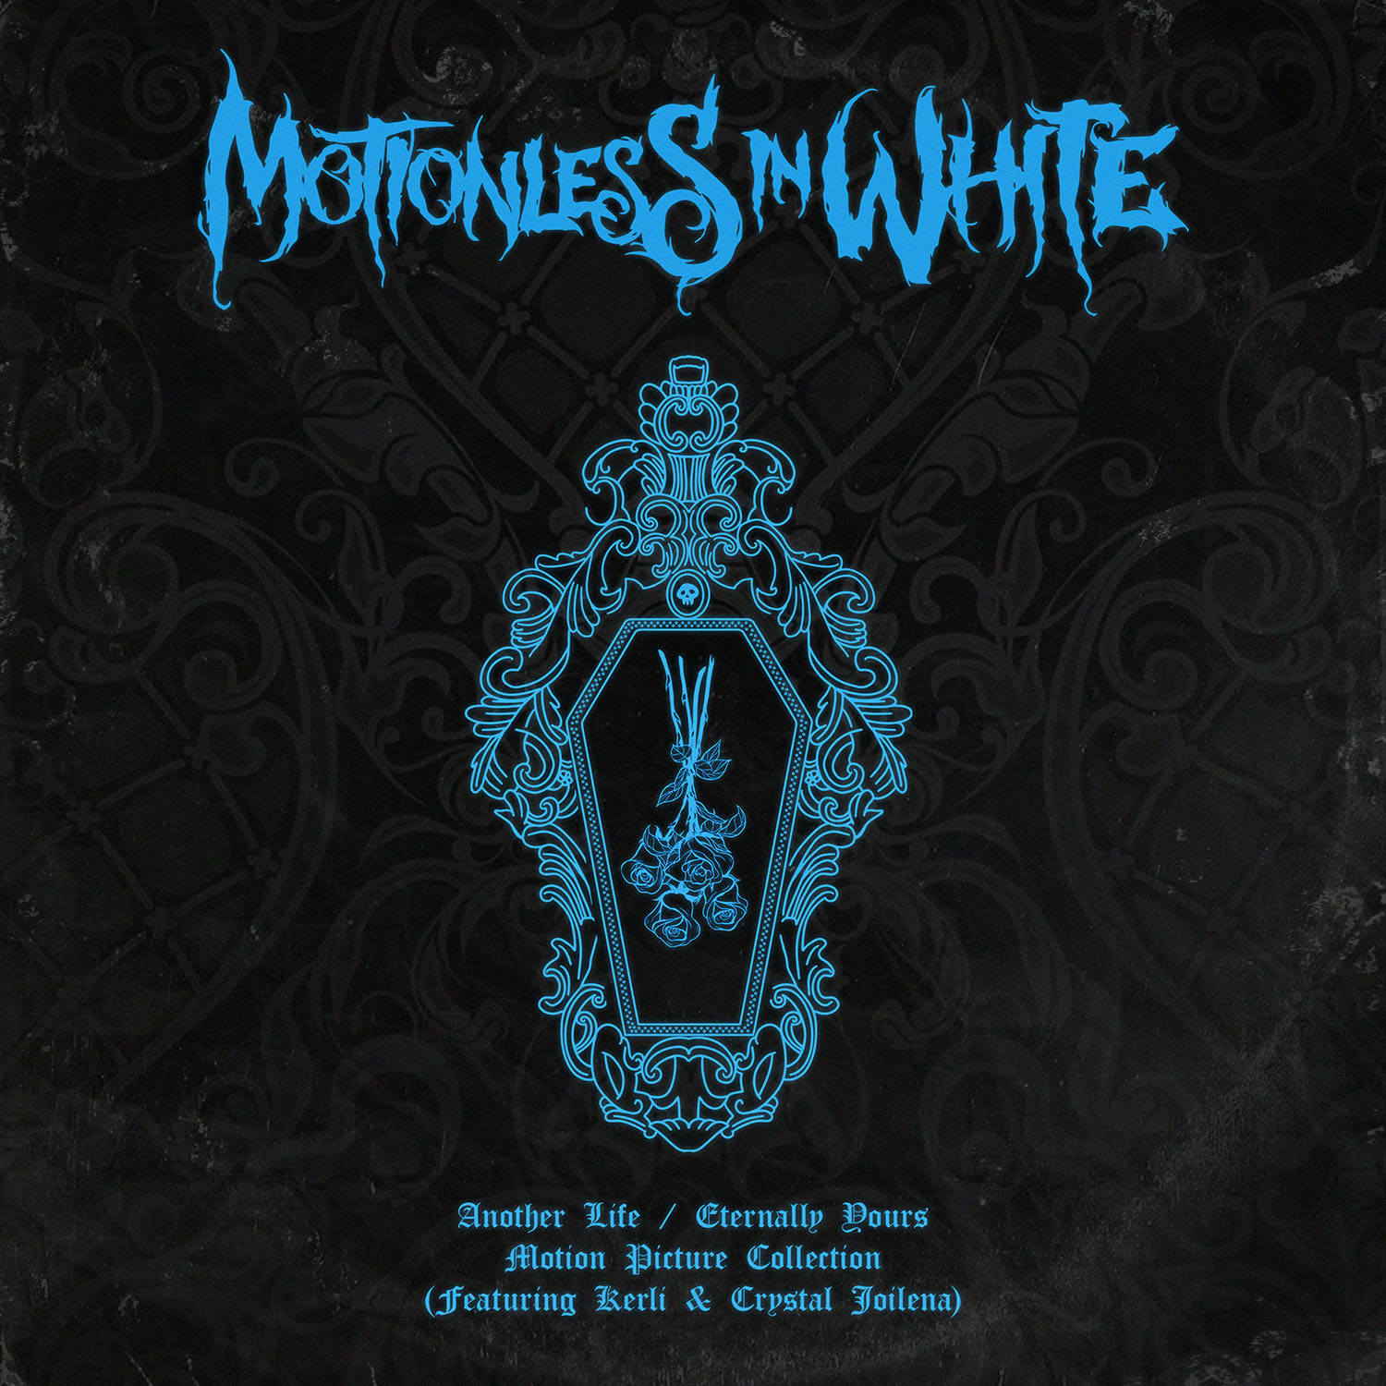
AUGUST 10, 2020 - Today, Motionless In White have unveiled a new EP entitled Another Life / Eternally Yours: Motion Picture Collection. Produced by Justin Deblieck and mixed by Steve Sopchack, the EP is available now on all streaming platforms.
The band commented on the new project: “With all of the down time of not touring, we wanted to take the opportunity to try something we’ve never done before. We give you, ‘Eternally Yours: Motion Picture Collection’ (Feat Crystal Joilena) & ‘Another Life: Motion Picture Collection’ (Feat Kerli). Thank you to Crystal and Kerli for your amazing vocals that helped transform these versions into something truly special. Thank you to Justin Deblieck for your ever-brilliant talents that shine so bright throughout these tracks, and thank you to Steve Sopchack for your keen ear and dedication to mixing this project. We hope you all enjoy and are still staying safe out there.”
For the project, the acclaimed Scranton, PA band reconstructed, reimagined, and reinvigorated two fan favorite singles: “Another Life” and “Eternally Yours.” Additionally, they included brand new cinematic instrumental tracks for both. For this big screen-worthy interpretation of “Another Life,” they recruited dark pop Estonian artist Kerli to contribute an emotionally charged vocal. Over a bed of orchestral strings and sparse piano, frontman Chris Motionless locks into a haunting and hypnotic duet with her. The official music video offers a ghostly counterpoint and alternate view of the original as well. View it HERE.
Meanwhile, Motionless In White enlisted Australian vocalist Crystal Joilena to join this nocturnal take of “Eternally Yours.” Classically inspired piano cuts through swells of strings as the vocals reach heavenly heights on a solemn promise. Punctuated by lasers and galactic vignettes, the accompanying visual complements the song’s otherworldly energy.
A highlight of the group’s latest album DISGUISE [Roadrunner Records], the original “Another Life” ascended to the Top 15 at Active Rock Radio, becoming their highest-charting single to date. It has notably gathered 9.5 million views on the official music video, not to mention, Beartooth frontman Caleb Shomo recently remixed “Another Life.”
Motionless In White stormed into 2020 in support of their latest album DISGUISE. Available now at all DSPs and at www.motionlessinwhite.net, DISGUISE made an explosive chart debut upon release, debuting at #4 on Billboard’s “Top Album Sales” chart while also claiming #2 on the “Hard Rock Albums” chart, and #27 on the SoundScan/Billboard 200 -- Motionless In White’s third consecutive Top 30 entry on the overall chart. DISGUISE is highlighted by a series of stellar singles, including “Brand New Numb,” “Undead Ahead 2: The Tale Of The Midnight Ride,” and “Disguise,” the latter joined by a haunting companion video directed by frequent collaborators Jeremy Danger & Travis Shinn and streaming HERE. In addition, “Another Life” was joined by an official visual, directed by Max Moore and is streaming now via Motionless In White’s official YouTube channel HERE.
TRACKLISTING
- “Another Life: Motion Picture Collection” (feat. Kerli)
- “Eternally Yours: Motion Picture Collection” (feat. Crystal Joilena)
- “Another Life: Motion Picture Collection” (Instrumental)
- “Eternally Yours: Motion Picture Collection” (Instrumental)

###

MOTIONLESS IN WHITE ONLINE:
https://www.motionlessinwhite.net
https://www.facebook.com/motionlessinwhite
https://twitter.com/MIWband
https://www.instagram.com/miwband/
https://www.youtube.com/user/motionless1234

