MOTIONLESS IN WHITE
SHARE NEW SONG “SLAUGHTERHOUSE” FEAT. KNOCKED LOOSE’S BRYAN GARRIS

NEW ALBUM SCORING THE END OF THE WORLD ARRIVES JUNE 10TH

ALBUM PRE-ORDERS AVAILABLE NOW

PHOTO CREDIT: @ROCKCANDYPHOTO

MAY 13, 2022 – Roadrunner Records band Motionless In White have shared “Slaughterhouse,” a brand new song featuring Knocked Loose’s Bryan Garris. “Slaughterhouse” is available today on all streaming platforms and featured on Motionless In White’s widely anticipated new album Scoring The End of the World, due out June 10th. The forthcoming album is available to pre-save on all streaming platforms today with exclusive merch bundles available for pre-order in the band’s official store [album art / tracklist below].

Building on the anticipation for Scoring The End of the World, “Slaughterhouse” follows the previously released singles “Masterpiece” and “Cyberhex,” the official videos for which quickly trended Top 10 on YouTube and have since amassed over 6 million views. Furthermore, “Masterpiece” continues to grow at the Active Rock radio format, jumping into the Top 30 this week and continuing to grow in audience.

Scoring The End of the World fully encompasses the expanse of the band’s dynamic, deep, and dark vision, and marks the band’s first full-length body of work in three years since 2019’s Disguise. The latter has quietly made a major impact on rock music and culture. The single “Another Life” stands out as their most-streamed song ever with over 23 million YouTube views on the music video. The record claimed a spot on Loudwire’s “50 Best Metal Albums of 2019,” plus it ignited the creative renaissance that would set the stage for the statement-making Scoring The End of the World.

Having recently wrapped their massively successful triple co-headline Trinity Of Terror Tour with Black Veil Brides and Ice Nine Kills, Motionless In White are set to make several U.S. festival appearances this year with anticipated performances slated for Sacramento, California’s Aftershock Festival (10/7) and Las Vegas, Nevada’s When We Were Young Festival (10/22, 10/23, 10/29). Additional upcoming international dates for Motionless in White include a summer run in Australia with I Prevail and then a 2023 European tour with Beartooth. For tickets and more information on the upcoming dates, visit www.motionlessinwhite.net/tour.
About Motionless In White:
Motionless In White harnessed the power of an unholy union between industrial metal dissonance, spellbinding gothic pop bombast, and big screen-worthy iconography to emerge as 21st century rock’s most iconoclastic and cinematic force. Climbing out of the shadows of the rustbelt in Scranton, PA, the group have tirelessly earned the undying allegiance of a devout worldwide audience one record at a time. With over half-a-billion cumulative streams and views to date, they have notched three consecutive Top 5 debuts on the Billboard Top Hard Rock Albums Chart and Top Rock Albums Chart with Reincarnate [2014], Graveyard Shift [2017], and Disguise [2019]. The latter spawned the inescapable “Another Life,” which tallied over 100 million streams and counting. Not to mention, Jonathan Davis of Korn, Maria Brink of In This Moment, and Dani Filth of Cradle of Filth have welcomed the opportunity to collaborate. After countless sold-out gigs and festivals, they co-headlined the Trinity Of Terror Tour, selling out venues coast-to-coast. However, everything set the stage for their 2022 opus, Scoring The End of the World. Right out of the gate, the single “Cyberhex” trended Top 10 on YouTube, while the follow-up “Masterpiece” lit up streaming platforms. With guests as diverse Bryan Garris of Knocked Loose, Caleb Shomo of Beartooth, and video game composer Mick Gordon, the album finds the group’s vision magnified wider than ever before with no shortage of teeth, fire, and blood. It’s the dawn of their biggest chapter yet.
Motionless In White are Chris Motionless [Vocals], Ricky Olson [Guitar], Ryan Sitkowski [Guitar], Vinny Mauro [Drums], and Justin Morrow [Bass].

[album art / tracklist / tour itinerary below]

MOTIONLESS IN WHITE
SCORING THE END OF THE WORLD

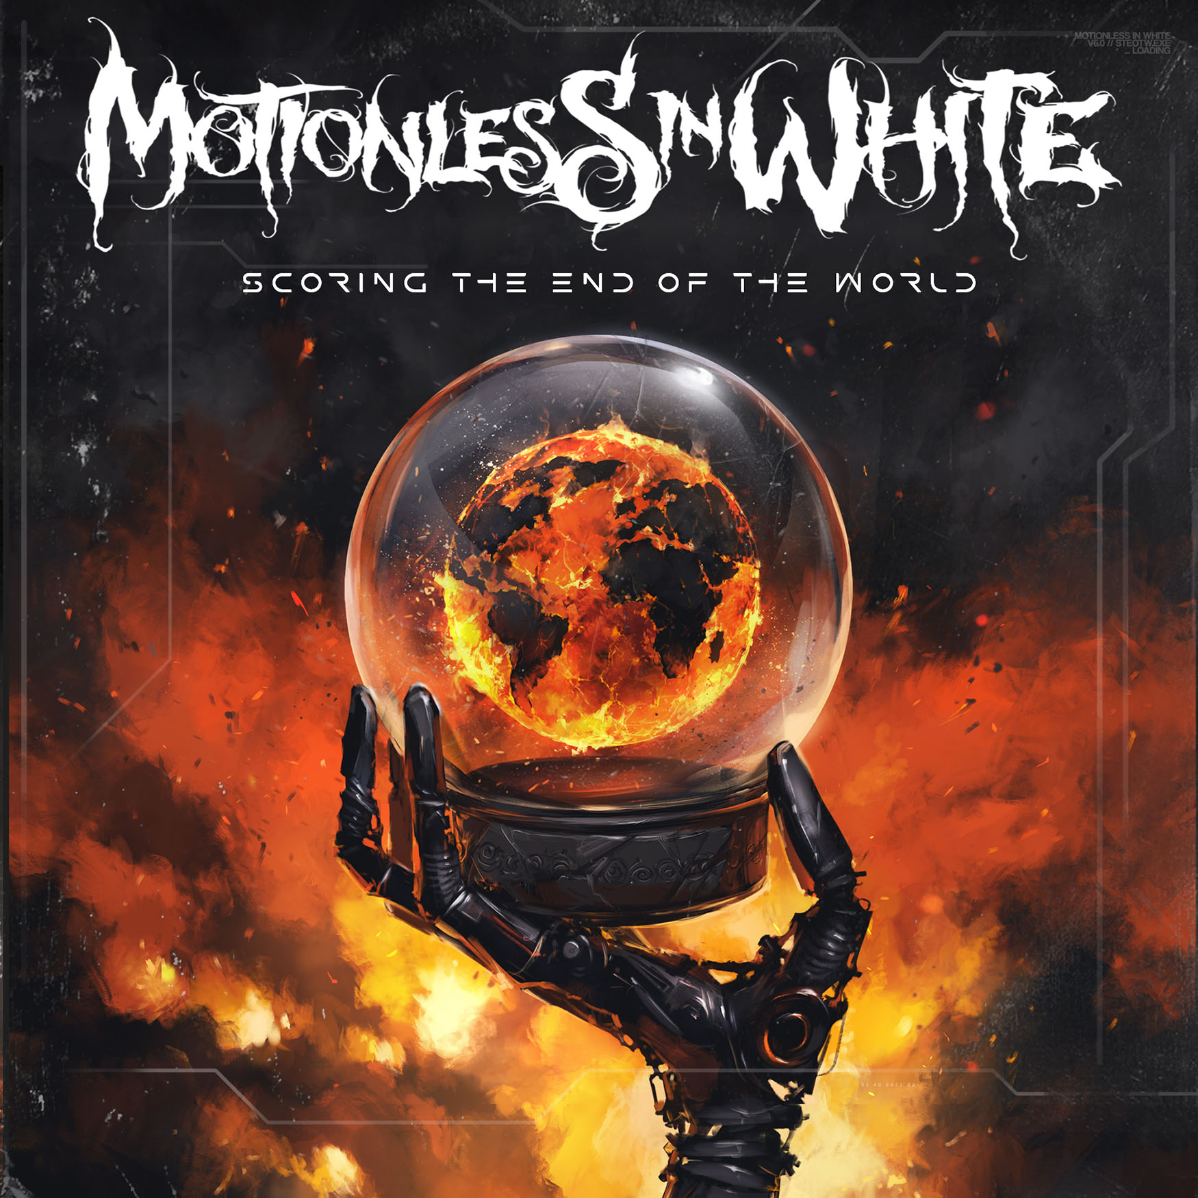

1. Meltdown
2. Sign Of Life
3. Werewolf
4. Porcelain
5. Slaughterhouse (Feat: Bryan Garris)
6. Masterpiece
7. Cause Of Death
8. We Become The Night
9. Burned At Both Ends 2
10. Broadcasting From Beyond The Grave: Corpse Nation
11. Cyberhex
12. Red, White & Boom (Feat: Caleb Shomo)
13. Scoring The End Of The World (Feat: Mick Gordon)

MOTIONLESS IN WHITE
U.S. TOUR DATES
7/16 - Cadott, WI - Rock Fest**
9/8-9/11 - Alton, VA - Blue Ridge Rock Festival**
10/7 - Sacramento, CA - Aftershock**
10/22 - Las Vegas, NV - When We Were Young**
10/23 - Las Vegas, NV - When We Were Young**
10/29 - Las Vegas, NV - When We Were Young**

** Festival Dates

###

MOTIONLESS IN WHITE ONLINE:
https://www.motionlessinwhite.net
https://www.facebook.com/motionlessinwhite
https://twitter.com/MIWband
https://www.instagram.com/miwband/
https://www.youtube.com/user/motionless1234

