MEET ME @ THE ALTAR SIGNS TO FUELED BY RAMEN

BAND SHARES MUSIC VIDEO FOR MAJOR LABEL DEBUT SINGLE “GARDEN”
WATCH HERE

MEET ME @ THE ALTAR “GARDEN”
YOUTUBE: https://youtu.be/SSFWTNbuteQ
EMBED: <iframe width="560" height="315" src="https://www.youtube.com/embed/UkTjA65YuZE" frameborder="0" allow="accelerometer; autoplay; encrypted-media; gyroscope; picture-in-picture" allowfullscreen></iframe>

October 9, 2020 – Rising pop-punk trio Meet Me @ The Altar have announced their signing to Fueled By Ramen in an exclusive interview with Billboard. The band’s major label debut single “Garden” is available to stream and download now HERE. Meet Me @ The Altar have also revealed an official music video for the track that premiered on The FADER earlier today, who touted the group as “one of the most exciting young pop bands in the United States.” The vibrant clip was directed by Alex Zarek and creative directed by Lindsey Byrnes. Watch it on Fueled By Ramen’s YouTube channel HERE.

“We want to be the representation we didn’t have growing up,” the band shared. “We hope to encourage young girls, especially black and brown girls like us. We definitely have a different perspective than the average pop punk white dude crying about his girlfriend. Even as a band, we experience the music world in our own way. It gives us an interesting viewpoint that we put into the songs.”

Crossing state lines and breaking all kinds of boundaries, the group’s members—Edith Johnson [vocals], Téa Campbell [guitar], and Ada Juarez [drums]—initially met online, bonding over the likes of Paramore and Twenty One Pilots and agreeing on a need for more representation in pop punk. Instead of waiting for somebody else to do it, they stepped up and became that representation as three proud women of color playing lightning fast riffs, pounding out double kicks, and chanting huge hooks.

Meet Me @ The Altar’s independent releases have earned co-signs from everyone from All Time Low frontman Alex Gaskarth to Halsey, who recently spotlighted the band as part of her Black Creators Fund. Flood Magazine praised the band’s “vibrant energy” and SPIN asserted, “Meet Me @ The Altar so lovingly summon the cues of ‘00s-era pop-punk and emo with an emotional intelligence and maturity that the genre’s most visible (re: white) sad boys never really lived up to,” in their ranking of “The 50 Best Rock Bands Right Now.”

Stay tuned for more from Meet Me @ The Altar soon.

(Single art below)

MEET ME @ THE ALTAR
“Garden”
AVAILABLE NOW
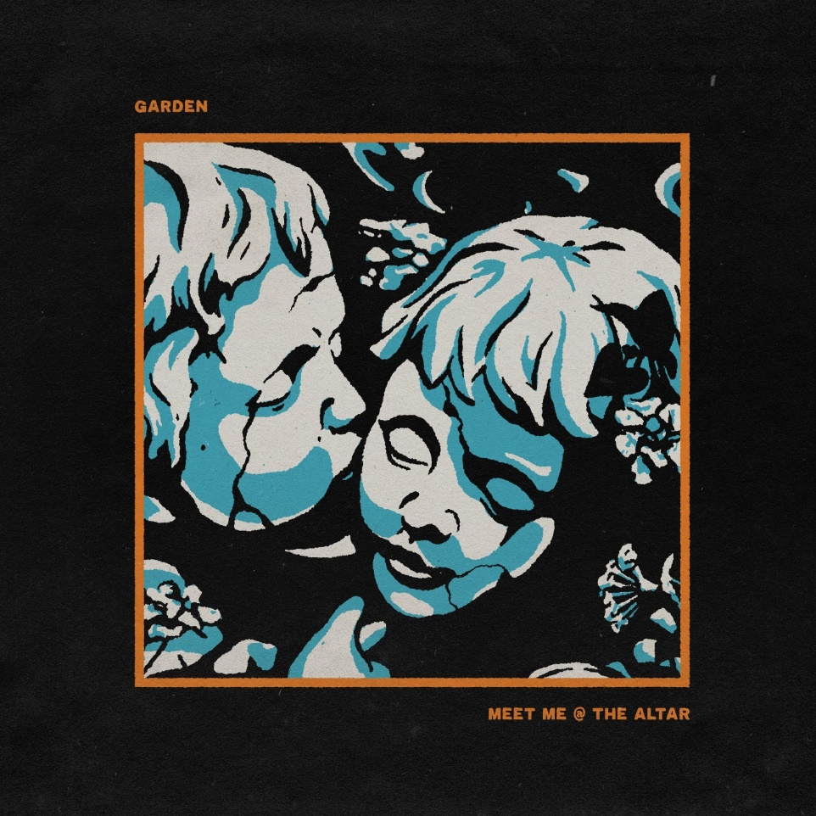

ABOUT MEET ME @ THE ALTAR:
Meet Me @ the Altar present a new musical and cultural paradigm for pop punk. The Florida trio—Edith Johnson [vocals], Téa Campbell [guitar], and Ada Juarez [drums]—certainly rip just as hard as the forbearers who inspired them, but the group also speak from a position rarely, if ever, heard in the genre as proud women of color. With Ada from New Jersey, Téa from Florida, and Edith from Georgia, the three-piece would meet in the Sunshine State and practice for hours nonstop just before gigs, morphing into a formidable force on stage. Booking their own tours, the band canvassed the country to promote their debut Changing States EP in 2018. Dozens of shows endeared them to a growing audience as they continued recording. During 2020, MM@TA’s independent releases turned heads, drawing admiration from Halsey and All Time Low’s Alex Gaskarth, and receiving praise from SPIN, FLOOD Magazine, and more. Now signed to their dream record label, the group kickstarts a revolution with their Fueled By Ramen debut single, “Garden.”

# # #

CONNECT WITH MEET ME @ THE ALTAR
MeetMeAtTheAltar.com
Instagram
Twitter
Facebook
YouTube

Press Contacts:
Sarah Goldstein / SarahGoldstein@Elektra.com
Collin Citron / CollinCitron@Elektra.com

