FOR IMMEDIATE RELEASE
MAY 6, 2022

MAISIE PETERS RELEASES HIGHLY ANTICIPATED TRACK “CATE’S BROTHER”
STREAM/DOWNLOAD HERE

WATCH THE OFFICIAL LIVE VIDEO SHOT AT LOS ANGELES’ EL REY THEATRE HERE

CURRENTLY SUPPORTING ED SHEERAN ON THE ‘+ - = ÷ x TOUR’ IN EUROPE

PRESS ASSETS HERE

Rising pop singer-songwriter Maisie Peters has released her highly anticipated track “Cate’s Brother,” available now on all streaming platforms. The release is accompanied by an official live video - shot at Los Angeles’ El Rey Theatre on the tail end of her sold-out North American headline tour - streaming now on Maisie’s official YouTube channel.

Based on a true story, Maisie originally teased the track live from a studio session in February and with an overwhelming response from her fanbase, continued working on the song in real time, sharing everything from Cate’s first listen reaction to debut performances. The teasers have already racked up over 15 million views on TikTok.

“I wrote this song in Stockholm at a time I was revisiting a lot of the pop punk music I grew up listening to and thinking about how live I wanted my next era of music to feel” Maisie explains. “I always wanted to be in a band and so I channelled that energy into this song about my friend Cate’s brother, that’s become this whole universe bigger than both of us.”

Having returned home after her sold-out 19-date headline North American tour, which included standout shows at The El Rey and New York’s Webster Hall, Maisie will play to a further 2.5 million+ people this summer as support on Ed Sheeran’s ‘+ - = ÷ x Tour’ in Europe. She is currently working on the follow up to her acclaimed debut album ‘You Signed Up For This’.

Be on the lookout for more from Maisie soon!

MAISIE PETERS
“CATE’S BROTHER”
AVAILABLE NOW
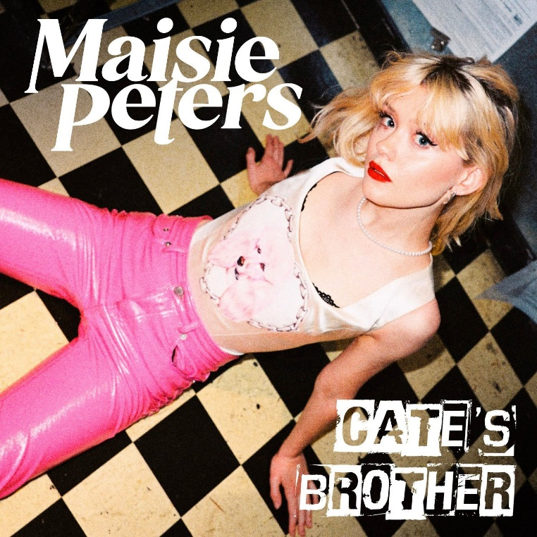

CONNECT WITH MAISIE:
YouTube | Instagram | Twitter | Facebook | TikTok

For more information please contact:
glennfukushima@elektra.com
rossanderson@elektra.com
sydneywordern@elektra.com

