FOR IMMEDIATE RELEASE
MAY 4, 2021

MAISIE PETERS UNVEILS “FUNERAL” FEAT. JAMES BAY

NEW ORIGINAL SONG FEATURED ON
‘TRYING: SEASON 2 (APPLE TV+ ORIGINAL SERIES SOUNDTRACK)’
LISTEN HERE

PERFORMING “FUNERAL” ON THE LATE LATE SHOW WITH JAMES CORDEN ON MAY 10TH

FULL SOUNDTRACK FEATURING GRIFF & BEAR’S DEN ARRIVES MAY 21ST
PRE-ORDER NOW

MAISIE BECOMES ONE OF THE YOUNGEST MUSICIANS IN HISTORY
TO WRITE AND CURATE A SOUNDTRACK

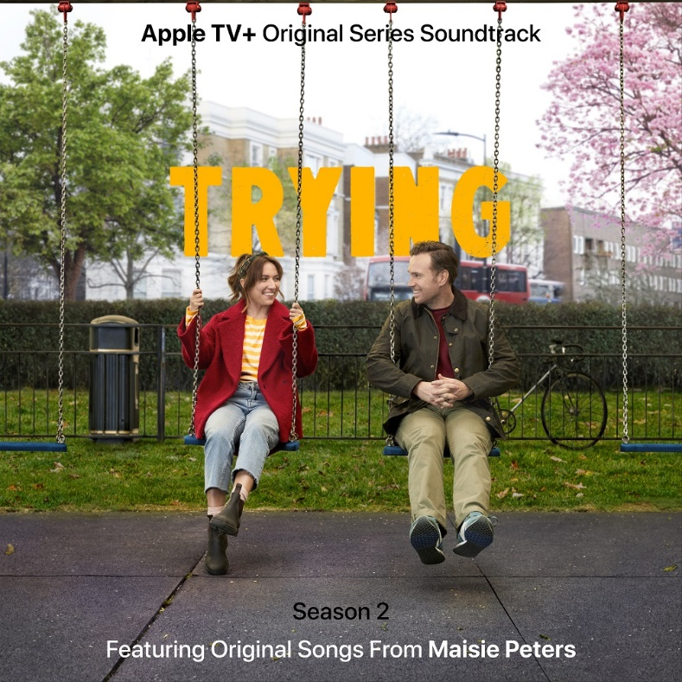

MAY 4, 2021 - Rising star Maisie Peters has unveiled “Funeral,” a heartfelt ballad featuring GRAMMY nominated singer-songwriter and guitarist, James Bay. The original song is featured on the ‘Trying: Season 2 (Apple TV+ Original Series Soundtrack)’. Listen HERE. Furthermore, both artists are set to perform the track for the first time on The Late Late Show with James Corden on Monday, May 10th.

Written entirely by Maisie and producer Joe Rubel (Ed Sheeran, L Devine), the ‘Trying: Season 2 (Apple TV+ Original Series Soundtrack)’ features co-writes with Bay and Sophie ‘Frances’ Cooke, as well as collaborations with BRITs Rising Star winner, Griff, and Ivor Novello nominated folk rockers, Bear’s Den. The full soundtrack will be released via Elektra Records on Friday, May 21st, and is available for pre-order now.

Having been spotted during soundcheck on a location scout by ‘Trying’ producer Jim O'Hanlon, Maisie was invited to make a cameo appearance on the first season of the Apple Original Series, where she performed her track “Favourite Ex.” Following the performance, she was reapproached to helm the entire soundtrack for season two, in turn, becoming one of the youngest musicians in history to write and curate an original soundtrack at only 20 years old. Maisie now joins an elite group of musicians, such as Prince, Karen O and Jay-Z, who have all helmed single-artist soundtracks during their careers.

Maisie says: “Being asked to make a whole soundtrack was a huge challenge as I’d never done anything like that before, but it was super interesting to me, so, I said ‘yes.’ Having spoken with Jim [O’Hanlon] and reading all the scripts, I started piecing it together with Joe [Rubel] and we wrote the bulk of it in two months last winter over FaceTime. Building the universe was so fun, and it was really special getting to collaborate with James, Griff, and Bear’s Den, as I’ve been big fans of them most of my life.”

“Funeral” follows Maisie’s latest single, “John Hughes Movie,” from her soon to be announced debut album. The track reached No. 1 on iTunes the weekend of release, was playlisted across BBC Radio 1 and 2, and has been streamed over 8.5 million times globally to date.

‘TRYING: SEASON 2 (APPLE TV+ ORIGINAL SERIES SOUNDTRACK)’ TRACKLIST

1. Episode 1 - Neck Of The Woods
2. Episode 2 - Milhouse
3. Episode 3 - Funeral (feat. James Bay)
4. Episode 4 - Helicopter
5. Episode 5 - Happy Hunting Ground (feat. Griff)
6. Episode 6 - I Want You To Change (Because You Want To Change) (feat. Bear’s Den)
7. Episode 7 - The Party
8. Episode 8 - Glowing Review
9. Lunar Years

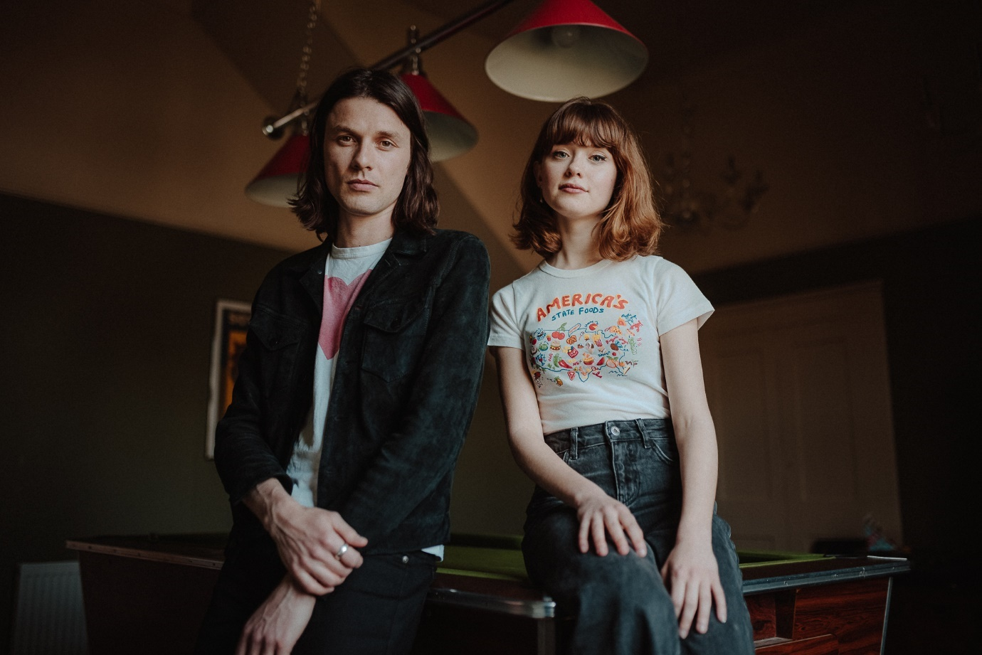
PHOTO CREDIT: LAURENCE HOWE

ABOUT MAISIE PETERS
YouTube | Instagram | Twitter | Facebook | TikTok

West Sussex born Maisie Peters has an innate gift for storytelling, crafting relatable, diary-entry songs which have racked up over half a billion global streams. Having won over the likes of Taylor Swift, Phoebe Bridgers and Sam Smith, she has progressed from busking on the streets of Brighton to selling out London’s Shepherd’s Bush Empire and headlining her own U.S. tour, well in advance of her debut album.

Last year, she launched the Maisie Peters Book Club, inspired by her love of literature and storytelling. The virtual club has over 6 thousand followers and has hosted live Q+A's with an array of the most exciting new names in the literary worlds, including Naoise Dolan (‘Exciting Times’), Florence Given (‘Women Don’t Owe You Pretty’) and Elif Bautman (‘The Idiot’).

For more information please contact:
rossanderson@elektra.com
sydneyworden@elektra.com

ABOUT JAMES BAY
YouTube | Instagram | Twitter | Facebook

James Bay has sold over 5 million albums and accumulated over 6 billion streams worldwide. His 2015 triple-platinum selling debut album, ‘Chaos And The Calm,’ was the first introduction to the expressive repertoire of an artist so tangibly steeped in the classics; its standout moments exposed a vulnerability that was underpinned by an eternal hope. Lead singles “Hold Back The River” and “Let It Go” exemplified Bay’s emotive duality, both going triple platinum in the UK - their combined streams exceeding a whopping 3 billion. Nominated for dozens of awards, he took home two BRIT Awards, two Q Awards, and top honours at the Ivor Novello Awards and ECHO Award. In 2018 James released his glistening second album, ‘Electric Light.’ Inspired by a raft of contemporary influences including Frank Ocean and Chance The Rapper, it sounded sleek and ultramodern, yet still exhibited an intimacy that is redolent throughout - most notably in sensuous first single “Wild Love,” and the captivating “Pink Lemonade.”

For more information please contact:
Taylor.Vaughn@umusic.com
Beau.Benton@umusic.com

ABOUT ‘TRYING’

In the eight-episode second season of ‘Trying’, Nikki (BAFTA nominee Esther Smith) and Jason (SAG nominee Rafe Spall) are continuing to navigate the adoption process. Having been approved by the adoption panel they now find that matching with a child is not as straightforward as they had hoped. It seems like children are being snapped up by other couples while somehow, they’re being left behind. Helped by their eccentric social worker Penny (Imelda Staunton) they are determined to do everything they can. When Nikki meets a little girl called Princess at an adoption event, she knows instantly that this is the child for them. But there are obstacles to Nikki’s plan that may prove insurmountable.
‘Trying’ is created, written and executive produced by Andy Wolton, directed and executive produced by Jim O’Hanlon (‘Catastrophe’, ‘Marvel’s The Punisher’), produced by Sam Pinnell, (‘Motherland’, ‘Derry Girls’), co-produced by Tim Mannion and executive produced by Josh Cole. The series is produced by BBC Studios.

