MAISIE PETERS AND JP SAXE
RELEASE “MAYBE DON’T” OFFICIAL MUSIC VIDEO

WATCH IT HERE

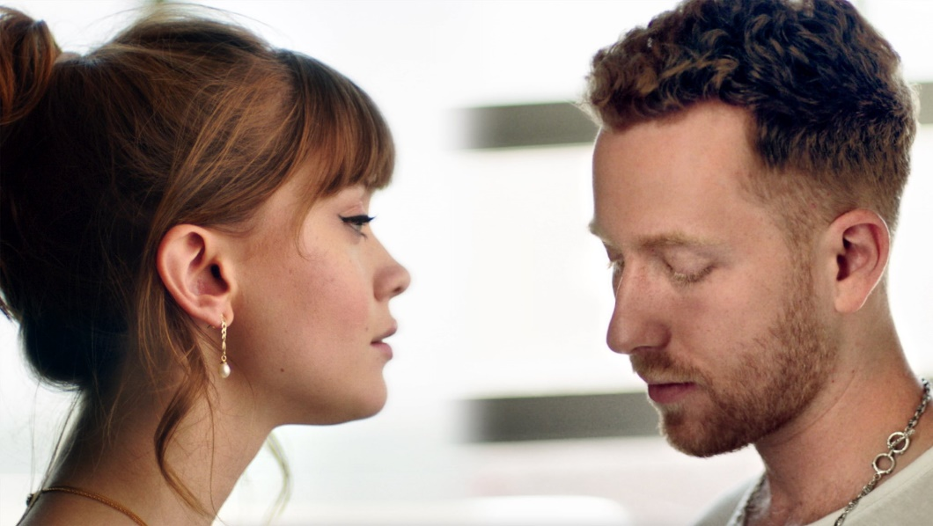

OCTOBER 9, 2020 - Maisie Peters and JP Saxe have shared the official music video for their new joint single “Maybe Don’t” - watch it HERE.

Directed by Alex Nicholson, the split-screen visual highlights the conversational nature of the track, featuring mirroring performances from Maisie and JP, captured in Margate, UK and Los Angeles, CA respectively.

A conversational love song, highlighting the contrasting feelings and vulnerabilities experienced during a relationship, “Maybe Don’t” is an instantly memorable and timeless track, showcasing the eloquence of both artists. Often lauded as modern-day storytellers, Maisie and JP wrote the song in London prior to lockdown, alongside GRAMMY-winning writer and producer, Joe Rubel (Ed Sheeran, L Devine). “Maybe Don’t” is available now all streaming platforms.

Already proving a poignant collaboration, “Maybe Don’t” has garnered over 1.5 million global streams in its first week of release and is seeing early support from both BBC Radio 1 and 2 in the UK. Furthermore, BILLBOARD included “Maybe Don’t” in their 10 Cool New Pop Songs round-up declaring, “it’s going to be a blast to sing in karaoke rooms someday,” while UPROXX placed the single in their Best New Pop Music recap attesting, “the song features both wide-eyed singers trading off verses about overcoming anxieties in the face of a new crush.”

Currently hard at work on her widely anticipated debut album, Maisie has kept her fans entertained over the past few months. She recently collaborated with bourgeoning indie-pop artist, Cavetown, for a special rework of her single, “Sad Girl Summer,” and also unveiled an Apple Music “At home with Maisie Peters Session,” and performed for renowned London-based YouTube channel, Mahogany. In July, Maisie caught the attention of her idol Taylor Swift for the second time, with the global superstar Tweeting to her 87 million followers that her “ears [had] been blessed” after hearing Maisie’s rendition of Folklore track, “Betty.”

Maisie also continues to run her rapidly-growing virtual book club (@mpbookclub), each month exploring different themes, such as unconventional love, self-acceptance and science, including Instagram Live Q+A’s with an array of the most exciting names in the literary worlds, including Dr Camilla Pang (“Explaining Humans”), Kiley Reid (“Such a Fun Age”) and Sophie Williams.

ABOUT MAISIE PETERS

West Sussex born singer-songwriter Maisie Peters has an innate gift for storytelling, crafting relatable, diary-entry songs which have racked up over quarter of a billion global streams. Having won over the likes of Taylor Swift, Lewis Capaldi and Sam Smith, she has progressed from busking on the streets of Brighton to selling out London’s Shepherd’s Bush Empire, headlining her own U.S. tour and landing support slots with superstars LAUV and Niall Horan, well in advance of her debut album.

A musical chameleon, Maisie is the only British artist to feature on the “Birds of Prey” soundtrack alongside the likes of Megan Thee Stallion, Normani and Halsey. In May, she made a cameo appearance in Apple TV’s critically acclaimed first British scripted original, “Trying.”
ABOUT JP SAXE

Toronto-born, Los Angeles-based singer-songwriter, JP Saxe always finds a way to cut beyond the surface, tapping into a deep connectivity with universal emotion and human experience. His powerful duet with Julia Michaels titled “If The World Was Ending” has been streamed over 800 million times to date and became JP’s first global chart hit, peaking at Number 8 on the Mediabase’s Top 40 Radio chart (US) and 14 on the UK’s Official Charts, where it remained in the Top 40 for 12 weeks.
In February, JP released his anticipated six-track debut EP, Hold It Together, receiving praise from Sunday Times Culture, The Line of Best Fit, Evening Standard, Dork, tmrw, Wonderland and more. He also completed a nationwide tour with Noah Kahan and joined Lennon Stella on her European tour last winter. This month, he shared his new single “A Little Bit Yours” off the back of his debut VMA’s performance with Julia Michaels. Watch HERE.

###

