MAISIE PETERS UNVEILS NEW SINGLE ‘JOHN HUGHES MOVIE’
FIRST SINGLE FROM HER SOON TO BE ANNOUNCED DEBUT ALBUM

LISTEN TO 'JOHN HUGHES MOVIE' HERE

WATCH THE OFFICIAL ‘JOHN HUGHES MOVIE’ MUSIC VIDEO HERE

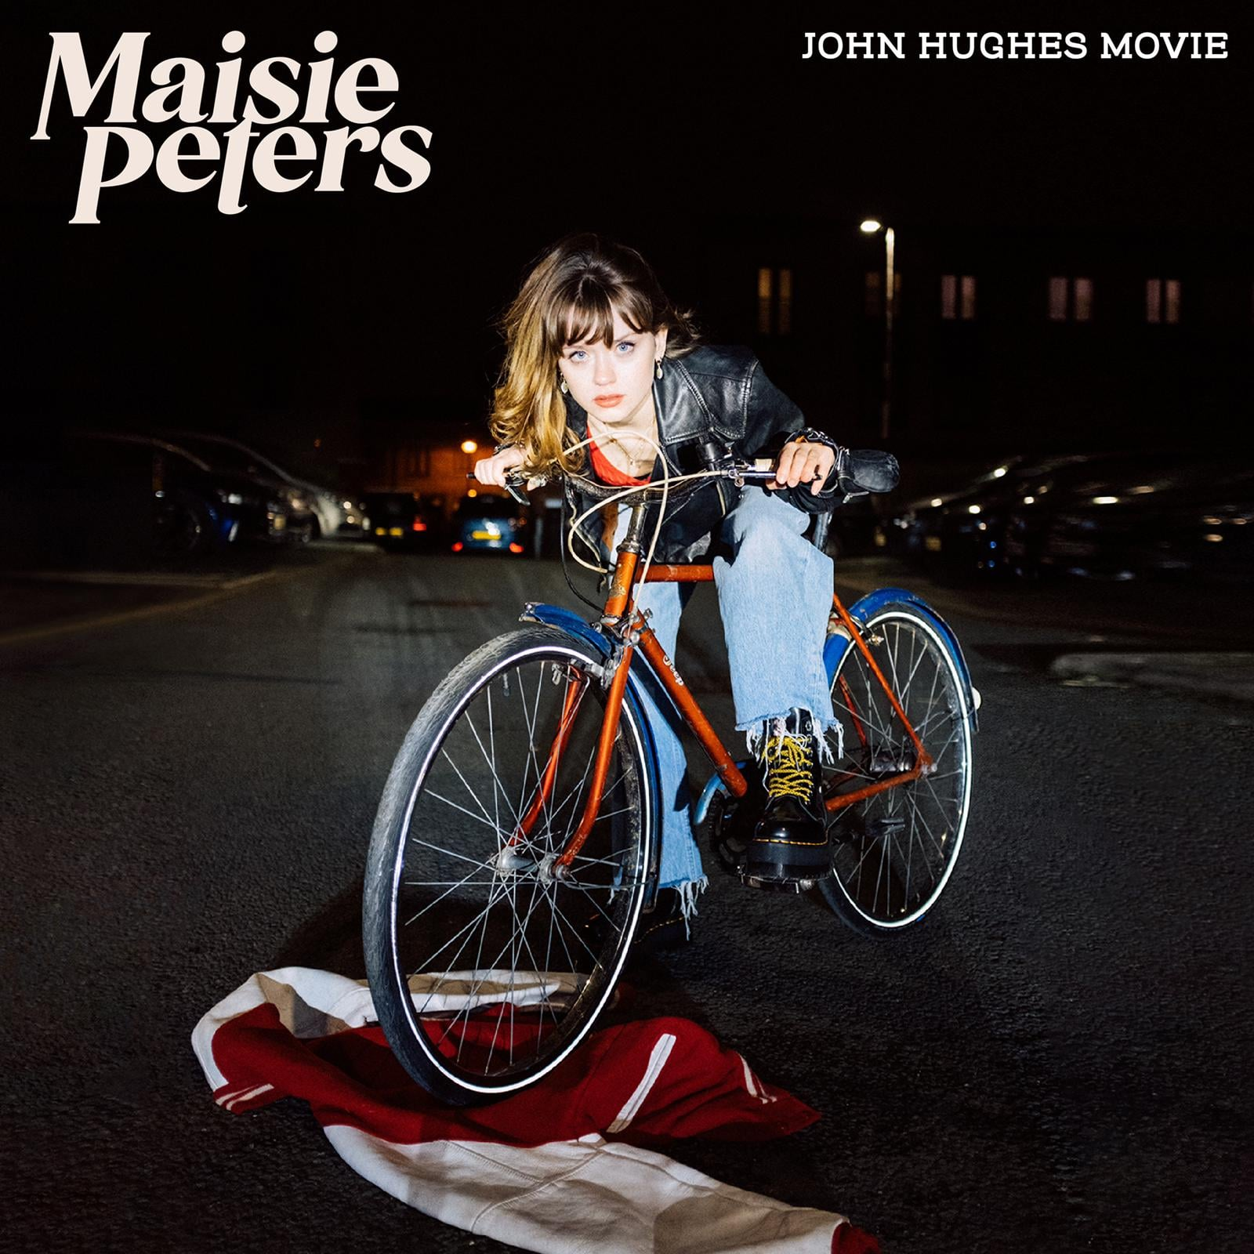

“the sort of heartfelt music that feels like peering into the pages of someone's diary” - Ones To Watch
“one of the most exciting singer-songwriters in the game” - The Independent
“singer-songwriter pop with a purpose” - Clash
“an icon for young girls just trying to navigate life” - POPSUGAR
“Maisie Peters’ music is perpetually, unwaveringly comforting and enthralling” - Atwood Magazine
“authentic and instantly relatable” - Sweety High

February 26, 2021 - Rising British pop singer-songwriter Maisie Peters has unveiled ‘John Hughes Movie’, the first single from her soon to be announced debut album, out today via Elektra Records. Listen HERE, and watch the official music video HERE.

Penned by Maisie alongside Miranda Cooper (Girls Aloud, Sugababes, Kylie Minogue) and Henrik Michelson, who also produced the track with Afterhrs (Victoria Monét, Niall Horan), ‘John Hughes Movie’ is an infectious song about unrequited love, inspired by the legendary film producer and his classic coming-of-age teen comedies (‘Sixteen Candles’, ‘The Breakfast Club’, ‘Pretty in Pink’).

Subverting the narrative of said films with her typical wit and charm, the official video, co-written by Maisie and director Louis Bhose (Loyle Carner, Arlo Parks, Lewis Capaldi), follows Maisie and her group of friends as they seek revenge on her non-committal prom crush.

Maisie explains: “I wrote ‘John Hughes Movie’ when I was 17 about a house party that I had gone to. It’s a really honest depiction of being a hopeless, melodramatic teenager, being awkward and drunk and getting your heart broken by people you don’t even remember anymore. John Hughes films encapsulate that foolish romantic energy of high school and everything that I, a small town English wannabe Molly Ringwald wanted to be, but was not.”

Although a headline European tour and high-profile support slots with LAUV and Niall Horan were postponed in 2020, Maisie continued to showcase her multifaceted artistry throughout the year, appearing as the only British artist on the award-winning ‘Birds of Prey’ soundtrack (Megan Thee Stallion, Normani and Halsey), making a cameo appearance in Apple TV’s critically-acclaimed first British scripted original, ‘Trying’, and participating in some of the year’s standout virtual festivals (Clash x WaterAid #BathroomSessions, Unity 2020, Dork's Homeschool, YouTube's Stream #WithMe).

Amassing over 200 million global streams in 2020 alone, Maisie released a string of new tracks, including ‘Daydreams’, ‘Sad Girl Summer’ and ‘The List’, which saw her collaborating with the likes of Ian Fitch and Daniel Tashian (Kacey Musgraves ‘Golden Hour’), Cavetown and HONNE. She also teamed up with Grammy-nominated Canadian musician JP Saxe for joint single, ‘Maybe Don’t’, which was playlisted across BBC Radio 1 / Radio 2 and garnered attention from Billboard and Uproxx, before rounding off the year by joining Griff for her ‘Against The Clock’ online series. Maisie was tasked with creating a cover of Taylor Swift’s ‘Exhile’ in only one hour, resulting in a tweet from Taylor herself who stated that she’s “a huge fan”.

Stay tuned for more news soon!

ABOUT MAISIE PETERS

West Sussex born singer-songwriter Maisie Peters has an innate gift for storytelling, crafting relatable, diary-entry songs which have racked up over half a billion global streams. Having won over the likes of Taylor Swift, Phoebe Bridgers and Sam Smith, she has progressed from busking on the streets of Brighton to selling out London’s Shepherd’s Bush Empire and headlining her own U.S. tour, well in advance of her debut album.

Last year, she launched the Maisie Peters Book Club, inspired by her love of literature and storytelling. The virtual club has over 6 thousand followers and has hosted live Q+A's with an array of the most exciting new names in the literary worlds, including Naoise Dolan (‘Exciting Times’), Florence Given (‘Women Don’t Owe You Pretty’) and Elif Bautman (‘The Idiot’).

CONNECT WITH MAISIE PETERS:
Official Site | Official Instagram | Official Facebook | Official Twitter| Official YouTube

