FOR IMMEDIATE RELEASE
SEPTEMBER 3, 2021

MASKED WOLF ANNOUNCES DEBUT MIXTAPE ASTRONOMICAL
ARRIVING SEPTEMBER 10

RELEASES NEW TRACK “RAZORS EDGE” FEATURING X AMBASSADORS
ALONGSIDE OFFICIAL MUSIC VIDEO
LISTEN HERE
WATCH HERE

FEATURES GUEST APPEARANCES BY KEVIN GATES, NICOLOSI, & MORE

INCLUDES THE AUSTRALIAN RAPPER’S BREAKOUT HIT
“ASTRONAUT IN THE OCEAN” AND FOLLOW-UP SINGLE “SAY SO”

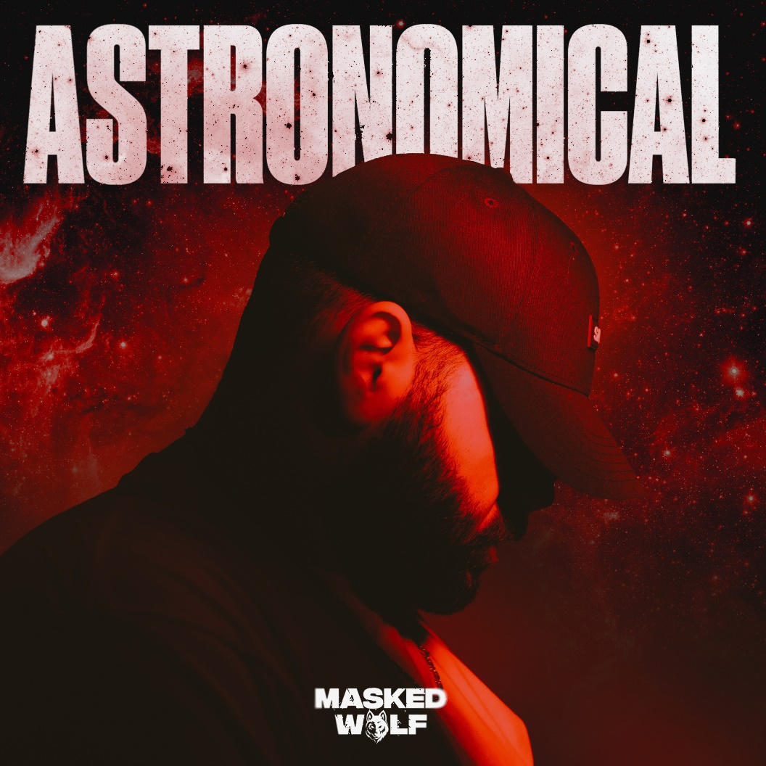
DOWNLOAD PRESS ASSETS HERE

Elektra recording artist Masked Wolf will release his debut mixtape Astronomical on September 10. It is available for pre-order and pre-save at all DSPs. To herald the project’s arrival, he has shared a new track, “Razors Edge” featuring X Ambassadors, available today on all DSPs. The track is accompanied by an official music video, streaming on his YouTube channel now – WATCH HERE.
Unfolding as an intriguing and irresistible collaboration, “Razors Edge” fuses tightly wound rapid fire rhymes from Masked Wolf to an anesthetically catchy chorus courtesy of X Ambassadors frontman Sam Harris. X Ambassadors also cooked up the hypnotic guitar-laden beat underneath this effortless collision of styles.
Regarding “Razors Edge,” Harris said: "Masked and I were on a Zoom call, working on a completely different song. We finished that one up, and he said ‘What else you got?’-- we'd had the original beat / hook for ‘Razors Edge’ for a couple months, and I was dying to get someone really dope on it, so I played that one for him. He wrote verses literally in front of me right then and there. It was SO fast. Mind-blowing."
Masked Wolf added: “’Razors Edge’ has such a unique sound - especially the chorus with the pitched up vocals As soon as I heard it, I told Sam that it was mine and nobody else could have it. From there, the magic happened.”
The 17-track Astronomical mixtape opens up the Australian rapper’s universe like never before. 2001: A Space Odyssey-size keys echo beneath dreamy verses on the opener and title track as the hook burns as brightly as a supernova. Nimble rhymes skitter across creaky acoustic guitar on “Interstellar,” while “Tightrope” balances Masked Wolf’s confessions with a high register hook from NICOLOSI. An engine hums on “Thief In The Night” before multiplatinum Baton Rouge superstar Kevin Gates locks into a verbal crossfire with Masked Wolf, unfurling as an otherworldly rap masterclass. Astronomical blasts off with an intergalactic vision of hip-hop unlike anything else in the game.
The mixtape boasts the recent banger “Bop.” Right out of the gate, it gathered over 1 million total streams and counting. Receiving critical acclaim, NME fittingly hailed it as “energetic” right out of the gate. Astronomical also features “Gravity Glidin’” and current single “Say So.”
Check out the full tracklisting below.
Described by Billboard as “a two minute romp with the type of hook that glistens on top 40 radio,” “Say So” - available now on all DSPs HERE – initially set itself up a contender for song of the summer and beginning its ascent on the pop radio charts. The buoyant track marked Masked Wolf’s much anticipated, follow up to his global smash “Astronaut In The Ocean” which has already gone to #1 in 8 countries around the world and amassed over a BILLION streams to date.

“Astronaut In The Ocean” has also proven to be a multi-format phenomenon in the U.S., climbing to #1 on the Rhythmic radio chart as well as the Top 10 at Top 40 radio. The song has spent 22 weeks and counting on the Billboard Hot 100, peaking at #6. Meanwhile, the official music video has logged over 200 million views on YouTube alone. Masked Wolf made his world television debut with an epic performance on “The Tonight Show Starring Jimmy Fallon” followed by his first, primetime television appearance on “The Voice” and, most recently, on “The Kelly Clarkson Show.”

Stay tuned for more from Masked Wolf soon.

ASTRONOMICAL MIXTAPE TRACKLISTING
1. Astronomical
2. Just Names
3. Gravity Glidin
4. Razors Edge (Feat. X Ambassadors)
5. Say So
6. Bop
7. Where’s Wally
8. Ain’t Gonna Change
9. Pandemonium
10. Paper Planes
11. Interstellar
12. Tightrope (Feat. NICOLOSI)
13. Work
14. Galaxy Garden
15. Reflections
16. Thief In The Night (Feat. Kevin Gates)
17. Astronaut in the Ocean

About MASKED WOLF:
Transforming from a mild-mannered man by day into an unrestrained beast in the studio, Masked Wolf (aka, Harry Michael) has unassumingly established himself as a powerful, passionate, and primal hip-hop force. After graduating from school, the Sydney, Australia native tirelessly worked in sales to fund recording. He even took out a loan to build a home studio as he cut hundreds of songs and logged thousands of hours in the lab. In 2018, he dropped his independent debut “Speed Racer.” It gathered millions of streams and turned heads across Australia. Following “Night Rider” and “Water Walkin,” he unveiled “Astronaut In The Ocean.” Awash in airy guitar, jagged 808s, neon keys, and deft wordplay, he submerged himself in honest lyricism, facing depression head-on. Re-released via Elektra Records at the top of 2021, “Astronaut In The Ocean” has become a global phenomenon, amassing over a BILLION streams to date and hitting #1 in 8 countries around the world. Masked Wolf recently released his follow-up single “Say So” and buzz track “Gravity Glidin’” with much more music to come.

ABOUT X AMBASSADORS
X Ambassadors made their full-length debut with VHS, a 2015 release that saw the band transition from Ithaca alt-rockers and Brooklyn-indie-scene outsiders to Billboard stalwarts. Now certified platinum, VHSprovided an intimate look at Sam Nelson Harris and his brother Casey Harris’s youth, delivering the genre-defying hits “Unsteady” and “Renegades” and leading to a three-year global touring odyssey as well as a string of high-profile festival performances. VHS was followed by X Ambassadors’ 2019 sophomore album ORION, which they supported with an extensive headline tour of the U.S. X Ambassadors will release their third studio album The Beautiful Liar on September 24th via KIDinaKORNER/Interscope Records.

Connect with MASKED WOLF

YouTube
Instagram
Twitter
Facebook
MaskedWolf.com

CONTACT:

Glenn Fukushima
Elektra Music Group
GlennFukushima@elektra.com

