FOR IMMEDIATE RELEASE
SEPTEMBER 10, 2021

MASKED WOLF UNVEILS DEBUT MIXTAPE ASTRONOMICAL
LISTEN HERE

RELEASES OFFICIAL VIDEO FOR “PANDEMONIUM”
WATCH HERE

MIXTAPE FEATURES GUEST APPEARANCES BY KEVIN GATES, NICOLOSI, & MORE

INCLUDES THE AUSTRALIAN RAPPER’S BREAKOUT HIT
“ASTRONAUT IN THE OCEAN” AND FOLLOW-UP SINGLE “SAY SO”

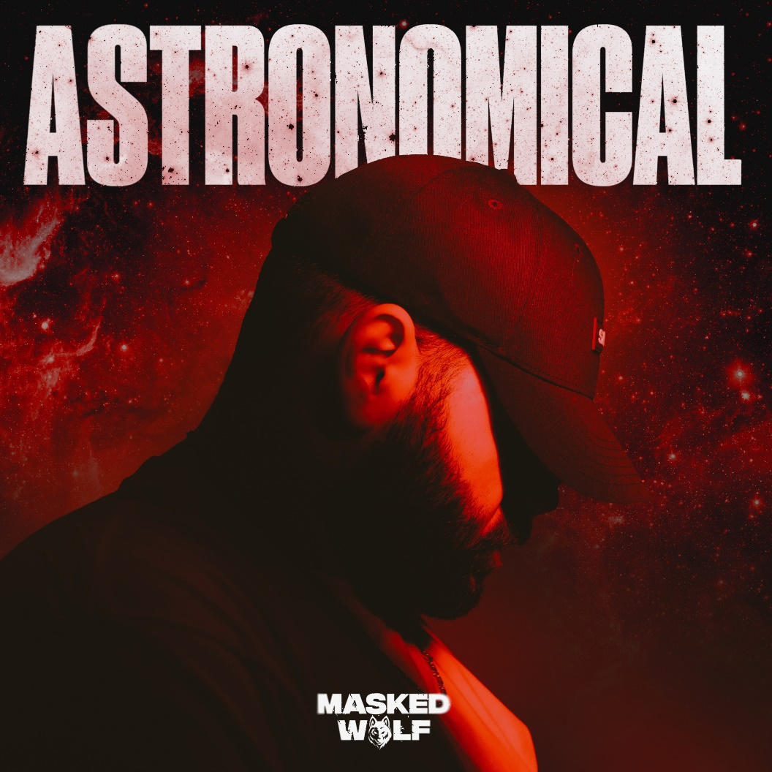
DOWNLOAD PRESS ASSETS HERE

Elektra recording artist Masked Wolf has unveiled his debut mixtape Astronomical, available now at all DSPs. The mixtape arrives alongside an official video for his track “Pandemonium,” streaming on his YouTube channel now – WATCH HERE. The 17-track collection is highlighted by the Australian rapper’s global smash “Astronaut In The Ocean,” and previously released bangers like “Gravity Glidin,” “Bop,” “Razors Edge (Feat. X Ambassadors),” and follow up single “Say So.”

The Astronomical mixtape opens up the Masked Wolf’s universe like never before. 2001: A Space Odyssey-size keys echo beneath dreamy verses on the opener and title track as the hook burns as brightly as a supernova. Nimble rhymes skitter across creaky acoustic guitar on “Interstellar,” while “Tightrope” balances Masked Wolf’s confessions with a high register hook from NICOLOSI. An engine hums on “Thief In The Night” before multiplatinum Baton Rouge superstar Kevin Gates locks into a verbal crossfire with Masked Wolf, unfurling as an otherworldly rap masterclass. Astronomical blasts off with an intergalactic vision of hip-hop unlike anything else in the game.

Described by Billboard as “a two minute romp with the type of hook that glistens on top 40 radio,” “Say So” initially set itself up a contender for song of the summer and has begun its ascent on the pop radio charts. The buoyant track marked Masked Wolf’s much anticipated, follow up to his global smash “Astronaut In The Ocean” which has already gone to #1 in 8 countries around the world and amassed over a BILLION streams to date.

“Astronaut In The Ocean” has also proven to be a multi-format phenomenon in the U.S., climbing to #1 on the Rhythmic radio chart as well as the Top 10 at Top 40 radio. The song spent 22 weeks on the Billboard Hot 100, peaking at #6. Meanwhile, the official music video has logged over 225 million views on YouTube alone. Masked Wolf made his world television debut with an epic performance on “The Tonight Show Starring Jimmy Fallon” followed by his first, primetime television appearance on “The Voice” and, most recently, on “The Kelly Clarkson Show.”

ASTRONOMICAL MIXTAPE TRACKLISTING
1. Astronomical
2. Just Names
3. Gravity Glidin
4. Razors Edge (Feat. X Ambassadors)
5. Say So
6. Bop
7. Where’s Wally
8. Ain’t Gonna Change
9. Pandemonium
10. Paper Planes
11. Interstellar
12. Tightrope (Feat. NICOLOSI)
13. Work
14. Galaxy Garden
15. Reflections
16. Thief In The Night (Feat. Kevin Gates)
17. Astronaut in the Ocean

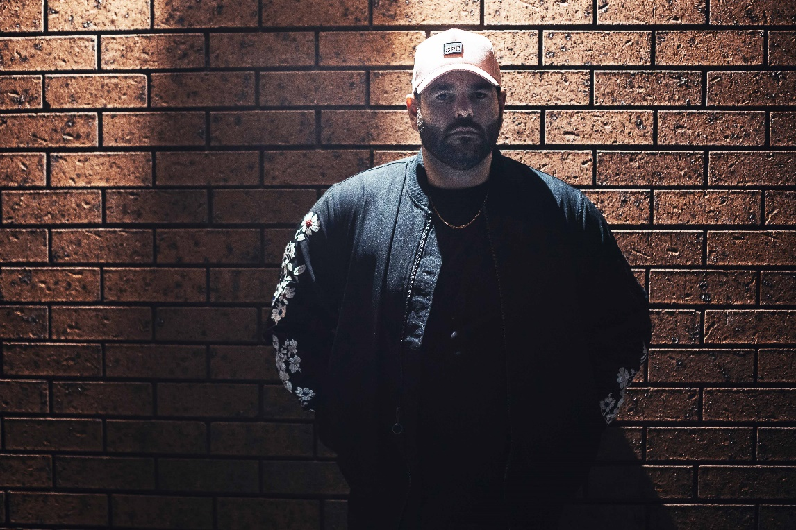

About MASKED WOLF:
Transforming from a mild-mannered man by day into an unrestrained beast in the studio, Masked Wolf (aka, Harry Michael) has unassumingly established himself as a powerful, passionate, and primal hip-hop force. After graduating from school, the Sydney, Australia native tirelessly worked in sales to fund recording. He even took out a loan to build a home studio as he cut hundreds of songs and logged thousands of hours in the lab. In 2018, he dropped his independent debut “Speed Racer.” It gathered millions of streams and turned heads across Australia. Following “Night Rider” and “Water Walkin,” he unveiled “Astronaut In The Ocean.” Awash in airy guitar, jagged 808s, neon keys, and deft wordplay, he submerged himself in honest lyricism, facing depression head-on. Re-released via Elektra Records at the top of 2021, “Astronaut In The Ocean” has become a global phenomenon, amassing over a BILLION streams to date and hitting #1 in 8 countries around the world.

Connect with MASKED WOLF

YouTube
Instagram
Twitter
Facebook
MaskedWolf.com

CONTACT:

Glenn Fukushima
Elektra Music Group
GlennFukushima@elektra.com

