MASKED WOLF RELEASES NEW SINGLE “FALLOUT” FEATURING BRING ME THE HORIZON

LISTEN HERE AND WATCH THE OFFICIAL LYRIC VIDEO HERE

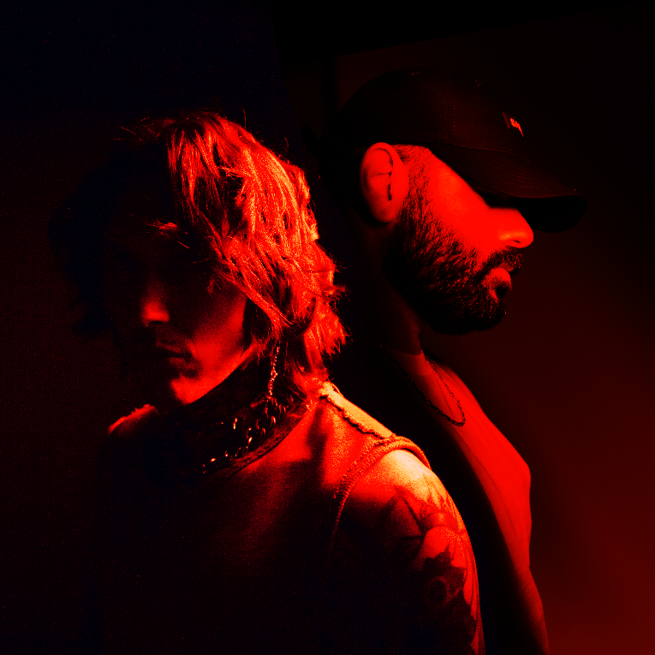
HI-RES ARTWORK AVAILABLE HERE
DOWNLOAD MASKED WOLF PRESS ASSETS HERE
(APRIL 1, 2022) – LOS ANGELES, CA – Platinum-certified recording artist Masked Wolf has shared his new genre-bending single “Fallout” featuring chart-topping, GRAMMY® Award-nominated rock band Bring Me The Horizon. Masked Wolf and the group originally joined forces in the summer of 2021 to record the track, which is complete with the rapper’s skillful verses and a massive chorus spotlighting frontman Oli Sykes’ powerful, uniquely-recognizable vocals. With its dark, cinematic vibe, the collaboration is heavily influenced by HVDES and features some of her vocals and production. Adding Wolf’s vocals to HVDES’ contribution gives the track a deeper feel, creating a new world for Bring Me The Horizon to step into. The song also arrives following Bring Me The Horizon’s recent collaborations with Ed Sheeran on “Bad Habits” – first performed live at the BRIT Awards – and Machine Gun Kelly on “maybe.” “Fallout” is available now on all streaming platforms, along with a companion lyric video available to view HERE.
Of the new collaboration, Masked Wolf commented, “I haven’t done a collaboration that felt dark; I always felt that my brand had that edge of darkness to it, and I was waiting for the right opportunity to come along. When I heard ‘Fallout,’ it grabbed me straight away. The way I felt like I was meant to be in the rubble but could still be brought out, that’s the feeling it gave me.” He continued, “The way the song builds over time made me feel like there was nothing wrong with it at all. To me, it’s perfectly structured and gives me the emotions I love diving deeper into when writing songs.”
Last fall, Masked Wolf unveiled his debut 17-track mixtape Astronomical, highlighted by the Australian rapper’s RIAA Certified double-Platinum smash “Astronaut In The Ocean” and standout track “Pandemonium.” “Astronaut In The Ocean” proved to be a phenomenon, hitting No. 1 in eight countries around the globe and amassing over one billion streams to date, not to mention becoming the eighth most-consumed song of 2021 and earning multiple nod’s on Variety’s esteemed Hitmakers List. It spent 22 weeks on the Billboard Hot 100 and climbed to the Top 10 at Top 40 Radio in the U.S. Meanwhile, the official music video has logged over nearly 300 million views on YouTube alone.
Masked Wolf made his world television debut with an epic performance of “Astronaut In The Ocean” on The Tonight Show Starring Jimmy Fallon followed by his first, primetime television appearance of the song on The Voice and then on The Kelly Clarkson Show. He also delivered a stellar performance of “Pandemonium” on Jimmy Kimmel Live! and most recently, on Dick Clark’s New Year’s Rockin’ Eve with Ryan Seacrest.

MASKED WOLF FT. BRING ME THE HORIZON
“FALLOUT”
AVAILABLE HERE
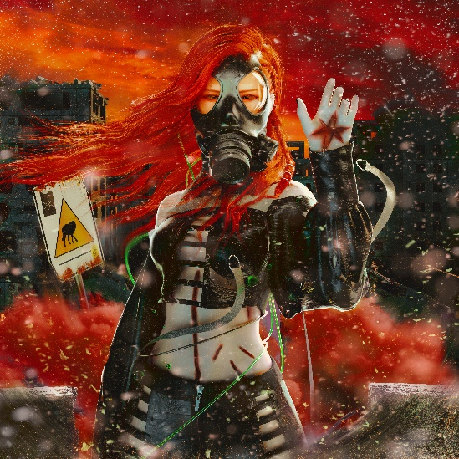
DOWNLOAD HI-RES SINGLE ARTWORK HERE

About MASKED WOLF:
Transforming from a mild-mannered man by day into an unrestrained beast in the studio, Masked Wolf (aka, Harry Michael) has unassumingly established himself as a powerful, passionate, and primal hip-hop force. After graduating from school, the Sydney, Australia native tirelessly worked in sales to fund recording. He even took out a loan to build a home studio as he cut hundreds of songs and logged thousands of hours in the lab. In 2018, he dropped his independent debut “Speed Racer.” It gathered millions of streams and turned heads across Australia. Following “Night Rider” and “Water Walkin,” he unveiled “Astronaut In The Ocean.” Awash in airy guitar, jagged 808s, neon keys, and deft wordplay, he submerged himself in honest lyricism, facing depression head-on. Re-released via Elektra Records at the top of 2021, “Astronaut In The Ocean” has become a global phenomenon, amassing over one BILLION streams to date and hitting #1 in 8 countries around the world.

About BRING ME THE HORIZON:
BRIT and GRAMMY®-nominated, multi-platinum-selling quintet Bring Me The Horizon is one of the most electrifying and successful rock bands to emerge from the UK. The group kicked off their POST HUMAN era in 2020 with the release of the first of four EPs aptly titled POST HUMAN: SURVIVAL HORROR. The critically acclaimed release debuted at Number 1 on the UK charts and was praised by NME for being “rooted in raw relevance for today and the cyber-punk energy of tomorrow.” In 2021, the band shared their hit single “DiE4u,” the most recent addition to the POST HUMAN collection. To support the release, the group embarked on a sold-out UK arena tour in September 2021 and are set to headline Reading & Leeds Festival in August 2022. Bring Me The Horizon took the stage at the 2022 BRIT Awards where they joined Grammy award winning singer-songwriter Ed Sheeran for an electrifying performance of “Bad Habits,” which was followed by the release of the official studio version on February 18.

Bring Me The Horizon has sold over 4 million albums globally to date, played sold-out shows in over 40 countries, including two sold out nights at London’s O2 and one night at The Forum in Los Angeles, wowed a traditionally non-rock crowd at Glastonbury Festival in 2016 and 2018, and stole the show at high profile festivals across Europe all summer 2019. They have now also amassed over 1 billion video views on YouTube. Bring Me The Horizon are vocalist Oli Sykes, guitarist Lee Malia, bassist Matt Kean, drummer Mat Nicholls, and keyboardist Jordan Fish.

Connect with MASKED WOLF:
YouTube
Instagram
Twitter
Facebook
MaskedWolf.com

Connect with BRING ME THE HORIZON:
YouTube
Instagram
Twitter
Facebook
BMTHofficial.com

# # #

MEDIA CONTACTS FOR MASKED WOLF:
Glenn Fukushima
GlennFukushima@elektra.com

Nathalie Rubin
NathalieRubin@elektra.com
MEDIA CONTACT FOR BRING ME THE HORIZON:
Christina Hankin
christina.hankin@sonymusic.com

