MOTIONLESS IN WHITE
RELEASE NEW SINGLE & MUSIC VIDEO - “TIMEBOMB”

SEPTEMBER TOUR DATES FEATURING SPECIAL GUESTS
LIGHT THE TORCH, SILENT PLANET, & DYING WISH BEGIN SEPTEMBER 5TH

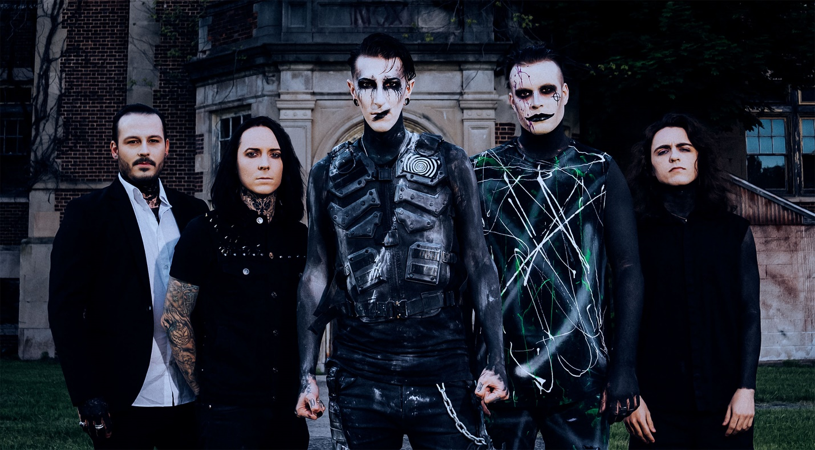
PHOTO CREDIT: BRYCE HALL

AUGUST 20, 2021 – Roadrunner Records band Motionless In White have released a new standalone single entitled “Timebomb” today. It is available on all streaming platforms now. It is also accompanied by an official animated music video directed and created by Logan Beaver / OhrangeCo—which is currently streaming on the band’s official YouTube channel. It serves as the group’s first new original music since 2020.

Regarding the single, Motionless In White vocalist Chris Motionless said, "We are really excited to release a new piece of music to bridge the gap between all of the covid downtime, and our next record coming in 2022. ‘Timebomb’ felt like a great stand-alone track to touch on the heavier side of the band, and to give fans something to headbang to during our return to touring this September. It feels so good to be getting back to work, and ‘Timebomb’ feels like a perfect way to celebrate the ‘next normal.’”

Uplifted by uncompromising spirit, the track represents a return to the group’s roots with its gnashing guitars, bludgeoning breakdowns, and haunting hooks. At the same time, their teeth have only grown sharper. The visual unspools a cinematic narrative as a female protagonist attempts to thwart the creation of a time-bending super weapon by a corrupt government. Motionless In White guitarist Ricky Olson personally edited and colored the clip, while Tiltshift Visual and Gabor Toth shot additional footage.

Up next, Motionless In White will make their much-anticipated return to the road in the states on a headline tour featuring special guests Light The Torch, Silent Planet and Dying Wish. The dates kick off with a festival appearance at Rocklahoma on September 5th and continue through the end of the month [full itinerary below]. For tickets and more information on the upcoming dates, visit www.motionlessinwhite.net/tour.

Last month, the quintet dropped the official music video for “Thoughts & Prayers,” which was directed by Olson and has already gathered over 1.7 million YouTube views

Earlier this summer, Motionless In White delivered a global deadstream performance - Deadstream #2 Pennhurst Asylum. They served up a set of fan favorites outside of one of the most notorious haunted locales in the country. Raving about the event, Rock Sound attested, “On the one hand, this was a breathless and bludgeoning display that celebrated Motionless In White’s past, present, and future. On the other, it was a career milestone from a band that has never allowed themselves to slow down or give up” and went on to call it “the perfect taster for whatever the next chapter of Motionless In White is set to be.”

Furthermore, the band also dropped “Voices: Synthwave Edition,” adding another dimension to the 2017 fan favorite, which Loudwire touted among “The Best + Metal Songs of May 2021.”

In late 2020 the group celebrated the 10th anniversary of their acclaimed debut album, Creatures, with a special ‘deadstream performance’ and the release of the standalone single “Creatures X: To The Grave.” They also released a special 10th anniversary reissue of Creatures —available on vinyl, cassette, and digital formats. The vinyl release features newly reimagined artwork, while the deluxe digital release includes three bonus tracks — “Dragula,” “Creatures” (Celldweller Beauty Remix), and “Mallevs Maleficarvm” (Tim Skold Remix). The LP comes pressed on yellow, purple, and black-splattered vinyl, and is available on the band’s official store alongside a limited edition run of 1,000 cassette copies. Plus, Motionless In White notably surprised fans with a cover of The Killers’ “Somebody Told Me” which is available on all streaming platforms with an official visualizer streaming on the band’s YouTube channel.
The cover followed the arrival of Motionless In White’s Another Life / Eternally Yours: Motion Picture Collection EP, which was produced by Justin Deblieck and mixed by Steve Sopchak. For the EP, the acclaimed Scranton, PA band reconstructed, reimagined, and reinvigorated two fan favorite singles: “Another Life” and “Eternally Yours.” Additionally, they included brand new cinematic instrumental tracks for both. For this big screen-worthy interpretation of “Another Life,” they recruited dark pop Estonian artist Kerli to contribute an emotionally charged vocal. Over a bed of orchestral strings and sparse piano, frontman Chris Motionless locks into a haunting and hypnotic duet with her. The official music video offers a ghostly counterpoint and alternate view of the original as well. View it HERE.
Meanwhile, Motionless In White enlisted Australian vocalist Crystal Joilena to join this nocturnal take of “Eternally Yours.” Classically inspired piano cuts through swells of strings as the vocals reach heavenly heights on a solemn promise. Punctuated by lasers and galactic vignettes, the accompanying visual complements the song’s otherworldly energy.
A highlight of DISGUISE, the original version of “Another Life” peaked at Top 15 at Active Rock Radio, becoming their highest-charting single to date with its official music video approaching 18 million views and Beartooth frontman Caleb Shomo serving up a special remix.
About Motionless In White:
In 2006, Motionless In White materialized out of Scranton, PA with an inimitable conjuration of sharp metallic rock, nocturnal industrial, magnetic melodies, and larger-than-life visual imagery. The quintet—Chris Motionless [Vocals], Ricky Olson [Guitar], Ryan Sitkowski [guitar], Vinny Mauro [drums], and Justin Morrow [bass]—quietly clawed their way to the forefront of hard rock, gathering nearly half-a-billion cumulative streams and views to date. Following the success of Creatures [2010] and Infamous [2012], Reincarnate [2014] sunk its teeth into the Top 10 of the Billboard Top 200, bowing at #9 and capturing #1 on the Top Rock Albums Chart. Both Graveyard Shift [2017] and Disguise [2019] cracked the Top 5 of the Top Hard Rock Albums Chart and Top Rock Albums Chart. The latter yielded the band’s biggest hit to date, “Another Life,” followed by “Brand New Numb” and “Disguise.” Along the way, they sold out headline tours and supported everyone from Slipknot and Korn to Breaking Benjamin. Not to mention, Motionless In White have collaborated with Jonathan Davis of Korn, Maria Brink of In This Moment, Dani Filth of Cradle of Filth, Tim Sköld of KMFDM, Caleb Shomo of Beartooth, and more. The five-piece kept busy throughout 2020 with the Deadstream event performance of Creatures for its decade-anniversary, a cover of The Killers’ “Somebody Told Me,” and the standalone single “Creatures X: To The Grave.” Once again, Motionless In White return to the studio and the road in 2021 as they perfect the poetically pummeling sound they patented.

[SINGLE ART / TOUR ITINERARY BELOW]

MOTIONLESS IN WHITE
“TIMEBOMB” SINGLE ARTWORK

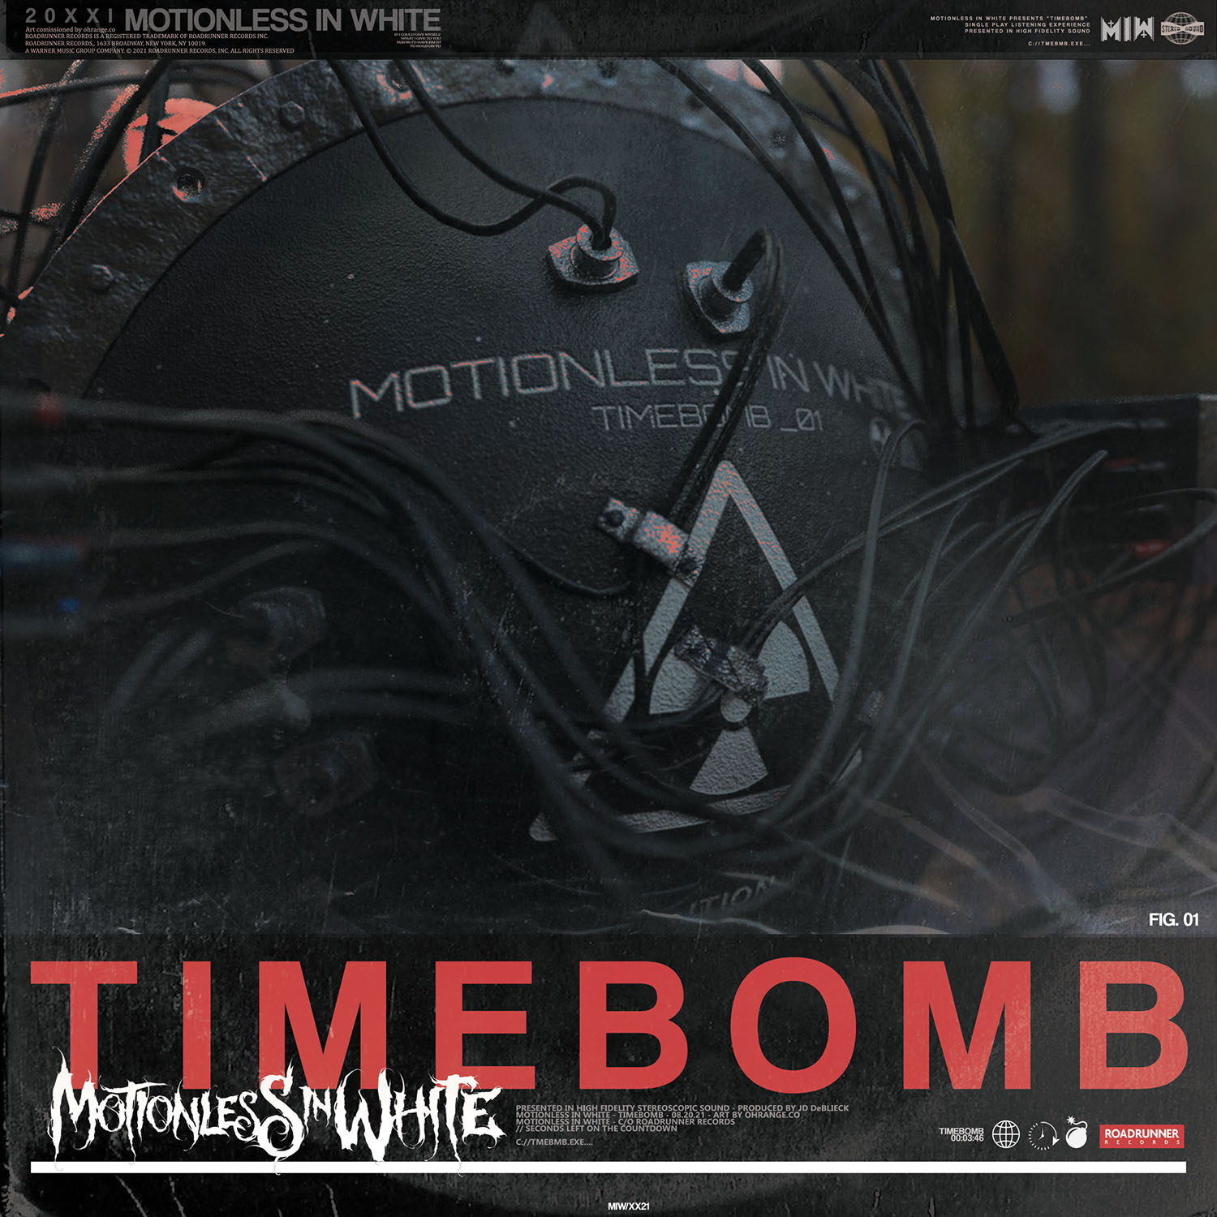

SEPTEMBER 2021 DATES
WITH SPECIAL GUESTS LIGHT THE TORCH, SILENT PLANET & DYING WISH

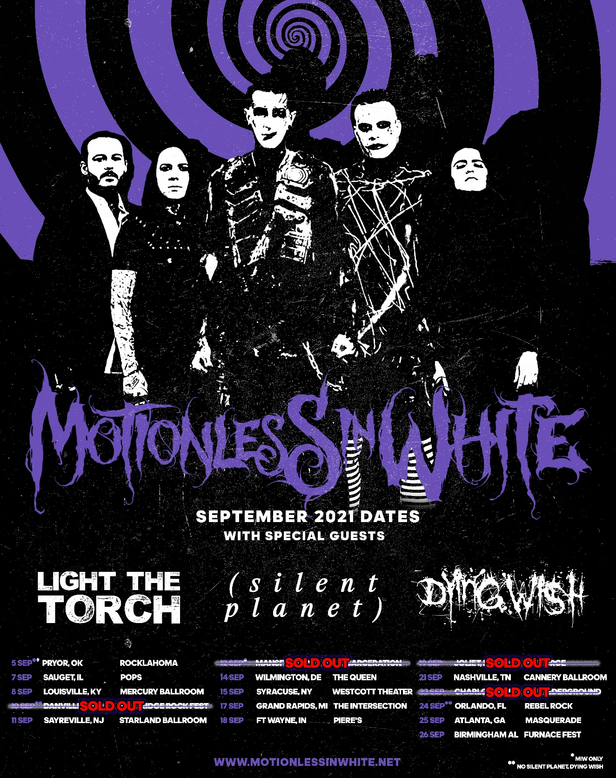

9/5 Pryor, OK Rocklahoma**
9/7 Sauget, IL Pops
9/8 Louisville, KY Mercury Ballroom
9/10 Danville, VA Blue Ridge Rock Fest**
9/11 Sayreville, NJ Starland Ballroom
9/12 Mansfield, OH Inkarceration Fest 2021*
9/14 Wilmington, DE The Queen
9/15 Syracuse, NY Westcott Theater
9/17 Grand Rapids, MI The Intersection
9/18 Ft. Wayne, IN Piere’s
9/19 Joliet, IL The Forge
9/21 Nashville, TN Cannery Ballroom
9/22 Charlotte, NC The Underground
9/24 Orlando, FL Rebel Rock 2021**
9/25 Atlanta, GA Masquerade
9/26 Birmingham, AL Furnace Fest

* Motionless In White Only
** No Silent Planet, Dying Wish

###

MOTIONLESS IN WHITE ONLINE:
https://www.motionlessinwhite.net
https://www.facebook.com/motionlessinwhite
https://twitter.com/MIWband
https://www.instagram.com/miwband/
https://www.youtube.com/user/motionless1234

