FOR IMMEDIATE RELEASE

JULY 30, 2021

**NEEDTOBREATHE RELEASE NEW STUDIO ALBUM *INTO THE MYSTERY***

**LISTEN** [**HERE**](https://nam04.safelinks.protection.outlook.com/?url=https%3A%2F%2Fntb.lnk.to%2FIntoTheMystery&data=04%7C01%7CSydneyWorden%40elektra.com%7Cafb6b0699dc8419037a108d95362aefb%7C8367939002ec4ba1ad3d69da3fdd637e%7C0%7C0%7C637632505599365102%7CUnknown%7CTWFpbGZsb3d8eyJWIjoiMC4wLjAwMDAiLCJQIjoiV2luMzIiLCJBTiI6Ik1haWwiLCJXVCI6Mn0%3D%7C1000&sdata=k2TW1vGXSNTLjli%2BJF34VvK9AxOUfcLl0DQOPb7MTSw%3D&reserved=0)

***INTO THE MYSTERY* DOCUMENTARY FILM TO ARRIVE THIS FALL**

**WATCH THE TRAILER** [**HERE**](https://nam04.safelinks.protection.outlook.com/?url=https%3A%2F%2Fyoutu.be%2FgljCvOlOmtU&data=04%7C01%7CSydneyWorden%40elektra.com%7Cafb6b0699dc8419037a108d95362aefb%7C8367939002ec4ba1ad3d69da3fdd637e%7C0%7C0%7C637632505599375097%7CUnknown%7CTWFpbGZsb3d8eyJWIjoiMC4wLjAwMDAiLCJQIjoiV2luMzIiLCJBTiI6Ik1haWwiLCJXVCI6Mn0%3D%7C1000&sdata=C94KZtn%2Ft1zJ%2F2aVFFelrYIvSgMqxg%2FN9UXbjJuaNgo%3D&reserved=0)

**TICKETS FOR THE INTO THE MYSTERY TOURAVAILABLE** [**HERE**](https://nam04.safelinks.protection.outlook.com/?url=https%3A%2F%2Fwww.needtobreathe.com%2Ftour&data=04%7C01%7CSydneyWorden%40elektra.com%7Cafb6b0699dc8419037a108d95362aefb%7C8367939002ec4ba1ad3d69da3fdd637e%7C0%7C0%7C637632505599385093%7CUnknown%7CTWFpbGZsb3d8eyJWIjoiMC4wLjAwMDAiLCJQIjoiV2luMzIiLCJBTiI6Ik1haWwiLCJXVCI6Mn0%3D%7C1000&sdata=1jVlsD4P1nM4xvtTKYSv8JWpPrjRFj1VPVAMq7chgsg%3D&reserved=0)

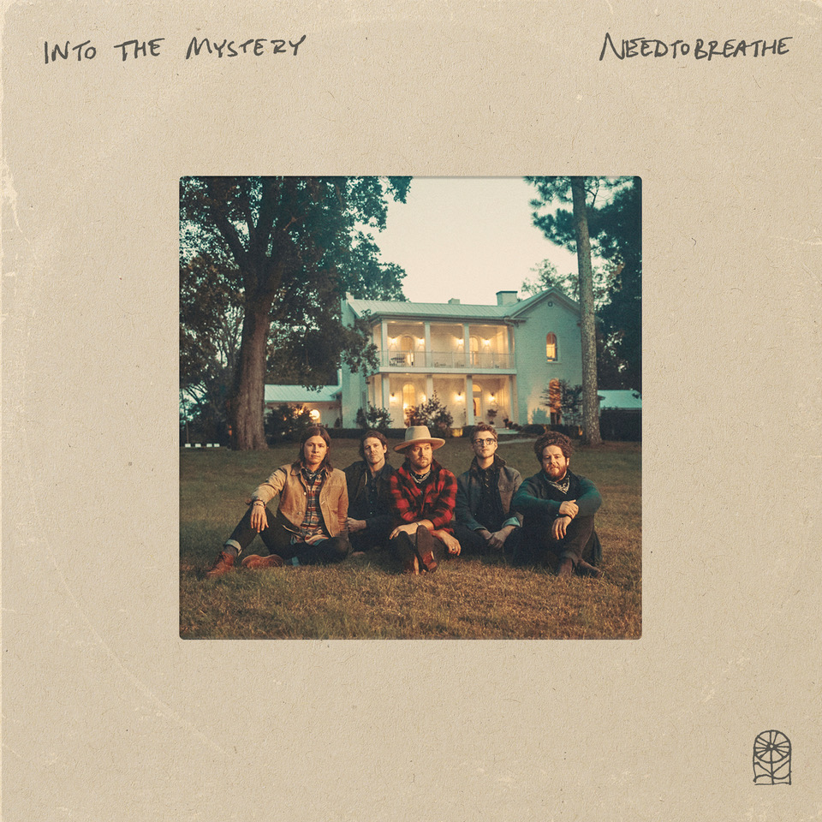

GRAMMY® Award-nominated rock band **NEEDTOBREATHE** have released their anxiously awaited new studio album, ***Into The Mystery***. The album is available physically and digitally via Elektra Records  starting today [HERE.](https://nam04.safelinks.protection.outlook.com/?url=https%3A%2F%2Fntb.lnk.to%2FIntoTheMystery&data=04%7C01%7CSydneyWorden%40elektra.com%7Cafb6b0699dc8419037a108d95362aefb%7C8367939002ec4ba1ad3d69da3fdd637e%7C0%7C0%7C637632505599395085%7CUnknown%7CTWFpbGZsb3d8eyJWIjoiMC4wLjAwMDAiLCJQIjoiV2luMzIiLCJBTiI6Ik1haWwiLCJXVCI6Mn0%3D%7C1000&sdata=SVKvOI9lUUuYYm5Hg3%2BAYQjqvwqqLnecjeVb13ODXhU%3D&reserved=0) Limited edition merch offerings are available exclusively through NEEDTOBREATHE’s online store [HERE](https://nam04.safelinks.protection.outlook.com/?url=https%3A%2F%2Fneedtobreathe.merchmadeeasy.com%2F&data=04%7C01%7CSydneyWorden%40elektra.com%7Cafb6b0699dc8419037a108d95362aefb%7C8367939002ec4ba1ad3d69da3fdd637e%7C0%7C0%7C637632505599395085%7CUnknown%7CTWFpbGZsb3d8eyJWIjoiMC4wLjAwMDAiLCJQIjoiV2luMzIiLCJBTiI6Ik1haWwiLCJXVCI6Mn0%3D%7C1000&sdata=Z%2F95zz2cmhW2h1Lb%2FEfueemr89NTziQOs4yxGICyYzQ%3D&reserved=0).

“For us to be in a band this long, still enjoy it, and make what we believe is the best record NEEDTOBREATHE has ever made, it comes down to resiliency,” the band shared. “We’re still hungry. We’re ready to take the next step. We also don’t have passive fans. They are living their lives to these songs. They’re resilient. We’re pretty honored and proud to carry these songs into a world that’s hurting right now. Maybe we could be a picture of hope that inspires someone else to keep going.”

Just as their critically acclaimed 2020 album *Out of Body* impacted audiences, NEEDTOBREATHE capitalized on a rush of creative inspiration. Without telling a soul, the band decamped to a historic house-turned-recording studio in Columbia, TN to begin working on new music. Over the course of three weeks, they resided under one roof, and recorded together with co-producer and engineer Konrad Snyder and special guests. Out of this *“extended summer camp*,*”* they handcrafted an album reflective of the moment, yet independent of all expectations—even their own.

For as intimate as the recording process was, the band filmed every minute of it for an upcoming documentary entitled, *Into The Mystery*. Last week, *Deadline* announced [Greenwich Entertainment](https://nam04.safelinks.protection.outlook.com/?url=https%3A%2F%2Fgreenwichentertainment.com%2F&data=04%7C01%7CSydneyWorden%40elektra.com%7Cafb6b0699dc8419037a108d95362aefb%7C8367939002ec4ba1ad3d69da3fdd637e%7C0%7C0%7C637632505599405080%7CUnknown%7CTWFpbGZsb3d8eyJWIjoiMC4wLjAwMDAiLCJQIjoiV2luMzIiLCJBTiI6Ik1haWwiLCJXVCI6Mn0%3D%7C1000&sdata=Vw52jOh6%2BXxu%2FJXpmsloqT7pE3loJaNQ0vJIHhnaLdw%3D&reserved=0) acquired the film’s North American distribution rights, and will release it this Fall following the band’s upcoming tour. *Into The Mystery* was directed by Chris Phelps and co-produced by Elektra Records and Foundations Music.  Watch the film’s trailer [HERE](https://nam04.safelinks.protection.outlook.com/?url=https%3A%2F%2Fyoutu.be%2FgljCvOlOmtU&data=04%7C01%7CSydneyWorden%40elektra.com%7Cafb6b0699dc8419037a108d95362aefb%7C8367939002ec4ba1ad3d69da3fdd637e%7C0%7C0%7C637632505599405080%7CUnknown%7CTWFpbGZsb3d8eyJWIjoiMC4wLjAwMDAiLCJQIjoiV2luMzIiLCJBTiI6Ik1haWwiLCJXVCI6Mn0%3D%7C1000&sdata=kqd0Hl7LzCbIriKbzdgfXoWFCX%2BGTJtAOV0jwCxE0bo%3D&reserved=0).

*Into The Mystery* is highlighted by current single “[I Wanna Remember](https://nam04.safelinks.protection.outlook.com/?url=https%3A%2F%2Fyoutu.be%2Fd4mh4jq_MYU&data=04%7C01%7CSydneyWorden%40elektra.com%7Cafb6b0699dc8419037a108d95362aefb%7C8367939002ec4ba1ad3d69da3fdd637e%7C0%7C0%7C637632505599415072%7CUnknown%7CTWFpbGZsb3d8eyJWIjoiMC4wLjAwMDAiLCJQIjoiV2luMzIiLCJBTiI6Ik1haWwiLCJXVCI6Mn0%3D%7C1000&sdata=JESbncFZ%2FX0S%2FMAseZvvGXZqZQfsxgkNJVoN1konG30%3D&reserved=0)” featuring seven-timeGRAMMY® Award winner Carrie Underwood. Last month, the band and Underwood delivered the television debut performance of the song at the 2021 “CMT Music Awards”. Crowned as one of the most showstopping moments of the evening by both *US Weekly,* *Vulture* hailed it as a “powerful, predictably huge performance of their duet,” and *E!* called it, “something fans will want to remember.” Watch their unforgettable performance [HERE](https://nam04.safelinks.protection.outlook.com/?url=https%3A%2F%2Fyoutu.be%2FPof8LfoTnbI&data=04%7C01%7CSydneyWorden%40elektra.com%7Cafb6b0699dc8419037a108d95362aefb%7C8367939002ec4ba1ad3d69da3fdd637e%7C0%7C0%7C637632505599425063%7CUnknown%7CTWFpbGZsb3d8eyJWIjoiMC4wLjAwMDAiLCJQIjoiV2luMzIiLCJBTiI6Ik1haWwiLCJXVCI6Mn0%3D%7C1000&sdata=y%2FAzvgDCnglK%2BFy2bMj7DPkOK41w2BeEfSuI%2BADSh9c%3D&reserved=0).

*Into The Mystery* was announced this Spring alongside the release of the album’s lead single and [title track](https://nam04.safelinks.protection.outlook.com/?url=https%3A%2F%2Fyoutu.be%2Fql8Qo4XLftM&data=04%7C01%7CSydneyWorden%40elektra.com%7Cafb6b0699dc8419037a108d95362aefb%7C8367939002ec4ba1ad3d69da3fdd637e%7C0%7C0%7C637632505599425063%7CUnknown%7CTWFpbGZsb3d8eyJWIjoiMC4wLjAwMDAiLCJQIjoiV2luMzIiLCJBTiI6Ik1haWwiLCJXVCI6Mn0%3D%7C1000&sdata=n39urMBNVueBjb6Id4SJj%2F%2Bnh2unb%2BLfcry4coqtvU0%3D&reserved=0). In recent weeks, the band has also unveiled “[What I’m Here For](https://nam04.safelinks.protection.outlook.com/?url=https%3A%2F%2Fwww.youtube.com%2Fwatch%3Fv%3DY8Zj9cpb8fI&data=04%7C01%7CSydneyWorden%40elektra.com%7Cafb6b0699dc8419037a108d95362aefb%7C8367939002ec4ba1ad3d69da3fdd637e%7C0%7C0%7C637632505599435057%7CUnknown%7CTWFpbGZsb3d8eyJWIjoiMC4wLjAwMDAiLCJQIjoiV2luMzIiLCJBTiI6Ik1haWwiLCJXVCI6Mn0%3D%7C1000&sdata=cD%2FEOeZtBiN8HoityWE11fANhxYzGAovqv8xV9krOC0%3D&reserved=0)”, “[Sunshine](https://nam04.safelinks.protection.outlook.com/?url=https%3A%2F%2Fyoutu.be%2FJnqG2Z68Cro&data=04%7C01%7CSydneyWorden%40elektra.com%7Cafb6b0699dc8419037a108d95362aefb%7C8367939002ec4ba1ad3d69da3fdd637e%7C0%7C0%7C637632505599445056%7CUnknown%7CTWFpbGZsb3d8eyJWIjoiMC4wLjAwMDAiLCJQIjoiV2luMzIiLCJBTiI6Ik1haWwiLCJXVCI6Mn0%3D%7C1000&sdata=bQRDJvK6pZnHGWABqpZ7NbMZ6vNu4Rag8K515St2fto%3D&reserved=0)”, “[Chances](https://nam04.safelinks.protection.outlook.com/?url=https%3A%2F%2Fyoutu.be%2FY0yokqrlHXg&data=04%7C01%7CSydneyWorden%40elektra.com%7Cafb6b0699dc8419037a108d95362aefb%7C8367939002ec4ba1ad3d69da3fdd637e%7C0%7C0%7C637632505599445056%7CUnknown%7CTWFpbGZsb3d8eyJWIjoiMC4wLjAwMDAiLCJQIjoiV2luMzIiLCJBTiI6Ik1haWwiLCJXVCI6Mn0%3D%7C1000&sdata=8FPbFNlRAXrljmGDZb%2FOucCEwt%2Fi4nRiXiX9GwlH0kU%3D&reserved=0)”, and [“Carry Me” (feat. Jon Foreman of Switchfoot)](https://nam04.safelinks.protection.outlook.com/?url=https%3A%2F%2Fwww.youtube.com%2Fwatch%3Fv%3DoNm02wt4m60&data=04%7C01%7CSydneyWorden%40elektra.com%7Cafb6b0699dc8419037a108d95362aefb%7C8367939002ec4ba1ad3d69da3fdd637e%7C0%7C0%7C637632505599455043%7CUnknown%7CTWFpbGZsb3d8eyJWIjoiMC4wLjAwMDAiLCJQIjoiV2luMzIiLCJBTiI6Ik1haWwiLCJXVCI6Mn0%3D%7C1000&sdata=VB7qj8jXSFEOhDPednmC36%2ButK5rE%2FXi61WpKBCzcxY%3D&reserved=0). *Into The Mystery’s* early releases have received praise from *Rolling Stone, Billboard, Entertainment Tonight, People, American Songwriter,* and more.

This Fall, NEEDTOBREATHE will embark on their massive Into The Mystery Tour with support from Switchfoot and The New Respects. The 38-city trek will visit iconic venues such as Denver, CO’s Red Rocks Amphitheatre (fifth consecutive sold out appearance) and Los Angeles, CA’s Greek Theatre, and see the band perform their first-ever headline show at Nashville, TN’s Bridgestone Arena. The Into The Mystery Tour will kick off on September 7 in St. Louis, MO, and wrap on October 30 in Atlanta, GA. Tickets for all dates are available now [HERE](https://nam04.safelinks.protection.outlook.com/?url=https%3A%2F%2Fwww.needtobreathe.com%2Ftour&data=04%7C01%7CSydneyWorden%40elektra.com%7Cafb6b0699dc8419037a108d95362aefb%7C8367939002ec4ba1ad3d69da3fdd637e%7C0%7C0%7C637632505599465036%7CUnknown%7CTWFpbGZsb3d8eyJWIjoiMC4wLjAwMDAiLCJQIjoiV2luMzIiLCJBTiI6Ik1haWwiLCJXVCI6Mn0%3D%7C1000&sdata=NBaimWYtuiSMiRrTjkKFDGPyDhhH8wTpkSJJ2W72B9E%3D&reserved=0).

***Into The Mystery* Tracklisting**

1. What I’m Here For

2. Into The Mystery

3. Sunshine

4. Carry Me (feat. Jon Foreman of Switchfoot)

5. I Am Yours

6. Chances

7. Sittin’ in the Back Seat

8. Give Me A Chance

9. Don’t Throw All The Good Things Away (feat. Natalie Hemby)

10. Innocence

11. I Wanna Remember (feat. Carrie Underwood)

12. West Texas Wind

**Into The Mystery Tour Dates**

September 07, 2021 - St. Louis, MO - Saint Louis Music Park

September 08, 2021 - Kansas City, MO - Midland Theatre

September 10, 2021 - Denver, CO - Red Rocks Amphitheatre - **SOLD OUT**

September 11, 2021 - Salt Lake City, UT - Sandy City Amphitheater

September 13, 2021 - Phoenix, AZ - Arizona Federal Theatre

September 14, 2021 - San Diego, CA - Cal Coast Credit Union OAT

September 16, 2021 - Los Angeles, CA - Greek Theatre

September 17, 2021 - Saratoga, CA - The Mountain Winery

September 18, 2021 - Bend, OR - Les Schwab Amphitheater

September 19, 2021 - Seattle, WA - Marymoor Amphitheater

September 21, 2021 - Missoula, MT - KettleHouse Amphitheater

September 23, 2021 - Fargo, ND - Bluestem Center for the Arts - Bluestem Amphitheater

September 24, 2021 - Minneapolis, MN - Armory

September 25, 2021 - Madison, WI - The Sylvee - **SOLD OUT**

September 26, 2021 - Indianapolis, IN - Amphitheater at White River State Park

September 28, 2021 - Cincinnati, OH - Andrew J Brady ICON Music Center

September 30, 2021 - Chicago, IL - Radius

October 01, 2021 - Detroit, MI - Michigan Lottery Amphitheatre at Freedom Hill

October 02, 2021 - Cleveland, OH - Nautica Pavilion

October 03, 2021 - Pittsburgh, PA - Robert Morris University - UPMC Events Center

October 07, 2021 - Philadelphia, PA - The Met Philadelphia

October 08, 2021 - Boston, MA - Leader Bank Pavilion

October 09, 2021 - New York, NY - The Rooftop at Pier 17

October 10, 2021 - Washington, DC - The Anthem

October 12, 2021 - Louisville, KY - The Louisville Palace Theater

October 14, 2021 - Charlotte, NC - Charlotte Metro Credit Union Amphitheatre

October 15, 2021 - Raleigh, NC - Red Hat Amphitheater

October 16, 2021 - Greenville, SC - Bon Secours Wellness Arena

October 17, 2021 - Charleston, SC - North Charleston Coliseum

October 19, 2021 - Rogers, AR - Walmart AMP

October 21, 2021 - Austin, TX - Moody Amphitheater

October 22, 2021 - Houston, TX - Smart Financial Centre

October 23, 2021 - Dallas, TX - The Pavilion at Toyota Music Factory

October 24, 2021 - Oklahoma City, OK - Zoo Amphitheatre

October 27, 2021 - Memphis, TN - Memphis Botanic Garden

October 28, 2021 - Birmingham, AL - Oak Mountain Amphitheatre

October 29, 2021 - Nashville, TN - Bridgestone Arena

October 30, 2021 - Atlanta, GA - Ameris Bank Amphitheatre

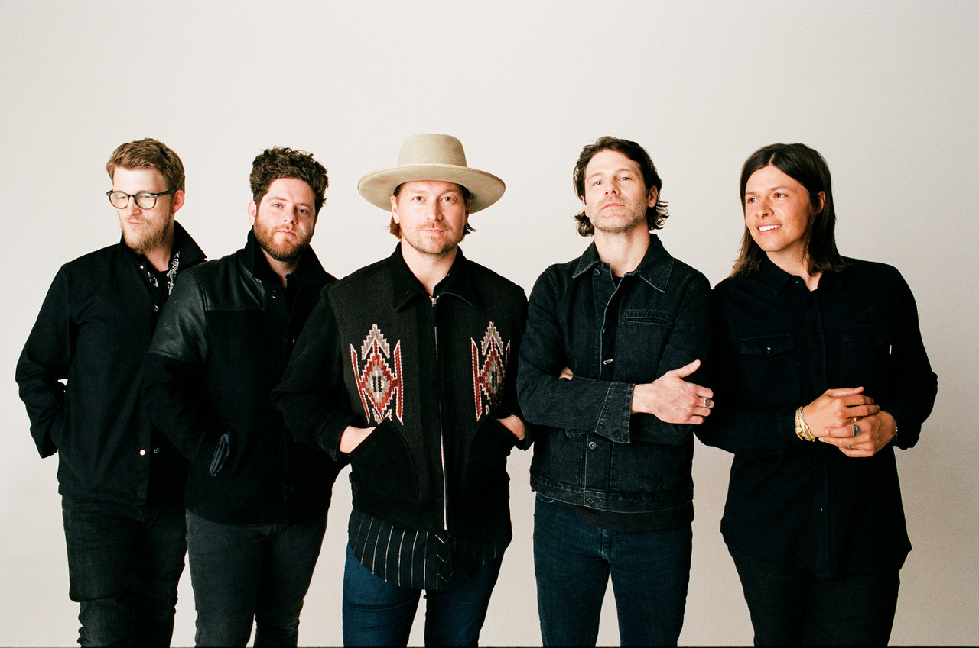

*Photo credit: David O’Donohue*

**About NEEDTOBREATHE:**

Since 1998, NEEDTOBREATHE have quietly emerged as a dynamic force in rock music, topping the charts, selling out historic venues, and generating hundreds of millions of streams to date. The band have gathered one platinum single, four gold singles, and a gold album. Along the way, “Multiplied” notched their first GRAMMY® nomination. Simultaneously, they performed to sold out crowds at arenas and amphitheaters coast to coast. In addition to garnering two nods at the Billboard Music Awards, they’ve attracted acclaim from People, Rolling Stone, Forbes, and many more. In 2020, they sowed the seeds for rebirth with Out of Body. It bowed in the Top 5 of three Billboard charts and reeled in acclaim. Within weeks of its release, the quintet—Bear Rinehart [vocals, guitar], Seth Bolt [bass, vocals], Josh Lovelace [keys, vocals], Randall Harris [drums], and Tyler Burkum [guitar]—stole away to an old historic house in Columbia, TN where they lived together, ate together, laughed together, and recorded together for three weeks in the fall of 2020. They returned home with their eighth album and documentary Into The Mystery [Elektra Records]. It’s the kind of record that could only be made by a band who has been through it all and still has enough faith to keep encouraging one another. It’s NEEDTOBREATHE.

[https://www.needtobreathe.com/](https://nam04.safelinks.protection.outlook.com/?url=https%3A%2F%2Fwww.needtobreathe.com%2F&data=04%7C01%7CSydneyWorden%40elektra.com%7Cafb6b0699dc8419037a108d95362aefb%7C8367939002ec4ba1ad3d69da3fdd637e%7C0%7C0%7C637632505599465036%7CUnknown%7CTWFpbGZsb3d8eyJWIjoiMC4wLjAwMDAiLCJQIjoiV2luMzIiLCJBTiI6Ik1haWwiLCJXVCI6Mn0%3D%7C1000&sdata=Tg8fzYCivu%2FyM%2FogkXaX2aEwNEqyT3sy4XQJzbmOOtM%3D&reserved=0)

[FACEBOOK](https://nam04.safelinks.protection.outlook.com/?url=https%3A%2F%2Fwww.facebook.com%2FNEEDTOBREATHE&data=04%7C01%7CSydneyWorden%40elektra.com%7Cafb6b0699dc8419037a108d95362aefb%7C8367939002ec4ba1ad3d69da3fdd637e%7C0%7C0%7C637632505599475032%7CUnknown%7CTWFpbGZsb3d8eyJWIjoiMC4wLjAwMDAiLCJQIjoiV2luMzIiLCJBTiI6Ik1haWwiLCJXVCI6Mn0%3D%7C1000&sdata=4bUayngOaMt86WRJChg%2BLo0l1z0DZ7fGlSzD05SN1wE%3D&reserved=0)

[TWITTER](https://nam04.safelinks.protection.outlook.com/?url=https%3A%2F%2Ftwitter.com%2FNEEDTOBREATHE&data=04%7C01%7CSydneyWorden%40elektra.com%7Cafb6b0699dc8419037a108d95362aefb%7C8367939002ec4ba1ad3d69da3fdd637e%7C0%7C0%7C637632505599475032%7CUnknown%7CTWFpbGZsb3d8eyJWIjoiMC4wLjAwMDAiLCJQIjoiV2luMzIiLCJBTiI6Ik1haWwiLCJXVCI6Mn0%3D%7C1000&sdata=M%2BBgYCIBpeperqSmw6k%2BdSHbcnh%2Bq8fVzax7qj%2F2aqQ%3D&reserved=0)

[INSTAGRAM](https://nam04.safelinks.protection.outlook.com/?url=https%3A%2F%2Fwww.instagram.com%2Fneedtobreathe%2F&data=04%7C01%7CSydneyWorden%40elektra.com%7Cafb6b0699dc8419037a108d95362aefb%7C8367939002ec4ba1ad3d69da3fdd637e%7C0%7C0%7C637632505599485024%7CUnknown%7CTWFpbGZsb3d8eyJWIjoiMC4wLjAwMDAiLCJQIjoiV2luMzIiLCJBTiI6Ik1haWwiLCJXVCI6Mn0%3D%7C1000&sdata=byau1vw2w7DPuHRhpga0pNCxks7Q4zkGRbouVBBwRro%3D&reserved=0)

[YOUTUBE](https://nam04.safelinks.protection.outlook.com/?url=https%3A%2F%2Fwww.youtube.com%2Fuser%2FNEEDTOBREATHEVIDEOS&data=04%7C01%7CSydneyWorden%40elektra.com%7Cafb6b0699dc8419037a108d95362aefb%7C8367939002ec4ba1ad3d69da3fdd637e%7C0%7C0%7C637632505599495020%7CUnknown%7CTWFpbGZsb3d8eyJWIjoiMC4wLjAwMDAiLCJQIjoiV2luMzIiLCJBTiI6Ik1haWwiLCJXVCI6Mn0%3D%7C1000&sdata=NXkVCVkjQJnjamP3PnMPxSIv9zK0%2FPl6vX4gTZ0NN38%3D&reserved=0)

**NEEDTOBREATHE Press Contact:**

Collin Citron / [CollinCitron@elektra.com](mailto:CollinCitron@elektra.com)