FOR IMMEDIATE RELEASE

November 10, 2020

**NEEDTOBREATHE RELEASE OFFICIAL MUSIC VIDEO FOR “BANKS”**

**WATCH**[**HERE**](https://nam04.safelinks.protection.outlook.com/?url=https%3A%2F%2Fyoutu.be%2FfqifjBtNzLw&data=04%7C01%7CSydneyWorden%40elektra.com%7C3e7f27ed358d4f9c72de08d8858d84cb%7C8367939002ec4ba1ad3d69da3fdd637e%7C0%7C0%7C637406190164559744%7CUnknown%7CTWFpbGZsb3d8eyJWIjoiMC4wLjAwMDAiLCJQIjoiV2luMzIiLCJBTiI6Ik1haWwiLCJXVCI6Mn0%3D%7C1000&sdata=DbkS0uAT6CCpGg8b4uHsI9x3nTeeJ%2Fl2JvlsqR4f8gk%3D&reserved=0)

**NEW ALBUM *OUT OF BODY* AVAILABLE NOW**[**HERE**](https://nam04.safelinks.protection.outlook.com/?url=https%3A%2F%2Fntb.lnk.to%2FOutOfBody&data=04%7C01%7CSydneyWorden%40elektra.com%7C3e7f27ed358d4f9c72de08d8858d84cb%7C8367939002ec4ba1ad3d69da3fdd637e%7C0%7C0%7C637406190164569738%7CUnknown%7CTWFpbGZsb3d8eyJWIjoiMC4wLjAwMDAiLCJQIjoiV2luMzIiLCJBTiI6Ik1haWwiLCJXVCI6Mn0%3D%7C1000&sdata=rrm4IZXYVnvWaNfw9HLHzbkKyrDqpIuszBSUHKTsbIg%3D&reserved=0)

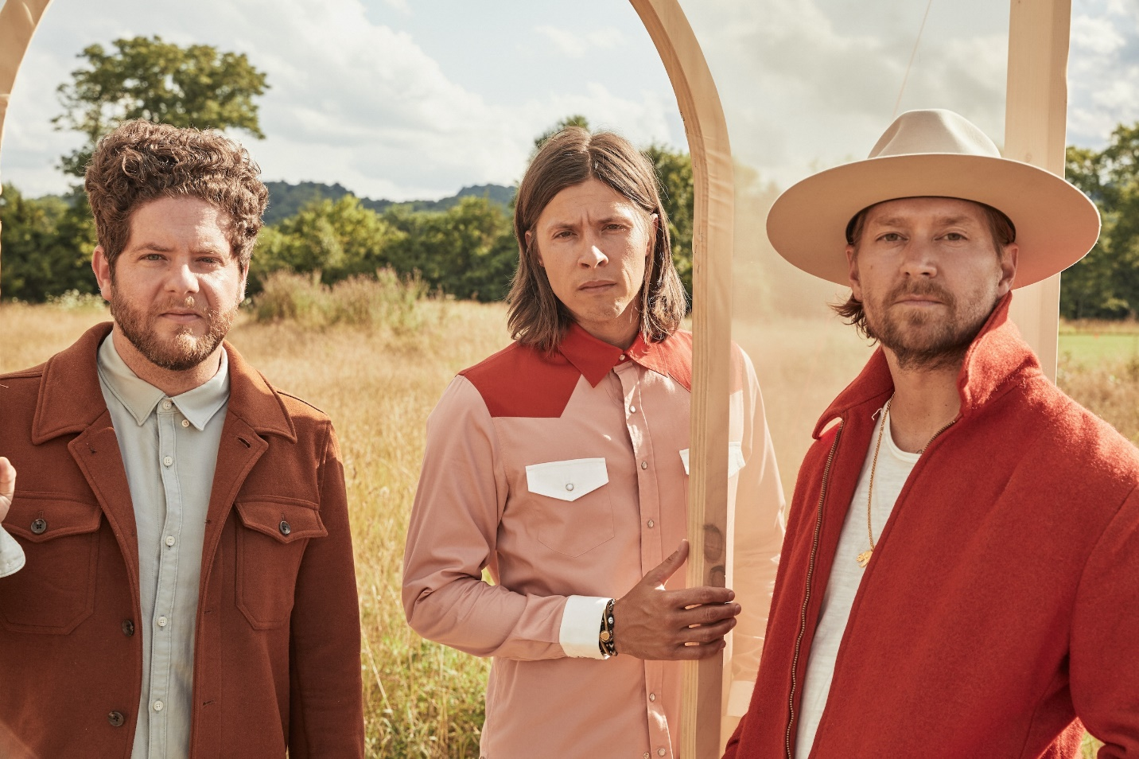

Photo credit: Brett Warren

GRAMMY® Award-nominated rock band **NEEDTOBREATHE**has released an official music video for “Banks”, off their critically acclaimed new album [*Out of Body*](https://nam04.safelinks.protection.outlook.com/?url=http%3A%2F%2Fntb.lnk.to%2FOutOfBody&data=04%7C01%7CSydneyWorden%40elektra.com%7C3e7f27ed358d4f9c72de08d8858d84cb%7C8367939002ec4ba1ad3d69da3fdd637e%7C0%7C0%7C637406190164569738%7CUnknown%7CTWFpbGZsb3d8eyJWIjoiMC4wLjAwMDAiLCJQIjoiV2luMzIiLCJBTiI6Ik1haWwiLCJXVCI6Mn0%3D%7C1000&sdata=qf1l1UhEdqjfsL3LKtqM%2BSZ4LslJ%2B9a5NddarCV4mfY%3D&reserved=0). The Chris Phelps-directed clip sees the band perform the anthemic song around a campfire. Watch it [HERE](https://nam04.safelinks.protection.outlook.com/?url=https%3A%2F%2Fyoutu.be%2FfqifjBtNzLw&data=04%7C01%7CSydneyWorden%40elektra.com%7C3e7f27ed358d4f9c72de08d8858d84cb%7C8367939002ec4ba1ad3d69da3fdd637e%7C0%7C0%7C637406190164579731%7CUnknown%7CTWFpbGZsb3d8eyJWIjoiMC4wLjAwMDAiLCJQIjoiV2luMzIiLCJBTiI6Ik1haWwiLCJXVCI6Mn0%3D%7C1000&sdata=YSFfO1Q6s9o7Vak5Og1Cfd81Gmky%2BsVmdZq5sVNfY0A%3D&reserved=0).

“This song is about the women in our lives... They are strong, ambitious, patient, caring, and intelligent forces of nature. ‘Banks’ is our way of saying we support you and that there’s nothing more beautiful than watching you effortlessly become the very thing you were made to be,” the band shared upon the song’s release.

*Out of Body* was released on August 28 and debuted in the top 5 across three Billboard charts. The album is available physically and digitally via Elektra Records/Centricity Music now [HERE](https://nam04.safelinks.protection.outlook.com/?url=https%3A%2F%2Fntb.lnk.to%2FOutOfBody&data=04%7C01%7CSydneyWorden%40elektra.com%7C3e7f27ed358d4f9c72de08d8858d84cb%7C8367939002ec4ba1ad3d69da3fdd637e%7C0%7C0%7C637406190164579731%7CUnknown%7CTWFpbGZsb3d8eyJWIjoiMC4wLjAwMDAiLCJQIjoiV2luMzIiLCJBTiI6Ik1haWwiLCJXVCI6Mn0%3D%7C1000&sdata=iDFdauRzNqSmUIre%2FjvGkoxg1SQbDzMa%2F1AI%2BIp66zU%3D&reserved=0). Limited edition merch bundles are available exclusively through NEEDTOBREATHE’s online store [HERE](https://nam04.safelinks.protection.outlook.com/?url=https%3A%2F%2Fneedtobreathe.merchmadeeasy.com%2F&data=04%7C01%7CSydneyWorden%40elektra.com%7C3e7f27ed358d4f9c72de08d8858d84cb%7C8367939002ec4ba1ad3d69da3fdd637e%7C0%7C0%7C637406190164589727%7CUnknown%7CTWFpbGZsb3d8eyJWIjoiMC4wLjAwMDAiLCJQIjoiV2luMzIiLCJBTiI6Ik1haWwiLCJXVCI6Mn0%3D%7C1000&sdata=g5XSRYXTzx18jWoio5Jnu4d6fukyEx3IZxkbdyU6y9s%3D&reserved=0). Last month, NEEDTOBREATHE unveiled a brand new version of the album’s current single “Who Am I” featuring vocals from multi-platinum recording artist, Elle King. “Who Am I” (feat. Elle King) is available to stream and download as an official *Out of Body*bonus track now [HERE](https://nam04.safelinks.protection.outlook.com/?url=https%3A%2F%2Fntb.lnk.to%2FWhoAmIElleKing&data=04%7C01%7CSydneyWorden%40elektra.com%7C3e7f27ed358d4f9c72de08d8858d84cb%7C8367939002ec4ba1ad3d69da3fdd637e%7C0%7C0%7C637406190164589727%7CUnknown%7CTWFpbGZsb3d8eyJWIjoiMC4wLjAwMDAiLCJQIjoiV2luMzIiLCJBTiI6Ik1haWwiLCJXVCI6Mn0%3D%7C1000&sdata=C4uIDyeBPt3MwVhv%2Bs9NMVRGLiJwDCBk9BpsUXQY1pY%3D&reserved=0).

Upon *Out of Body*’s release, *People* applauded the band’s “super catchy” new music, while *American Songwriter* commended NEEDTOBREATHE’s “solid capabilities in both ballads and upbeat anthem-style songs”. *Southern Living* praised the group as “our favorite Southern rock band”, adding “several songs feel like they were written specifically to get us through this difficult moment in time. *Taste of Country* noted, “NEEDTOBREATHE prove beautiful, collaborative art can still be made amid a pandemic.”

NEEDTOBREATHE welcomed the album with *Celebrating Out of Body*, a fully immersive release-day concert experience that saw them perform *Out of Body* in its entirety, live for the very first time. Last month the band took the stage at *CBS This Morning Saturday*to deliver the network television debut performances of “[Hang On](https://nam04.safelinks.protection.outlook.com/?url=https%3A%2F%2Fwww.youtube.com%2Fwatch%3Fv%3D25QxJheGNmY&data=04%7C01%7CSydneyWorden%40elektra.com%7C3e7f27ed358d4f9c72de08d8858d84cb%7C8367939002ec4ba1ad3d69da3fdd637e%7C0%7C0%7C637406190164589727%7CUnknown%7CTWFpbGZsb3d8eyJWIjoiMC4wLjAwMDAiLCJQIjoiV2luMzIiLCJBTiI6Ik1haWwiLCJXVCI6Mn0%3D%7C1000&sdata=zQ30Os2oS8dewPolj7kofJ3wMlfRTLkD%2FZcd75bM8yk%3D&reserved=0)”, “[Who Am I](https://nam04.safelinks.protection.outlook.com/?url=https%3A%2F%2Fwww.youtube.com%2Fwatch%3Fv%3DU857IGqZt7A&data=04%7C01%7CSydneyWorden%40elektra.com%7C3e7f27ed358d4f9c72de08d8858d84cb%7C8367939002ec4ba1ad3d69da3fdd637e%7C0%7C0%7C637406190164599720%7CUnknown%7CTWFpbGZsb3d8eyJWIjoiMC4wLjAwMDAiLCJQIjoiV2luMzIiLCJBTiI6Ik1haWwiLCJXVCI6Mn0%3D%7C1000&sdata=YkFJS2pBqPaYh3Zu9zlyrletsweQEFeh%2FHHvf%2Bwr69Q%3D&reserved=0)”, and “[Survival](https://nam04.safelinks.protection.outlook.com/?url=https%3A%2F%2Fwww.youtube.com%2Fwatch%3Fv%3DZWb3rAR4TK0&data=04%7C01%7CSydneyWorden%40elektra.com%7C3e7f27ed358d4f9c72de08d8858d84cb%7C8367939002ec4ba1ad3d69da3fdd637e%7C0%7C0%7C637406190164599720%7CUnknown%7CTWFpbGZsb3d8eyJWIjoiMC4wLjAwMDAiLCJQIjoiV2luMzIiLCJBTiI6Ik1haWwiLCJXVCI6Mn0%3D%7C1000&sdata=kyjlCceagZ4i9qj0hKW%2BTWChgon4ohLiym%2FjjmKhWaw%3D&reserved=0)”.  The band also performed sessions for [*Billboard*](https://nam04.safelinks.protection.outlook.com/?url=https%3A%2F%2Fwww.facebook.com%2FBillboard%2Fvideos%2F1186787911696692%2F&data=04%7C01%7CSydneyWorden%40elektra.com%7C3e7f27ed358d4f9c72de08d8858d84cb%7C8367939002ec4ba1ad3d69da3fdd637e%7C0%7C0%7C637406190164609717%7CUnknown%7CTWFpbGZsb3d8eyJWIjoiMC4wLjAwMDAiLCJQIjoiV2luMzIiLCJBTiI6Ik1haWwiLCJXVCI6Mn0%3D%7C1000&sdata=PAsZngoIlf0Q7iJhRweBGuPrxwrGUfx7BhhD22BdM%2B8%3D&reserved=0), *The Grammy Museum*, [*Spin*](https://nam04.safelinks.protection.outlook.com/?url=https%3A%2F%2Fwww.instagram.com%2Fp%2FCEvGstNDGGG%2F&data=04%7C01%7CSydneyWorden%40elektra.com%7C3e7f27ed358d4f9c72de08d8858d84cb%7C8367939002ec4ba1ad3d69da3fdd637e%7C0%7C0%7C637406190164609717%7CUnknown%7CTWFpbGZsb3d8eyJWIjoiMC4wLjAwMDAiLCJQIjoiV2luMzIiLCJBTiI6Ik1haWwiLCJXVCI6Mn0%3D%7C1000&sdata=s3GoYLoOnaf0fNNwjOHQOVTb90TaR9X0VfLuXOpo76k%3D&reserved=0), [*American Songwriter*](https://nam04.safelinks.protection.outlook.com/?url=https%3A%2F%2Fwww.facebook.com%2F116043963997%2Fvideos%2F304714297341670%2F%3F__so__%3Dchannel_tab%26__rv__%3Dall_videos_card&data=04%7C01%7CSydneyWorden%40elektra.com%7C3e7f27ed358d4f9c72de08d8858d84cb%7C8367939002ec4ba1ad3d69da3fdd637e%7C0%7C0%7C637406190164619708%7CUnknown%7CTWFpbGZsb3d8eyJWIjoiMC4wLjAwMDAiLCJQIjoiV2luMzIiLCJBTiI6Ik1haWwiLCJXVCI6Mn0%3D%7C1000&sdata=VpVHurPWFDPjdZLadKkDX3D3w%2BvWJDbRejYxkrl0i%2Fk%3D&reserved=0), and more.

On *Out of Body*, the platinum-certified trio—Bear Rinehart [vocals, guitar], Seth Bolt [bass, vocals], and Josh Lovelace [keys, vocals]—examine life, family, and friends through a youthful prism. The guys take stock of not only two decades as a band, but also first-time fatherhood and the future over a rich soundtrack of soulful rock with stadium-size scope and poetic intimacy. After spending a week at a beach house in Charleston to gather thoughts and ideas, the trio headed to Nashville, to record alongside producers Cason Cooley and Jeremy Lutito. As they cultivated a team atmosphere, the songs organically came to life.

**ABOUT NEEDTOBREATHE:**

GRAMMY® Award-nominated NEEDTOBREATHE have mounted a steady ascent to the top of the charts and packed arenas everywhere. Formed in 1998, the group attracted a loyal grassroots following with their full-length debut *Daylight* [2006] and its follow-up *The Heat* [2007]. Two years later, *The Outsiders* became their first Top 20 entry on the Billboard Top 200 before eventually going gold. During 2011, *The Reckoning* landed at #1 on the Billboard Top Rock Albums Chart and #6 on the Top 200. In addition to bowing at #3 on the Top 200, 2014’s *Rivers in the Wasteland* yielded the platinum-selling Hot 100 hit “Brother” [feat. Gavin DeGraw] and “Multiplied,” which garnered their first GRAMMY® nod. Meanwhile, *H A R D L O V E* [2016] marked their highest chart bow yet, debuting at #1 on the Billboard Top Current Album Sales Chart, as the title track “Hard Love” [feat. Andra Day] scored a gold plaque. Along the way, they headlined and sold out iconic venues such as Red Rocks Amphitheatre, The Greek Theatre, and Ryman Auditorium, to name a few. The group picked up a pair of nominations at the Billboard Music Awards, and received praise from People, Rolling Stone, Forbes, and more. Now, NEEDTOBREATHE reflect the freedom of youth on their seventh full-length offering, *Out of Body* [Elektra Records/Centricity Music] over a rich soundtrack of soulful rock with stadium-size scope and poetic intimacy.

[https://www.needtobreathe.com/](https://nam04.safelinks.protection.outlook.com/?url=https%3A%2F%2Fwww.needtobreathe.com%2F&data=04%7C01%7CSydneyWorden%40elektra.com%7C3e7f27ed358d4f9c72de08d8858d84cb%7C8367939002ec4ba1ad3d69da3fdd637e%7C0%7C0%7C637406190164619708%7CUnknown%7CTWFpbGZsb3d8eyJWIjoiMC4wLjAwMDAiLCJQIjoiV2luMzIiLCJBTiI6Ik1haWwiLCJXVCI6Mn0%3D%7C1000&sdata=Pzp12si62AB6nPCPw6iL1jrep1zB0MPxVER%2BfopvWkc%3D&reserved=0)

[https://www.facebook.com/NEEDTOBREATHE](https://nam04.safelinks.protection.outlook.com/?url=https%3A%2F%2Fwww.facebook.com%2FNEEDTOBREATHE&data=04%7C01%7CSydneyWorden%40elektra.com%7C3e7f27ed358d4f9c72de08d8858d84cb%7C8367939002ec4ba1ad3d69da3fdd637e%7C0%7C0%7C637406190164629703%7CUnknown%7CTWFpbGZsb3d8eyJWIjoiMC4wLjAwMDAiLCJQIjoiV2luMzIiLCJBTiI6Ik1haWwiLCJXVCI6Mn0%3D%7C1000&sdata=GuPLKu4vwFNdZ3yObEL1mM64eAnL1UwobmZH3J4P2GU%3D&reserved=0)

[https://twitter.com/NEEDTOBREATHE](https://nam04.safelinks.protection.outlook.com/?url=https%3A%2F%2Ftwitter.com%2FNEEDTOBREATHE&data=04%7C01%7CSydneyWorden%40elektra.com%7C3e7f27ed358d4f9c72de08d8858d84cb%7C8367939002ec4ba1ad3d69da3fdd637e%7C0%7C0%7C637406190164629703%7CUnknown%7CTWFpbGZsb3d8eyJWIjoiMC4wLjAwMDAiLCJQIjoiV2luMzIiLCJBTiI6Ik1haWwiLCJXVCI6Mn0%3D%7C1000&sdata=nDUUlmDx7ZzIe6EGI6Bcg1Ven3qaHZ35hvqLgSx3J%2BI%3D&reserved=0)

[https://www.instagram.com/needtobreathe/](https://nam04.safelinks.protection.outlook.com/?url=https%3A%2F%2Fwww.instagram.com%2Fneedtobreathe%2F&data=04%7C01%7CSydneyWorden%40elektra.com%7C3e7f27ed358d4f9c72de08d8858d84cb%7C8367939002ec4ba1ad3d69da3fdd637e%7C0%7C0%7C637406190164639697%7CUnknown%7CTWFpbGZsb3d8eyJWIjoiMC4wLjAwMDAiLCJQIjoiV2luMzIiLCJBTiI6Ik1haWwiLCJXVCI6Mn0%3D%7C1000&sdata=lot6wUx4luhFwulUOVODCOLavEEgBnTuuqLP3lnmJVg%3D&reserved=0)

[https://www.youtube.com/user/NEEDTOBREATHEVIDEOS](https://nam04.safelinks.protection.outlook.com/?url=https%3A%2F%2Fwww.youtube.com%2Fuser%2FNEEDTOBREATHEVIDEOS&data=04%7C01%7CSydneyWorden%40elektra.com%7C3e7f27ed358d4f9c72de08d8858d84cb%7C8367939002ec4ba1ad3d69da3fdd637e%7C0%7C0%7C637406190164639697%7CUnknown%7CTWFpbGZsb3d8eyJWIjoiMC4wLjAwMDAiLCJQIjoiV2luMzIiLCJBTiI6Ik1haWwiLCJXVCI6Mn0%3D%7C1000&sdata=%2BoHfz48uSOMTyiuOekMn5XaJqc5A1fHjo6LTpxhy%2Fc8%3D&reserved=0)

**NEEDTOBREATHE Press Contact:**

Collin Citron / [collincitron@elektra.com](mailto:collincitron@elektra.com)