FOR IMMEDIATE RELEASE

JUNE 17, 2021

**NEEDTOBREATHE RELEASE NEW TRACK “SUNSHINE” OFF FORTHCOMING ALBUM *INTO THE MYSTERY***

**LISTEN**[**HERE**](https://nam04.safelinks.protection.outlook.com/?url=https%3A%2F%2Fyoutu.be%2FJnqG2Z68Cro&data=04%7C01%7CSydneyWorden%40elektra.com%7Cc9f43542c2b547212d2c08d93199b0ab%7C8367939002ec4ba1ad3d69da3fdd637e%7C0%7C0%7C637595358431730576%7CUnknown%7CTWFpbGZsb3d8eyJWIjoiMC4wLjAwMDAiLCJQIjoiV2luMzIiLCJBTiI6Ik1haWwiLCJXVCI6Mn0%3D%7C1000&sdata=YQF%2B2IijgsZ0F84IrgLK9Tppe0B%2FzPMDGjhiPmy72yg%3D&reserved=0)**/ PRE-ORDER THE ALBUM** [**HERE**](https://nam04.safelinks.protection.outlook.com/?url=https%3A%2F%2Fntb.lnk.to%2FIntoTheMystery&data=04%7C01%7CSydneyWorden%40elektra.com%7Cc9f43542c2b547212d2c08d93199b0ab%7C8367939002ec4ba1ad3d69da3fdd637e%7C0%7C0%7C637595358431740568%7CUnknown%7CTWFpbGZsb3d8eyJWIjoiMC4wLjAwMDAiLCJQIjoiV2luMzIiLCJBTiI6Ik1haWwiLCJXVCI6Mn0%3D%7C1000&sdata=Ax9%2BIIxtxjUoX9B2vdCBNjISoyoyzAZnPaXbH2R0794%3D&reserved=0)

**NEEDTOBREATHE AND CARRIE UNDERWOOD DELIVER UNFORGETTABLE PERFORMANCE OF “I WANNA REMEMBER” AT THE 2021 “CMT MUSIC AWARDS” - WATCH** [**HERE**](https://nam04.safelinks.protection.outlook.com/?url=https%3A%2F%2Fwww.youtube.com%2Fwatch%3Fv%3DPof8LfoTnbI&data=04%7C01%7CSydneyWorden%40elektra.com%7Cc9f43542c2b547212d2c08d93199b0ab%7C8367939002ec4ba1ad3d69da3fdd637e%7C0%7C0%7C637595358431750566%7CUnknown%7CTWFpbGZsb3d8eyJWIjoiMC4wLjAwMDAiLCJQIjoiV2luMzIiLCJBTiI6Ik1haWwiLCJXVCI6Mn0%3D%7C1000&sdata=PirbxNHi5IAdvHsej2HbTJScuQGQ8Hs%2Bu4k4WhkVilg%3D&reserved=0)

**TICKETS FOR THE *INTO THE MYSTERY TOUR* AVAILABLE NOW** [**HERE**](https://nam04.safelinks.protection.outlook.com/?url=https%3A%2F%2Fwww.needtobreathe.com%2Ftour&data=04%7C01%7CSydneyWorden%40elektra.com%7Cc9f43542c2b547212d2c08d93199b0ab%7C8367939002ec4ba1ad3d69da3fdd637e%7C0%7C0%7C637595358431750566%7CUnknown%7CTWFpbGZsb3d8eyJWIjoiMC4wLjAwMDAiLCJQIjoiV2luMzIiLCJBTiI6Ik1haWwiLCJXVCI6Mn0%3D%7C1000&sdata=46s77zr7NyYiIf7aJpipGs%2FLA%2FJTSXPY5H19%2BC3%2Bazg%3D&reserved=0)

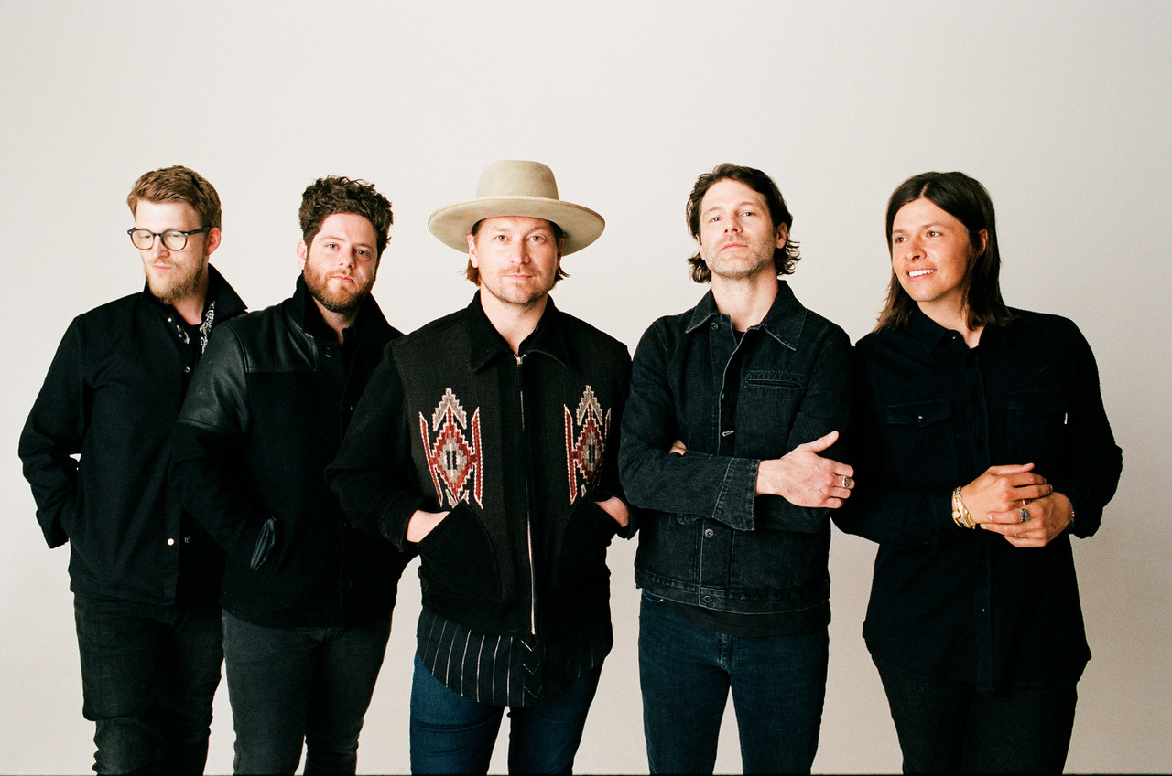

*Photo credit: David O'Donohue*

GRAMMY® Award-nominated rock band **NEEDTOBREATHE** have released “[Sunshine](https://nam04.safelinks.protection.outlook.com/?url=https%3A%2F%2Fyoutu.be%2FJnqG2Z68Cro&data=04%7C01%7CSydneyWorden%40elektra.com%7Cc9f43542c2b547212d2c08d93199b0ab%7C8367939002ec4ba1ad3d69da3fdd637e%7C0%7C0%7C637595358431760558%7CUnknown%7CTWFpbGZsb3d8eyJWIjoiMC4wLjAwMDAiLCJQIjoiV2luMzIiLCJBTiI6Ik1haWwiLCJXVCI6Mn0%3D%7C1000&sdata=7LM1ogKPmgYasJkhrkS8TjvIAkcBhiw12JewDDJwzyE%3D&reserved=0)”, the fourth track off their forthcoming studio album *Into The Mystery.* The song is available to stream and download starting today [HERE](https://nam04.safelinks.protection.outlook.com/?url=https%3A%2F%2Fntb.lnk.to%2FIntoTheMystery&data=04%7C01%7CSydneyWorden%40elektra.com%7Cc9f43542c2b547212d2c08d93199b0ab%7C8367939002ec4ba1ad3d69da3fdd637e%7C0%7C0%7C637595358431760558%7CUnknown%7CTWFpbGZsb3d8eyJWIjoiMC4wLjAwMDAiLCJQIjoiV2luMzIiLCJBTiI6Ik1haWwiLCJXVCI6Mn0%3D%7C1000&sdata=IFmEMWg1TfWKhuHjIlIBcNmmZgjzh1wP6ijH5JV%2F85Y%3D&reserved=0). *Into The Mystery* is due for release on July 30 via Elektra Records and is available for pre-order now [HERE](https://nam04.safelinks.protection.outlook.com/?url=https%3A%2F%2Fntb.lnk.to%2FIntoTheMystery&data=04%7C01%7CSydneyWorden%40elektra.com%7Cc9f43542c2b547212d2c08d93199b0ab%7C8367939002ec4ba1ad3d69da3fdd637e%7C0%7C0%7C637595358431770552%7CUnknown%7CTWFpbGZsb3d8eyJWIjoiMC4wLjAwMDAiLCJQIjoiV2luMzIiLCJBTiI6Ik1haWwiLCJXVCI6Mn0%3D%7C1000&sdata=wjTLQNeKR0I1ufy7iGTTcB4afvzPui3C4HLe0%2BdSfXQ%3D&reserved=0). Limited edition merch offerings are available exclusively through NEEDTOBREATHE’s online store [HERE](https://nam04.safelinks.protection.outlook.com/?url=https%3A%2F%2Fneedtobreathe.merchmadeeasy.com%2F&data=04%7C01%7CSydneyWorden%40elektra.com%7Cc9f43542c2b547212d2c08d93199b0ab%7C8367939002ec4ba1ad3d69da3fdd637e%7C0%7C0%7C637595358431970430%7CUnknown%7CTWFpbGZsb3d8eyJWIjoiMC4wLjAwMDAiLCJQIjoiV2luMzIiLCJBTiI6Ik1haWwiLCJXVCI6Mn0%3D%7C1000&sdata=wcyQTGKdOIweRUD1MaEwS2Zuak6kLTUbVaQF1U0fRqk%3D&reserved=0).

Last week NEEDTOBREATHE delivered the television debut performance of *Into The Mystery’s* current single “[I Wanna Remember](https://nam04.safelinks.protection.outlook.com/?url=https%3A%2F%2Fyoutu.be%2Fd4mh4jq_MYU&data=04%7C01%7CSydneyWorden%40elektra.com%7Cc9f43542c2b547212d2c08d93199b0ab%7C8367939002ec4ba1ad3d69da3fdd637e%7C0%7C0%7C637595358431970430%7CUnknown%7CTWFpbGZsb3d8eyJWIjoiMC4wLjAwMDAiLCJQIjoiV2luMzIiLCJBTiI6Ik1haWwiLCJXVCI6Mn0%3D%7C1000&sdata=t5eTR8DCOzTvtSIGiAsI353kJGs0mZOYofwLRKPQaRU%3D&reserved=0)” alongside seven-timeGRAMMY® Award winner Carrie Underwood at the 2021 “CMT Music Awards”. Watch their unforgettable performance [HERE](https://nam04.safelinks.protection.outlook.com/?url=https%3A%2F%2Fyoutu.be%2FPof8LfoTnbI&data=04%7C01%7CSydneyWorden%40elektra.com%7Cc9f43542c2b547212d2c08d93199b0ab%7C8367939002ec4ba1ad3d69da3fdd637e%7C0%7C0%7C637595358431980435%7CUnknown%7CTWFpbGZsb3d8eyJWIjoiMC4wLjAwMDAiLCJQIjoiV2luMzIiLCJBTiI6Ik1haWwiLCJXVCI6Mn0%3D%7C1000&sdata=Dz2CG1rxkvg9s62n%2FDRbPzrhr5C3ej4HeUvmiw0DlzM%3D&reserved=0). Crowned as one of the most showstopping moments of the evening by both *US Weekly* and *Entertainment Tonight,* *Billboard* shared  “Bear Rinehart and Underwood’s vocals intertwining like leather and lace,” and praised, “the love song about wanting to remember an especially romantic moment felt particularly poignant as we head into a summer where new memories will be made after putting dreams on hold for more than a year.”

*Into The Mystery* was announced last month alongside the release of the album’s lead single and [title track](https://nam04.safelinks.protection.outlook.com/?url=https%3A%2F%2Fntb.lnk.to%2FIntoTheMystery&data=04%7C01%7CSydneyWorden%40elektra.com%7Cc9f43542c2b547212d2c08d93199b0ab%7C8367939002ec4ba1ad3d69da3fdd637e%7C0%7C0%7C637595358431990426%7CUnknown%7CTWFpbGZsb3d8eyJWIjoiMC4wLjAwMDAiLCJQIjoiV2luMzIiLCJBTiI6Ik1haWwiLCJXVCI6Mn0%3D%7C1000&sdata=cV%2FcbveF2ZDqOaQ4alBMtcuam9H5vtcJ8QGO4FpG4nE%3D&reserved=0). Earlier this month, the band unveiled the album’s opening track “[What I’m Here For](https://nam04.safelinks.protection.outlook.com/?url=https%3A%2F%2Fwww.youtube.com%2Fwatch%3Fv%3DY8Zj9cpb8fI&data=04%7C01%7CSydneyWorden%40elektra.com%7Cc9f43542c2b547212d2c08d93199b0ab%7C8367939002ec4ba1ad3d69da3fdd637e%7C0%7C0%7C637595358431990426%7CUnknown%7CTWFpbGZsb3d8eyJWIjoiMC4wLjAwMDAiLCJQIjoiV2luMzIiLCJBTiI6Ik1haWwiLCJXVCI6Mn0%3D%7C1000&sdata=TEEHLwLxbdZyiNvH4%2F%2BW5%2BsJ89cPTkopeCgnRTxaVZ4%3D&reserved=0)”. *Into The Mystery’s* early songs have received praise from *Rolling Stone, Billboard, People, American Songwriter,* and more. The album will also feature collaborations with Jon Foreman of Switchfoot and Natalie Hemby of The Highwomen.

This Fall, NEEDTOBREATHE will embark on their massive Into The Mystery Tour with support from Switchfoot and The New Respects. The 38-city trek will visit iconic venues such as Denver, CO’s Red Rocks Amphitheatre (fifth consecutive sold out appearance) and Los Angeles, CA’s Greek Theatre, and see the band perform their first-ever headline show at Nashville, TN’s Bridgestone Arena. The Into The Mystery Tour will kick off on September 7 in St. Louis, MO, and wrap on October 30 in Atlanta, GA. Tickets for all dates are available now [HERE](https://nam04.safelinks.protection.outlook.com/?url=https%3A%2F%2Fwww.needtobreathe.com%2Ftour&data=04%7C01%7CSydneyWorden%40elektra.com%7Cc9f43542c2b547212d2c08d93199b0ab%7C8367939002ec4ba1ad3d69da3fdd637e%7C0%7C0%7C637595358432000417%7CUnknown%7CTWFpbGZsb3d8eyJWIjoiMC4wLjAwMDAiLCJQIjoiV2luMzIiLCJBTiI6Ik1haWwiLCJXVCI6Mn0%3D%7C1000&sdata=J%2FMGRUQ6sYg8hDh34OHMih%2Fgol1fsifUMEEjqly0ip0%3D&reserved=0).

Just as their critically acclaimed 2020 album *Out of Body* impacted audiences, NEEDTOBREATHE capitalized on a rush of inspiration and rode the wave of creativity. Without telling a soul, the band decamped to a historic house-turned-recording studio in Columbia, TN to begin working on new music. Over the course of three weeks, they resided under one roof, laughed during meals, explored their surroundings, and recorded together with co-producer and engineer Konrad Snyder and special guests. Out of this de facto creative hub and *“extended summer camp*,*”* they handcrafted an album reflective of the moment, yet independent of all expectations—even their own. For as intimate as the story may seem, they filmed every minute of it for an upcoming documentary entitled, *Into The Mystery*. Watch a teaser for the film [HERE](https://nam04.safelinks.protection.outlook.com/?url=https%3A%2F%2Fwww.instagram.com%2Fp%2FCOf9uwiHu2v%2F&data=04%7C01%7CSydneyWorden%40elektra.com%7Cc9f43542c2b547212d2c08d93199b0ab%7C8367939002ec4ba1ad3d69da3fdd637e%7C0%7C0%7C637595358432000417%7CUnknown%7CTWFpbGZsb3d8eyJWIjoiMC4wLjAwMDAiLCJQIjoiV2luMzIiLCJBTiI6Ik1haWwiLCJXVCI6Mn0%3D%7C1000&sdata=B8gsY4n1UGB3Hh234A13%2FjarwT2OGHLsTJgraTa73tQ%3D&reserved=0).

The past 12 months represent one of the most prolific periods in the band’s career thus far. They recently unveiled *Live from the Woods Vol. 2*—a live album recorded during three sold out, socially distanced outdoor concerts at Pelham, TN’s famed The Caverns. The band previewed the album with a performance of “Alive” on CBS’s *The Late Late Show with James Corden*. Meanwhile, *Out of Body* debuted in the top 5 across three Billboard charts, and received critical acclaim from *Billboard, Spin, Southern Living, American Songwriter, Taste of Country,* and more.

**Into The Mystery Tour Dates**

September 07, 2021 - St. Louis, MO - Saint Louis Music Park

September 08, 2021 - Kansas City, MO - Midland Theatre

September 10, 2021 - Denver, CO - Red Rocks Amphitheatre - **SOLD OUT**

September 11, 2021 - Salt Lake City, UT - Sandy City Amphitheater

September 13, 2021 - Phoenix, AZ - Arizona Federal Theatre

September 14, 2021 - San Diego, CA - Cal Coast Credit Union OAT

September 16, 2021 - Los Angeles, CA - Greek Theatre

September 17, 2021 - Saratoga, CA - The Mountain Winery

September 18, 2021 - Bend, OR - Les Schwab Amphitheater

September 19, 2021 - Seattle, WA - Marymoor Amphitheater

September 21, 2021 - Missoula, MT - KettleHouse Amphitheater

September 23, 2021 - Fargo, ND - Bluestem Center for the Arts - Bluestem Amphitheater

September 24, 2021 - Minneapolis, MN - Armory

September 25, 2021 - Madison, WI - The Sylvee

September 26, 2021 - Indianapolis, IN - Amphitheater at White River State Park

September 28, 2021 - Cincinnati, OH - Andrew J Brady ICON Music Center

September 30, 2021 - Chicago, IL - Radius

October 01, 2021 - Detroit, MI - Michigan Lottery Amphitheatre at Freedom Hill

October 02, 2021 - Cleveland, OH - Nautica Pavilion

October 03, 2021 - Pittsburgh, PA - Robert Morris University - UPMC Events Center

October 07, 2021 - Philadelphia, PA - The Met Philadelphia

October 08, 2021 - Boston, MA - Leader Bank Pavilion

October 09, 2021 - New York, NY - The Rooftop at Pier 17

October 10, 2021 - Washington, DC - The Anthem

October 12, 2021 - Louisville, KY - The Louisville Palace Theater

October 14, 2021 - Charlotte, NC - Charlotte Metro Credit Union Amphitheatre

October 15, 2021 - Raleigh, NC - Red Hat Amphitheater

October 16, 2021 - Greenville, SC - Bon Secours Wellness Arena

October 17, 2021 - Charleston, SC - North Charleston Coliseum

October 19, 2021 - Rogers, AR - Walmart AMP

October 21, 2021 - Austin, TX - Moody Amphitheater

October 22, 2021 - Houston, TX - Smart Financial Centre

October 23, 2021 - Dallas, TX - The Pavilion at Toyota Music Factory

October 24, 2021 - Oklahoma City, OK - Zoo Amphitheatre

October 27, 2021 - Memphis, TN - Memphis Botanic Garden

October 28, 2021 - Birmingham, AL - Oak Mountain Amphitheatre

October 29, 2021 - Nashville, TN - Bridgestone Arena

October 30, 2021 - Atlanta, GA - Ameris Bank Amphitheatre

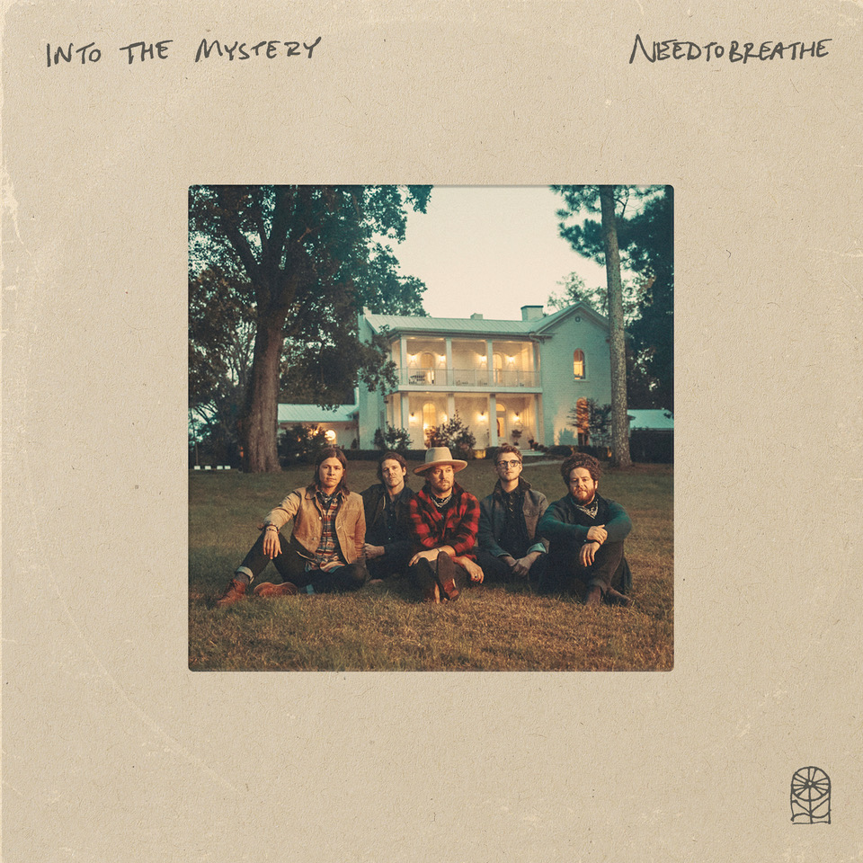

**About NEEDTOBREATHE:**

Since 1998, NEEDTOBREATHE have quietly emerged as a dynamic force in rock music, topping the charts, selling out historic venues, and generating hundreds of millions of streams to date. The band have gathered one platinum single, four gold singles, and a gold album. Along the way, “Multiplied” notched their first GRAMMY® nomination. Simultaneously, they performed to sold out crowds at arenas and amphitheaters coast to coast. In addition to garnering two nods at the Billboard Music Awards, they’ve attracted acclaim from People, Rolling Stone, Forbes, and many more. In 2020, they sowed the seeds for rebirth with Out of Body. It bowed in the Top 5 of three Billboard charts and reeled in acclaim. Within weeks of its release, the quintet—Bear Rinehart [vocals, guitar], Seth Bolt [bass, vocals], Josh Lovelace [keys, vocals], Randall Harris [drums], and Tyler Burkum [guitar]—stole away to an old historic house in Columbia, TN where they lived together, ate together, laughed together, and recorded together for three weeks in the fall of 2020. They returned home with their eighth album and documentary Into The Mystery [Elektra Records]. It’s the kind of record that could only be made by a band who has been through it all and still has enough faith to keep encouraging one another. It’s NEEDTOBREATHE.

[https://www.needtobreathe.com/](https://nam04.safelinks.protection.outlook.com/?url=https%3A%2F%2Fwww.needtobreathe.com%2F&data=04%7C01%7CSydneyWorden%40elektra.com%7Cc9f43542c2b547212d2c08d93199b0ab%7C8367939002ec4ba1ad3d69da3fdd637e%7C0%7C0%7C637595358432010418%7CUnknown%7CTWFpbGZsb3d8eyJWIjoiMC4wLjAwMDAiLCJQIjoiV2luMzIiLCJBTiI6Ik1haWwiLCJXVCI6Mn0%3D%7C1000&sdata=C8lBWO4o5A9Dn5b1yX3I8CptqKl1yyFnx%2FqRbG8I%2BMc%3D&reserved=0)

[FACEBOOK](https://nam04.safelinks.protection.outlook.com/?url=https%3A%2F%2Fwww.facebook.com%2FNEEDTOBREATHE&data=04%7C01%7CSydneyWorden%40elektra.com%7Cc9f43542c2b547212d2c08d93199b0ab%7C8367939002ec4ba1ad3d69da3fdd637e%7C0%7C0%7C637595358432010418%7CUnknown%7CTWFpbGZsb3d8eyJWIjoiMC4wLjAwMDAiLCJQIjoiV2luMzIiLCJBTiI6Ik1haWwiLCJXVCI6Mn0%3D%7C1000&sdata=ZXm2u1lTIp69mfTkhgGYouBcYX2K6B%2B7YyeteEEwg0U%3D&reserved=0)

[TWITTER](https://nam04.safelinks.protection.outlook.com/?url=https%3A%2F%2Ftwitter.com%2FNEEDTOBREATHE&data=04%7C01%7CSydneyWorden%40elektra.com%7Cc9f43542c2b547212d2c08d93199b0ab%7C8367939002ec4ba1ad3d69da3fdd637e%7C0%7C0%7C637595358432020407%7CUnknown%7CTWFpbGZsb3d8eyJWIjoiMC4wLjAwMDAiLCJQIjoiV2luMzIiLCJBTiI6Ik1haWwiLCJXVCI6Mn0%3D%7C1000&sdata=W0tfLBoO6Uc6G3gOk9aX5tDOswM92pH0YzOG%2Bbma8UM%3D&reserved=0)

[INSTAGRAM](https://nam04.safelinks.protection.outlook.com/?url=https%3A%2F%2Fwww.instagram.com%2Fneedtobreathe%2F&data=04%7C01%7CSydneyWorden%40elektra.com%7Cc9f43542c2b547212d2c08d93199b0ab%7C8367939002ec4ba1ad3d69da3fdd637e%7C0%7C0%7C637595358432020407%7CUnknown%7CTWFpbGZsb3d8eyJWIjoiMC4wLjAwMDAiLCJQIjoiV2luMzIiLCJBTiI6Ik1haWwiLCJXVCI6Mn0%3D%7C1000&sdata=1xNfRabTEcmKcGuCLUGA43TeghsPubXR9sUdmx5E%2F5A%3D&reserved=0)

[YOUTUBE](https://nam04.safelinks.protection.outlook.com/?url=https%3A%2F%2Fwww.youtube.com%2Fuser%2FNEEDTOBREATHEVIDEOS&data=04%7C01%7CSydneyWorden%40elektra.com%7Cc9f43542c2b547212d2c08d93199b0ab%7C8367939002ec4ba1ad3d69da3fdd637e%7C0%7C0%7C637595358432030401%7CUnknown%7CTWFpbGZsb3d8eyJWIjoiMC4wLjAwMDAiLCJQIjoiV2luMzIiLCJBTiI6Ik1haWwiLCJXVCI6Mn0%3D%7C1000&sdata=81ruc2OpMiTVn8u234ojxXHI1peKL%2F5W5byozEZqoNA%3D&reserved=0)

**NEEDTOBREATHE Press Contact:**

Collin Citron / [CollinCitron@elektra.com](mailto:CollinCitron@elektra.com)