FOR IMMEDIATE RELEASE

SEPTEMBER 28, 2021

**NEEDTOBREATHE TO LIVESTREAM FIRST-EVER HEADLINE SHOW AT NASHVILLE, TN’S BRIDGESTONE ARENA ON OCTOBER 29**

**TICKETS AVAILABLE BEGINNING TODAY** [**HERE**](https://nam04.safelinks.protection.outlook.com/?url=https%3A%2F%2Fneedtobreathe.veeps.com%2F&data=04%7C01%7CSydneyWorden%40elektra.com%7C697b469948bd420a93aa08d982991da7%7C8367939002ec4ba1ad3d69da3fdd637e%7C0%7C0%7C637684416444654863%7CUnknown%7CTWFpbGZsb3d8eyJWIjoiMC4wLjAwMDAiLCJQIjoiV2luMzIiLCJBTiI6Ik1haWwiLCJXVCI6Mn0%3D%7C1000&sdata=25t6%2Fypyb4F0ncYZWBqeKrsFjH8cTODhtOOIijuk5OY%3D&reserved=0) **VIA VEEPS**

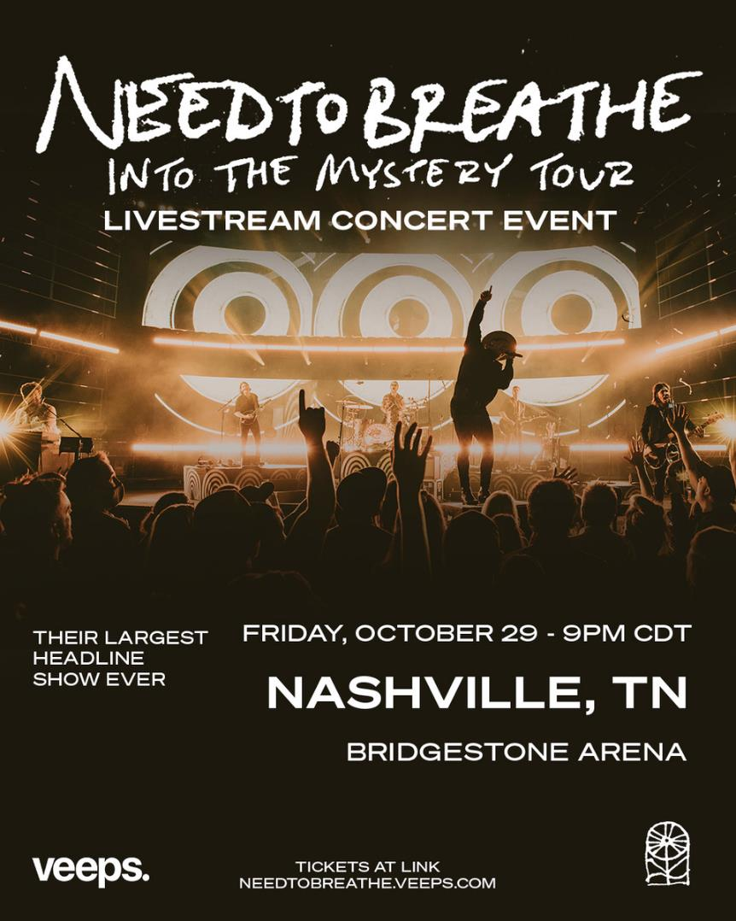

***INTO THE MYSTERY* DOCUMENTARY FILM HITS CINEMAS NATIONWIDE NOVEMBER 3**

**TICKETS FOR REMAINING *INTO THE MYSTERY* TOURDATESAVAILABLE** [**HERE**](https://nam04.safelinks.protection.outlook.com/?url=https%3A%2F%2Fwww.needtobreathe.com%2Ftour&data=04%7C01%7CSydneyWorden%40elektra.com%7C697b469948bd420a93aa08d982991da7%7C8367939002ec4ba1ad3d69da3fdd637e%7C0%7C0%7C637684416444664856%7CUnknown%7CTWFpbGZsb3d8eyJWIjoiMC4wLjAwMDAiLCJQIjoiV2luMzIiLCJBTiI6Ik1haWwiLCJXVCI6Mn0%3D%7C1000&sdata=qsddMKfL%2F1G1dRP01VrzROVSyb4%2FPnBdUBf5guj%2FezM%3D&reserved=0)

**NEW STUDIO ALBUM *INTO THE MYSTERY* OUT NOW** [**HERE**](https://nam04.safelinks.protection.outlook.com/?url=https%3A%2F%2Fntb.lnk.to%2FIntoTheMystery&data=04%7C01%7CSydneyWorden%40elektra.com%7C697b469948bd420a93aa08d982991da7%7C8367939002ec4ba1ad3d69da3fdd637e%7C0%7C0%7C637684416444674851%7CUnknown%7CTWFpbGZsb3d8eyJWIjoiMC4wLjAwMDAiLCJQIjoiV2luMzIiLCJBTiI6Ik1haWwiLCJXVCI6Mn0%3D%7C1000&sdata=QvG88hreUc2mMdLCJeXhqQWOZcI%2FypPXYc7zWGd6Y78%3D&reserved=0)

GRAMMY® Award-nominated rock band **NEEDTOBREATHE** have announced they will livestream the Nashville, TN date of their Into The Mystery Tour on October 29 at 9:00pm CT. The show notably marks the band’s first-ever headline performance at Bridgestone Arena. Tickets for the livestream are available beginning today [HERE](https://nam04.safelinks.protection.outlook.com/?url=https%3A%2F%2Fneedtobreathe.veeps.com%2F&data=04%7C01%7CSydneyWorden%40elektra.com%7C697b469948bd420a93aa08d982991da7%7C8367939002ec4ba1ad3d69da3fdd637e%7C0%7C0%7C637684416444674851%7CUnknown%7CTWFpbGZsb3d8eyJWIjoiMC4wLjAwMDAiLCJQIjoiV2luMzIiLCJBTiI6Ik1haWwiLCJXVCI6Mn0%3D%7C1000&sdata=yEWTDtNH1K3qyXj2wMJjrnN1Mq3eDE2AEUPFrvCZFok%3D&reserved=0) via Veeps for $11. $1 from each ticket sold will be donated to [For Others](https://nam04.safelinks.protection.outlook.com/?url=https%3A%2F%2Fwww.forothers.com%2F&data=04%7C01%7CSydneyWorden%40elektra.com%7C697b469948bd420a93aa08d982991da7%7C8367939002ec4ba1ad3d69da3fdd637e%7C0%7C0%7C637684416444684852%7CUnknown%7CTWFpbGZsb3d8eyJWIjoiMC4wLjAwMDAiLCJQIjoiV2luMzIiLCJBTiI6Ik1haWwiLCJXVCI6Mn0%3D%7C1000&sdata=d6Et5kUv9wmxOxSvNy1bVzMc34ra1TGslC0VihqCVxE%3D&reserved=0), the band’s charitable partner for the tour.

NEEDTOBREATHE massive Into The Mystery Tour with support from Switchfoot and The New Respects kicked off earlier this month. The tour has already visited iconic venues such as Denver, CO’s Red Rocks Amphitheatre (fifth consecutive sold out appearance) and Los Angeles, CA’s Greek Theatre. The Into The Mystery tour will visit US cities for the next month before wrapping on October 30 in Atlanta, GA. Tickets for remaining dates are available now [HERE](https://nam04.safelinks.protection.outlook.com/?url=https%3A%2F%2Fwww.needtobreathe.com%2Ftour&data=04%7C01%7CSydneyWorden%40elektra.com%7C697b469948bd420a93aa08d982991da7%7C8367939002ec4ba1ad3d69da3fdd637e%7C0%7C0%7C637684416444694861%7CUnknown%7CTWFpbGZsb3d8eyJWIjoiMC4wLjAwMDAiLCJQIjoiV2luMzIiLCJBTiI6Ik1haWwiLCJXVCI6Mn0%3D%7C1000&sdata=RqjrQGfUqFeaOsDLDSM0%2B0POCdZhDZb81Zax74gWcrA%3D&reserved=0).

On November 3, Fathom Events and Greenwich Entertainment will present “NEEDTOBREATHE: *Into The Mystery”* in movie theaters nationwide in a special one-night cinema event. This intimate documentary chronicles the recording of NEEDTOBREATHE’s latest album *Into The Mystery*, while quarantined in a historic house-turned-recording studio in remote Tennessee in fall of 2020. Watch the film’s trailer [HERE](https://nam04.safelinks.protection.outlook.com/?url=https%3A%2F%2Fyoutu.be%2FgljCvOlOmtU&data=04%7C01%7CSydneyWorden%40elektra.com%7C697b469948bd420a93aa08d982991da7%7C8367939002ec4ba1ad3d69da3fdd637e%7C0%7C0%7C637684416444704839%7CUnknown%7CTWFpbGZsb3d8eyJWIjoiMC4wLjAwMDAiLCJQIjoiV2luMzIiLCJBTiI6Ik1haWwiLCJXVCI6Mn0%3D%7C1000&sdata=A35QdIJFjfheW4T30Vi0J0qyeKc1Wgf4Zlx%2Fd%2F9TgZA%3D&reserved=0) and visit [needtobreathemovie.com](https://nam04.safelinks.protection.outlook.com/?url=http%3A%2F%2Fneedtobreathemovie.com%2F&data=04%7C01%7CSydneyWorden%40elektra.com%7C697b469948bd420a93aa08d982991da7%7C8367939002ec4ba1ad3d69da3fdd637e%7C0%7C0%7C637684416444704839%7CUnknown%7CTWFpbGZsb3d8eyJWIjoiMC4wLjAwMDAiLCJQIjoiV2luMzIiLCJBTiI6Ik1haWwiLCJXVCI6Mn0%3D%7C1000&sdata=9Ht8q9xqjLsi6OvVhkaMI%2FUt2GCgwdBOhS1VgxwsxIM%3D&reserved=0) for more information.

*Into The Mystery*is available physically and digitally now via Elektra Records [HERE.](https://nam04.safelinks.protection.outlook.com/?url=https%3A%2F%2Fntb.lnk.to%2FIntoTheMystery&data=04%7C01%7CSydneyWorden%40elektra.com%7C697b469948bd420a93aa08d982991da7%7C8367939002ec4ba1ad3d69da3fdd637e%7C0%7C0%7C637684416444714824%7CUnknown%7CTWFpbGZsb3d8eyJWIjoiMC4wLjAwMDAiLCJQIjoiV2luMzIiLCJBTiI6Ik1haWwiLCJXVCI6Mn0%3D%7C1000&sdata=5MSUwZNE2TixU%2B4UXFCUCtpGT9fwVEY%2B%2FLsJKTz3MWQ%3D&reserved=0) Limited edition merch offerings are available exclusively through NEEDTOBREATHE’s online store [HERE](https://nam04.safelinks.protection.outlook.com/?url=https%3A%2F%2Fneedtobreathe.merchmadeeasy.com%2F&data=04%7C01%7CSydneyWorden%40elektra.com%7C697b469948bd420a93aa08d982991da7%7C8367939002ec4ba1ad3d69da3fdd637e%7C0%7C0%7C637684416444714824%7CUnknown%7CTWFpbGZsb3d8eyJWIjoiMC4wLjAwMDAiLCJQIjoiV2luMzIiLCJBTiI6Ik1haWwiLCJXVCI6Mn0%3D%7C1000&sdata=FJ%2BAtwz3Mj5CLRvUPT1NZg8i3iYUw6io1EBWR%2BFVdvg%3D&reserved=0). *Into The Mystery* was released in July, and debuted in the Top 10 across three Billboard charts. The critically acclaimed collection has received praise from *Rolling Stone*, *Billboard*, *Entertainment Tonight*, *People*, *American Songwriter,* and more.

*Into The Mystery* is highlighted by current single “[I Wanna Remember](https://nam04.safelinks.protection.outlook.com/?url=https%3A%2F%2Fyoutu.be%2Fd4mh4jq_MYU&data=04%7C01%7CSydneyWorden%40elektra.com%7C697b469948bd420a93aa08d982991da7%7C8367939002ec4ba1ad3d69da3fdd637e%7C0%7C0%7C637684416444724822%7CUnknown%7CTWFpbGZsb3d8eyJWIjoiMC4wLjAwMDAiLCJQIjoiV2luMzIiLCJBTiI6Ik1haWwiLCJXVCI6Mn0%3D%7C1000&sdata=RY4f8Jwk%2FckcxmmYJsJFzOMAbdhIV92HTW1FXNIQXcM%3D&reserved=0)” featuring seven-timeGRAMMY® Award winner Carrie Underwood. The band and Underwood recently delivered the television debut performance of the song at the 2021 “CMT Music Awards”. Crowned as one of the most showstopping moments of the evening by both *US Weekly,* *Vulture* hailed it as a “powerful, predictably huge performance of their duet,” and *E!* called it, “something fans will want to remember.” Watch their unforgettable performance [HERE](https://nam04.safelinks.protection.outlook.com/?url=https%3A%2F%2Fyoutu.be%2FPof8LfoTnbI&data=04%7C01%7CSydneyWorden%40elektra.com%7C697b469948bd420a93aa08d982991da7%7C8367939002ec4ba1ad3d69da3fdd637e%7C0%7C0%7C637684416444734817%7CUnknown%7CTWFpbGZsb3d8eyJWIjoiMC4wLjAwMDAiLCJQIjoiV2luMzIiLCJBTiI6Ik1haWwiLCJXVCI6Mn0%3D%7C1000&sdata=u7t%2F%2Fmhcv4NeOJ7%2F9m54iWnf8ORuKqZruDoUOneZm%2Fc%3D&reserved=0).

**Into The Mystery Tour Dates**

September 28, 2021 - Cincinnati, OH - Andrew J Brady ICON Music Center

September 30, 2021 - Chicago, IL - Radius

October 01, 2021 - Detroit, MI - Michigan Lottery Amphitheatre at Freedom Hill

October 02, 2021 - Cleveland, OH - Nautica Pavilion

October 03, 2021 - Pittsburgh, PA - Robert Morris University - UPMC Events Center

October 07, 2021 - Philadelphia, PA - The Met Philadelphia

October 08, 2021 - Boston, MA - Leader Bank Pavilion

October 09, 2021 - New York, NY - The Rooftop at Pier 17

October 10, 2021 - Washington, DC - The Anthem

October 12, 2021 - Louisville, KY - The Louisville Palace Theater

October 14, 2021 - Charlotte, NC - Charlotte Metro Credit Union Amphitheatre

October 15, 2021 - Raleigh, NC - Red Hat Amphitheater

October 16, 2021 - Greenville, SC - Bon Secours Wellness Arena

October 17, 2021 - Charleston, SC - North Charleston Coliseum

October 19, 2021 - Rogers, AR - Walmart AMP

October 21, 2021 - Austin, TX - Moody Amphitheater

October 22, 2021 - Houston, TX - Smart Financial Centre

October 23, 2021 - Dallas, TX - The Pavilion at Toyota Music Factory

October 24, 2021 - Oklahoma City, OK - Zoo Amphitheatre

October 27, 2021 - Memphis, TN - Memphis Botanic Garden

October 28, 2021 - Birmingham, AL - Oak Mountain Amphitheatre

October 29, 2021 - Nashville, TN - Bridgestone Arena

October 30, 2021 - Atlanta, GA - Ameris Bank Amphitheatre

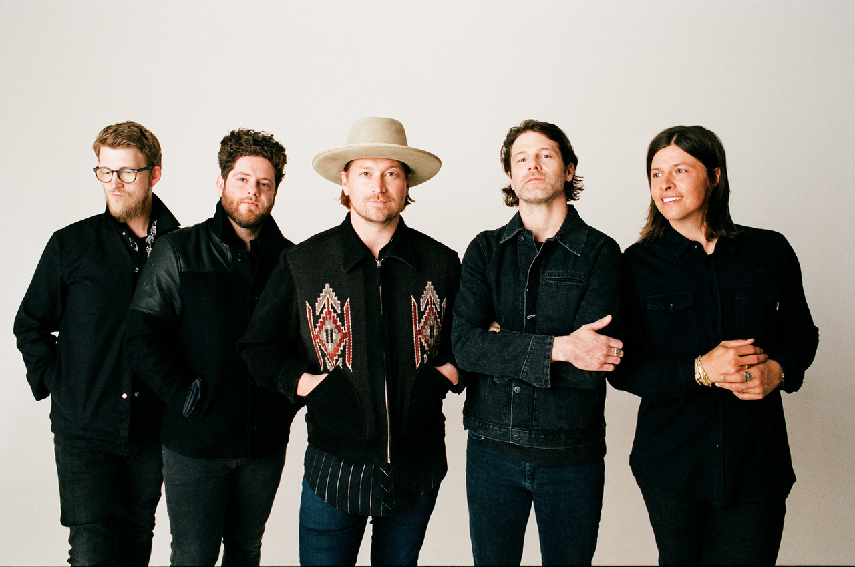

*Photo credit: David O’Donohue*

**About NEEDTOBREATHE:**

Since 1998, NEEDTOBREATHE have quietly emerged as a dynamic force in rock music, topping the charts, selling out historic venues, and generating hundreds of millions of streams to date. The band have gathered one platinum single, four gold singles, and a gold album. Along the way, “Multiplied” notched their first GRAMMY® nomination. Simultaneously, they performed to sold out crowds at arenas and amphitheaters coast to coast. In addition to garnering two nods at the Billboard Music Awards, they’ve attracted acclaim from People, Rolling Stone, Forbes, and many more. In 2020, they sowed the seeds for rebirth with Out of Body. It bowed in the Top 5 of three Billboard charts and reeled in acclaim. Within weeks of its release, the quintet—Bear Rinehart [vocals, guitar], Seth Bolt [bass, vocals], Josh Lovelace [keys, vocals], Randall Harris [drums], and Tyler Burkum [guitar]—stole away to an old historic house in Columbia, TN where they lived together, ate together, laughed together, and recorded together for three weeks in the fall of 2020. They returned home with their eighth album and documentary Into The Mystery [Elektra Records]. It’s the kind of record that could only be made by a band who has been through it all and still has enough faith to keep encouraging one another. It’s NEEDTOBREATHE.

[https://www.needtobreathe.com/](https://nam04.safelinks.protection.outlook.com/?url=https%3A%2F%2Fwww.needtobreathe.com%2F&data=04%7C01%7CSydneyWorden%40elektra.com%7C697b469948bd420a93aa08d982991da7%7C8367939002ec4ba1ad3d69da3fdd637e%7C0%7C0%7C637684416444734817%7CUnknown%7CTWFpbGZsb3d8eyJWIjoiMC4wLjAwMDAiLCJQIjoiV2luMzIiLCJBTiI6Ik1haWwiLCJXVCI6Mn0%3D%7C1000&sdata=HU%2B%2Fq7YdtN2XJTzZzA9XfvJpCq%2B3xhs9J%2BoZSSFeB6Y%3D&reserved=0)

[FACEBOOK](https://nam04.safelinks.protection.outlook.com/?url=https%3A%2F%2Fwww.facebook.com%2FNEEDTOBREATHE&data=04%7C01%7CSydneyWorden%40elektra.com%7C697b469948bd420a93aa08d982991da7%7C8367939002ec4ba1ad3d69da3fdd637e%7C0%7C0%7C637684416444744814%7CUnknown%7CTWFpbGZsb3d8eyJWIjoiMC4wLjAwMDAiLCJQIjoiV2luMzIiLCJBTiI6Ik1haWwiLCJXVCI6Mn0%3D%7C1000&sdata=Y1OzDqi2ik5xNKvwJ7YaMXCgerY%2BMn55aN3vuthH4CM%3D&reserved=0)

[TWITTER](https://nam04.safelinks.protection.outlook.com/?url=https%3A%2F%2Ftwitter.com%2FNEEDTOBREATHE&data=04%7C01%7CSydneyWorden%40elektra.com%7C697b469948bd420a93aa08d982991da7%7C8367939002ec4ba1ad3d69da3fdd637e%7C0%7C0%7C637684416444744814%7CUnknown%7CTWFpbGZsb3d8eyJWIjoiMC4wLjAwMDAiLCJQIjoiV2luMzIiLCJBTiI6Ik1haWwiLCJXVCI6Mn0%3D%7C1000&sdata=%2FlEhNb8Ig51%2Fm8TTw72GiVWQauvqpJpQcKGzGTR16o4%3D&reserved=0)

[INSTAGRAM](https://nam04.safelinks.protection.outlook.com/?url=https%3A%2F%2Fwww.instagram.com%2Fneedtobreathe%2F&data=04%7C01%7CSydneyWorden%40elektra.com%7C697b469948bd420a93aa08d982991da7%7C8367939002ec4ba1ad3d69da3fdd637e%7C0%7C0%7C637684416444754805%7CUnknown%7CTWFpbGZsb3d8eyJWIjoiMC4wLjAwMDAiLCJQIjoiV2luMzIiLCJBTiI6Ik1haWwiLCJXVCI6Mn0%3D%7C1000&sdata=1ALidf0dX0SJOOZ8hqqtY0VwnG9nL9OrMQLAGr9pJ8M%3D&reserved=0)

[YOUTUBE](https://nam04.safelinks.protection.outlook.com/?url=https%3A%2F%2Fwww.youtube.com%2Fuser%2FNEEDTOBREATHEVIDEOS&data=04%7C01%7CSydneyWorden%40elektra.com%7C697b469948bd420a93aa08d982991da7%7C8367939002ec4ba1ad3d69da3fdd637e%7C0%7C0%7C637684416444764796%7CUnknown%7CTWFpbGZsb3d8eyJWIjoiMC4wLjAwMDAiLCJQIjoiV2luMzIiLCJBTiI6Ik1haWwiLCJXVCI6Mn0%3D%7C1000&sdata=nI8hIxSl8Hj%2BoyB96I9SRwsLE2%2B7h%2FrJdN0w6%2FM11P0%3D&reserved=0)

**NEEDTOBREATHE Press Contact:**

Collin Citron / [CollinCitron@elektra.com](mailto:CollinCitron@elektra.com)