FOR IMMEDIATE RELEASE

May 20, 2021

**NEEDTOBREATHE UNVEIL NEW SINGLE & MUSIC VIDEO “I WANNA REMEMBER” FEATURING CARRIE UNDERWOOD**

**LISTEN**[**HERE**](https://nam04.safelinks.protection.outlook.com/?url=https%3A%2F%2Fntb.lnk.to%2Fiwannaremember&data=04%7C01%7CSydneyWorden%40elektra.com%7C69211864abc34624bb1d08d91b93bc08%7C8367939002ec4ba1ad3d69da3fdd637e%7C0%7C0%7C637571143617560580%7CUnknown%7CTWFpbGZsb3d8eyJWIjoiMC4wLjAwMDAiLCJQIjoiV2luMzIiLCJBTiI6Ik1haWwiLCJXVCI6Mn0%3D%7C1000&sdata=SugJsjEycxHYGnKZte719ABlE%2Fy2mOXfrHJeifEGE%2Bc%3D&reserved=0)**/ WATCH**[**HERE**](https://nam04.safelinks.protection.outlook.com/?url=https%3A%2F%2Fntb.lnk.to%2FIWRvideo&data=04%7C01%7CSydneyWorden%40elektra.com%7C69211864abc34624bb1d08d91b93bc08%7C8367939002ec4ba1ad3d69da3fdd637e%7C0%7C0%7C637571143617570581%7CUnknown%7CTWFpbGZsb3d8eyJWIjoiMC4wLjAwMDAiLCJQIjoiV2luMzIiLCJBTiI6Ik1haWwiLCJXVCI6Mn0%3D%7C1000&sdata=9Et3UB2SFJkucm7v6loT7%2FefU2tsBYydN0B34cuObrc%3D&reserved=0)

**EXCLUSIVE VIDEO WORLD PREMIERE ON CMT, MTV & VIACOMCBS’ TIMES SQUARE BILLBOARD**

**NEW STUDIO ALBUM *INTO THE MYSTERY*DUEOUT JULY 30**

**PRE-ORDER NOW**[**HERE**](https://nam04.safelinks.protection.outlook.com/?url=https%3A%2F%2Fntb.lnk.to%2FIntoTheMystery&data=04%7C01%7CSydneyWorden%40elektra.com%7C69211864abc34624bb1d08d91b93bc08%7C8367939002ec4ba1ad3d69da3fdd637e%7C0%7C0%7C637571143617570581%7CUnknown%7CTWFpbGZsb3d8eyJWIjoiMC4wLjAwMDAiLCJQIjoiV2luMzIiLCJBTiI6Ik1haWwiLCJXVCI6Mn0%3D%7C1000&sdata=4TUP0e09xR%2FUDY3mqFIOcfYWcX7cEcruogNplh1zkc4%3D&reserved=0)

**TICKETS FOR THE *INTO THE MYSTERY TOUR* AVAILABLE NOW**[**HERE**](https://nam04.safelinks.protection.outlook.com/?url=https%3A%2F%2Fwww.needtobreathe.com%2Ftour&data=04%7C01%7CSydneyWorden%40elektra.com%7C69211864abc34624bb1d08d91b93bc08%7C8367939002ec4ba1ad3d69da3fdd637e%7C0%7C0%7C637571143617580568%7CUnknown%7CTWFpbGZsb3d8eyJWIjoiMC4wLjAwMDAiLCJQIjoiV2luMzIiLCJBTiI6Ik1haWwiLCJXVCI6Mn0%3D%7C1000&sdata=LwMdBcbpkJJ72w0O8Fy%2Be3P5WPJNMwP0ES%2FiaVpsvNc%3D&reserved=0)

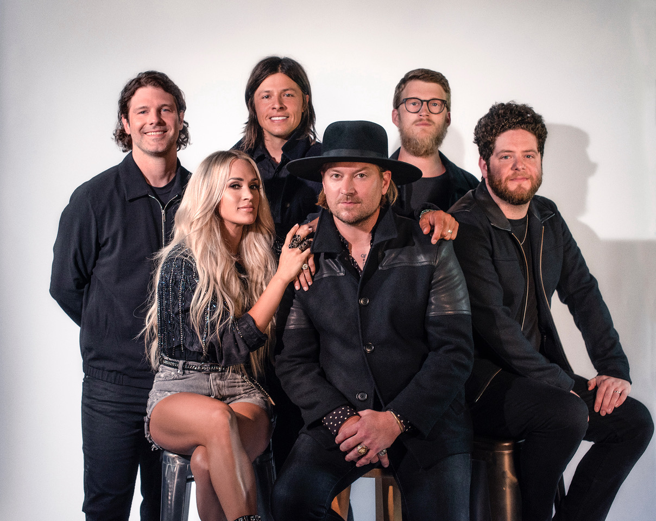

*Photo credit: Jacq Justice*

GRAMMY® Award-nominated rock band **NEEDTOBREATHE**have released their brand new single **“I Wanna Remember”**featuring seven-time GRAMMY® Award winner **Carrie Underwood**. The song is available to stream and download now [HERE](https://nam04.safelinks.protection.outlook.com/?url=https%3A%2F%2Fntb.lnk.to%2Fiwannaremember&data=04%7C01%7CSydneyWorden%40elektra.com%7C69211864abc34624bb1d08d91b93bc08%7C8367939002ec4ba1ad3d69da3fdd637e%7C0%7C0%7C637571143617580568%7CUnknown%7CTWFpbGZsb3d8eyJWIjoiMC4wLjAwMDAiLCJQIjoiV2luMzIiLCJBTiI6Ik1haWwiLCJXVCI6Mn0%3D%7C1000&sdata=m5YKM73vVZNkORL3ndBVLYa23KOPyS1yEb3wF3BGcaM%3D&reserved=0). Underwood also appears alongside NEEDTOBREATHE in the track’s official music video, which exclusively world premiered earlier today on CMT, MTV, and ViacomCBS’ Times Square Billboard. Watch it now on the band’s official YouTube channel [HERE](https://nam04.safelinks.protection.outlook.com/?url=https%3A%2F%2Fntb.lnk.to%2FIWRvideo&data=04%7C01%7CSydneyWorden%40elektra.com%7C69211864abc34624bb1d08d91b93bc08%7C8367939002ec4ba1ad3d69da3fdd637e%7C0%7C0%7C637571143617590562%7CUnknown%7CTWFpbGZsb3d8eyJWIjoiMC4wLjAwMDAiLCJQIjoiV2luMzIiLCJBTiI6Ik1haWwiLCJXVCI6Mn0%3D%7C1000&sdata=AL8TGa6ebkvYRghcejvZ9VBt3n5Hbh24VXUpEOrDO5g%3D&reserved=0).

“‘I Wanna Remember’ is a nostalgic track and takes you back to the moments you never want to forget. We all came from small towns, and those roots have cemented into the fabric of the band and our music,” NEEDTOBREATHE shared. “Bear worked with Carrie on some of her recent projects, and we felt like her small town roots and humble beginnings were the perfect addition to this song. As soon as we got into the studio, we felt a connection with her as if she was a long time member of the band. Having someone with her talent and spirit sing on the song is an absolute honor for us."

“I have been a huge fan of NEEDTOBREATHE forever and I was so honored when the stars aligned and Bear agreed to lend his incredible vocals to a song on my recent gospel album,” says Underwood.”  “Needless to say, I was thrilled when he and the band invited me to be a part of their new project.  I love the song and have had the best time getting to know and sing with these amazingly talented guys.”

“I Wanna Remember” will appear on NEEDTOBREATHE’s forthcoming studio album, ***Into The Mystery***, which is due for release on July 30 via Elektra Records. The album is available to pre-order and pre-save starting today [HERE](https://nam04.safelinks.protection.outlook.com/?url=https%3A%2F%2Fntb.lnk.to%2FIntoTheMystery&data=04%7C01%7CSydneyWorden%40elektra.com%7C69211864abc34624bb1d08d91b93bc08%7C8367939002ec4ba1ad3d69da3fdd637e%7C0%7C0%7C637571143617590562%7CUnknown%7CTWFpbGZsb3d8eyJWIjoiMC4wLjAwMDAiLCJQIjoiV2luMzIiLCJBTiI6Ik1haWwiLCJXVCI6Mn0%3D%7C1000&sdata=oYQ4GsrAlRM%2BhQoeLygX59tjcYqYQyr3bDqy3foiP2o%3D&reserved=0). Limited edition merch offerings are available exclusively through NEEDTOBREATHE’s online store [HERE](https://nam04.safelinks.protection.outlook.com/?url=https%3A%2F%2Fneedtobreathe.merchmadeeasy.com%2F&data=04%7C01%7CSydneyWorden%40elektra.com%7C69211864abc34624bb1d08d91b93bc08%7C8367939002ec4ba1ad3d69da3fdd637e%7C0%7C0%7C637571143617600557%7CUnknown%7CTWFpbGZsb3d8eyJWIjoiMC4wLjAwMDAiLCJQIjoiV2luMzIiLCJBTiI6Ik1haWwiLCJXVCI6Mn0%3D%7C1000&sdata=xZBR7Qnr7sm0AWbmytLs%2FUUz7FVLBNHSxpNAsXG9ilU%3D&reserved=0). The band has also unveiled the album’s full tracklisting, which features additional collaborations with Jon Foreman of Switchfoot and Natalie Hemby of The Highwomen. *Into The Mystery*was announced earlier this month alongside the release of the album’s lead single and [title track](https://nam04.safelinks.protection.outlook.com/?url=https%3A%2F%2Fntb.lnk.to%2FIntoTheMystery&data=04%7C01%7CSydneyWorden%40elektra.com%7C69211864abc34624bb1d08d91b93bc08%7C8367939002ec4ba1ad3d69da3fdd637e%7C0%7C0%7C637571143617600557%7CUnknown%7CTWFpbGZsb3d8eyJWIjoiMC4wLjAwMDAiLCJQIjoiV2luMzIiLCJBTiI6Ik1haWwiLCJXVCI6Mn0%3D%7C1000&sdata=E6MFTAN6GiZvikUok5Q0fseo8hNJ%2BqyuNEurI6zSHzA%3D&reserved=0). The band also shared an accompanying music video that premiered on [*People*](https://nam04.safelinks.protection.outlook.com/?url=https%3A%2F%2Fpeople.com%2Fmusic%2Fneedtobreathe-releases-into-the-mystery-music-video-lead-single-from-new-album-exclusive%2F&data=04%7C01%7CSydneyWorden%40elektra.com%7C69211864abc34624bb1d08d91b93bc08%7C8367939002ec4ba1ad3d69da3fdd637e%7C0%7C0%7C637571143617610553%7CUnknown%7CTWFpbGZsb3d8eyJWIjoiMC4wLjAwMDAiLCJQIjoiV2luMzIiLCJBTiI6Ik1haWwiLCJXVCI6Mn0%3D%7C1000&sdata=idopgXN8MM%2BO47gDGuhd4dqBFqj2H7LMPW%2BCEzUNgfw%3D&reserved=0)*.*

Just as their critically acclaimed 2020 album *Out of Body* impacted audiences, NEEDTOBREATHE capitalized on a rush of inspiration and rode the wave of creativity. Without telling a soul, the band decamped to a historic house-turned-recording studio in Columbia, TN to begin working on new music. Over the course of three weeks, they resided under one roof, laughed during meals, explored their surroundings, and recorded together with co-producer and engineer Konrad Snyder and special guests. Out of this de facto creative hub and *“extended summer camp*,*”* they handcrafted an album reflective of the moment, yet independent of all expectations—even their own. For as intimate as the story may seem, they filmed every minute of it for an upcoming documentary entitled, *Into The Mystery*. Watch a teaser for the film [HERE](https://nam04.safelinks.protection.outlook.com/?url=https%3A%2F%2Fwww.instagram.com%2Fp%2FCOf9uwiHu2v%2F&data=04%7C01%7CSydneyWorden%40elektra.com%7C69211864abc34624bb1d08d91b93bc08%7C8367939002ec4ba1ad3d69da3fdd637e%7C0%7C0%7C637571143617610553%7CUnknown%7CTWFpbGZsb3d8eyJWIjoiMC4wLjAwMDAiLCJQIjoiV2luMzIiLCJBTiI6Ik1haWwiLCJXVCI6Mn0%3D%7C1000&sdata=p7JOHRLczBcFM0XD2MFGqfkVQJcqCyCSFmNCSCHNZqQ%3D&reserved=0).

This Fall, NEEDTOBREATHE will embark on their massive Into The Mystery Tour with support from Switchfoot and The New Respects. The 38-city trek will visit iconic venues such as Denver, CO’s Red Rocks Amphitheatre and Los Angeles, CA’s Greek Theatre, and see the band perform their first-ever headline show at Nashville, TN’s Bridgestone Arena. The Into The Mystery Tour will kick off on September 7 in St. Louis, MO, and wrap on October 30 in Atlanta, GA. Tickets for all dates are available now [HERE](https://nam04.safelinks.protection.outlook.com/?url=https%3A%2F%2Fwww.needtobreathe.com%2Ftour&data=04%7C01%7CSydneyWorden%40elektra.com%7C69211864abc34624bb1d08d91b93bc08%7C8367939002ec4ba1ad3d69da3fdd637e%7C0%7C0%7C637571143617620547%7CUnknown%7CTWFpbGZsb3d8eyJWIjoiMC4wLjAwMDAiLCJQIjoiV2luMzIiLCJBTiI6Ik1haWwiLCJXVCI6Mn0%3D%7C1000&sdata=L%2Fp9cRPpQgtw6Lvj7AD%2B14jVJ%2BeI6q8CBOHzcbEFkiQ%3D&reserved=0).

The past 12 months represent one of the most prolific periods in the band’s career thus far. They recently unveiled *Live from the Woods Vol. 2*—a live album recorded during three sold out, socially distanced outdoor concerts at Pelham, TN’s famed The Caverns. The band previewed the album with an appearance on CBS’s *The Late Late Show with James Corden*. Watch their interview and performance of “Alive” [HERE](https://nam04.safelinks.protection.outlook.com/?url=https%3A%2F%2Fwww.youtube.com%2Fwatch%3Fv%3DKM_Z7FlEJNk&data=04%7C01%7CSydneyWorden%40elektra.com%7C69211864abc34624bb1d08d91b93bc08%7C8367939002ec4ba1ad3d69da3fdd637e%7C0%7C0%7C637571143617620547%7CUnknown%7CTWFpbGZsb3d8eyJWIjoiMC4wLjAwMDAiLCJQIjoiV2luMzIiLCJBTiI6Ik1haWwiLCJXVCI6Mn0%3D%7C1000&sdata=0XFSccA2r2CnDwRVEe7o7Y6pNR3qQJKawxVqvd2T41w%3D&reserved=0). Meanwhile, *Out of Body* debuted in the top 5 across three Billboard charts, and received critical acclaim from *Billboard, Spin, Southern Living, American Songwriter, Taste of Country,*and more.

***Into The Mystery*Tracklisting**

1. What I’m Here For

2. Into The Mystery

3. Sunshine

4. Carry Me (feat. Jon Foreman of Switchfoot)

5. I Am Yours

6. Chances

7. Sittin’ in the Back Seat

8. Give Me A Chance

9. Don’t Throw All the Good Things Away (feat. Natalie Hemby)

10. Innocence

11. I Wanna Remember (feat. Carrie Underwood)

12. West Texas Wind

**Into The Mystery Tour Dates**

September 07, 2021 - St. Louis, MO - Saint Louis Music Park

September 08, 2021 - Kansas City, MO - Midland Theatre

September 10, 2021 - Denver, CO - Red Rocks Amphitheatre

September 11, 2021 - Salt Lake City, UT - Sandy City Amphitheater

September 13, 2021 - Phoenix, AZ - Arizona Federal Theatre

September 14, 2021 - San Diego, CA - Cal Coast Credit Union OAT

September 16, 2021 - Los Angeles, CA - Greek Theatre

September 17, 2021 - Saratoga, CA - The Mountain Winery

September 18, 2021 - Bend, OR - Les Schwab Amphitheater

September 19, 2021 - Seattle, WA - Marymoor Amphitheater

September 21, 2021 - Missoula, MT - KettleHouse Amphitheater

September 23, 2021 - Fargo, ND - Bluestem Center for the Arts - Bluestem Amphitheater

September 24, 2021 - Minneapolis, MN - Armory

September 25, 2021 - Madison, WI - The Sylvee

September 26, 2021 - Indianapolis, IN - Amphitheater at White River State Park

September 28, 2021 - Cincinnati, OH - Andrew J Brady ICON Music Center

September 30, 2021 - Chicago, IL - Radius

October 01, 2021 - Detroit, MI - Michigan Lottery Amphitheatre at Freedom Hill

October 02, 2021 - Cleveland, OH - Nautica Pavilion

October 03, 2021 - Pittsburgh, PA - Robert Morris University - UPMC Events Center

October 07, 2021 - Philadelphia, PA - The Met Philadelphia

October 08, 2021 - Boston, MA - Leader Bank Pavilion

October 09, 2021 - New York, NY - The Rooftop at Pier 17

October 10, 2021 - Washington, DC - The Anthem

October 12, 2021 - Louisville, KY - The Louisville Palace Theater

October 14, 2021 - Charlotte, NC - Charlotte Metro Credit Union Amphitheatre

October 15, 2021 - Raleigh, NC - Red Hat Amphitheater

October 16, 2021 - Greenville, SC - Bon Secours Wellness Arena

October 17, 2021 - Charleston, SC - North Charleston Coliseum

October 19, 2021 - Rogers, AR - Walmart AMP

October 21, 2021 - Austin, TX - Moody Amphitheater

October 22, 2021 - Houston, TX - Smart Financial Centre

October 23, 2021 - Dallas, TX - The Pavilion at Toyota Music Factory

October 24, 2021 - Oklahoma City, OK - Zoo Amphitheatre

October 27, 2021 - Memphis, TN - Memphis Botanic Garden

October 28, 2021 - Birmingham, AL - Oak Mountain Amphitheatre

October 29, 2021 - Nashville, TN - Bridgestone Arena

October 30, 2021 - Atlanta, GA - Ameris Bank Amphitheatre

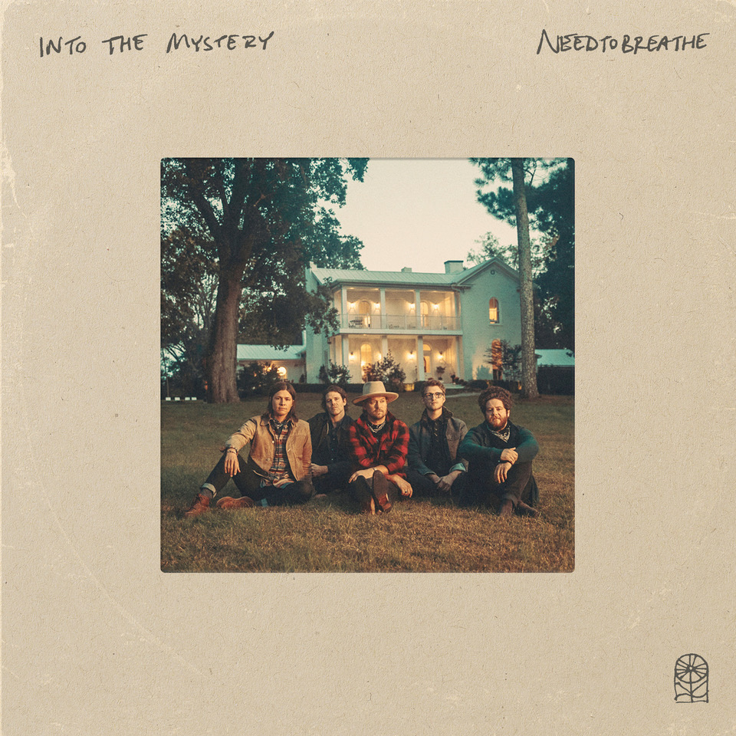

**About NEEDTOBREATHE:**

Since 1998, NEEDTOBREATHE have quietly emerged as a dynamic force in rock music, topping the charts, selling out historic venues, and generating hundreds of millions of streams to date. The band have gathered one platinum single, four gold singles, and a gold album. Along the way, “Multiplied” notched their first GRAMMY® nomination. Simultaneously, they performed to sold out crowds at arenas and amphitheaters coast to coast. In addition to garnering two nods at the Billboard Music Awards, they’ve attracted acclaim from People, Rolling Stone, Forbes, and many more. In 2020, they sowed the seeds for rebirth with Out of Body. It bowed in the Top 5 of three Billboard charts and reeled in acclaim. Within weeks of its release, the quintet—Bear Rinehart [vocals, guitar], Seth Bolt [bass, vocals], Josh Lovelace [keys, vocals], Randall Harris [drums], and Tyler Burkum [guitar]—stole away to an old historic house in Columbia, TN where they lived together, ate together, laughed together, and recorded together for three weeks in the fall of 2020. They returned home with their eighth album and documentary Into The Mystery [Elektra Records]. It’s the kind of record that could only be made by a band who has been through it all and still has enough faith to keep encouraging one another. It’s NEEDTOBREATHE.

[https://www.needtobreathe.com/](https://nam04.safelinks.protection.outlook.com/?url=https%3A%2F%2Fwww.needtobreathe.com%2F&data=04%7C01%7CSydneyWorden%40elektra.com%7C69211864abc34624bb1d08d91b93bc08%7C8367939002ec4ba1ad3d69da3fdd637e%7C0%7C0%7C637571143617630543%7CUnknown%7CTWFpbGZsb3d8eyJWIjoiMC4wLjAwMDAiLCJQIjoiV2luMzIiLCJBTiI6Ik1haWwiLCJXVCI6Mn0%3D%7C1000&sdata=WV15QDJx3p1L3vOPFH8hkstXInOozANuYobyel0Ak4M%3D&reserved=0)

[FACEBOOK](https://nam04.safelinks.protection.outlook.com/?url=https%3A%2F%2Fwww.facebook.com%2FNEEDTOBREATHE&data=04%7C01%7CSydneyWorden%40elektra.com%7C69211864abc34624bb1d08d91b93bc08%7C8367939002ec4ba1ad3d69da3fdd637e%7C0%7C0%7C637571143617630543%7CUnknown%7CTWFpbGZsb3d8eyJWIjoiMC4wLjAwMDAiLCJQIjoiV2luMzIiLCJBTiI6Ik1haWwiLCJXVCI6Mn0%3D%7C1000&sdata=wAE5oDN20gjjsO47qF1mHvjL6BsEbgVZTAt1cBq0sd0%3D&reserved=0)

[TWITTER](https://nam04.safelinks.protection.outlook.com/?url=https%3A%2F%2Ftwitter.com%2FNEEDTOBREATHE&data=04%7C01%7CSydneyWorden%40elektra.com%7C69211864abc34624bb1d08d91b93bc08%7C8367939002ec4ba1ad3d69da3fdd637e%7C0%7C0%7C637571143617630543%7CUnknown%7CTWFpbGZsb3d8eyJWIjoiMC4wLjAwMDAiLCJQIjoiV2luMzIiLCJBTiI6Ik1haWwiLCJXVCI6Mn0%3D%7C1000&sdata=MtjiXyfd2zT6aGl7C%2B7XLAtz2f%2BGjMpnMffKPjJ%2BwZE%3D&reserved=0)

[INSTAGRAM](https://nam04.safelinks.protection.outlook.com/?url=https%3A%2F%2Fwww.instagram.com%2Fneedtobreathe%2F&data=04%7C01%7CSydneyWorden%40elektra.com%7C69211864abc34624bb1d08d91b93bc08%7C8367939002ec4ba1ad3d69da3fdd637e%7C0%7C0%7C637571143617640534%7CUnknown%7CTWFpbGZsb3d8eyJWIjoiMC4wLjAwMDAiLCJQIjoiV2luMzIiLCJBTiI6Ik1haWwiLCJXVCI6Mn0%3D%7C1000&sdata=jlC64O2IbALcKGvLXOSeH%2FL6dO9qAuJNANnx0AVs4Mc%3D&reserved=0)

[YOUTUBE](https://nam04.safelinks.protection.outlook.com/?url=https%3A%2F%2Fwww.youtube.com%2Fuser%2FNEEDTOBREATHEVIDEOS&data=04%7C01%7CSydneyWorden%40elektra.com%7C69211864abc34624bb1d08d91b93bc08%7C8367939002ec4ba1ad3d69da3fdd637e%7C0%7C0%7C637571143617640534%7CUnknown%7CTWFpbGZsb3d8eyJWIjoiMC4wLjAwMDAiLCJQIjoiV2luMzIiLCJBTiI6Ik1haWwiLCJXVCI6Mn0%3D%7C1000&sdata=chfKD%2B5hEOaTuk%2B6zoKmxGIBX6YOnclHop7a9Ew5f1w%3D&reserved=0)

**About Carrie Underwood:**

Carrie Underwood is a true multi-format, multi-media superstar, spanning achievements in music, television, film, and as a New York Times bestselling author and successful entrepreneur.  She has sold more than 64 million records worldwide, recorded 27 #1 singles (14 of which she co-wrote), and has seven albums that are certified Platinum or Multi-Platinum by the RIAA, all while continuing to sell out arena tours across North America and the UK.  All nine of her consecutive studio album releases (two of which she co-produced) from the beginning of her career debuted #1 on the Billboard Country Chart, making her the only artist to accomplish that feat.  She has won over 100 major awards including 7 GRAMMY® Awards, 15 ACM Awards including three for Entertainer of the Year (the first female in history to win twice and the only female ever to win three times), 22 CMT Music Awards (holding the record for the most award wins ever for the show), 7 CMA Awards, and 15 American Music Awards. She has also built a successful business portfolio inspired by her passion for health and wellness, including her fitness and lifestyle brand, CALIA by Carrie Underwood, bestselling book, FIND YOUR PATH, her fit52 app, and a partnership with BODYARMOR Sports Drink.  She recently announced her first-ever residency, ***REFLECTION: The Las Vegas Residency***, at The Theatre at Resorts World Las Vegas, which will begin December 1.

[https://www.carrieunderwoodofficial.com/](https://nam04.safelinks.protection.outlook.com/?url=https%3A%2F%2Fwww.carrieunderwoodofficial.com%2F&data=04%7C01%7CSydneyWorden%40elektra.com%7C69211864abc34624bb1d08d91b93bc08%7C8367939002ec4ba1ad3d69da3fdd637e%7C0%7C0%7C637571143617650528%7CUnknown%7CTWFpbGZsb3d8eyJWIjoiMC4wLjAwMDAiLCJQIjoiV2luMzIiLCJBTiI6Ik1haWwiLCJXVCI6Mn0%3D%7C1000&sdata=OFBaFKTEMaA5PiW8EIGMU7EatU6haanPX6Dh3qlyGi8%3D&reserved=0)

[FACEBOOK](https://nam04.safelinks.protection.outlook.com/?url=https%3A%2F%2Fwww.facebook.com%2Fcarrieunderwood&data=04%7C01%7CSydneyWorden%40elektra.com%7C69211864abc34624bb1d08d91b93bc08%7C8367939002ec4ba1ad3d69da3fdd637e%7C0%7C0%7C637571143617650528%7CUnknown%7CTWFpbGZsb3d8eyJWIjoiMC4wLjAwMDAiLCJQIjoiV2luMzIiLCJBTiI6Ik1haWwiLCJXVCI6Mn0%3D%7C1000&sdata=05C7j%2BK3kD0UdceV1ZTQnx3vrlo6t0glOmsn2EdChDc%3D&reserved=0)

[TWITTER](https://nam04.safelinks.protection.outlook.com/?url=https%3A%2F%2Ftwitter.com%2Fcarrieunderwood&data=04%7C01%7CSydneyWorden%40elektra.com%7C69211864abc34624bb1d08d91b93bc08%7C8367939002ec4ba1ad3d69da3fdd637e%7C0%7C0%7C637571143617660523%7CUnknown%7CTWFpbGZsb3d8eyJWIjoiMC4wLjAwMDAiLCJQIjoiV2luMzIiLCJBTiI6Ik1haWwiLCJXVCI6Mn0%3D%7C1000&sdata=AolsBTyYm7J7dWo9liVAbYZ6hI7X2mcH7ROveIOipzU%3D&reserved=0)  
[INSTAGRAM](https://nam04.safelinks.protection.outlook.com/?url=https%3A%2F%2Fwww.instagram.com%2Fcarrieunderwood%2F&data=04%7C01%7CSydneyWorden%40elektra.com%7C69211864abc34624bb1d08d91b93bc08%7C8367939002ec4ba1ad3d69da3fdd637e%7C0%7C0%7C637571143617660523%7CUnknown%7CTWFpbGZsb3d8eyJWIjoiMC4wLjAwMDAiLCJQIjoiV2luMzIiLCJBTiI6Ik1haWwiLCJXVCI6Mn0%3D%7C1000&sdata=yCxJWzNcHDuYlTuvUq7mOkPX7bKUoEqNG6Cq9umjg0w%3D&reserved=0)  
[YOUTUBE](https://nam04.safelinks.protection.outlook.com/?url=https%3A%2F%2Fwww.youtube.com%2Fuser%2Fcarrieunderwood&data=04%7C01%7CSydneyWorden%40elektra.com%7C69211864abc34624bb1d08d91b93bc08%7C8367939002ec4ba1ad3d69da3fdd637e%7C0%7C0%7C637571143617670516%7CUnknown%7CTWFpbGZsb3d8eyJWIjoiMC4wLjAwMDAiLCJQIjoiV2luMzIiLCJBTiI6Ik1haWwiLCJXVCI6Mn0%3D%7C1000&sdata=58KXp%2F51S0m7GKW%2FrmORIlhaO6qifec29reC%2BX0UStw%3D&reserved=0)

**NEEDTOBREATHE Press Contact:**

Collin Citron / [CollinCitron@elektra.com](mailto:CollinCitron@elektra.com)

**Carrie Underwood Press Contact:**

Brad Cafarelli / [Brad.Cafarelli@fullcov.com](mailto:Brad.Cafarelli@fullcov.com)