FOR IMMEDIATE RELEASE
October 14, 2020

NEEDTOBREATHE UNVEILS “WHO AM I” (FEAT. ELLE KING)
LISTEN HERE

NEW ALBUM OUT OF BODY AVAILABLE NOW HERE

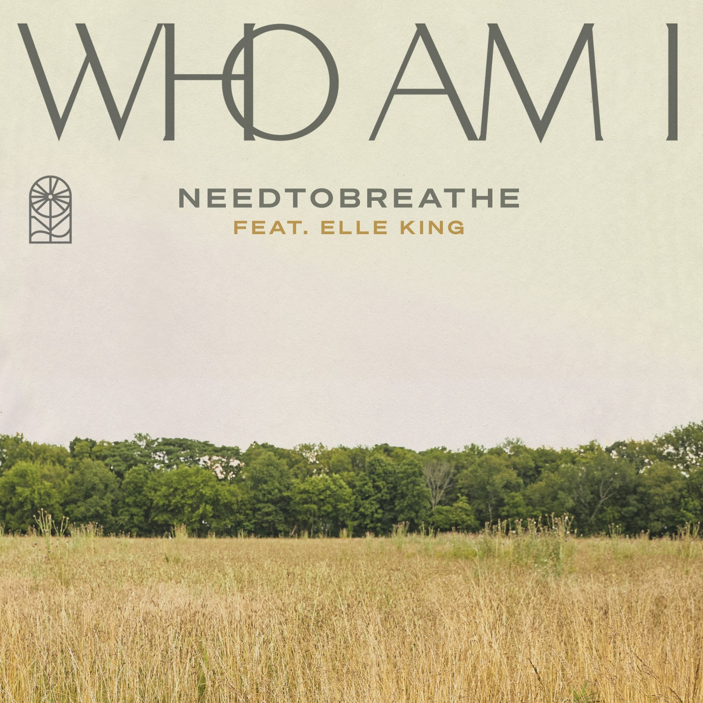

GRAMMY® Award-nominated rock band NEEDTOBREATHE has unveiled a brand new version of their latest single “Who Am I” featuring vocals from multi-platinum recording artist, Elle King. The track is available to stream and download now HERE. “Who Am I” (feat. Elle King) joins NEEDTOBREATHE’s critically acclaimed new album, Out of Body as an official bonus track starting today.

“It’s been amazing watching ‘Who Am I’ take on a life of its own. Our fans have a way of making that happen,” the band shared. “We have been big admirers of Elle King for some time and are thrilled to have her voice and spirit on this new version of the song. Elle came in and crushed it. Thank you to everyone for all the love on this song!”

Out of Body was released on August 28 and debuted in the top 5 across three Billboard charts. The album is available physically and digitally via Elektra Records/Centricity Music now HERE. Limited edition merch bundles are available exclusively through NEEDTOBREATHE’s online store HERE.

People applauded the “super catchy” new music, while American Songwriter commended NEEDTOBREATHE’s “solid capabilities in both ballads and upbeat anthem-style songs”. Southern Living praised the group as “our favorite Southern rock band”, adding “several songs feel like they were written specifically to get us through this difficult moment in time. Taste of Country noted, “NEEDTOBREATHE prove beautiful, collaborative art can still be made amid a pandemic.”

NEEDTOBREATHE welcomed the album with Celebrating Out of Body, a fully immersive release-day concert experience that saw them perform Out of Body in its entirety, live for the very first time. Last month the band took the stage at CBS This Morning Saturday to deliver the network television debut performances of “Hang On”, “Who Am I”, and “Survival”. The band also performed sessions for Billboard, The Grammy Museum, Spin, American Songwriter, and more.

On Out of Body, the platinum-certified trio—Bear Rinehart [vocals, guitar], Seth Bolt [bass, vocals], and Josh Lovelace [keys, vocals]—examine life, family, and friends through a youthful prism. The guys take stock of not only two decades as a band, but also first-time fatherhood and the future over a rich soundtrack of soulful rock with stadium-size scope and poetic intimacy. After spending a week at a beach house in Charleston to gather thoughts and ideas, the trio headed to Nashville, to record alongside producers Cason Cooley and Jeremy Lutito. As they cultivated a team atmosphere, the songs organically came to life.

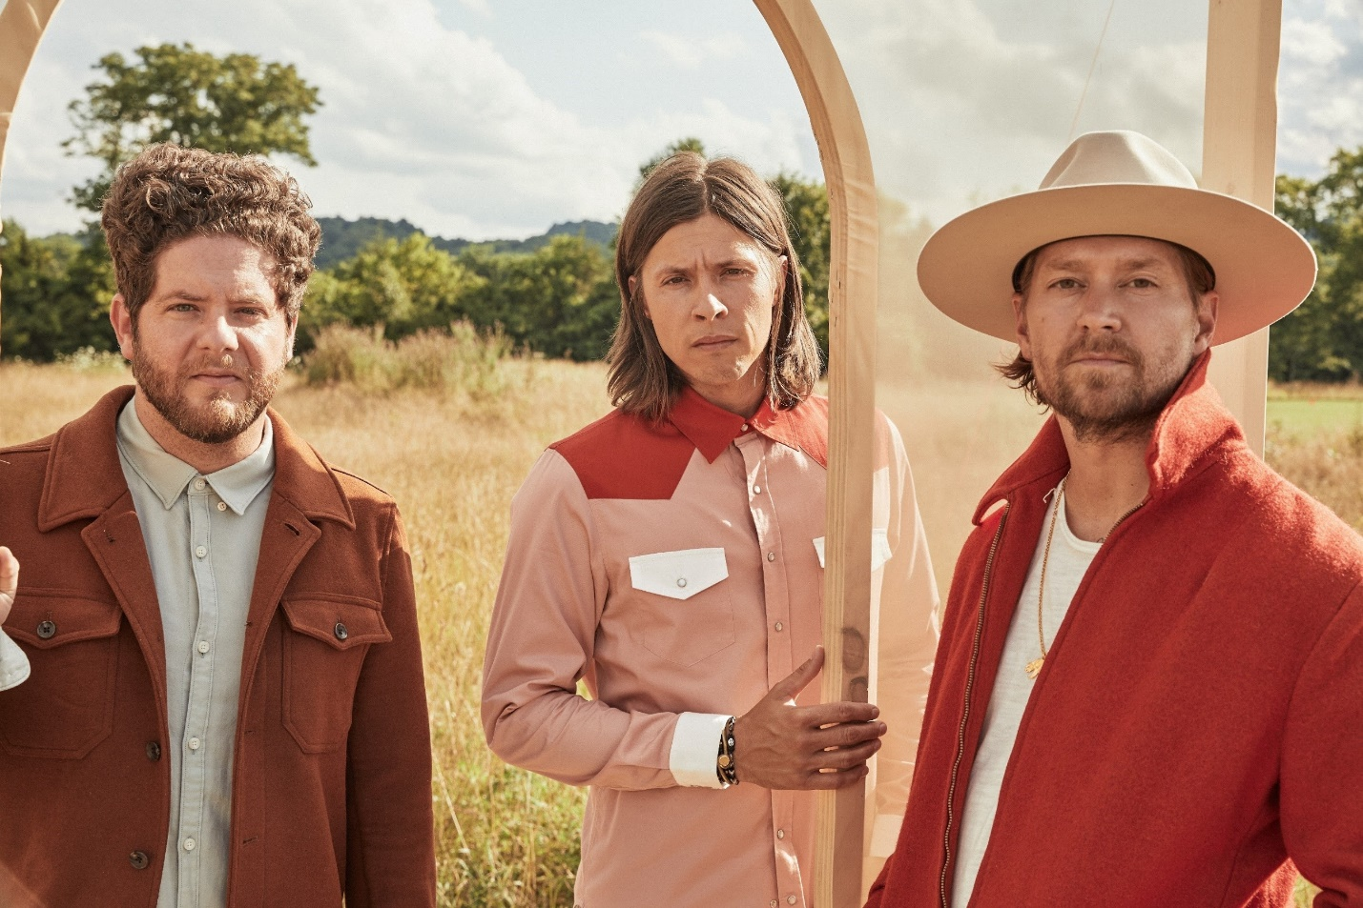
Photo credit: Brett Warren

ABOUT NEEDTOBREATHE:
GRAMMY® Award-nominated NEEDTOBREATHE have mounted a steady ascent to the top of the charts and packed arenas everywhere. Formed in 1998, the group attracted a loyal grassroots following with their full-length debut Daylight [2006] and its follow-up The Heat [2007]. Two years later, The Outsiders became their first Top 20 entry on the Billboard Top 200 before eventually going gold. During 2011, The Reckoning landed at #1 on the Billboard Top Rock Albums Chart and #6 on the Top 200. In addition to bowing at #3 on the Top 200, 2014’s Rivers in the Wasteland yielded the platinum-selling Hot 100 hit “Brother” [feat. Gavin DeGraw] and “Multiplied,” which garnered their first GRAMMY® nod. Meanwhile, H A R D L O V E [2016] marked their highest chart bow yet, debuting at #1 on the Billboard Top Current Album Sales Chart, as the title track “Hard Love” [feat. Andra Day] scored a gold plaque. Along the way, they headlined and sold out iconic venues such as Red Rocks Amphitheatre, The Greek Theatre, and Ryman Auditorium, to name a few. The group picked up a pair of nominations at the Billboard Music Awards, and received praise from People, Rolling Stone, Forbes, and more. Now, NEEDTOBREATHE reflect the freedom of youth on their seventh full-length offering, Out of Body [Elektra Records/Centricity Music] over a rich soundtrack of soulful rock with stadium-size scope and poetic intimacy.

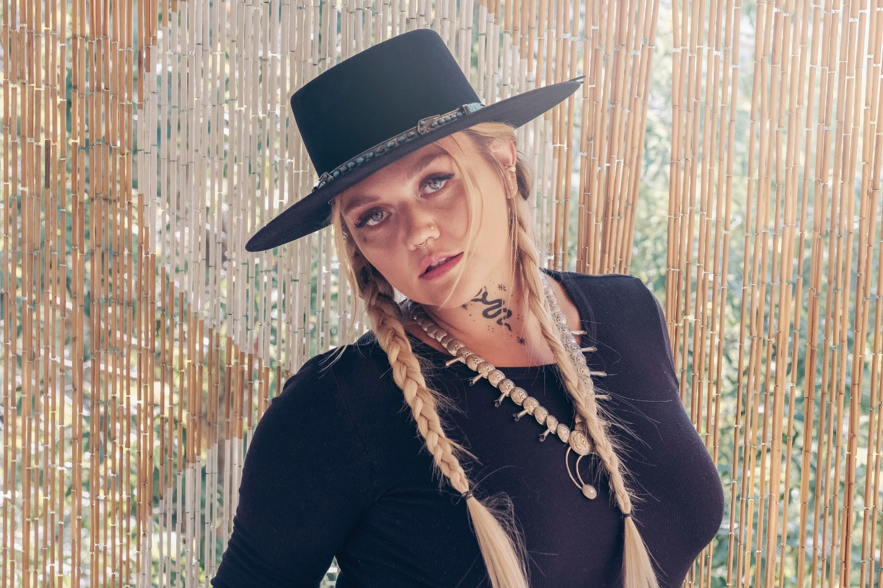
Photo credit: Corey Bost

ABOUT ELLE KING:

Multi-platinum and award-winning recording artist Elle King has enjoyed over 1.2 billion streams worldwide. Her latest EP Elle King: In Isolation featuring her current single “The Let Go” was released in 2020 and is a collection of raw demos/songs she’s recorded acoustically while quarantining at home in LA. She is currently working on her forthcoming third studio album for RCA Records. Her collaboration on the hit single “Fooled Around and Fell in Love” with Miranda Lambert, Maren Morris, Ashley McBryde, Tenille Townes and Caylee Hammack just won the 2020 ACM Award for “Music Event of The Year.”

King’s sophomore critically acclaimed album Shake The Spirit was released in late 2018 and follows her debut album Love Stuff, a sultry, badass mix of rock and roll, blues, and country, with a twinge of pop. Love Stuff introduced the world to Elle King and featured her breakthrough single “Ex’s & Oh’s,” which earned her two GRAMMY nominations and was certified double platinum. Her breakthrough single hit No. 1 on Billboard’s Hot Rock Songs Chart, and topped the AAA, Hot AC, and Alternative Radio charts, leading King to become the second female artist in 18 years to reach No. 1 at the latter format. That same year she collaborated with Dierks Bentley on “Different for Girls,” their #1 Country Airplay chart topper and CMA Award -winning single for “Musical Event of the Year.”

Her lead single off of Shake The Spirit “Shame,” marked her fourth radio #1 single and led Elle to become the only act in history to have scored number 1 singles on the Adult Pop Songs, Adult Alternative Songs, Alternative Songs and Country Airplay charts. Her follow up single “Baby Outlaw” achieved Top 15 charting at AAA Radio. Rolling Stone wrote of her Austin City Limits live set: “Elle King is a little bit country, a little bit rock n’ roll, but ultimately, she’s punk as fuck.” Variety wrote of her Philadelphia Shake The Spirit tour date “…King churned the clotted cream of punkish country, raw R&B, crotchety rock and deep blues into rich, buttery musical drama with her band, The Brethren… (she) belted, crooned, purred, sauntered and swaggered her way through a tautly rocking set…one thing became very clear: nearly every song that came before (the finale) was equally contagious, catty-cool, and hit-worthy.”

https://www.needtobreathe.com/
https://www.facebook.com/NEEDTOBREATHE
https://twitter.com/NEEDTOBREATHE
https://www.instagram.com/needtobreathe/
https://www.youtube.com/user/NEEDTOBREATHEVIDEOS

NEEDTOBREATHE Press Contact:
Collin Citron / collincitron@elektra.com

Elle King Press Contact:
Sarah Weinstein Dennison / sarah.weinstein@rcarecords.com

