NEW RULES DEBUT NEW SINGLE “CHEERS”

DECEMBER 3, 2021 – UK/Irish trio New Rules have debuted new single “Cheers.” The infectious track arrives alongside an official lyric video, which is streaming now on the band’s official YouTube channel. “Cheers” is available now on all streaming platforms via Elektra Records.
The group commented, “We wrote ‘Cheers’ as lockdown was coming to an end and we were truly sick of being stuck inside. We see the song as a big middle finger to the hardest parts of the last 24 months. Now life seems to be getting back to normal, we can finally go out again, see people and do our favorite thing in the whole world: drink…. I mean play shows! To that we say ‘Cheers’🍻”
Earlier this fall, the group announced their signing to Elektra Records and shared new single and video “Really Wanna Dance With You.” On the track, breezy acoustic guitars and the group’s signature three-part harmonies underline a recollection of mustering enough courage to break the ice with an attractive stranger at the other end of the bar. Sweety High praised the single’s “catchy chorus and … beat that's impossible to resist,” while Wonderland Magazine raved “New Rules are set to become the next big thing.”
With bold voices, upbeat live musicianship, sly wit, and enough energy to bring any crowd to its feet, New Rules infuse pop with unbridled spirit and undeniable charm. The group—Alec McGarry [vocals, acoustic guitar], Nathan Lambert [vocals, electric guitar], and Ryan Meaney [vocals, bass]—have emerged as a phenomenon, drawing magnetic and modern anthems from a traditional musical brotherhood.
In 2018, Nathan stumbled on a YouTube cover of Hozier’s “Someone New” by Ryan and reached out. Not long after, he met Alec online too, and New Rules took shape. Relocating to London together, they gained initial traction with their debut single “Call It” during 2019. On its heels, “Fix Somebody” landed a high-profile sync on the hit TV show Love Island. Along the way, the band sold out two headline tours across the UK, supported Julia Michaels, and performed to over 350,000 fans on the road with Little Mix during the pop powerhouse’s massive arena tour across the UK and Ireland.
At the same time, New Rules’ influence grew internationally. They hit the stage at the Alfa Radio Show in Mexico City in front of a crowd of 5,000 as their self-titled EP reached #1 on Mexico’s iTunes Chart. They linked up with Filipino megastar Inigo Pascual for the medley “Dahil Sa ‘Yo/Fix Somebody Mix” in The Philippines and took over primetime television shows—It’s Showtime and ASAP. They stoked buzz stateside, gaining early support from Radio Disney, iHeartRadio, and SiriusXM. In 2020, the group racked up millions of streams with singles “Pasta” and “Emily” – the latter of which trended #5 on Twitter UK with the hashtag #GetThisToEmily. In the middle of lockdown, New Rules built a studio in the house they shared, writing feverishly throughout the pandemic and eventually signing to Elektra Records.
Stay tuned for more from New Rules soon.
(Single Art below)

NEW RULES
“Cheers”
AVAILABLE NOW
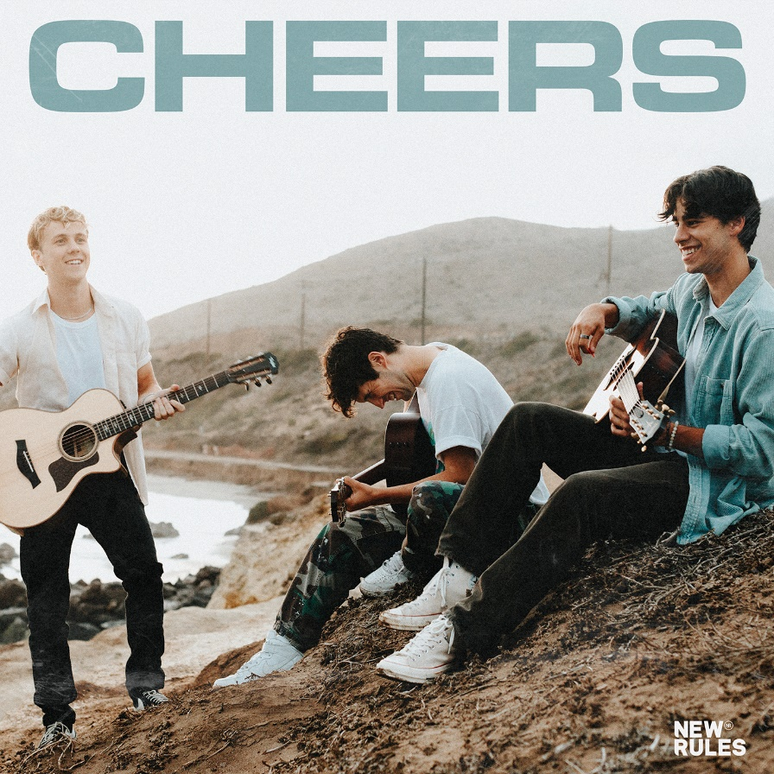

###

CONNECT WITH NEW RULES
Official Website
Instagram
TikTok
Twitter
Facebook
YouTube

Press Contact:
Sarah Goldstein
sarahgoldstein@elektra.com

