NEW RULES RETURN WITH NEW SINGLE
“GO THE DISTANCE”
OFFICIAL LYRIC VIDEO STREAMING NOW

BAND TO PERFORM SOLD-OUT INTIMATE DEBUT
U.S. HEADLINE SHOWS
IN NEW YORK CITY AND LOS ANGELES THIS JUNE

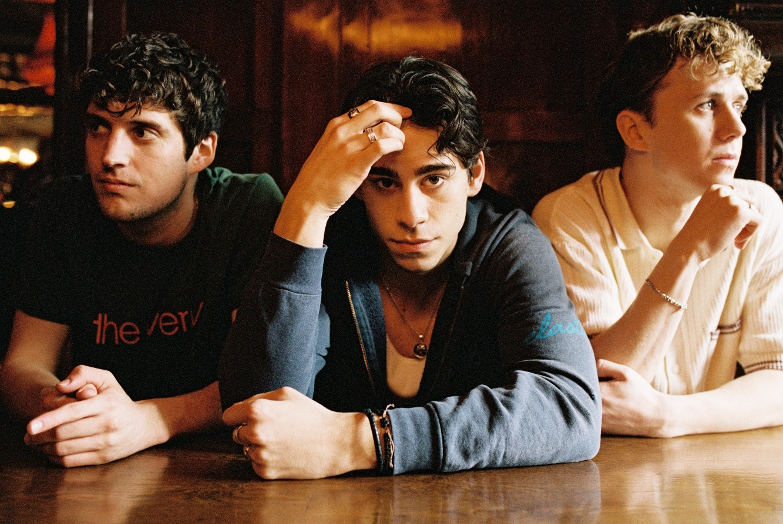

APRIL 8, 2022 – UK/Irish trio New Rules have returned with new single “Go The Distance.” Produced by Sir Nolan [Selena Gomez, Tate McRae, Shawn Mendes] and co-produced and co-written with Kieran Shudall of Circa Waves, the track bounces between a slick bass line, handclaps, and glossy synths. “Go The Distance” is available now on all streaming platforms via Elektra Records and is accompanied by an official lyric video on the band’s official YouTube channel.
“The phrase, ‘go the distance,’ means a few things for us—it’s a theme we’ve touched on before and seems even more relevant now,” the group shared. “We deal with distance when we’re on the road and we’re away from our loved ones. We also hope our new music goes the distance—to number one maybe!”
Earlier this week, the trio announced their intimate “New Songs For New People” debut U.S. headline shows, hitting New York City’s Mercury Lounge on June 2nd and The Moroccan Lounge in Los Angeles on June 6th. The announce was met with overwhelming demand, with both dates selling out within 48 hours. For up-to-date ticketing information, please visit www.newrulesband.com.
In the fall, the group announced their signing to Elektra Records and shared new singles “Really Wanna Dance With You” and “Cheers.” The tracks racked up praise, with Sweety High celebrating the “catchy chorus and … beat that's impossible to resist,” of “Really Wanna Dance With You” while Wonderland Magazine attested “New Rules are set to become the next big thing.” Entirely written and co-produced by the band, the group’s 2022 name songs EP ignited a flurry of activity on TikTok.
For New Rules, three guitars and three voices converge upon one stadium-size sound. The London-based trio—Alec McGarry [vocals, guitar], Nathan Lambert [vocals, guitar], and Ryan Meaney [vocals, guitar]—elevate pop to the rafters fueled by singer-songwriter soul, rock ‘n’ roll spirit, and a whole lot of personality.
With Ryan from Ireland, Alec from Hertfordshire, and Nathan from Chelmsford, the boys initially met online, bonding over similar backgrounds playing music on street corners, uploading covers online, and penning original material. The musicians congregated in London and introduced New Rules with “Call It” and “Fix Somebody” during 2019. Beyond hitting the road with Julia Michaels, Little Mix, and Picture This, they sold out successive headline tours. Following the viral success of “Pasta” and “Emily,” they caught the attention of Elektra Records and signed to the label in 2021.
Stay tuned for more from New Rules soon.
(Tour Itinerary/Single Art below)

NEW RULES
2022 U.S. HEADLINE TOUR DATES
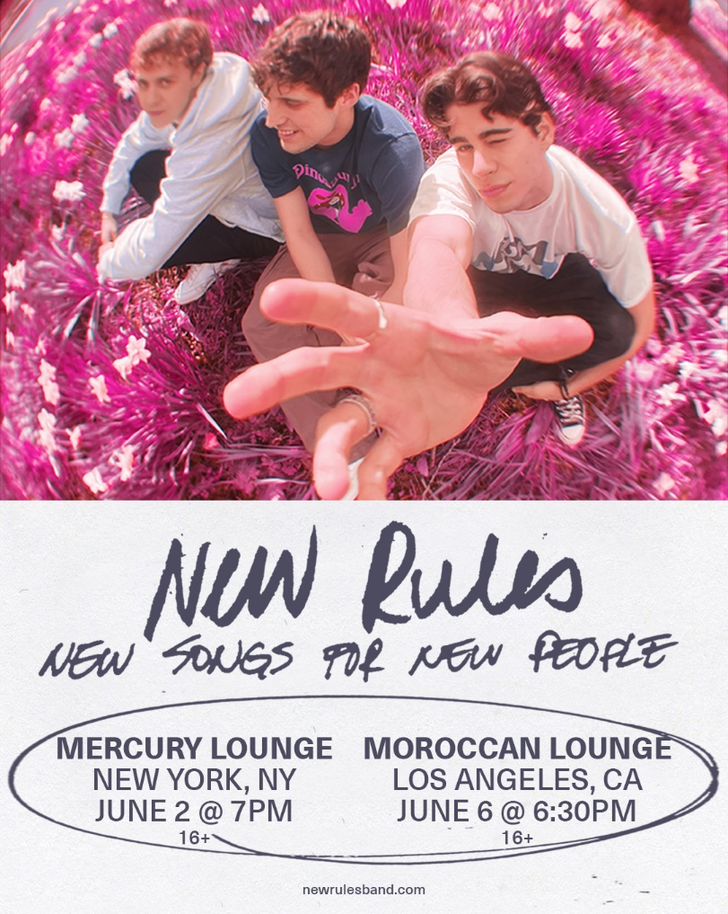
June 2 Mercury Lounge New York, NY SOLD OUT
June 6 The Moroccan Lounge Los Angeles, CA SOLD OUT

NEW RULES
“Go The Distance”
AVAILABLE NOW
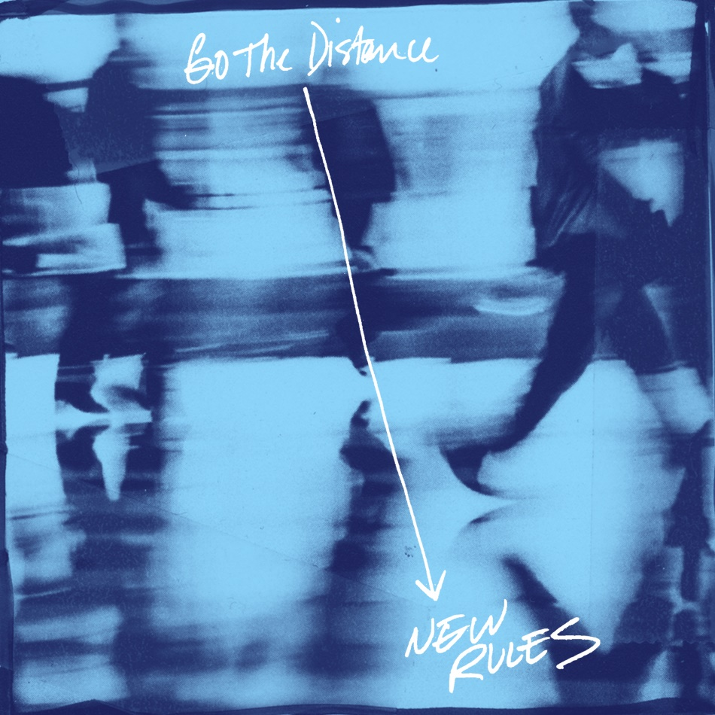

###
CONNECT WITH NEW RULES
Official Website
Instagram
TikTok
Twitter
Facebook
YouTube

Press Contact:
Sarah Goldstein
sarahgoldstein@elektra.com

