NEW RULES ANNOUNCE DEBUT MIXTAPE
GO THE DISTANCE
ARRIVING JUNE 3 VIA ELEKTRA RECORDS

BAND TO PERFORM INTIMATE DEBUT U.S. HEADLINE SHOWS
IN NEW YORK CITY, LOS ANGELES, AND CHICAGO THIS JUNE

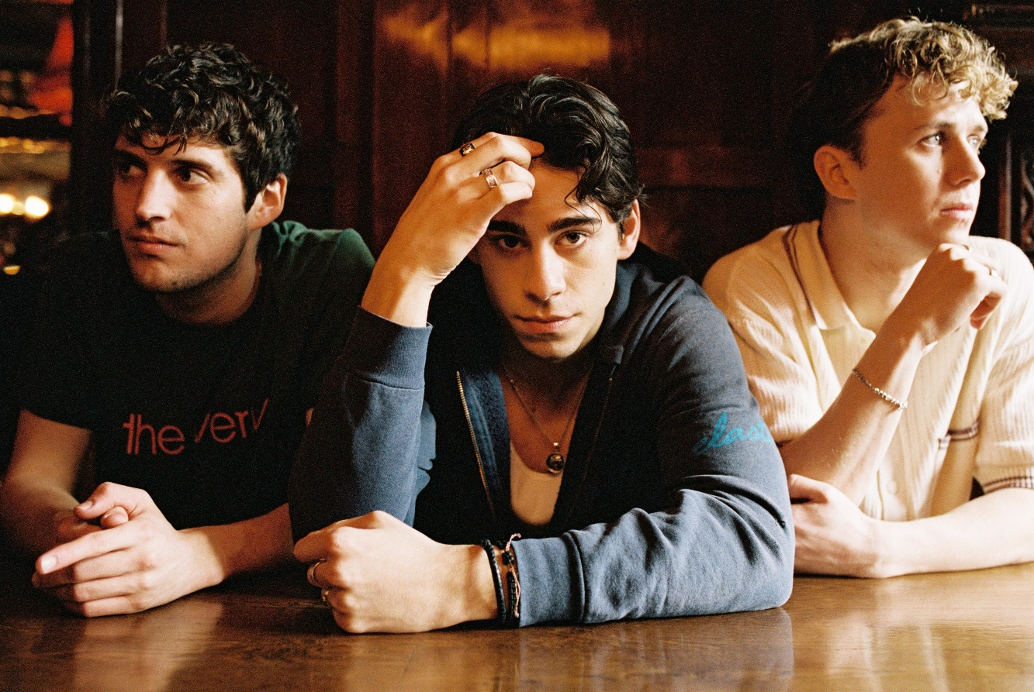

MAY 4, 2022 – UK/Irish trio New Rules have announced their debut mixtape Go The Distance, arriving June 3rd via Elektra Records. The group first shared the news exclusively with fans via livestream earlier today. Go The Distance is available for presave now.
The announcement follows the trio’s April single “Go The Distance,” which was produced by Sir Nolan [Selena Gomez, Tate McRae, Shawn Mendes] and co-produced and co-written with Kieran Shudall of Circa Waves. The track bounces between a slick bass line, handclaps, and glossy synths, and is accompanied by an official lyric video on the band’s official YouTube channel.
In celebration of the mixtape, New Rules will also be performing their intimate “New Songs For New People” debut U.S. headline shows, playing sold-out dates at New York City’s Mercury Lounge on June 2nd and The Moroccan Lounge in Los Angeles on June 6th. Last week, the group announced an additional performance at Chicago, IL’s Subterranean on June 10th. For up-to-date ticketing information, please visit www.newrulesband.com.
In the fall, the group announced their signing to Elektra Records and shared new singles “Really Wanna Dance With You” and “Cheers.” The tracks racked up praise, with Sweety High celebrating the “catchy chorus and … beat that's impossible to resist,” of “Really Wanna Dance With You” while Wonderland Magazine attested “New Rules are set to become the next big thing.” Entirely written and co-produced by the band, the group’s 2022 name songs EP ignited a flurry of activity on TikTok.
For New Rules, three guitars and three voices converge upon one stadium-size sound. The London-based trio—Alec McGarry [vocals, guitar], Nathan Lambert [vocals, guitar], and Ryan Meaney [vocals, guitar]—elevate pop to the rafters fueled by singer-songwriter soul, rock ‘n’ roll spirit, and a whole lot of personality.
With Ryan from Ireland, Alec from Hertfordshire, and Nathan from Chelmsford, the boys initially met online, bonding over similar backgrounds playing music on street corners, uploading covers online, and penning original material. The musicians congregated in London and introduced New Rules with “Call It” and “Fix Somebody” during 2019. Beyond hitting the road with Julia Michaels, Little Mix, and Picture This, they sold out successive headline tours. Following the viral success of “Pasta” and “Emily,” they caught the attention of Elektra Records and signed to the label in 2021.
Stay tuned for more from New Rules soon.
(Tour Itinerary/Mixtape Art below)

NEW RULES
2022 U.S. HEADLINE TOUR DATES
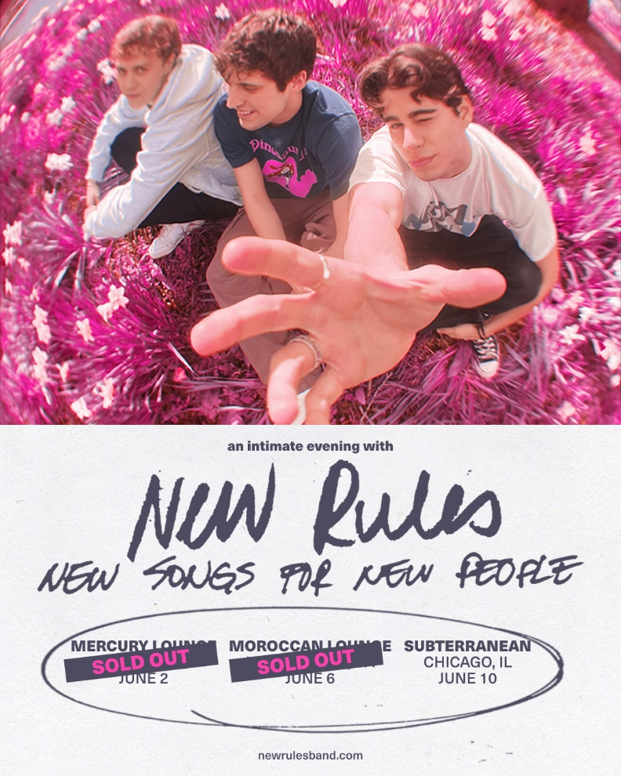

June 2 Mercury Lounge New York, NY SOLD OUT
June 6 The Moroccan Lounge Los Angeles, CA SOLD OUT
June 10 Subterranean Chicago, IL

NEW RULES
Go The Distance
MIXTAPE ARRIVING JUNE 3rd
PRESAVE NOW
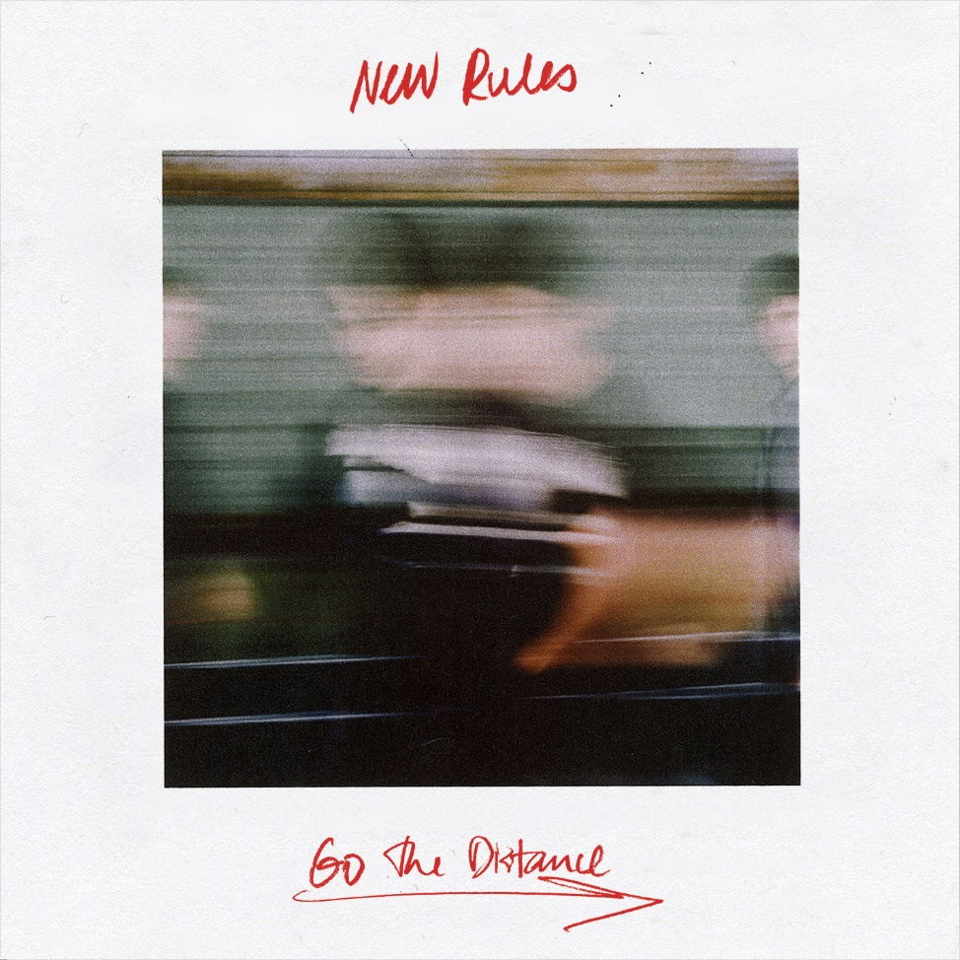

###
CONNECT WITH NEW RULES
Official Website
Instagram
TikTok
Twitter
Facebook
YouTube

Press Contact:
Sarah Goldstein
sarahgoldstein@elektra.com

