NEW RULES SHARE DEBUT MIXTAPE
GO THE DISTANCE

“LOVE YOU LIKE THAT” OFFICIAL LYRIC VIDEO
STREAMING NOW

INTIMATE DEBUT U.S. HEADLINE SHOWS UNDERWAY

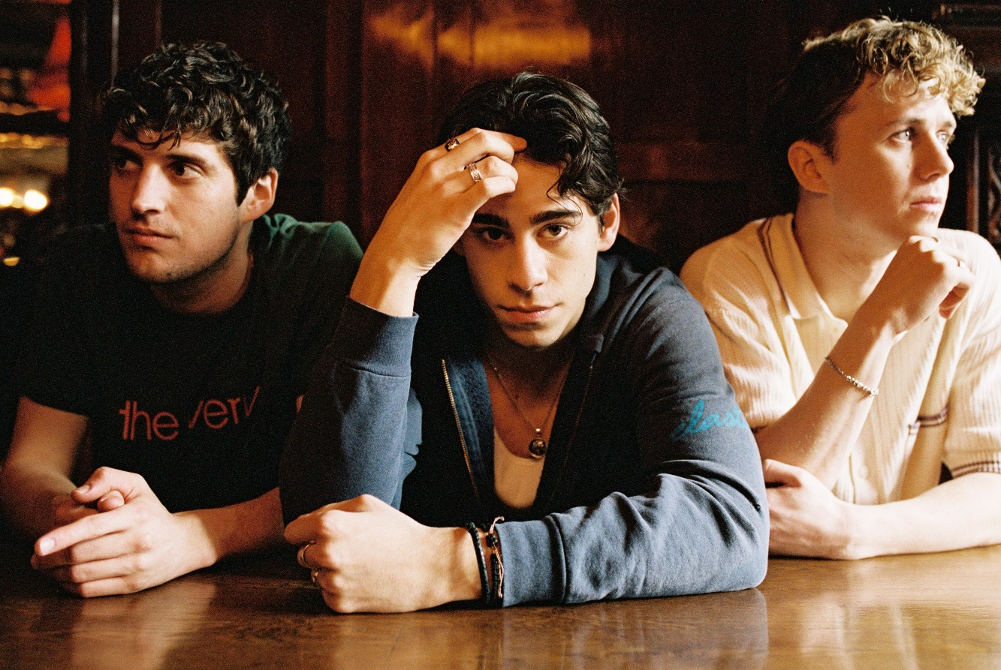

JUNE 3, 2022 – UK/Irish trio New Rules have shared their debut mixtape Go The Distance. The eight-track collection includes six brand-new offerings in addition to the previously released title track and longtime fan-favorite single “Pasta.” The release is also accompanied by an official lyric video for focus track “Love You Like That,” which is streaming now on the band’s official YouTube channel. Go The Distance is available now on all streaming platforms now via Elektra Records.
The group expanded on the mixtape, “Go The Distance is basically eight stories from the last year of our lives. We feel like it’s a new chapter for New Rules and shows a lot of growth from where we started together musically. We hope everyone enjoys the details and can hear a bit of themselves in every track.”

In April, the mixtape was heralded by title track “Go The Distance,” produced by Sir Nolan [Selena Gomez, Tate McRae, Shawn Mendes] and co-produced and co-written with Kieran Shudall of Circa Waves. The single – which bounces between a slick bass line, handclaps, and glossy synths – was crowned a “perfect track” by The Honey Pop and is accompanied by an official lyric video on the band’s official YouTube channel.
In celebration of the release, New Rules have embarked on their intimate “New Songs For New People” debut U.S. headline shows, which kicked off last night with a sold-out performance at New York City’s Mercury Lounge. The trio will hit The Moroccan Lounge in Los Angeles for another sold-out show on June 6th, before wrapping up the run at Chicago, IL’s Subterranean on June 10th. For up-to-date ticketing information, please visit www.newrulesband.com.
In the fall, the group announced their signing to Elektra Records and shared new singles “Really Wanna Dance With You” and “Cheers.” The tracks racked up praise, with Sweety High celebrating the “catchy chorus and … beat that's impossible to resist,” of “Really Wanna Dance With You” while Wonderland Magazine attested “New Rules are set to become the next big thing.” Entirely written and co-produced by the band, the group’s 2022 name songs EP ignited a flurry of activity on TikTok.
For New Rules, three guitars and three voices converge upon one stadium-size sound. The London-based trio—Alec McGarry [vocals, guitar], Nathan Lambert [vocals, guitar], and Ryan Meaney [vocals, guitar]—elevate pop to the rafters fueled by singer-songwriter soul, rock ‘n’ roll spirit, and a whole lot of personality.
With Ryan from Ireland, Alec from Hertfordshire, and Nathan from Chelmsford, the boys initially met online, bonding over similar backgrounds playing music on street corners, uploading covers online, and penning original material. The musicians congregated in London and introduced New Rules with “Call It” and “Fix Somebody” during 2019. Beyond hitting the road with Julia Michaels, Little Mix, and Picture This, they sold out successive headline tours. Following the viral success of “Pasta” and “Emily,” they caught the attention of Elektra Records and signed to the label in 2021.
(Tour Itinerary/Mixtape Art/Tracklisting below)

NEW RULES
2022 U.S. HEADLINE TOUR DATES
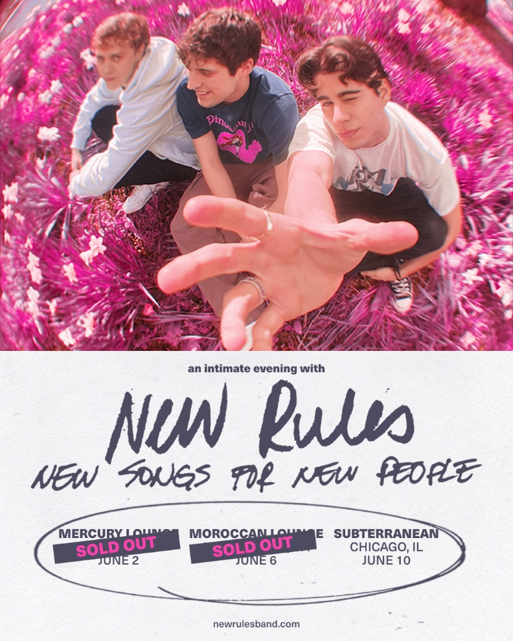

June 6 The Moroccan Lounge Los Angeles, CA SOLD OUT
June 10 Subterranean Chicago, IL

NEW RULES
Go The Distance
AVAILABLE NOW
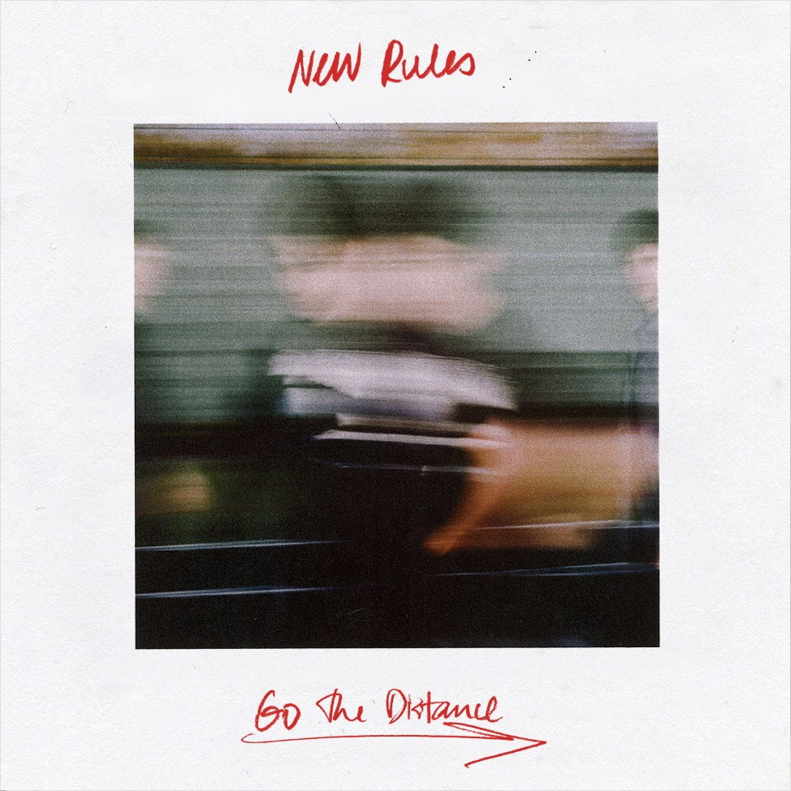

Tracklisting:
- Go The Distance
- Love You Like That
- RIDE
- Where To Find Me
- Drunk Texts
- Lucky Me
- Fireaway
- Pasta

###
CONNECT WITH NEW RULES
Official Website
Instagram
TikTok
Twitter
Facebook
YouTube

Press Contact:
Sarah Goldstein
sarahgoldstein@elektra.com

