ONE OK ROCK ANNOUNCE NEW ALBUM LUXURY DISEASE

SHARE NEW SINGLE “SAVE YOURSELF” – OFFICIAL VIDEO STREAMING NOW

FALL NORTH AMERICAN HEADLINE TOUR GETS UNDERWAY SEPTEMBER 19TH
FEATURING SPECIAL GUESTS YOU ME AT SIX & FAME ON FIRE

LUXURY DISEASE ARRIVES WORLDWIDE SEPTEMBER 9TH

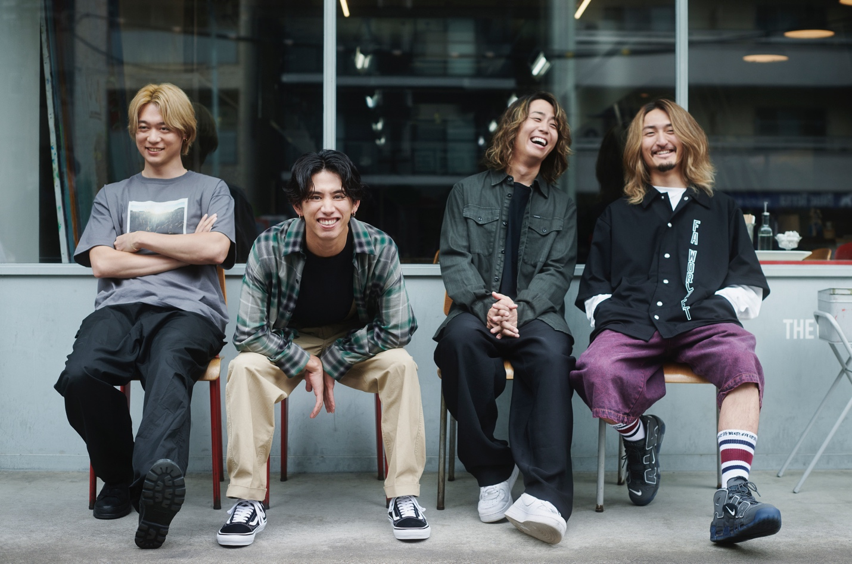

JUNE 24, 2022 – Beloved at home in Japan and worldwide, Fueled By Ramen band ONE OK ROCK have announced details of their anxiously awaited new full-length album, Luxury Disease, which will arrive on September 9th. It is available for pre-order / pre-save at all streaming platforms now. ONE OK ROCK have also shared the album’s lead single: “Save Yourself” (streaming HERE), which is joined by a Tanu Muino (Harry Styles, Cardi B, Lil Nas X) directed music video streaming on the band’s official YouTube channel.

Regarding the LP, vocalist Taka shared, “We can’t wait for everyone to hear the new album! Finally, ONE OK ‘ROCK’ is back!!!!”

Produced by Rob Cavallo (Linkin Park, My Chemical Romance), Luxury Disease finds ONE OK ROCK confounding expectations, piling element on element, and putting forth one of the year’s most ambitious rock records [tracklisting / album art below].

This fall ONE OK ROCK will embark on a North American headline tour which will see the group returning to stages in the U.S. and Canada for the first time in over three years. The upcoming tour will feature support from special guests You Me At Six and Fame On Fire, and is set to get underway September 19th at Emo’s in Austin, TX with stops in New York City, Toronto, Chicago, Los Angeles and more [full itinerary below]. Tickets for the tour are on sale now. For tickets and more information on ONE OK ROCK’s fall tour and upcoming international dates, visit www.oneokrock.com.

2021 saw the release of ONE OK ROCK’s singles “Wonder,” “Broken Heart of Gold,” and “Renegades,” the latter of which they co-wrote with international superstar Ed Sheeran. The band also released their Netflix documentary “Flip A Coin,” which gives fans a backstage look at intimate moments from their massive 2020 “Field of Wonder” livestream concert held at ZOZOMARINE Stadium in Chiba, Japan.

ONE OK ROCK’s widely acclaimed 2019 album EYE OF THE STORM established the band as a global force, featuring the singles “Stand Out Fit In,” “Wasted Nights,” and “Change.” Comprised of vocalist Taka, guitarist Toru, drummer Tomoya, and bassist Ryota, ONE OK ROCK is among Japan’s most popular and beloved rock outfits, with each of their last six releases debuting in the nation’s Top 5, including the #1 blockbusters, 35xxxv, AMBITIONS, and EYE OF THE STORM.

ONE OK ROCK
LUXURY DISEASE

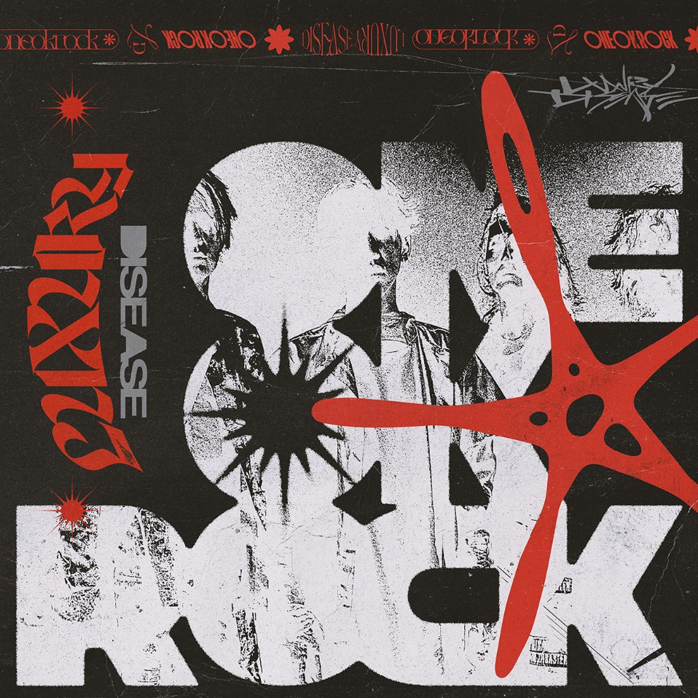

1. Save Yourself
2. Neon
3. Vandalize
4. When They Turn the Lights On
5. Let Me Let You Go
6. So Far Gone
7. Prove
8. Mad World
9. Free Them feat. Teddy Swims
10. Renegades
11. Outta Sight
12. Your Tears are Mine
13. Wonder (Bonus Track)

ONE OK ROCK LUXURY DISEASE NORTH AMERICA 2022
WITH YOU ME AT SIX & FAME ON FIRE

09/19/2022 Austin, TX - Emo’s
09/20/2022 Houston, TX - House of Blues
09/21/2022 Dallas, TX - House of Blues
09/23/2022 Orlando, FL - House of Blues
09/24/2022 Atlanta, GA - Tabernacle *
09/25/2022 Charlotte, NC - The Underground
09/27/2022 Philadelphia, PA - Franklin Music Hall
09/28/2022 Silver Spring, MD - The Fillmore
09/30/2022 New York, NY - Hammerstein Ballroom
10/01/2022 Boston, MA - House of Blues
10/02/2022 Montreal, QC - Club Soda
10/04/2022 Toronto, ON - Rebel
10/05/2022 Detroit, MI - Saint Andrews Hall *
10/07/2022 Cleveland, OH - House of Blues
10/08/2022 Chicago, IL - Concord Music Hall
10/09/2022 Minneapolis, MN - The Fillmore
10/11/2022 Denver, CO - Ogden Theatre
10/12/2022 Salt Lake City, UT - The Complex
10/14/2022 Portland, OR - Roseland Theater
10/15/2022 Vancouver, BC - Harbour Event Centre
10/16/2022 Seattle, WA - Showbox SoDo
10/19/2022 Oakland, CA - Fox Theater
10/20/2022 Los Angeles, CA - Hollywood Palladium

* No Fame On Fire

FOLLOW ONE OK ROCK:
Website | TikTok | Facebook | Instagram | Twitter | YouTube | Spotify

