ONE OK ROCK
ANNOUNCE NEW SINGLE “RENEGADES” CO-WRITTEN WITH ED SHEERAN
SET FOR RELEASE ON APRIL 16th

“RENEGADES” TO FEATURE AS THE OFFICIAL THEME SONG
FOR THE UPCOMING JAPANESE FILM RUROUNI KENSHIN: THE FINAL

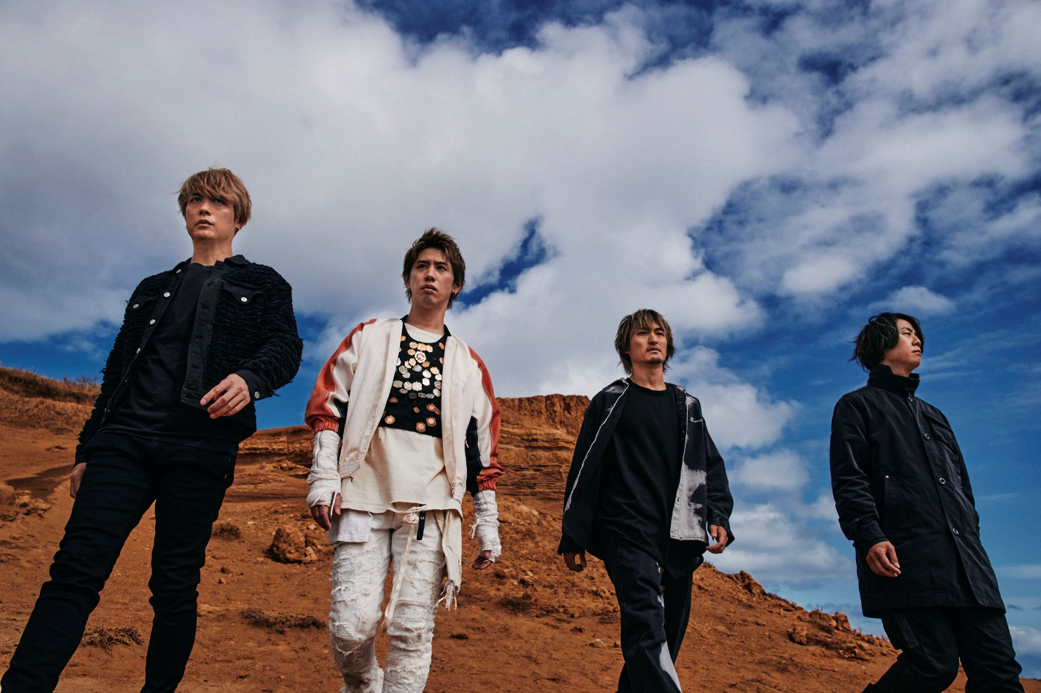

APRIL 9th, 2021 – Powerhouse rock group ONE OK ROCK have announced details of their brand-new single “Renegades,” which the band wrote alongside international superstar Ed Sheeran at his hometown studio in rural England [single artwork below]. The new track will be released alongside an official music video via YouTube Premiere on ONE OK ROCK’s channel next week on Friday, April 16th at 5:00AM PT / 8:00AM ET / 1:00PM BST. In anticipation of the release, ONE OK ROCK has shared an official trailer for “Renegades” which is available today on their YouTube channel and their newly launched official TikTok account. Furthermore, “Renegades” will feature as the official theme song for the upcoming Japanese film, Rurouni Kenshin: The Final, which is due out April 23rd.

“Renegades” conveys an urgent message calling into question the current state of affairs across the globe and serves as an anthem for renegades everywhere who refuse to allow their battles and passions be ignored. For ONE OK ROCK, collaborating with Ed Sheeran on “Renegades” was the culmination of a friendship that began in 2019 when Ed invited the band to be the opening act on the Asian leg of his “DIVIDE WORLD TOUR.” Later that year Ed joined ONE OK ROCK onstage for an unforgettable performance during the band’s “EYE OF THE STORM” Japan Tour.

Last year, ONE OK ROCK raised the bar for livestream performances with their Field of Wonder virtual concert which broadcasted worldwide from ZOZO Marine Stadium in Chiba, Japan with 120,000 fans tuning in. ONE OK ROCK’s widely acclaimed 2019 album EYE OF THE STORM established the band as a global force, featuring the singles “Stand Out Fit In,” “Wasted Nights,” and “Change.” Comprised of vocalist Taka, guitarist Toru, drummer Tomoya, and bassist Ryota, ONE OK ROCK is among Japan’s most popular and beloved rock outfits, with each of their last six releases debuting in the nation’s Top 5, including the #1 blockbusters, 35xxxv, AMBITIONS, and EYE OF THE STORM.

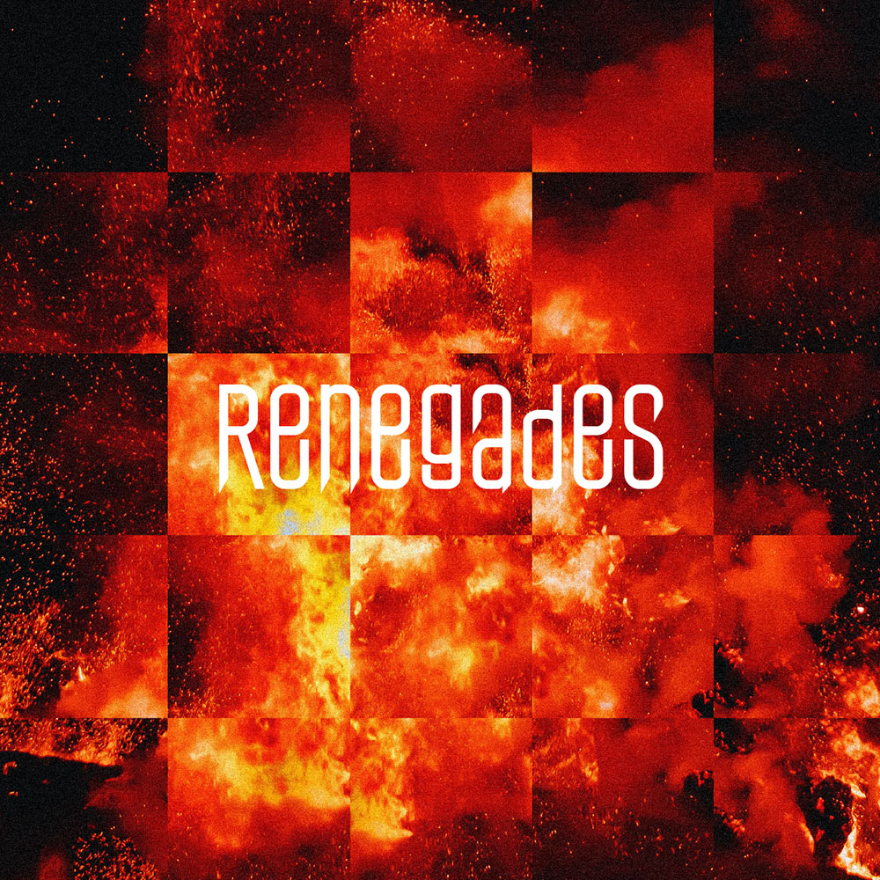

FOLLOW ONE OK ROCK:
Website | TikTok | Facebook | Instagram | Twitter | YouTube | Spotify

