ONE OK ROCK RELEASE NEW SINGLE “WONDER”

NEW NETFLIX DOCUMENTARY “FLIP A COIN” STREAMING NOW

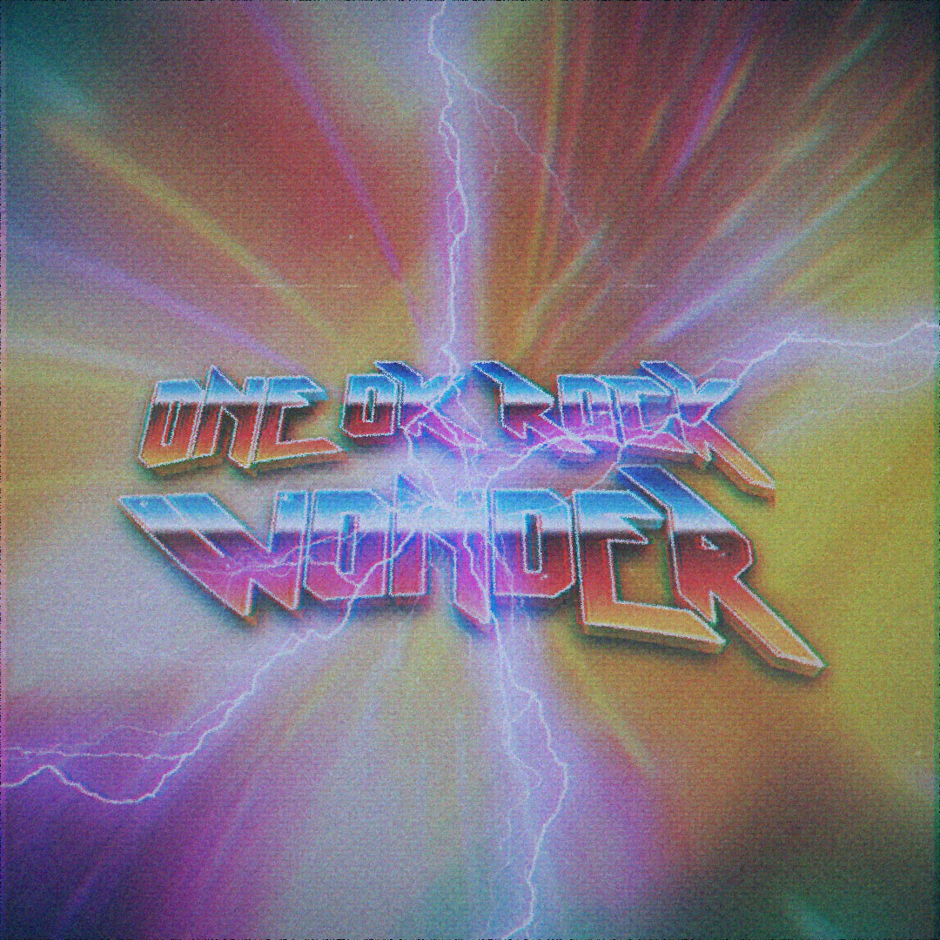

OCTOBER 22, 2021 - ONE OK ROCK have released a brand-new single “Wonder,” which is available today on all streaming platforms and joined by an official lyric video. ONE OK ROCK first performed “Wonder” during their massive livestream concert “Field of Wonder,” which was held last year at Japan’s ZOZOMARINE Stadium. The song embodies ONE OK ROCK’s current interpretation of dynamic rock reminiscent of the stadium acts from yesteryear. It calls upon the memories of the livestream performance which brought life back to the vacant stadium during the pandemic. Through all the chaos the song’s lyrics radiate with a positive energy that moves us forward.

ONE OK ROCK have also shared their new Netflix documentary “Flip A Coin,” which goes behind the scenes at the their 2020 “Field of Wonder” livestream concert, bringing fans backstage for intimate and rarely seen moments with the band. Furthermore, ONE OK ROCK will release the full-length “Field of Wonder” livestream concert on DVD & Blu-ray separately on November 14th. For more information www.oneokrock.com.

FOLLOW ONE OK ROCK:
Website | TikTok | Facebook | Instagram | Twitter | YouTube | Spotify

