**PANIC! AT THE DISCO RELEASES NEW MUSIC VIDEO FOR “DANCING’S NOT A CRIME”**

**BAND KICKS OFF SOLD OUT EUROPEAN LEG OF ARENA TOUR TODAY**

**NEW GLOBAL SINGLE “HEY LOOK MA, I MADE IT” HAS CLOCKED OVER 100 MILLION STREAMS AND GROWING AT RADIO**

[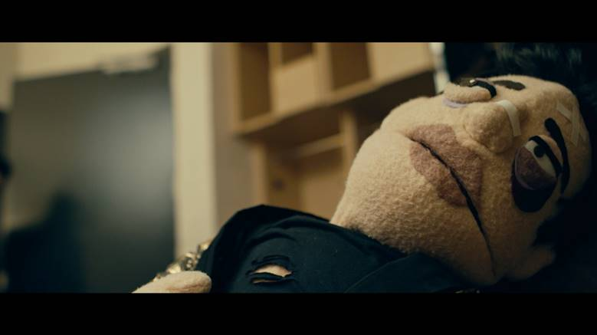](https://youtu.be/rODNMWBLZzY)

**Los Angeles, CA - March 18, 2019 -** Grammy-nominated band **Panic! At The Disco** has shared a new music video for track “Dancing’s Not A Crime”, off their latest album *Pray For The Wicked*. Directed by Brandon Dermer, the video stars frontman Brendon Urie’s puppet alter ego [The Amazing Beebo](https://www.instagram.com/theamazingbeebo), who first appeared in the band’s music video “Hey Look Ma, I Made It”, and has gone on to amass over 250,000 followers on Instagram. Watch the video [HERE](https://youtu.be/rODNMWBLZzY).

The video arrives as the band’s current single [“Hey Look Ma, I Made It”](https://www.youtube.com/watch?v=BzbxacRr5Gk) continues to ascend both the Alternative and Pop radio charts.  The song made its national television premiere on the season finale of [NBC’s The Voice](https://www.youtube.com/watch?v=3kOmtqU26nk) and has already amassed over 100 million streams worldwide to date. “Hey Look Ma, I Made It” is the third single off of Panic! At The Disco’s critically acclaimed sixth album *Pray For The Wicked* is available digitally [HERE](https://patd.lnk.to/prayforthewicked) and physically [HERE](https://store.panicatthedisco.com/) via Fueled By Ramen/DCD2 Records. *Pray For The Wicked* was released in June 2018 and earned the band their second consecutive #1 on the Billboard Top 200 Albums Chart. The album debuted at #1 on iTunes in 22 countries and was recently certified GOLD by the RIAA.

The album’s second single “[High Hopes](https://youtu.be/IPXIgEAGe4U)” is a bonafide smash, simultaneously hitting #1 across three different radio formats including Pop, Alternative, and Hot AC, where it broke the record by topping the chart for 14 weeks, the longest run in 15 years.  Certified 2x-PLATINUM by the RIAA, “High Hopes” also peaked at #4 on the Billboard Hot 100, surpassing the 2006 breakout “I Write Sins Not Tragedies” as Panic! At The Disco’s highest-charting song to date.  Sirius XM’s Hits 1 alone played the song a remarkable 4000 times.   Lead single “[Say Amen (Saturday Night)](https://www.youtube.com/watch?v=jVXauWq9Hwg)” was also certified GOLD and peaked at #1 on Billboard’s Alternative Songs Chart. The band took hold of the American TV airwaves around album release, performing the song on [The Tonight Show Starring Jimmy Fallon](https://www.youtube.com/watch?v=tRdu-vB2Tkg), [The Ellen DeGeneres Show](https://www.youtube.com/watch?v=GiEuzWc62V4), NBC’s The Voice, and NBC’s Today.

Last month, Panic! At The Disco wrapped the second North American leg of their Pray For The Wicked Tour. The 28-city leg, which sold out numerous arenas, received critical praise including, *“[Urie’s] got the charisma, musical talent and stamina to be one of music’s longest-lasting leading men*,” (Variety), “*Brendon Urie embodies on-stage theatrics like few other frontmen*,” (SF Weekly), and “*From dancing fire to a flying piano, Panic! At The Disco puts on a wild show*” (Milwaukee Journal Sentinel). This evening, Panic! At The Disco will kick off a run of sold out shows on the tour’s European leg – overall the tour has sold out 85 shows globally. Later this year, the band is scheduled to appear at numerous US and international festivals including a headline performance at Firefly Music Festival. A complete list of upcoming live dates and ticket information can be found [HERE](https://panicatthedisco.com/tour/)**.**

**PRAY FOR THE WICKED INTERNATIONAL TOUR DATES:**

03/18/2019 - Amsterdam, Netherlands - AFAS Live - SOLD OUT

03/19/2019 - Paris, France - Zenith - SOLD OUT

03/21/2019 - Antwerp, Belgium - Lotto Arena - SOLD OUT

03/24/2019 - Glasgow, United Kingdom - SSE Hydro - SOLD OUT

03/25/2019 - Cardiff, United Kingdom - Motorpoint Arena - SOLD OUT

03/26/2019 - Birmingham, United Kingdom - Arena Birmingham - SOLD OUT

03/28/2019 - London, United Kingdom - The O2 - SOLD OUT

03/29/2019 - London, United Kingdom - The O2 - SOLD OUT

03/30/2019 - Manchester, United Kingdom - Manchester Arena - SOLD OUT

04/01/2019 - Düsseldorf, Germany - ISS Dome  - SOLD OUT

04/03/2019 - Berlin, Germany - Mercedes-Benz Arena

04/04/2019 - Hamburg, Germany - Barclaycard Arena

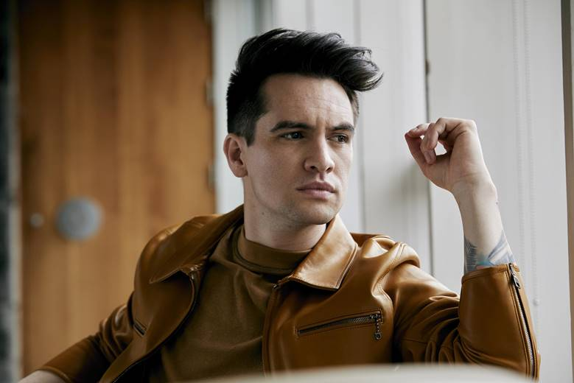

*Photo credit: Jimmy Fontaine*

**About Panic! At The Disco**

Panic! At The Disco released their #1 album "Pray For The Wicked" in June (via Fueled by Ramen/DCD2 Records) off the heels of their critically acclaimed fifth album, "Death Of A Bachelor.” "DOAB" debuted at #1 on the Billboard 200 Chart and was nominated for Best Rock Album at the 2017 GRAMMY® Awards. The RIAA platinum selling release was the highest selling rock album and fourth-highest selling album released in 2016, according to Nielsen Soundscan. "DOAB" has also spawned RIAA certified gold singles “Hallelujah,” “LA Devotee,” Don’t Threaten Me With A Good Time,” and platinum singles "Death Of A Bachelor,” "Emperor's New Clothes,” and “Victorious." Panic! At The Disco have been nominated for multiple awards, including the GRAMMYS, Teen Choice Awards, Alternative Press Music Awards, Kerrang! Awards and VMAs. At the 2006 VMAs they won "Video of the Year" for their smash "I Write Sins Not Tragedies.” Urie recently took on Broadway, first starring as Charlie Price in the critically acclaimed, TONY Award-winning, Broadway hit Kinky Boots and then receiving a 2018 TONY Award nomination for “Best Original Score Written For Theatre" for the song he wrote called “Simple Sponge” for SpongeBob SquarePants: The Broadway Musical. P!ATD currently wrapped up the first leg of their headline arena Pray For The Wicked Tour and will headlined Reading & Leeds Festival before taking on the second leg of the tour which will kick off in January 2019. Outside of music, Urie has founded the Highest Hopes Foundation - an umbrella fund which supports the efforts of non-profit organizations that lead, develop, and advocate support for human rights for all people and communities subject to discrimination or abuse on the basis of gender, race, religion, sexual orientation and gender identity. Last June, Urie named GLSEN the foundation’s first beneficiary and pledged $1 million donation to the LGBTQ non-profit.

For more, please visit:

[panicatthedisco.com](https://panicatthedisco.com/)

[facebook.com/panicatthedisco](https://www.facebook.com/panicatthedisco)

[panicatthedisco.tumblr.com](http://panicatthedisco.tumblr.com/)

[twitter.com/panicatthedisco](https://twitter.com/panicatthedisco)

[instagram.com/panicatthedisco](https://www.instagram.com/panicatthedisco/)

[youtube.com/panicatthedisco](https://www.youtube.com/panicatthedisco)

[dcd2records.com](http://www.dcd2records.com/)

[fueledbyramen.com](http://www.fueledbyramen.com/)

Contact:

Glenn Fukushima and Collin Citron

[GlennFukushima@elektra.com](mailto:GlennFukushima@elektra.com) and [CollinCitron@elektra.com](mailto:CollinCitron@elektra.com)

Nadine Pena

[nadine@crushmusic.com](mailto:nadine@crushmusic.com)