FOR IMMEDIATE RELEASE
NOVEMBER 10, 2021

AVRIL LAVIGNE RELEASES BRAND NEW SINGLE “BITE ME”

LISTEN HERE

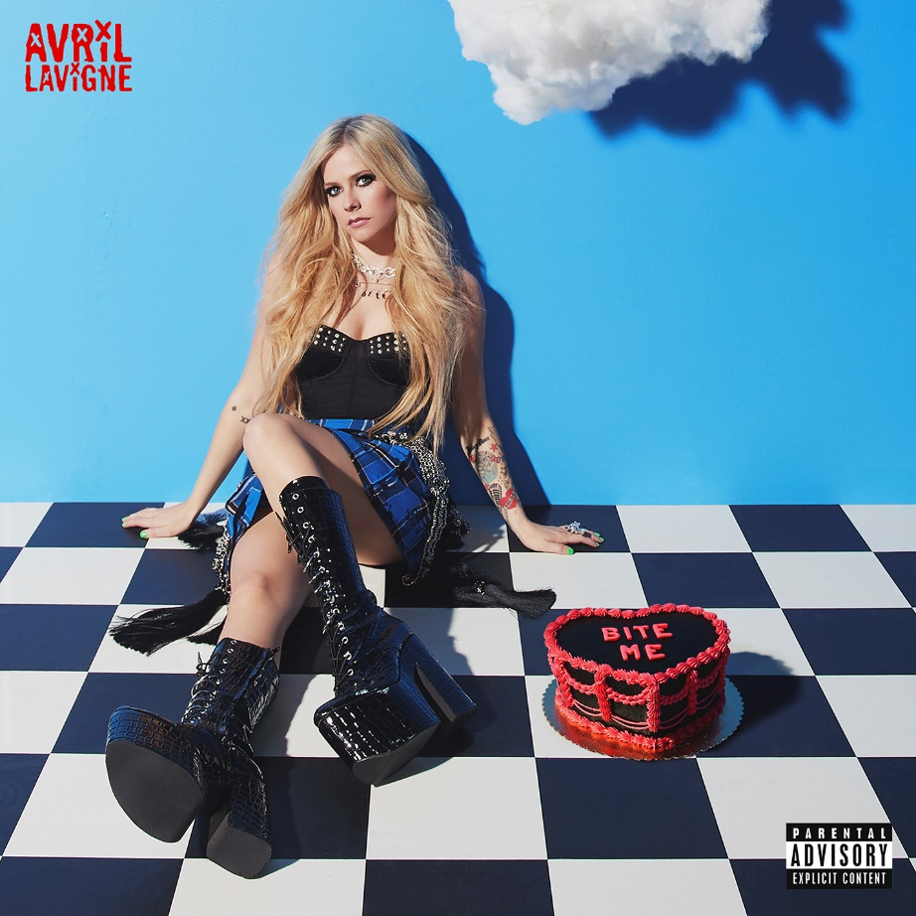
PRESS ASSETS HERE

MULTI-PLATINUM ARTIST’S FIRST NEW MUSIC SINCE 2019
MARKS HER LABEL DEBUT FOR TRAVIS BARKER’S DTA RECORDS

FIRST EVER, TELEVISED PERFORMANCE OF “BITE ME” AIRS ON
THE LATE LATE SHOW WITH JAMES CORDEN TONIGHT

OFFICIAL MUSIC VIDEO DIRECTED BY HANNAH LUX DAVIS COMING SOON

“BITE ME” AVAILABLE EVERYWHERE NOW

Multiplatinum star Avril Lavigne has released “Bite Me,” her first new music since 2019 and label debut for Travis Barker’s DTA Records. The exhilarating track is available everywhere now, and, to celebrate the arrival of “Bite Me,” the eight-time GRAMMY® Award-nominated multiplatinum singer, songwriter, designer, and philanthropist will treat fans to the song’s first late-night television performance on CBS’s The Late Late Show With James Corden tonight. Founded by Barker, DTA Records operates as a worldwide venture with Elektra Music Group.
Welcoming Avril to the DTA Records family, Barker said, “Avril and I have been friends for a long time, but I think I’ve been a fan of hers even longer! She’s a true badass and an icon as a performer, songwriter, and presence. We had gotten in the studio earlier this year, and we were having so much fun that I knew I wanted to ask her to join the DTA team. I’m so stoked she’s now part of the label. I can’t wait for everybody to experience the incredible music she’s about to drop.”
Avril offered, “I’ve always admired Travis and his work. The first time we worked together was 15 years ago on my album ‘The Best Damn Thing’ and I have really enjoyed watching him develop into the producer that he is today. We spent a lot of time writing songs and working on this record together, and signing to his record label, DTA felt like the perfect home for me and my new music. Travis understands my vision as a musician, my creative process as an artist, and my goals at this stage of my career. I am excited to be dropping ‘Bite Me.’ It’s an anthem about knowing your worth, what you deserve, and not giving someone a second chance who doesn’t deserve you.”
Elektra Music Group Co-Presidents Mike Easterlin and Gregg Nadel commented, “Avril is the rare superstar whose influence only grows with each generation. You can feel her impact across popular music, and it continues to magnify. It comes down to the fact that she’s an amazing songwriter and dynamic performer with undeniable artistic integrity. That holds true in her new music. We’re excited to work with Travis to bring her vision to life.”
Baring her teeth like never before, the high energy and anthemic “Bite Me” was co-produced by Barker, John Feldmann, and Mod Sun. The official music video – directed by Hannah Lux Davis – is in the final stages of production now. Last week, Avril shared a post on TikTok that teased her signing to DTA Records with a clip of her and Travis performing a snippet of “Bite Me” that has amassed over 10 million views and 1.5 million “likes” in just a few days. Avril had broken the internet earlier this year with her first foray onto the platform: her viral “Sk8er Boi” post co-starring none other than skateboarding legend Tony Hawk. The clip impressively reached 33.9 million views and generated 6.7 million “likes.”
Avril is set to launch a world tour in 2022 with dates to be revealed imminently. Stay tuned for much more from Avril Lavigne soon.
Photo Credit: Ryan McFadden

ABOUT AVRIL LAVIGNE:
Avril Lavigne has made history, smashed records, and consistently blazed a trail of her own as an uncompromising force in music and culture. Beyond selling 40 million albums worldwide with 12.5 million units sold in the U.S. alone, she has notched eight GRAMMY® Award nominations in categories such as “Best New Artist” and “Song of the Year” twice for “Complicated” and “I’m with You.” In addition, she has received eight Juno Awards, including “Artist of the Year.” Her catalog comprises the septuple platinum Let Go [2002], triple-platinum Under My Skin [2004], double-platinum The Best Damn Thing [2007], gold-selling Goodbye Lullaby [2011], gold-selling Avril Lavigne [2013], and Head Above Water [2019] highlighted by definitive smashes such as “Complicated,” “Sk8er Boi,” “Girlfriend,” “Here’s To Never Growing Up,” and “Head Above Water.” As such, she remains of “one of the Soundscan-era’s top-selling artists releasing albums in the U.S.” and “the third bestselling Canadian female artist of all-time.” She earned a spot in the Top 10 of Billboard’s “Best of the 2000s” chart and holds a Guinness World Record as “the youngest female solo artist to top the UK chart,” while “Girlfriend” emerged as “first music video to reach 100 million views on YouTube.” She has also earned multiple #1‘s around the globe. Her social media following notably exceeds 93.6 million fans worldwide. Not to mention, she starred Richard Linklater’s Fast Food Nation, DreamWorks Animation’s film Over the Hedge, The Flock, and more. Kicking off her biggest and boldest chapter to date, she makes her debut for DTA Records with the single “Bite Me” and more to come in 2021.

CONTACT:

Kristen Foster Glenn Fukushima
full coverage PR Elektra Music Group
Kristen.Foster@fullcov.com GlennFukushima@elektra.com

