FOR IMMEDIATE RELEASE

DECEMBER 17, 2021

**AVRIL LAVIGNE RELEASES “BITE ME” (ACOUSTIC VERSION)**

**STRIPPED DOWN VERSION OF HER NEW SINGLE ARRIVES ALONGSIDE**

**MOD SUN - DIRECTED OFFICIAL MUSIC VIDEO**

**LISTEN** [**HERE**](https://avrillavigne.lnk.to/biteme-acoustic)

**WATCH** [**HERE**](https://youtu.be/-zs63sGJZlU)

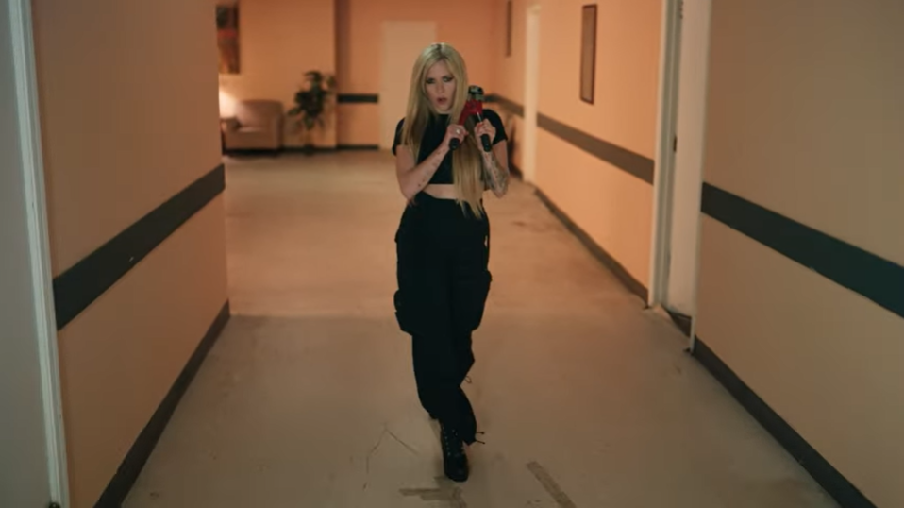

**MULTI-PLATINUM ARTIST TO RING IN 2022 WITH A PERFORMANCE ON**

**“DICK CLARK’S NEW YEAR’S ROCKIN’ EVE”**

**HIGH PROFILE TELEVISION APPEARANCES ON**

**“THE LATE LATE SHOW WITH JAMES CORDEN,” “THE TONIGHT SHOW STARRING JIMMY FALLON,” AND “THE ELLEN DEGENERES SHOW”**

**“BITE ME”** [**AVAILABLE EVERYWHERE NOW**](https://nam04.safelinks.protection.outlook.com/?url=https%3A%2F%2Favrillavigne.lnk.to%2Fbiteme&data=04%7C01%7CSydneyWorden%40elektra.com%7Cfdb5ff623ad64e9a22d108d9a61512ab%7C8367939002ec4ba1ad3d69da3fdd637e%7C0%7C0%7C637723431696202337%7CUnknown%7CTWFpbGZsb3d8eyJWIjoiMC4wLjAwMDAiLCJQIjoiV2luMzIiLCJBTiI6Ik1haWwiLCJXVCI6Mn0%3D%7C1000&sdata=uObKrh1%2BPHMrfhfOKTOSwpVmpFt6L4%2FlhClwXocZuSE%3D&reserved=0) **VIA DTA RECORDS**

**PRESS ASSETS** [**HERE**](https://nam04.safelinks.protection.outlook.com/?url=https%3A%2F%2Fwarnermusicgroup.box.com%2Fs%2Foh4kldb1egkcrpzaf4acu0flkmv9zv5v&data=04%7C01%7CSydneyWorden%40elektra.com%7Cfdb5ff623ad64e9a22d108d9a61512ab%7C8367939002ec4ba1ad3d69da3fdd637e%7C0%7C0%7C637723431696202337%7CUnknown%7CTWFpbGZsb3d8eyJWIjoiMC4wLjAwMDAiLCJQIjoiV2luMzIiLCJBTiI6Ik1haWwiLCJXVCI6Mn0%3D%7C1000&sdata=cpbGur5QI0SFcpCzQXFnWjhuKPXGUnJEdqkQBNTd%2Feg%3D&reserved=0)

Multiplatinum star Avril Lavigne has unveiled an acoustic version of her new single “Bite Me,” [available everywhere now](https://avrillavigne.lnk.to/biteme-acoustic). The re-imagined track arrives alongside an official music video, directed by Mod Sun, now streaming on her [official YouTube channel](https://youtu.be/-zs63sGJZlU).

Her first new music since 2019 and label debut for Travis Barker’s DTA Records, “[Bite Me](https://nam04.safelinks.protection.outlook.com/?url=https%3A%2F%2Favrillavigne.lnk.to%2Fbiteme&data=04%7C01%7CSydneyWorden%40elektra.com%7Cfdb5ff623ad64e9a22d108d9a61512ab%7C8367939002ec4ba1ad3d69da3fdd637e%7C0%7C0%7C637723431696202337%7CUnknown%7CTWFpbGZsb3d8eyJWIjoiMC4wLjAwMDAiLCJQIjoiV2luMzIiLCJBTiI6Ik1haWwiLCJXVCI6Mn0%3D%7C1000&sdata=uObKrh1%2BPHMrfhfOKTOSwpVmpFt6L4%2FlhClwXocZuSE%3D&reserved=0)” arrived last month to a raft of praise from the likes of *Rolling Stone*, *Billboard*, *USA Today*, *People*, and *Vulture* who called the song “…*a full-fledged, pop-punk banger*.”  To celebrate the arrival of “Bite Me,” the eight-time GRAMMY® Award-nominated multiplatinum singer, songwriter, designer, and philanthropist treated fans to the song’s first late-night television performance on CBS’s *The Late Late Show With James Corden*, followed by appearances on NBC’s *The Tonight Starring Jimmy Fallon* and the nationally syndicated *Ellen DeGeneres Show*. Avril is currently on the cover of the December issue of NYLON magazine and is set to ring in 2022 with a performance on the iconic ABC’s *Dick Clark’s New Year’s Rockin’ Eve*. Founded by Barker, DTA Records operates as a worldwide venture with Elektra Music Group.

Avril is set to launch a world tour in 2022 with more dates to be announced.  Stay tuned for much more from Avril Lavigne soon.

              Photo Credit: Ryan McFadden

**ABOUT AVRIL LAVIGNE:**

Avril Lavigne has made history, smashed records, and consistently blazed a trail of her own as an uncompromising force in music and culture. Beyond selling 40 million albums worldwide with 12.5 million units sold in the U.S. alone, she has notched eight GRAMMY® Award nominations in categories such as *“Best New Artist”* and *“Song of the Year”* twice for “Complicated” and “I’m with You.” In addition, she has received eight Juno Awards, including *“Artist of the Year*.*”* Her catalog comprises the septuple platinum *Let Go* [2002], triple-platinum *Under My Skin* [2004], double-platinum *The Best Damn Thing* [2007], gold-selling *Goodbye Lullaby* [2011], gold-selling *Avril Lavigne* [2013], and *Head Above Water* [2019] highlighted by definitive smashes such as “Complicated,” “Sk8er Boi,” “Girlfriend,” “Here’s To Never Growing Up,” and “Head Above Water.” As such, she remains of *“one of the Soundscan-era’s top-selling artists releasing albums in the U.S.”* and *“the third bestselling Canadian female artist of all-time*.*”* She earned a spot in the Top 10 of *Billboard*’s *“Best of the 2000s”* chart and holds a Guinness World Record as *“the youngest female solo artist to top the UK chart*,*”* while “Girlfriend” emerged as *“first music video to reach 100 million views on YouTube*.*”* She has also earned multiple #1‘s around the globe. Her social media following notably exceeds 93.6 million fans worldwide. Not to mention, she starred Richard Linklater’s *Fast Food Nation*, DreamWorks Animation’s film *Over the Hedge*, *The Flock*, and more. Kicking off her biggest and boldest chapter to date, she makes her debut for DTA Records with the single “Bite Me” and more to come in 2021.

CONTACT:

Kristen Foster                                             Glenn Fukushima

full coverage PR                                         Elektra Music Group

[Kristen.Foster@fullcov.com](mailto:Kristen.Foster@fullcov.com)                  [GlennFukushima@elektra.com](mailto:GlennFukushima@elektra.com)