FOR IMMEDIATE RELEASE
APRIL 30, 2021

SINGER-SONGWRITER BRYNN CARTELLI unveils “IF I COULD”

ANNOUNCES DEBUT EP based on a true story – out may 28

set to perform on the kelly clarkson show may 14

listen/download “if i could”

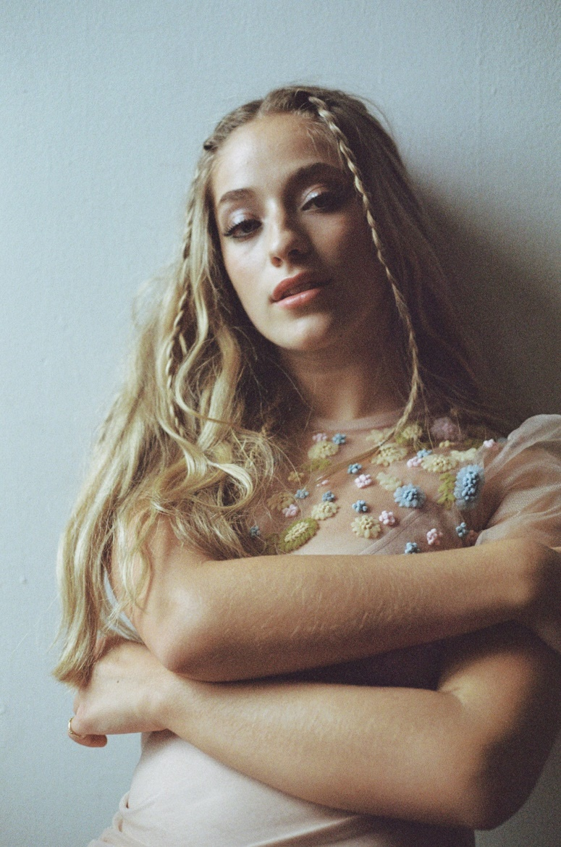

PRESS ASSETS HERE

18-year-old Singer Songwriter Brynn Cartelli has unveiled her new song “If I Could,” available at all DSPS and streaming services now. Co-written by Brynn and Ben Abraham (Demi Lovato, Sara Bareilles, and Kesha), Brynn sends a message to a friend in a one-sided relationship, “If I could do it for you, then I would say, ‘Goodbye’.” Earlier this week Cartelli announced her debut EP Based On A True Story – out May 28th. Fans can pre-order and pre-save the EP here.

Cartelli elaborates on the track, “Releasing ‘If I Could’ is like letting a bunch of strangers read my diary. It’s terrifying and slightly invasive, but I knew if I was bold enough to release it, the song would be an honest description of such a hopeless and frustrating feeling too many people experience with their best friends. And for that, I am honored to be the one delivering the message.”

Inspired by a teenage friend’s experience, “If I Could” showcases her ability to take small moments and turn them into anthemic ballads that people of all ages can relate to. Brynn originally shared a snippet of the song through a post on Tik Tok that has amassed over 7 million views and is set to perform the track on The Kelly Clarkson show on May 14th.

“Long Way Home,” co-written by Brynn and Nathan Chapman (Taylor Swift, Kylie Minogue and Colbie Caillat), was the first track released off her upcoming EP and her first new music since 2019, attracting praise as People named Brynn among its “Emerging Artists to Watch.” Last week Brynn unveiled the official video for the track, which was directed by Blythe Thomas (Julia Michaels, Hozier, Grace Vanderwall) and sees Brynn and her real-life friends driving around New York City, singing and dancing through the streets of Greenwich Village and Times Square, and even celebrating her friend Piper's 18th birthday - Cartelli also turned 18 this month - with a surprise cake.

BRYNN CARTELLI
“IF I COULD”
AVAILABLE NOW
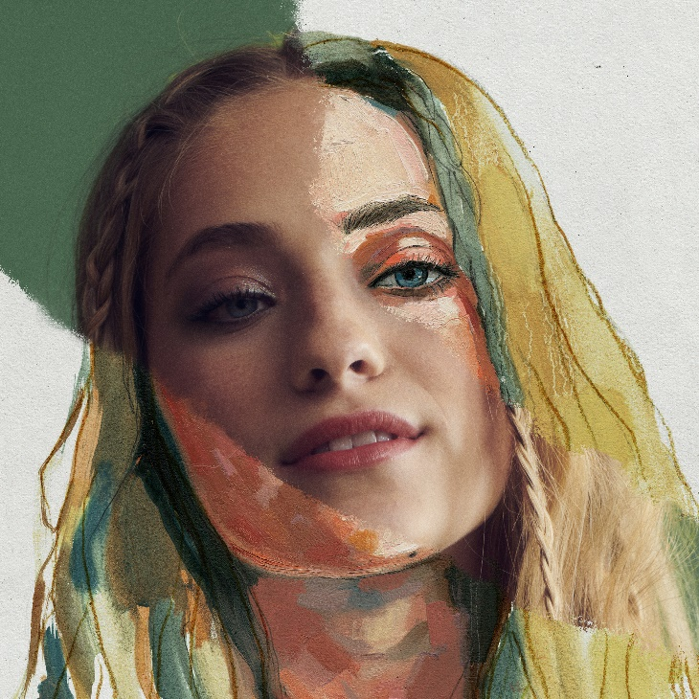

***
ABOUT BRYNN CARTELLI
Flaunting a skyscraping range, undeniable presence, and eloquent songcraft, Brynn Cartelli tells relatable stories without filter, but with a whole lot of finesse and fire. Long before amassing 20 million-plus streams and receiving acclaim from People, Billboard, and more, she grew up in Longmeadow, MA where she embraced music as a kid. At just five-years-old, she took regular piano lessons. She eventually learned guitar and developed her chops by performing in talent shows, at coffeehouses, and anywhere else with a stage. Her vocals captivated viewers everywhere when she won Season 14 of NBC’s “The Voice” and emerged as “the youngest champion in the show’s history.” However, she hunkered down and focused on writing original material in the aftermath. Introducing her signature style, “Last Night’s Mascara” amassed over 10 million streams globally. Meanwhile, her 2019 follow-up and original composition “Grow Young (Version 1)” cracked over 1 million total streams. Hitting the road coast-to-coast, she supported Kelly Clarkson on the Meaning Of Life Tour and opened for Maroon 5. Along the way, she also garnered a nomination at the “People’s Choice Awards” and captivated audiences on the NBC’s “TODAY” and “Macy’s Thanksgiving Day Parade,” “Radio Disney Music Awards,” and on Boston’s most hallowed ground, Fenway Park. Brynn released her fan favorite, holiday cover of “Have Yourself A Merry Little Christmas” and gave an unforgettable performance of the staple on The Kelly Clarkson Show to cap off 2019. After two years of writing and recording, she’s back in 2021 with her debut EP Based On A True Story – out May 28th.

CONNECT:
Facebook | Twitter | Instagram | YouTube

CONTACT:
Glenn Fukushima | GlennFukushima@elektra.com
Sydney Worden | SydneyWorden@elektra.com

