FOR IMMEDIATE RELEASE
MARCH 19, 2021

BRYNN CARTELLI RETURNS with “LONG WAY HOME”

acclaimed singer-songwriter and winner of NBC’S “the voice”
unveils first new music of the year with more to come soon

LISTEN HERE

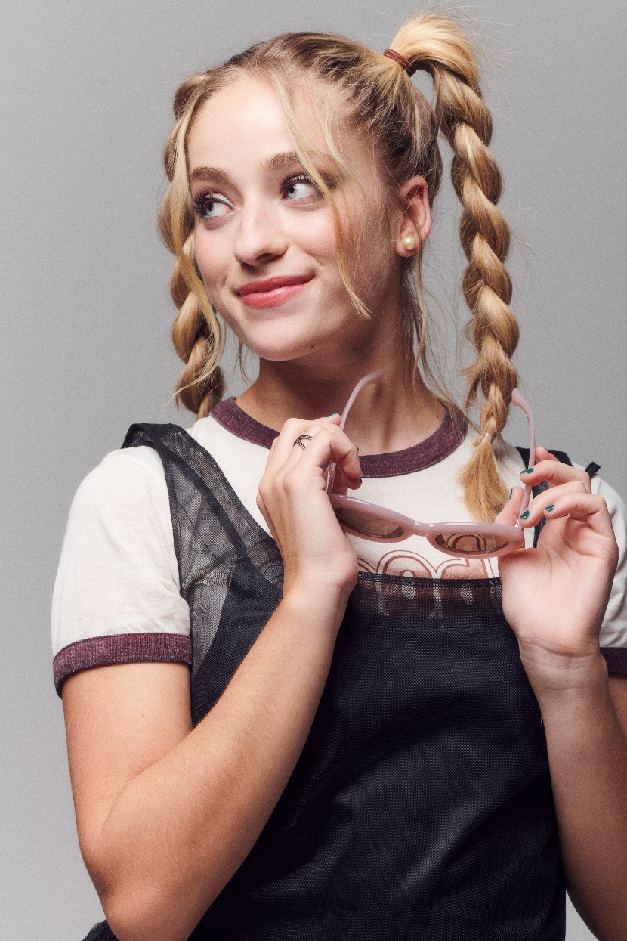

PRESS ASSETS HERE

Elektra Records artist Brynn Cartelli has returned with a new single “Long Way Home,” available at all DSPS and streaming services now. The 17-year old singer-songwriter – best known as the winner of NBC’s The Voice - also shared the accompanying lyric video today. Co-written by Brynn and Nathan Chapman (Taylor Swift, Kylie Minogue and Colbie Caillat), “Long Way Home” marks her first release since 2019 and heralds more to come very soon.

About the song, she commented, “Long Way Home is the first story I wanted to share off of my next project. I will never forget the day I wrote it with Nathan Chapman in Nashville, going around the studio and using random items as percussion. What started as a slow, weirdly depressing idea on piano (as almost all of my songs do) became a super fun pop record. Each lyric to me is a wink at the rush of young love in a small town. Getting lost on streets with no names, letting yellow lights turn red, purposely taking the Long Way Home, I’ll do anything to push the limits of my curfew. Long Way Home is the beginning of a story revealing who I am as a singer and songwriter.”

Illuminating her evolution as a dynamic pop force, the upbeat track hinges on a thumping bass-heavy beat and natural acoustic guitar riff. Her dynamic vocals take the spotlight with a traffic-stopping crescendo on the bridge, “Let’s take the long way home,” as she captures the bliss of a lovestruck couple on a night car ride. Last month, Cartelli shared a snippet of the song with her fans through a post on Tik Tok that has already amassed over 2 million views and counting.

Be on the lookout for the premiere of the official music video very soon.

Right now, Brynn is putting the finishing touches on more music to come in 2021. Stay tuned.

BRYNN CARTELLI
“LONG WAY HOME”
AVAILABLE NOW
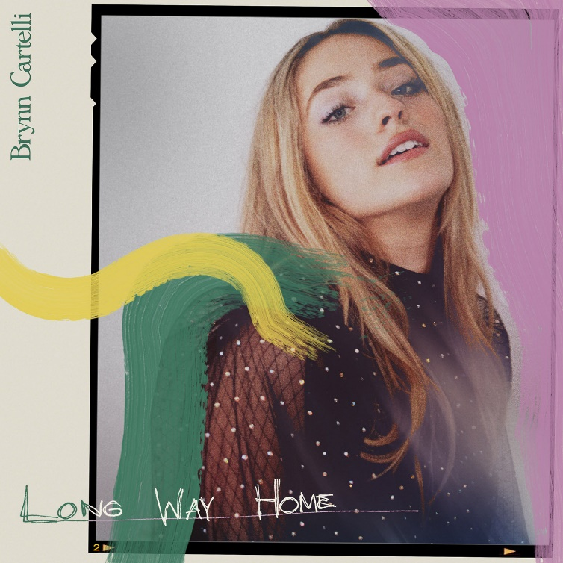

***
ABOUT BRYNN CARTELLI
Flaunting a skyscraping range, undeniable presence, and eloquent songcraft, Brynn Cartelli tells relatable stories without filter, but with a whole lot of finesse and fire. Long before amassing 20 million-plus streams and receiving acclaim from People, Billboard, and more, she grew up in Longmeadow, MA where she embraced music as a kid. At just five-years-old, she took regular piano lessons. She eventually learned guitar and developed her chops by performing in talent shows, at coffeehouses, and anywhere else with a stage. Her vocals captivated viewers everywhere when she won Season 14 of NBC’s “The Voice” and emerged as “the youngest champion in the show’s history.” However, she hunkered down and focused on writing original material in the aftermath. Introducing her signature style, “Last Night’s Mascara” amassed over 10 million streams globally. Meanwhile, her 2019 follow-up and original composition “Grow Young (Version 1)” cracked over 1 million total streams. Hitting the road coast-to-coast, she supported Kelly Clarkson on the Meaning Of Life Tour and opened for Maroon 5. Along the way, she also garnered a nomination at the “People’s Choice Awards” and captivated audiences on the NBC’s “TODAY” and “Macy’s Thanksgiving Day Parade,” “Radio Disney Music Awards,” and on Boston’s most hallowed ground, Fenway Park. Brynn released her fan favorite, holiday cover of “Have Yourself A Merry Little Christmas” and gave an unforgettable performance of the staple on The Kelly Clarkson Show to cap off 2019. After two years of writing and recording, she’s back in 2021 with her new single “Long Way Home” and much more to come.

CONNECT:
Facebook | Twitter | Instagram | YouTube

CONTACT:
Glenn Fukushima | GlennFukushima@elektra.com
Sydney Worden | SydneyWorden@elektra.com

