FOR IMMEDIATE RELEASE
APRIL 23, 2021

BRYNN CARTELLI unveils official video for “LONG WAY HOME”

18-YEAR-OLD SINGER-SONGWRITER ENLISTS
HER REAL-LIFE FRIENDS TO CO-STAR IN THE carefree CLIP

watch “long way home” here

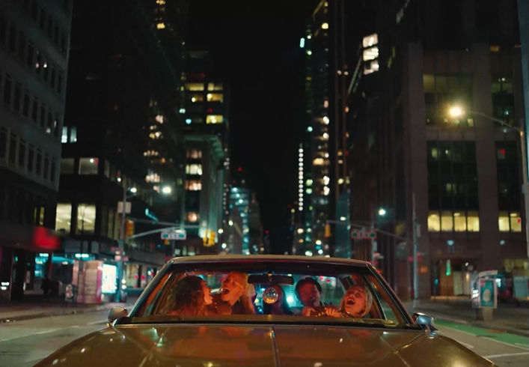

PRESS ASSETS HERE

Singer Songwriter Brynn Cartelli has unveiled the official video for her latest single “Long Way Home,” now streaming on her YouTube channel. Directed by Blythe Thomas (Julia Michaels, Hozier, Grace Vanderwall), the video sees Brynn and her real-life friends driving around New York City, singing and dancing through the streets of Greenwich Village and Times Square, and even celebrating her friend Piper's 18th birthday - Cartelli also turned 18 just last week - with a surprise cake. Co-written by Brynn and Nathan Chapman (Taylor Swift, Kylie Minogue and Colbie Caillat), “Long Way Home” marked her first release since 2019 and attracted praise as People named Brynn among its “Emerging Artists to Watch.”

About the song, she commented, “Long Way Home is the first story I wanted to share off of my next project. I will never forget the day I wrote it with Nathan Chapman in Nashville, going around the studio and using random items as percussion. What started as a slow, weirdly depressing idea on piano (as almost all of my songs do) became a super fun pop record. Each lyric to me is a wink at the rush of young love in a small town. Getting lost on streets with no names, letting yellow lights turn red, purposely taking the Long Way Home, I’ll do anything to push the limits of my curfew. Long Way Home is the beginning of a story revealing who I am as a singer and songwriter.”

Earlier this week, Cartelli shared a snippet of her upcoming single “If I Could” through a post on Tik Tok that has already amassed over 5 million views and counting. The song is set for release on April 30th and fans can pre-save the track here.

Be on the lookout for more news from Brynn soon!

BRYNN CARTELLI
“LONG WAY HOME”
AVAILABLE NOW
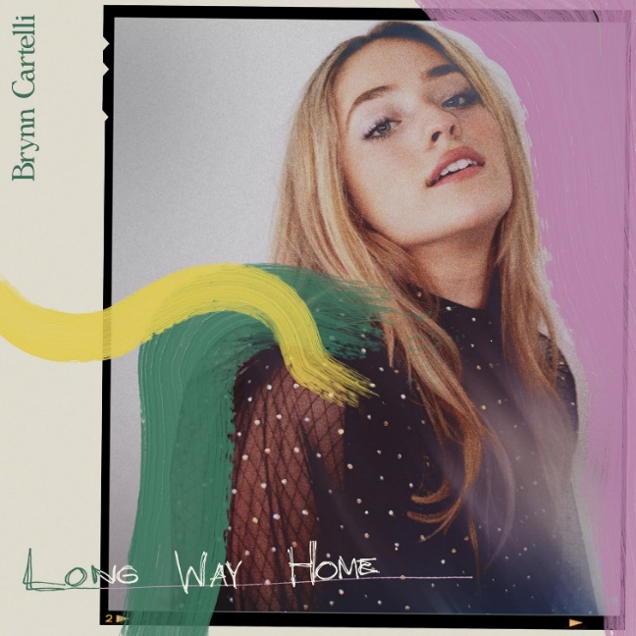

***
ABOUT BRYNN CARTELLI
Flaunting a skyscraping range, undeniable presence, and eloquent songcraft, Brynn Cartelli tells relatable stories without filter, but with a whole lot of finesse and fire. Long before amassing 20 million-plus streams and receiving acclaim from People, Billboard, and more, she grew up in Longmeadow, MA where she embraced music as a kid. At just five-years-old, she took regular piano lessons. She eventually learned guitar and developed her chops by performing in talent shows, at coffeehouses, and anywhere else with a stage. Her vocals captivated viewers everywhere when she won Season 14 of NBC’s “The Voice” and emerged as “the youngest champion in the show’s history.” However, she hunkered down and focused on writing original material in the aftermath. Introducing her signature style, “Last Night’s Mascara” amassed over 10 million streams globally. Meanwhile, her 2019 follow-up and original composition “Grow Young (Version 1)” cracked over 1 million total streams. Hitting the road coast-to-coast, she supported Kelly Clarkson on the Meaning Of Life Tour and opened for Maroon 5. Along the way, she also garnered a nomination at the “People’s Choice Awards” and captivated audiences on the NBC’s “TODAY” and “Macy’s Thanksgiving Day Parade,” “Radio Disney Music Awards,” and on Boston’s most hallowed ground, Fenway Park. Brynn released her fan favorite, holiday cover of “Have Yourself A Merry Little Christmas” and gave an unforgettable performance of the staple on The Kelly Clarkson Show to cap off 2019. After two years of writing and recording, she’s back in 2021 with her new single “Long Way Home” and much more to come.

CONNECT:
Facebook | Twitter | Instagram | YouTube

CONTACT:
Glenn Fukushima | GlennFukushima@elektra.com
Sydney Worden | SydneyWorden@elektra.com

