FOR IMMEDIATE RELEASE
OCTOBER 22, 2020

FITZ RELEASES FIRST EVER SOLO SINGLE “HEAD UP HIGH” TODAY

FRONTMAN & NAMESAKE OF MULTIPLATINUM FITZ AND THE TANTRUMS STEPS INTO THE SPOTLIGHT WITH SOLO MUSIC

WATCH THE DYNAMIC OFFICIAL MUSIC VIDEO HERE
LISTEN HERE

DEBUT FULL LENGTH ALBUM COMING IN 2021

PRESS ASSETS HERE

Founder and namesake of LA-based multiplatinum band Fitz and the Tantrums and Elektra Recording artist FITZ has released his first ever solo single “HEAD UP HIGH” today. It is available at all DSPs and streaming services now. “HEAD UP HIGH” – which also arrives with a dynamic official music video - notably marks the first-ever solo music from the singer, songwriter, and multi-instrumentalist.

Co-produced and co-written with Ryan Daly, “HEAD UP HIGH” gallops forward on bright acoustic guitar and bold horns as FITZ carries an instantly chantable and immediately uplifting hook. The track introduces this new chapter for him with an important message.

He commented, “‘HEAD UP HIGH’ was a telling moment. I wanted to do a tune centered around the acoustic, which is very different from Fitz and the Tantrums. We’ve only used an acoustic guitar on one song in four albums! The chords and lyrics spilled out of me. Ryan and I logged into the ZOOM session, and you could read the weight we were carrying on our faces. Collectively…not as a city, community, country, or even continent…the whole world is carrying the weight of what the Global Pandemic has meant. We’re all experiencing it at the same time. So, the statement rang out, ‘You’ve got to keep your head up’. The message feels so relevant. Life is not a sprint; it’s a marathon. I needed to hear that message and express it in a song to rally everybody to keep their heads above water.”

This music came to life unexpectedly. On day one of the Los Angeles quarantine, FITZ had his first ZOOM songwriting session with Daly. Adapting to songwriting online, they locked into a groove, spending 12 hours per day six days per week writing and recording remotely. In the music, FITZ presented another facet of his personality—surely recognizable, yet gleefully independent of Fitz and the Tantrums.

For the first time, at the age of 50, he followed this rush of inspiration to his very first solo music.

“I didn’t even get my first break until I was 38-years-old,” he states. “By that, I mean I could sell a bunch of tickets to people other than my friends! It wasn’t until I turned 40 that the band experienced any real success. I busted my ass and faced so much rejection for a good 15 years. I put down this dream more than once because I was so heartbroken and devastated by the industry. However, I had this monkey on my back that said, ‘You’ve got to try again’. To have the opportunity to make what will be my fifth album overall is mind-blowing. It’s already an incredibly unusual path. To make it even more usual, my wife and I were lying in bed and laughing once we finished the contract. I was like, ‘Can we take a moment to appreciate the fact I’m a 50-year-old man who just signed his first record deal?’.”

FITZ will release his debut full length album in early 2021. More details coming soon.

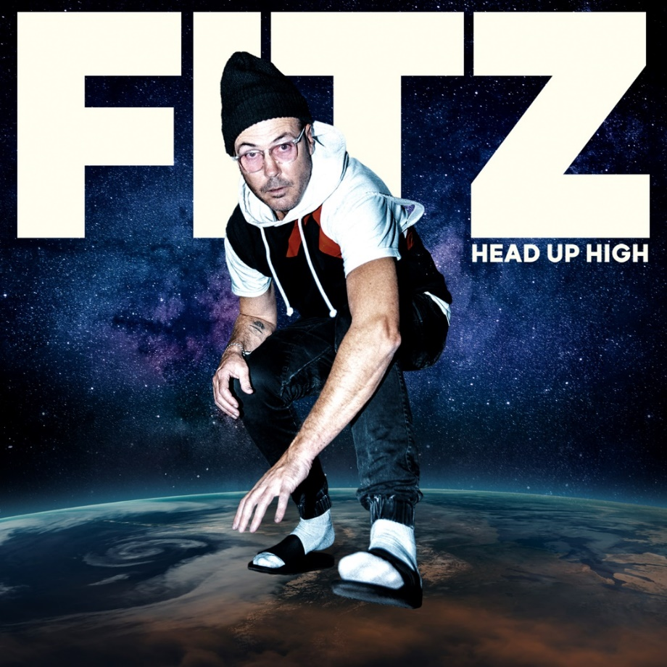

*****

Since 2008, FITZ a.k.a. Michael Fitzpatrick has galvanized and energized fans around the world as the frontman and namesake of Fitz and the Tantrums. Over the course of four albums, the band has cooked up a series of instantly recognizable and hummable anthems such as the platinum “The Walker,” platinum “Out of My League,” and double-platinum “HandClap.” Amassing billions of streams and attracting praise from People, Billboard, and many more, the group quietly morphed into an arena-ready force, headlining and packing historic venues such as The Forum in Los Angeles, Red Rocks Amphitheatre in Morrison, CO, and more. Not to mention, he lent his voice to collaborations with everyone from Weezer to LL Cool J. After twelve unbelievable years, FITZ did something he’s never done before. The singer, songwriter, and multi-instrumentalist electrified his very first solo music to life—at 50-years-young. On his debut single “Head Up High,” he introduces another side of himself and his artistry, reaching a new apex of his wonderfully unbelievable journey thus far. However, 50 is just the beginning for FITZ as he plans more music and surprises for 2020 and beyond.

# # #

PRESS CONTACT:

Glenn Fukushima (National)
818.238.6833
GlennFukushima@elektra.com

Collin Citron (National)
818.238.6314
CollinCitron@elektra.com

Sydney Worden (Tour/Online)
818.238.6834
SydneyWorden@elektra.com

