SINGER-RAPPER MILES UNVEILS TIMELY NEW SINGLE “MOSH PIT” ALONGSIDE OFFICIAL MUSIC VIDEO

LISTEN HERE | WATCH HERE

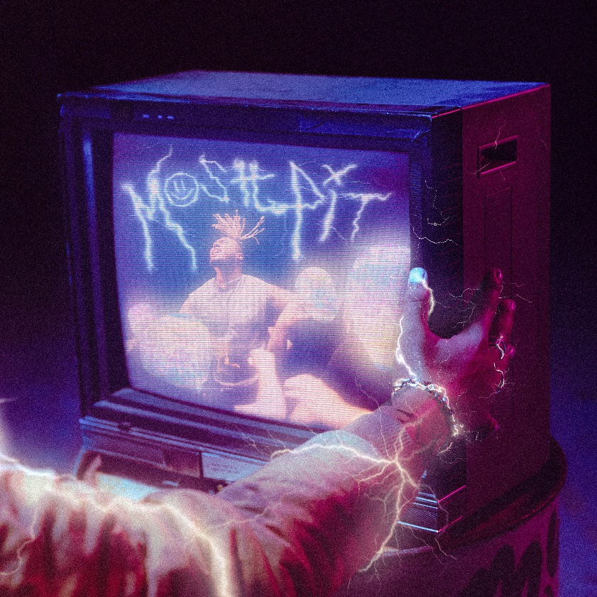
DOWNLOAD HIGH-RES PRESS ASSETS HERE

JULY 9, 2021 - Elektra Records artist MILES has unveiled his timely new single “MOSH PIT,” available now at all DSPS and streaming services. The track arrives alongside an official music video streaming now on his official YouTube channel. With many people not having been to a show in over a year and craving live music, the well-timed track hears MILES “Fiendin' for the show” while the official video, directed by Nicholas Jandora (24kGoldn, Lil Skies, Bankrol Hayden) and co-concepted by MILES himself, sees him jamming to a Rock Band-type video game and eventually getting transported into a mosh pit.

“MOSH PIT” follows the St. Louis-born/Los Angeles-based singer-rapper’s latest track “Desperados,” which marked his official debut for Elektra Records. Pulling inspiration from the 1995 Robert Rodriguez film Desperado, the official music video was shot in the Southern California desert and explores the life of a modern outlaw.

MILES’ story so far engenders such enthusiasm. The St. Louis native grew up singing and naturally gravitated towards music inspired by everyone from Lil Wayne and Chance the Rapper to Charlie Puth and Khalid in high school. Admitted to prestigious Dartmouth College on a football scholarship, he quietly uploaded music to Soundcloud and gradually made waves online. Leaving school, he wound up in Los Angeles and dropped a series of independent singles, culminating on the viral “WHAT IN TARNATION.” Nearly 3,000 Tik Tok videos utilized the track as he generated just shy of 7 million total streams.

Photo Credit- Christian Sarkine

*****

St. Louis-born and Los Angeles-based singer-rapper MILES brings hip-hop grit to pop with deft wordplay and dusty soundscapes. Named after Miles Davis, he possessed a predisposition for music fueled by listening to everything from dad’s jazz records, Kirk Franklin, and Bill Withers to Lauryn Hill, Wiz Khalifa, and Travis Scott. He honed his vocals through constantly singing before beginning to freestyle in high school. At the same time, he excelled on the football field, earning a scholarship to Dartmouth College as a defensive tackle. In between a grueling Ivy league schedule of practice and class, he still managed to maintain a prolific output of independent music online. Picking up steam, he left school, moved to L.A. and crashed at YouTuber Justin Escalona’s pad. On a weekly basis, he appeared in vlogs and released music at a rapid pace, logging millions of streams and quickly building a fanbase, including over 385K followers on TikTok alone in just 3 months. In 2020, he ignited the viral “WHAT IN TARNATION,” attracting 2,700 Tik Tok videos and drumming up 6.3 million streams. On the heels of its success, he inked a deal with Elektra Records and rustled up his formal debut for the label “Desperados” with much more to come.

