FOR IMMEDIATE RELEASE
DECEMBER 18, 2020

MILES MAKES ELEKTRA RECORDS DEBUT WITH NEW SINGLE “DESPERADOS” TODAY

MORE NEW MUSIC FROM RISING SINGER-RAPPER COMING IN 2021

LISTEN TO “DESPERADOS” HERE

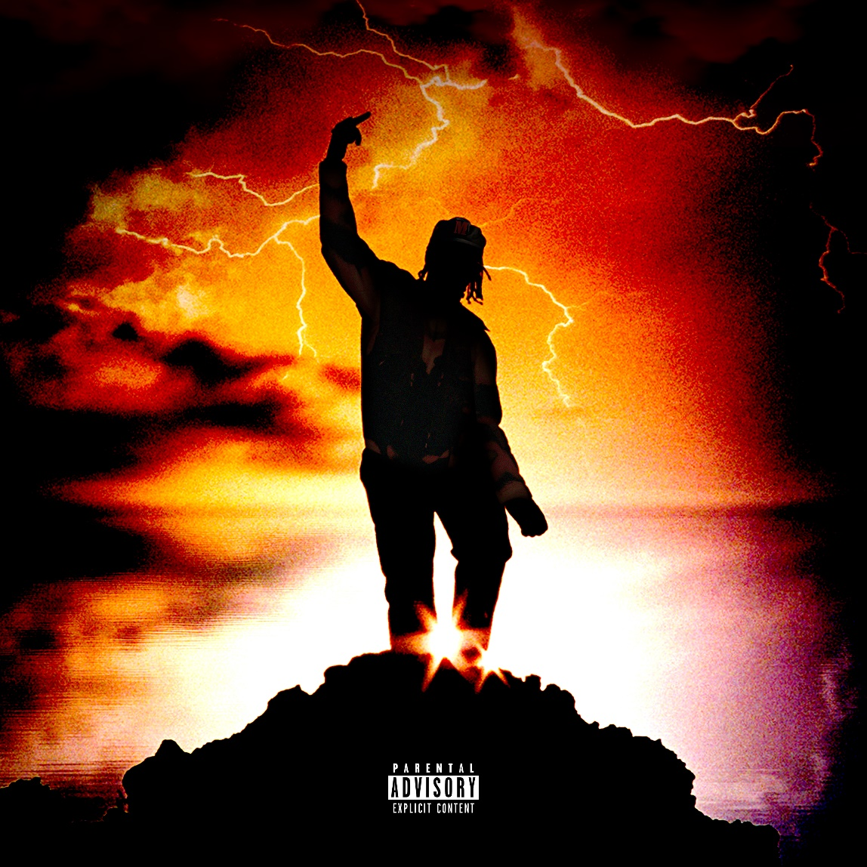

SINGLE ART/PRESS IMAGE AVAILABLE HERE

Buzzing St. Louis-born/Los Angeles-based singer-rapper MILES has released his new single “Desperados” today. Available at all DSPS and streaming services now, the track marks his official debut for Elektra Records following his recent signing.

“Desperados” entwines hip-hop and pop with airy guitars, 808s, and big screen-worthy modern outlaw themes. Flexing an expansive vocal range, nimble rhymes give way to the chorus’ instantly hummable hook. Built to turn up in the Hills or on the trail, he rides into the culture with a sizzling style of his own. The official music video for the track is currently in post-production and set to premiere in early 2021.

About the song, MILES said, “I watched hundreds of old Westerns with my dad. In these movies, the Desperado was always dressed in black, riding around solo on a horse, and dueling from town to town. I was thinking about what it means to be an anti-hero. He’s the guy that marches to his own drumbeat and someone you might not really want to root for, but you can’t help it because he’s just staying true to himself and actually one of the good guys. That’s who I want to be in music—the anti-hero you end up rooting for.”

MILES’ story so far engenders such enthusiasm. The St. Louis native grew up singing and naturally gravitated towards music inspired by everyone from Lil Wayne and Chance the Rapper to Charlie Puth and Khalid in high school. Admitted to prestigious Dartmouth College on a football scholarship, he quietly uploaded music to Soundcloud and gradually made waves online. Leaving school, he wound up in Los Angeles and dropped a series of independent singles, culminating on the viral “WHAT IN TARNATION” earlier this year. Nearly 3,000 Tik Tok videos utilized the track as he generated just shy of 7 million total streams.

Watch out for more from MILES very soon.

*****
St. Louis-born and Los Angeles-based singer-rapper MILES brings hip-hop grit to pop with deft wordplay and dusty soundscapes. Named after Miles Davis, he possessed a predisposition for music fueled by listening to everything from dad’s jazz records, Kirk Franklin, and Bill Withers to Lauryn Hill, Wiz Khalifa, and Travis Scott. He honed his vocals through constantly singing before beginning to freestyle in high school. At the same time, he excelled on the football field, earning a scholarship to Dartmouth College as a defensive tackle. In between a grueling Ivy league schedule of practice and class, he still managed to maintain a prolific output of independent music online. Picking up steam, he left school, moved to L.A. and crashed at YouTuber Justin Escalona’s pad. On a weekly basis, he appeared in vlogs and released music at a rapid pace, logging millions of streams and quickly building a fanbase, including over 385K followers on TikTok alone in just 3 months. In 2020, he ignited the viral “WHAT IN TARNATION,” attracting 2,700 Tik Tok videos and drumming up 6.3 million streams. On the heels of its success, he inked a deal with Elektra Records and rustled up his formal debut for the label “Desperados” with much more to come.

# # #

