FOR IMMEDIATE RELEASE
SEPTEMBER 18, 2020

SAINT MOTEL RELEASE
“THE ORIGINAL MOTION PICTURE SOUNDTRACK: PART 2”

LA-BASED QUARTET UNVEIL THE SECOND INSTALLMENT OF A THREE-PART ALBUM
HIGHLIGHTED BY LEAD SINGLE “PREACH”

SAINT MOTEL’S “NEW WORLD,” AN IMMERSIVE, VIRTUAL WORLD DEVELOPED IN COLLABORATION WITH MOZILLA HUBS IS OPEN TO EXPLORE

“THE ORIGINAL MOTION PICTURE SOUNDTRACK: PART 2” AVAILABLE EVERYWHERE NOW
STREAM/DOWNLOAD HERE

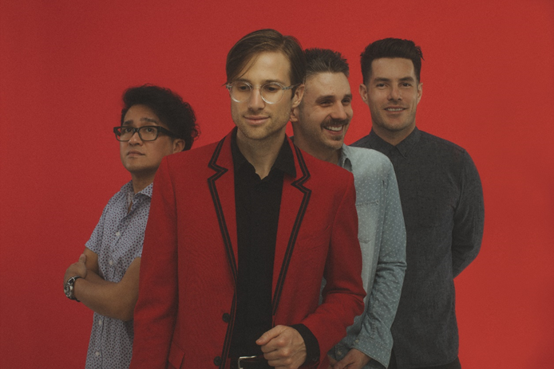

PRESS ASSETS HERE

Elektra recording group Saint Motel have released “THE ORIGINAL MOTION PICTURE SOUNDTRACK: PART 2,” the second installment of a three-part album, available now at all DSPs and streaming services HERE.

The five-song collection is highlighted by lead single “Preach” whose official music video is available to stream on the band’s YouTube channel. Part 2 also features the previously released track, “A Good Song Never Dies” which debuted in PlayStation’s MLB The Show 20. Keep on the lookout for accompanying visualizers and acoustic videos which are currently in pre-production. Conceptually, “THE ORIGINAL MOTION PICTURE SOUNDTRACK” is modeled after a three-act movie, sometimes referred to as the “Hero’s Journey” storyline, manifested as three Parts that eventually combine to form a single album.

PART 1 was heralded by the infectious lead single “Van Horn.” Known for their cinematic aesthetic, the band brought the western-themed official music video for track – directed by Saint Motel frontman A/J Jackson – to life with an inventive performance on Jimmy Kimmel LIVE!. Earlier this year, the band sold out their entire North American headline tour in support of PART 1, culminating with hometown finale in Los Angeles, days before the country went into quarantine due to Covid-19.

Remaining on the cutting edge of innovation, Saint Motel make history as “the first band to open their own virtual world” powered by Mozilla Hubs. The virtual world is designed as a motel with each room dedicated to a song on the band’s three-part album, THE ORIGINAL MOTION PICTURE SOUNDTRACK. Last month, the quartet’s launch of “New World” welcomed fans to the virtual space where Jackson performed a live acoustic set. In this 3D VR chatroom enabled for all headsets and browsers, audiences can enter an exclusive, immersive environment to engage directly with the band through virtual meet-and-greets and intimate, live performances, consume exclusive video content, and much more. Additionally, it doubles as a space for fans to congregate and get to know each other. Saint Motel’s “New World” upholds what has become a tradition of engaging with groundbreaking technology for the guys. Visit www.saintmotel.com/newworld to explore the “New World.” In 2016, they dropped their Elektra full length debut saintmotelevision as the first-ever Virtual Reality album and first-ever Augmented Reality album and accompanied the record with the free saintmotel AR/VR app.

In recent months, Saint Motel has made a concerted effort to mobilize their fans to join them on a pair of philanthropic causes through special, limited edition merchandise. With blood donations needed now more than ever, the band has partnered with The American Red Cross to offer a “Just My Blood Type” enamel pin, available for free to those who donate blood. Named for their breakout hit “Just My Type, the pins are also available for purchase with 100% of net profits going to The American Red Cross. Likewise, Saint Motel has joined with the National Independent Venue Association’s #SaveOurStages campaign to ask Congress to provide aid to their network of nearly 2,000 independent live music venues across the country – many of which the band has performed in – that have been 100% shut down with zero revenue due to the pandemic. All profits from a special “Saint Motel X Save Our Stages” tour t-shirt will go directly to NIVA’s efforts. Both items are available in the Saint Motel Gift Shop.

Stay tuned for more from Saint Motel soon.

[ART/TRACKLISTING BELOW]

SAINT MOTEL
THE ORIGINAL MOTION PICTURE SOUNDTRACK: PART 2
AVAILABLE NOW

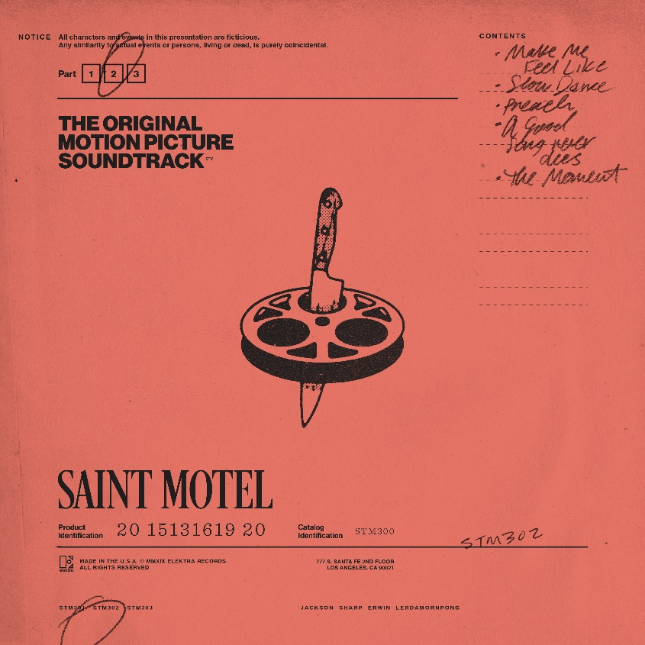

Tracklisting:
*begins at #6 as it’s a continuation of Part 1*
- Make Me Feel Like
- Slow Dance
- Preach
- A Good Song Never Dies
- The Moment
*****

Projecting pop hooks through an alternative lens with a flair for dramatic presentation, Saint Motel make music worthy of the big screen. Streamed and viewed over half-a-billion times, the gold-selling Los Angeles quartet magnify this vision with immersive live experiences and one unpredictable move after another. The group initially came together at film school before introducing themselves on 2012’s Voyeur. Signing to Elektra Records, their 2014 My Type EP boasted both the gold-certified title track “My Type” and fan favorite “Cold Cold Man.” In 2016, saintmotelevision yielded the smash “Move.” Flipping the script once again, the musicians reimagined the record with a series of history-making first-of-their-kind innovations: an award-winning Virtual Reality version and an Augmented Reality version. In 2019, Saint Motel launched their most ambitious undertaking yet, unveiling their third full-length album in three parts. First up, they uncovered THE ORIGINAL MOTION PICTURE SOUNDTRACK: PART 1 powered by the shimmy and shake of Alternative Top 15 lead single “Van Horn.” Between packing houses coast to coast on headline jaunts and earning acclaim from People, Billboard, and more, the four-piece plotted to roll out PART 2 and PART 3 throughout 2020. In addition to unforgettable sets everywhere from Coachella and Lollapalooza to Bonnaroo, the boys lit up shows such as NBC’s TODAY, ABC’s Jimmy Kimmel Live!, and CBS’ The Late Late Show with James Corden, among others.

Saint Motel is: A/J Jackson (vocals), Aaron Sharp (guitar), Dak Lerdamornpong (bass), and Greg Erwin (drums).

CONNECT WITH SAINT MOTEL

WWW.SAINTMOTEL.COM
WWW.SAINTMOTEL.COM/NEWWORLD
TWITTER
FACEBOOK
YOUTUBE
INSTAGRAM

# # #

PRESS CONTACT:

Glenn Fukushima (National)
818.238.6833
GlennFukushima@elektra.com

Collin Citron (National)
818.238.6314
CollinCitron@elektra.com

Sydney Worden (Tour/Online)
818.238.6834
SydneyWorden@elektra.com

