FOR IMMEDIATE RELEASE
APRIL 19, 2022

GENRE-DEFYING LIVE SENSATION RAINBOW KITTEN SURPRISE UNVEIL
NORTH AMERICAN + EUROPEAN TOUR DATES
FOR FALL/WINTER 2022

NEWLY ANNOUNCED SHOWS GO ON SALE
THIS FRIDAY, APRIL 22, AT 10AM LOCAL TIME
PRESALE BEGINS TOMORROW

NORTH AMERICAN TOUR ROLLS ON WITH NEARLY ALL DATES SOLD OUT – INCLUDING 2-NIGHT STAND AT THE ICONIC RED ROCKS AMPHITHEATER

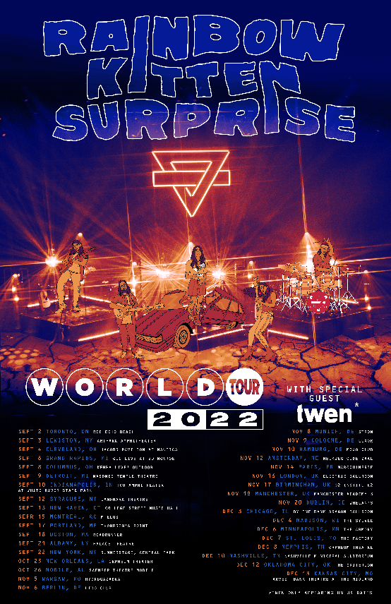

DOWNLOAD ASSETS HERE

Genre-defying, live sensations Rainbow Kitten Surprise have unveiled touring plans for Fall/Winter 2022. The newly announced dates, comprised of both North American and European legs, kick off September 2nd at RBC Echo Beach in Toronto, Ontario, with stops in New York City, Chicago, London, Paris, and more. General on sale begins this Friday, April 22nd, at 10am Local Time, with presale tickets available starting tomorrow, April 20th, at 10am Local Time.

Fans can purchase limited VIP packages with exclusive perks including: early entry into the venue, specially designed RKS holographic fanny pack, limited edition lenticular poster and more. For more information on VIP packages, please visit https://rksfallvip.wun.io/.

Rainbow Kitten Surprise is currently in the midst of their highly anticipated North American headline tour with most dates already sold out, including back-to-back nights at The Caverns in Pelham, TN and a triumphant, two-night return to Red Rocks Amphitheater in Morrison, CO, which sold-out in a matter of minutes of being announced. Always a festival favorite, Rainbow Kitten Surprise top the lineups at Shaky Knees Festival in Atlanta, GA and Bottle Rock Festival in Napa, CA. Full tour itinerary listed below.

For all upcoming headline shows, Rainbow Kitten Surprise has again partnered with PLUS1, so that $1 of every ticket sold will go to local food banks working to fight hunger and food insecurity in their communities. The band – who has worked with PLUS1 since 2019 – is expected to direct over $25,000 towards these organizations on this upcoming run alone.

Rainbow Kitten Surprise recently released the emotionally charged track “Work Out,” marking the band’s first new music in nearly two years. The song’s beautiful melody-line and effervescent vibe is a stark juxtaposition to its poignant lyrics about the difficult relationships – of all sorts – that people struggle with. “Work Out” arrived alongside a lyric video, handwritten by RKS frontperson Ela Melo. Watch HERE. An official music video is in post-production now.

ABOUT RAINBOW KITTEN SURPRISE:
As if channeling another dimension where genres simply don’t exist, Rainbow Kitten Surprise find harmony in unpredictability – weaving together lyrical poetry, hummable melodies, and a rush of instrumental eccentricities. Now boasting over 1 billion global streams across platforms, the band first began building their devoted fanbase with independent albums “SEVEN + MARY” (2013) and “RKS” (2015). Arriving in 2018, the band’s breakout full-length debut for Elektra, “HOW TO: FRIEND, LOVE, FREEFALL.” Produced by Grammy Award-winner Jay Joyce (Cage The Elephant, Sleeper Agent), the album featured RIAA-certified Gold single “It’s Called: Freefall”, earned widespread praise from Billboard, TIME, Vice, and NPR who described their sound as “…a mix of jam and indie and whatever else you can throw into the soup…very earnest, beautiful, political, loving rock n’ roll,” and saw the band make several national television appearances, including performances on “CBS This Morning Saturday,” “The Late Show with Stephen Colbert,” and PBS’s “Austin City Limits.” After gracing the bills of Bonnaroo, Lollapalooza, and Osheaga, to name a few, RKS moved 80,000 tickets of their own on their sold-out Friend, Love Freefall Tour earmarked by a packed night at Red Rocks Amphitheatre and three consecutive gigs in Athens, GA—as chronicled on their first official live album, “LIVE FROM ATHENS GEORGIA,” released in 2021. Most recently, two longtime fan-favorite tracks began to take off organically on TikTok, with “It’s Called: Freefall” and “Cocaine Jesus” experiencing massive upticks after user-created content on the platform went viral – resulting in over 11 million *weekly* streams for the band. The songs now boast 85 and 80 million streams, respectively.

Rainbow Kitten Surprise is: Ela Melo (lead vocals), Darrick “Bozzy” Keller (guitar, vocals), Ethan Goodpaster (lead guitar, vocals), Charlie Holt (bass, vocals), Jess Haney (drums)

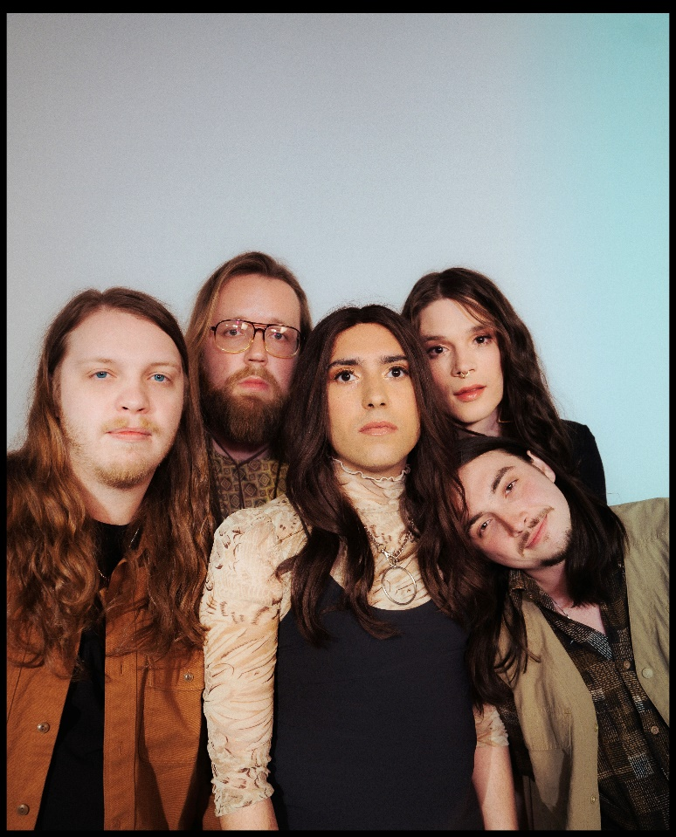
photo credit: Aubrey Denis; download HERE

RAINBOW KITTEN SURPRISE – UPCOMING LIVE DATES:
*NEWLY ANNOUNCED DATES IN BOLD*
^ Flipturn supporting
# 99 Neighbors supporting
+ Briston Maroney supporting
* The Brook & The Bluff supporting
> Houndmouth supporting
= Twen supporting

APRIL
Thur, April 21st - Harrisburg University at XL Live - Harrisburg, PA * sold-out
Fri, April 22nd – The Norva - Norfolk, VA * sold-out
Sun, April 24th - Ting Pavilion - Charlottesville, VA ^ sold-out
Mon, April 25th - Knoxville Civic Auditorium - Knoxville, TN ^ sold-out
Tue, April 26th - Florida Theatre - Jacksonville, FL ^ sold-out
Fri, Apr 29 – Shaky Knees Festival – Atlanta, GA

MAY
Fri, May 20th – Arizona Federal Theater – Phoenix, AZ #
Sun, May 22nd – Humphrey’s – San Diego, CA # sold-out
Sun, May 23rd – Humphrey’s – San Diego, CA # sold-out
Tues, May 24th – House of Blues Anaheim – Anaheim, CA # sold-out
Thur, May 26th – Brooklyn Bowl – Las Vegas, NV #
Fri, May 27th – Santa Barbara Bowl – Santa Barbara, CA #
Sat, May 28th – Bottle Rock Festival – Napa, CA

JULY
Fri, July 1st - The Woodlands Nature Reserve - Charleston, SC +
Sat, July 2nd - Riverfront Park - Live Oak Bank Pavilion - Wilmington, NC +
Sun, July 3rd - Rabbit Rabbit - Asheville, NC + sold-out
Tue, July 5th - Avondale Brewing Company - Birmingham, AL + sold-out
Tue, July 6th - Avondale Brewing Company - Birmingham, AL +
Fri, July 8th – Tulsa Theater – Tulsa, OK
Sat, July 9th - Whitewater Amphitheatre - New Braunfels, TX + low tix
Mon, Jul 11 – Red Rocks Amphitheater – Morrison, CO + sold-out
Tue, Jul 12 – Red Rocks Amphitheater – Morrison, CO + sold-out
Thur, July 14th - VENUE TBA - Salt Lake City, UT > sold-out
Fri, July 15th - Idaho Botanical Garden - Boise, ID > sold-out
Sat, July 16th - KettleHouse Amphitheater - Bonner, MT > sold-out
Mon, July 18th - Marymoor Amphitheater - Redmond, WA >
Tue, July 19th – Orpheum - Vancouver, BC > low tix
Wed, July 20th - McMenamins Edgefield - Troutdale, OR > low tix

AUGUST
Fri, August 5th – Hinterland - Saint Charles, IA

SEPTEMBER
Fri, September 2nd - RBC Echo Beach- Toronto, ON
Sat, September 3rd – ArtPark Amphitheater – Lewiston, NY =
Sun, September 4th – Jacobs Pavilion at Nautica – Cleveland, OH =
Tue, September 6th – GLC Live at 20 Monroe – Grand Rapids, MI =
Thur, September 8th - KEMBA Live! – Outdoor Amphitheater – Columbus, OH =
Fri, September 9th – Masonic Temple Theatre – Detroit, MI =
Sat, September 10th - TCU Amphitheater at White River State Park - Indianapolis, IN =
Mon, September 12th - Landmark Theatre - Syracuse, NY =
Tue, September 13th - College Street Music Hall - New Haven, CT =
Thur, September 15th – MTELUS – Montreal, QC
Sat, September 17th – Thompson’s Point – Portland, ME =
Sun, September 18th – Roadrunner – Boston, MA =
Wed, September 21st – Palace Theatre – Albany, NY =
Thur, September 22nd – Central Park – New York, NY =

OCTOBER
Tue, October 25th – Orpheum – New Orleans, LA =
Wed, October 26th – Saenger Theatre – Mobile, AL =

NOVEMBER
Sat, November 5th – Hydrogazadka– Warsaw, Poland
Sun, November 6th – Lido Club – Berlin, Germany
Tue, November 8th – Strom – Munich, Germany
Wed, November 9th – Luxor – Cologne, Germany
Thur, November 10th – Mojo Club – Hamburg, Germany
Sat, November 12th – Melkweg Oude Zaal – Amsterdam, Netherlands
Mon, November 14th - Maroquinerie - Paris, France
Wed, November 16th – Electric Ballroom – London, United Kingdom
Thur, November 17th – O2 Institute2 – Birmingham, United Kingdom
Fri, November 18th – Manchester Academy 3 – Manchester, United Kingdom
Sun, November 20th – Whelan’s – Dublin Ireland

DECEMBER
Sat, December 3rd – Aragon – Chicago, IL =
Sun, December 4th – Sylvee – Madison, WI =
Tue, December 6th – Armory – Minneapolis, MN =
Wed, December 7th – The Factory – St. Louis, MO =
Thur, December 8th – Orpheum Theater – Memphis, TN =
Sat, December 10th – Municipal Auditorium – Nashville, TN =
Mon, December 12th – Criterion – Oklahoma City, OK =
Tue, December 13h – Uptown Theater – Kansas City, MO

For more ticket information and tour updates, please visit www.rksband.com/tour.

###

For more information, please visit:
RAINBOWKITTENSURPRISE.COM
FACEBOOK * TWITTER * INSTAGRAM * YOUTUBE * SPOTIFY

PRESS CONTACTS:
Glenn Fukushima | GlennFukushima@elektra.com
Libby Kober | Libby.Kober@atlanticrecords.com

