GENRE-DEFYING LIVE SENSATIONS RAINBOW KITTEN SURPRISE ADD DATES TO HIGHLY ANTICIPATED NORTH AMERICAN TOUR

FOLLOWS SOLD-OUT 3-NIGHT STAND AT NASHVILLE’S BROOKLYN BOWL + SOLD-OUT NYE SHOW AT THE ANTHEM IN DC

2-NIGHT STAND AT RED ROCKS AMPHITHEATER – SET FOR JULY 2022 – SELLS OUT IN MINUTES

MULTIPLE FAN-FAVORITE TRACKS EXPERIENCE VIRAL POPULARITY ON TIKTOK

NEW DATES KICK OFF MAY 20TH AT THE VAN BUREN IN PHOENIX, AZ

PRE-SALE BEGINS TUESDAY, FEBRUARY 15TH AT 10AM (LOCAL)
GENERAL ON-SALE BEGINS FRIDAY, FEBRUARY 18TH AT 10AM (LOCAL)

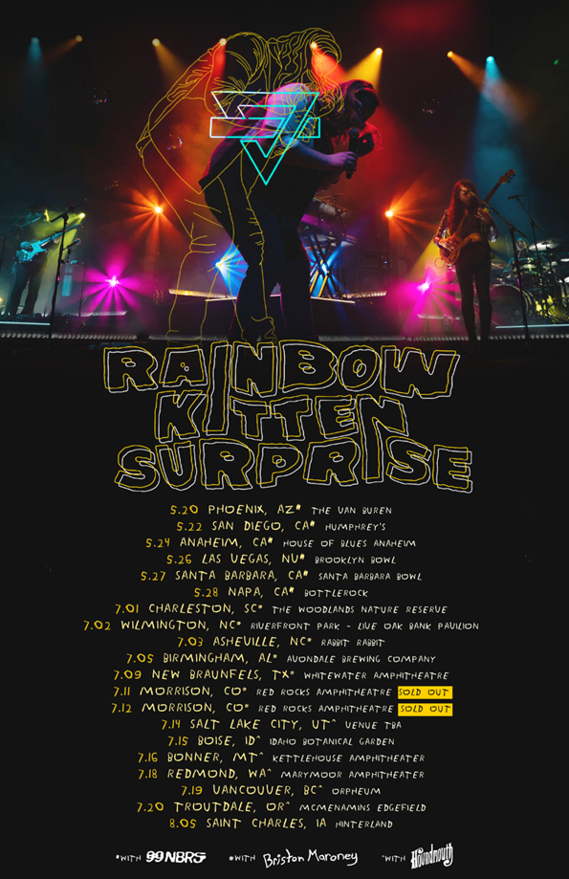

Genre-defying, Nashville-based quintet and live sensations Rainbow Kitten Surprise have unveiled additional dates for their upcoming highly anticipated North American headline tour. The newly announced shows kick off at The Van Buren in Phoenix on May 20th. Presale begins Tuesday, February 15th^{th,} at 10am (Pre-sale password: WORKOUT), with the general on-sale starting Friday, February 18th at 10am (all times local).

For the newly announced dates, fans can purchase VIP packages with exclusive perks including: early entry into the venue, RKS holographic fanny pack, limited poster and more. For more information on VIP packages, please visit https://bit.ly/rainbowkittensurprisevip.

For all upcoming headline shows, Rainbow Kitten Surprise has again teamed up with PLUS1, ensuring $1 of every ticket sold will go to local food banks working to fight hunger and food insecurity in their communities. The band – who has worked with PLUS1 since 2019 – is expected to direct over $25,000 towards these organizations on this upcoming run alone.

The shows join previously announced tour dates set for Spring + Summer 2022 – including two sold-out shows at The Caverns in Pelham, TN and performances at marquee festivals Shaky Knees (Atlanta) and Bottle Rock Festival (Napa). Also previously announced is a forthcoming two-night stand at Colorado’s iconic Red Rocks Amphitheater – set for July 11 + 12 – which sold-out in a matter of minutes when announced back in November. Full tour itinerary listed below.

This past December, the band made their triumphant return to the live stage after a nearly two-year hiatus – selling out 3 nights at Nashville’s Brooklyn Bowl (a run they dubbed Crimbo Limbo after the ambiguous time between Christmas and New Year’s). They then ended the year with a bang – selling out The Anthem in Washington DC.

At the same time as these live successes, two longtime fan-favorite tracks began to take off organically on TikTok. Both “It’s Called: Freefall” and “Cocaine Jesus” experienced massive upticks after user-created content on the platform went viral – resulting in over 11 million *weekly* streams for the band. The songs now boast 85 and 80 million streams, respectively.

Last year, the band released their first ever live album, RKS! LIVE FROM ATHENS GEORGIA, harnessing all the magic of a Rainbow Kitten Surprise show as they electrify sold-out audiences with signature anthems and fan favorites. Recorded live from a two-night stand at The Georgia Theatre in Athens, GA during the band’s sold-out 2019 Friend, Love Freefall Tour, the 25-song collection also arrived as a limited-edition 3-LP vinyl.

The 2019 North American tour came in support of the band’s Elektra Records debut How To: Friend, Love, Freefall, and spanned 50 sold-out shows highlighted by 6 venue upgrades, 3 second nights added, and over 80,000 tickets sold. To date, the album itself has gathered north of 230 million streams, while the lead single “Fever Pitch” has eclipsed 40 million streams, having vaulted into the Top 10 at Triple A Radio upon release.

###

RAINBOW KITTEN SURPRISE – UPCOMING LIVE DATES:
*NEWLY ANNOUNCED DATES IN BOLD*
^ Flipturn supporting
# 99 Neighbors supporting
+ Briston Maroney supporting
* The Brook & The Bluff supporting
> Houndmouth supporting

APRIL
Thur, April 7th – Township Auditorium - Columbia, SC *
Fri, April 8th – The Caverns - Pelham, TN * sold-out
Sat, April 9th – The Caverns - Pelham, TN * sold-out
Mon, April 11th - JJ's Live - Fayetteville, AR *
Tue, April 12th - Hoyt Sherman Place - Theatre - Des Moines, IA *
Thur, April 14th - The Admiral - Omaha, NE *
Fri, April 15th - Riverside Theater - Milwaukee, WI *
Sat, April 16th - PromoWest Pavilion at OVATION - Newport, KY *
Tue, April 19th - Roxian Theatre - McKees Rocks, PA * sold-out
Thur, April 21st - Harrisburg University at XL Live - Harrisburg, PA * sold-out
Fri, April 22nd – The Norva - Norfolk, VA *
Sun, April 24th - Ting Pavilion - Charlottesville, VA ^
Mon, April 25th - Knoxville Civic Auditorium - Knoxville, TN ^ sold-out
Tue, April 26th - Florida Theatre - Jacksonville, FL ^
Fri, Apr 29 – Shaky Knees Festival – Atlanta, GA

MAY
Fri, May 20th – The Van Buren – Phoenix, AZ #
Sun, May 22nd – Humphrey’s – San Diego, CA #
Tues, May 24th – House of Blues Anaheim – Anaheim, CA #
Thur, May 26th – Brooklyn Bowl – Las Vegas, NV #
Fri, May 27th – Santa Barbara Bowl – Santa Barbara, CA #
Sat, May 28th – Bottle Rock Festival – Napa, CA

JULY
Fri, July 1st - The Woodlands Nature Reserve - Charleston, SC +
Sat, July 2nd - Riverfront Park - Live Oak Bank Pavilion - Wilmington, NC +
Sun, July 3rd - Rabbit Rabbit - Asheville, NC +
Tue, July 5th - Avondale Brewing Company - Birmingham, AL +
Sat, July 9th - Whitewater Amphitheatre - New Braunfels, TX +
Mon, Jul 11 – Red Rocks Amphitheater – Morrison, CO + sold-out
Tue, Jul 12 – Red Rocks Amphitheater – Morrison, CO + sold-out
Thur, July 14th - VENUE TBA - Salt Lake City, UT >
Fri, July 15th - Idaho Botanical Garden - Boise, ID >
Sat, July 16th - KettleHouse Amphitheater - Bonner, MT >
Mon, July 18th - Marymoor Amphitheater - Redmond, WA >
Tue, July 19th – Orpheum - Vancouver, BC >
Wed, July 20th - McMenamins Edgefield - Troutdale, OR >

AUGUST
Fri, August 5th – Hinterland - Saint Charles, IA

For more ticket information and tour updates, please visit www.rksband.com/tour.

###

ABOUT RAINBOW KITTEN SURPRISE:
As if channeling another dimension where genres simply don’t exist, Rainbow Kitten Surprise find harmony in unpredictability, weaving together lyrical poetry, hummable melodies, and a rush of instrumental eccentricities. They quietly built an audience with Seven + Mary [2013] and RKS [2015] before serving up their 2018 full-length debut for Elektra, “HOW TO: FRIEND, LOVE, FREEFALL” – produced by Grammy Award-winner Jay Joyce (Cage The Elephant, Sleeper Agent). Igniting a two-year whirlwind, it brought the band’s total stream tally well past half-a-billion, while they garnered widespread praise from Billboard, TIME, Vice, and NPR who described their sound as “…a mix of jam and indie and whatever else you can throw into the soup…very earnest, beautiful, political, loving rock n’ roll.” Meanwhile, “Fever Pitch” marked their first Top 10 at AAA. Not to mention, they’ve performed on “CBS This Morning Saturday,” “The Late Show with Stephen Colbert,” PBS’s “Austin City Limits,” and graced the bills of Bonnaroo, Lollapalooza, and Osheaga, to name a few. Moving 80,000 tickets, they embarked on the sold-out Friend, Love Freefall Tour earmarked by a packed night at Red Rocks Amphitheatre and three consecutive gigs in Athens, GA—as chronicled on their first official live album, Live From Athens Georgia, out in 2021.

Rainbow Kitten Surprise is: Ela Melo (lead vocals), Darrick “Bozzy” Keller (guitar, vocals), Ethan Goodpaster (lead guitar, vocals), Charlie Holt (bass, vocals), Jess Haney (drums)

For more information, please visit:
RAINBOWKITTENSURPRISE.COM
FACEBOOK * TWITTER * INSTAGRAM * YOUTUBE * SPOTIFY

PRESS CONTACTS:
Glenn Fukushima | GlennFukushima@elektra.com
Libby Kober | Libby.Kober@atlanticrecords.com

