**RAINBOW KITTEN SURPRISE TEAMS UP WITH PLUS1 AS FOUNDING PARTNER OF LGBTQ+ EQUALITY FUND**

**LAUNCHES SPECIAL AUCTION OF WARDROBE ITEMS WORN DURING THEIR HIGH-ENERGY LIVE SHOWS**

**PROCEEDS TO BENEFIT APPALACHIAN OUTREACH & TENNESSEE EQUALITY**

**VIEW AUCTION** [**HERE**](https://www.ebay.com/usr/plus1org)

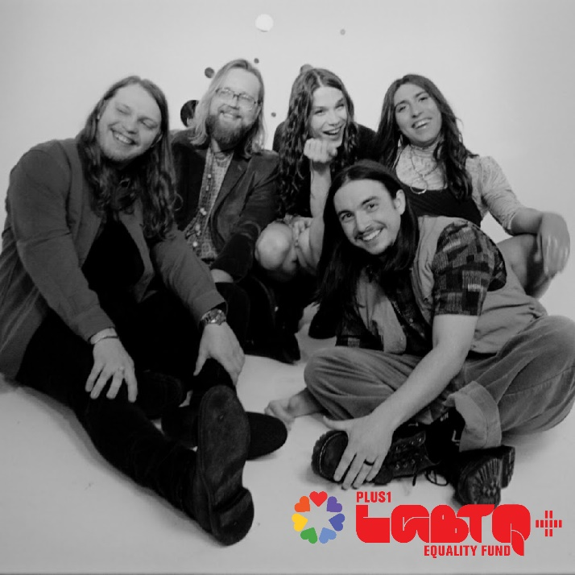

In recognition of pride, genre-defying Nashville quintet **Rainbow Kitten Surprise** has teamed up with [**PLUS1**](https://plus1.org/) as a founding partner of their [**LGBTQ+ Equality Fund**](https://plus1-lgbtq-equality-fund.raisely.com/rainbowkittensurprise). Officially launching today, the fund will support grassroots organizations [Appalachian Outreach](https://nam04.safelinks.protection.outlook.com/?url=https%3A%2F%2Fappalachianoutreach.org%2F&data=05%7C01%7CLibby.Kober%40atlanticrecords.com%7C957d0fbb0d904f6151a608da47d628be%7C8367939002ec4ba1ad3d69da3fdd637e%7C0%7C0%7C637901282440375721%7CUnknown%7CTWFpbGZsb3d8eyJWIjoiMC4wLjAwMDAiLCJQIjoiV2luMzIiLCJBTiI6Ik1haWwiLCJXVCI6Mn0%3D%7C3000%7C%7C%7C&sdata=gP7QpFX8aoFxy3ZnMZlgO3361TcwLjMP5t3ho%2FrkgzE%3D&reserved=0) and [Tennessee Equality](https://nam04.safelinks.protection.outlook.com/?url=https%3A%2F%2Fwww.tnep.org%2F&data=05%7C01%7CLibby.Kober%40atlanticrecords.com%7C957d0fbb0d904f6151a608da47d628be%7C8367939002ec4ba1ad3d69da3fdd637e%7C0%7C0%7C637901282440375721%7CUnknown%7CTWFpbGZsb3d8eyJWIjoiMC4wLjAwMDAiLCJQIjoiV2luMzIiLCJBTiI6Ik1haWwiLCJXVCI6Mn0%3D%7C3000%7C%7C%7C&sdata=dOvfRgoYB4AxP34LbTyVDR7S7jV%2BJH3LqU5yI23CTdU%3D&reserved=0), both of which help support LGBTQ+ youth in the South.

To kick off the fund, the band has launched **a special wardrobe auction**, putting up stage looks previously worn during their high-energy live shows. All proceeds will go towards the Equality Fund. Fans can learn more about the stories behind each auction item and bid on their favorites [HERE](https://www.ebay.com/usr/plus1org). The auction will run through June 15th with over 30 unique items to bid on.

The band has also launched an exclusive RKS Pride t-shirt, with all proceeds also going towards the newly formed fund. The item is available via the band’s merch store [here](https://rainbowkittensurprise.shop.redstarmerch.com/product/XZCTRK55).

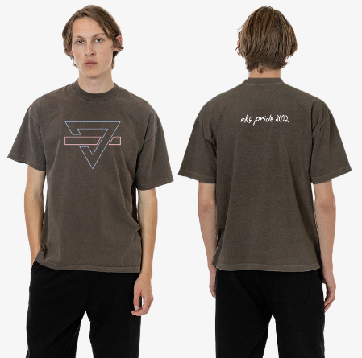

Today’s announcement continues a longstanding partnership with [**PLUS1**](https://plus1.org/) and Rainbow Kitten Surprise dating back to 2019 whereby $1 of every ticket sold on the band’s headline shows is directed towards charitable organizations. On their most recent run of tour dates, funds have been directed towards local food banks working to fight hunger and food insecurity in their communities. The band is expected to direct over $25,000 towards these organizations on this year’s touring alone.

***

**ABOUT RAINBOW KITTEN SURPRISE:**

As if channeling another dimension where genres simply don’t exist, **Rainbow Kitten Surprise** find harmony in unpredictability – weaving together lyrical poetry, hummable melodies, and a rush of instrumental eccentricities. Now boasting **over 1 billion global streams** across platforms, the band first began building their devoted fanbase with independent albums **“SEVEN + MARY”** (2013) and **“RKS”** (2015).  Arriving in 2018, the band’s **RIAA-certified Gold, full-length debut for Elektra, “HOW TO: FRIEND, LOVE, FREEFALL**” – produced by Grammy Award-winner **Jay Joyce** (Cage The Elephant, Sleeper Agent) – earned widespread praise from **Billboard**, **TIME**, **Vice**, and **NPR** who described their sound as *“…a mix of jam and indie and whatever else you can throw into the soup…very earnest, beautiful, political, loving rock n’ roll*,” and several national television appearances, including performances on “**CBS This Morning Saturday**,” “**The Late Show with Stephen Colbert**,” and **PBS**’s “**Austin City Limits**.” After gracing the bills of **Bonnaroo**, **Lollapalooza**, and **Osheaga**, to name a few, RKS moved 80,000 tickets of their own on their sold-out ***Friend, Love Freefall Tour*** earmarked by a packed night at Red Rocks Amphitheatre and three consecutive gigs in Athens, GA—as chronicled on their first official live album, “***LIVE FROM ATHENS GEORGIA,”*** released in 2021. Most recently, two longtime fan-favorite tracks began to take off organically on TikTok, with “**It’s Called: Freefall**” and “**Cocaine Jesus**” experiencing massive upticks after user-created content on the platform went viral – resulting in over **11 million *weekly* streams** for the band. The songs now boast **85** and **80 million streams**, respectively.

Rainbow Kitten Surprise is: **Ela Melo** (lead vocals), **Darrick “Bozzy” Keller** (guitar, vocals), **Ethan Goodpaster** (lead guitar, vocals), **Charlie Holt** (bass, vocals), **Jess Haney** (drums)