FOR IMMEDIATE RELEASE
JUNE 16, 2022

RAINBOW KITTEN SURPRISE UNVEIL OFFICIAL MUSIC VIDEO FOR “WORK OUT”
WATCH HERE

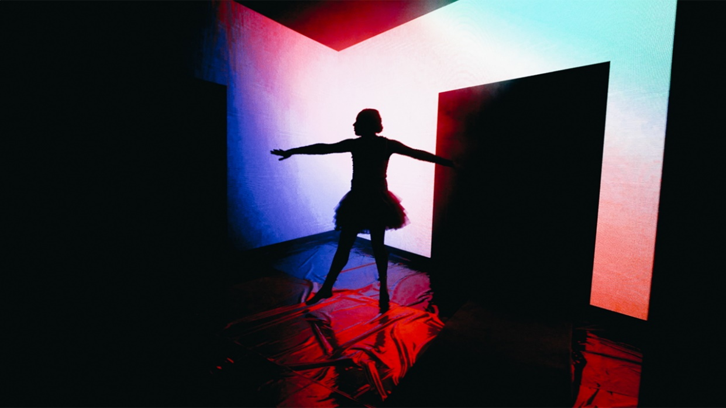

CAPTIVATING VISUAL SERVES AS A COMPANION PIECE TO THE BAND’S RECENTLY RELEASED, EMOTIONALLY CHARGED NEW SINGLE

SUMMER 2022 TOUR ON TRACK TO COMPLETELY SELL OUT,
INCLUDING 2-NIGHT STAND AT THE ICONIC RED ROCKS AMPHITHEATER

NORTH AMERICAN + EUROPEAN TOUR DATES FOR FALL/WINTER
ON SALE NOW

DOWNLOAD ASSETS HERE

Genre-defying, Nashville-based quintet and live sensations Rainbow Kitten Surprise have unveiled the official music video for their emotionally charged track “Work Out”- WATCH HERE. The stunning visual - directed by Joey Brodnax – is the companion piece to the band’s first new music in nearly two years. Released in April, the song’s beautiful melody-line and effervescent vibe stands as a stark juxtaposition to its poignant lyrics about the difficult relationships – of all sorts – that people struggle with.

Rainbow Kitten Surprise is currently in the midst of their North American headline tour with nearly all of the remaining summer dates sold out, including a triumphant, two-night return to Red Rocks Amphitheater in Morrison, CO, which sold-out in a matter of minutes of being announced. The band’s Fall/Winter tour – which includes a second North American leg as well as a European run – is set to kick off on September 2nd in Toronto, ON, and is on sale now. Full tour itinerary listed below.

For all upcoming headline shows, Rainbow Kitten Surprise has again teamed up with PLUS1, ensuring $1 of every ticket sold will go to local food banks working to fight hunger and food insecurity in their communities. As of April, the band had already donated $25,000 to the organization and is on track to donate $75,000 on this upcoming summer run alone.

The band – who has worked with PLUS1 since 2019 – is also a founding partner of their LGBTQ+ Equality Fund. The fund will support grassroots organizations including Appalachian Outreach and Tennessee Equality, both of which help support LGBTQ+ youth in the South. To kick off the fund, the band launched a special wardrobe auction of their on-stage outfits previously worn on tour. The auction closes today at 3pm ET, with all proceeds going to the Equality Fund.

ABOUT RAINBOW KITTEN SURPRISE:
As if channeling another dimension where genres simply don’t exist, Rainbow Kitten Surprise find harmony in unpredictability – weaving together lyrical poetry, hummable melodies, and a rush of instrumental eccentricities. Now boasting over 1 billion global streams across platforms, the band first began building their devoted fanbase with independent albums “SEVEN + MARY” (2013) and “RKS” (2015). Arriving in 2018, the band’s breakout full-length debut for Elektra, “HOW TO: FRIEND, LOVE, FREEFALL.” Produced by Grammy Award-winner Jay Joyce (Cage The Elephant, Sleeper Agent), the album featured RIAA-certified Gold single “It’s Called: Freefall”, earned widespread praise from Billboard, TIME, Vice, and NPR who described their sound as “…a mix of jam and indie and whatever else you can throw into the soup…very earnest, beautiful, political, loving rock n’ roll,” and saw the band make several national television appearances, including performances on “CBS This Morning Saturday,” “The Late Show with Stephen Colbert,” and PBS’s “Austin City Limits.” After gracing the bills of Bonnaroo, Lollapalooza, and Osheaga, to name a few, RKS moved 80,000 tickets of their own on their sold-out Friend, Love Freefall Tour earmarked by a packed night at Red Rocks Amphitheatre and three consecutive gigs in Athens, GA—as chronicled on their first official live album, “LIVE FROM ATHENS GEORGIA,” released in 2021. Most recently, two longtime fan-favorite tracks began to take off organically on TikTok, with “It’s Called: Freefall” and “Cocaine Jesus” experiencing massive upticks after user-created content on the platform went viral – resulting in over 11 million *weekly* streams for the band. The songs now boast 108 and 94 million streams, respectively.

Rainbow Kitten Surprise is: Ela Melo (she/her; lead vocals), Darrick “Bozzy” Keller (he/him; guitar, vocals), Ethan Goodpaster (he/him; lead guitar, vocals), Charlie Holt (they/them; bass, vocals), Jess Haney (he/him; drums)

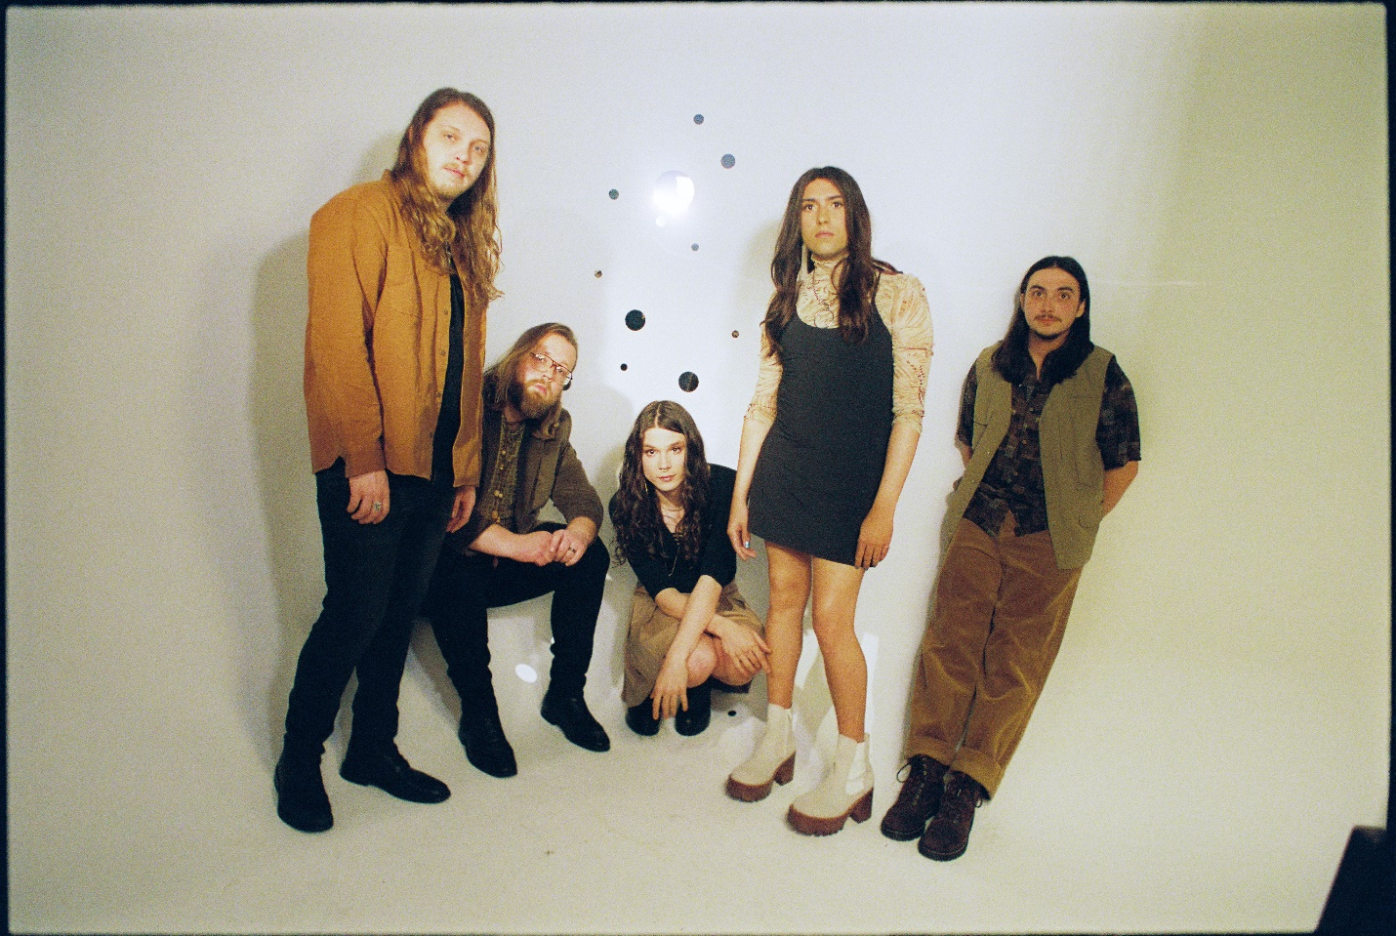
photo credit: Aubrey Denis; download HERE

RAINBOW KITTEN SURPRISE – UPCOMING LIVE DATES:
+ Briston Maroney supporting
> Houndmouth supporting
= Twen supporting
*Support TBA

JUNE
Sat, June 25th – Electric Forest – Rothbury, MI

JULY
Fri, July 1st - The Woodlands Nature Reserve - Charleston, SC +
Sat, July 2nd - Riverfront Park - Live Oak Bank Pavilion - Wilmington, NC + sold-out
Sun, July 3rd - Rabbit Rabbit - Asheville, NC + sold-out
Tue, July 5th - Avondale Brewing Company - Birmingham, AL + sold-out
Tue, July 6th - Avondale Brewing Company - Birmingham, AL + sold-out
Fri, July 8th – Tulsa Theater – Tulsa, OK sold-out
Sat, July 9th - Whitewater Amphitheatre - New Braunfels, TX + sold-out
Mon, Jul 11 – Red Rocks Amphitheater – Morrison, CO + sold-out
Tue, Jul 12th – Red Rocks Amphitheater – Morrison, CO + sold-out
Thur, July 14th - The Gallivan Center - Salt Lake City, UT > sold-out
Fri, July 15th - Idaho Botanical Garden - Boise, ID > sold-out
Sat, July 16th - KettleHouse Amphitheater - Bonner, MT > sold-out
Mon, July 18th - Marymoor Amphitheater - Redmond, WA > sold-out
Tue, July 19th – Orpheum - Vancouver, BC > sold-out
Wed, July 20th - McMenamins Edgefield - Troutdale, OR > sold-out

AUGUST
Fri, August 5th – Hinterland - Saint Charles, IA sold-out

SEPTEMBER
Fri, September 2nd - RBC Echo Beach - Toronto, ON =
Sat, September 3rd - ArtPark Mainstage Theatre - Lewiston, NY =
Sun, September 4th - Jacobs Pavillion at Nautica - Cleveland, OH =
Tue, September 6th - GLC Live at 20 Monroe - Grand Rapids, MI =
Thur, September 8th - KEMBA Live! Outdoor Amphitheater - Columbus, OH =
Fri, September 9th - The Masonic Temple Theatre - Detroit, MI =
Sat, September 10th - TCU Amphitheater at White River State Park - Indianapolis, IN =
Mon, September 12th - Landmark Theatre - Syracuse, NY =
Tue, September 13th - College Street Music Hall - New Haven, CT =
Thur, September 15th – MTELUS - Montreal, QC =
Sat, September 17th - Thompson's Point - Portland, ME =
Sun, September 18th – Roadrunner - Boston, MA = sold-out
Mon, September 19th – Roadrunner - Boston, MA =
Wed, September 21st - Palace Theatre - Albany, NY =
Thur, September 22nd - Central Park - New York, NY =
Sun, September 25th - Firefly Music Festival - Dover, DE

OCTOBER
Sun, October 9th - Ohana Encore - Dana Point, CA
Tue, October 25th – Orpheum - New Orleans, LA =
Wed, October 26th - Saenger Theatre Mobile - Mobile, AL =
Fri, October 28th - Spirit of the Suwannee Music Park And Campground - Live Oak, FL

NOVEMBER
Sat, November 5th– Hydrogazadka - Warsaw, Poland *
Sun, November 6th - Lido Club - Berlin, Germany *
Tue, November 8th – Strom - Munich, Germany *
Wed, November 9th – Luxor - Cologne, Germany *
Thur, November 10th - Mojo Club - Hamburg, Germany *
Sat, November 12th - Melkweg Oude Zaal - Amsterdam, Netherlands * sold-out
Mon, November 14th – Maroquinerie - Paris, France *
Wed, November 16th -Electric Ballroom* - London, United Kingdom sold-out
Thur, November 17th - O2 Institute2 - Birmingham, United Kingdom * sold-out
Fri, November 18th – O2 Ritz Manchester - Manchester, United Kingdom * sold-out
Sun, November 20th - Opium - Dublin, Ireland *upgraded venue + sold-out

DECEMBER
Sat, December 3rd – Aragon - Chicago, IL =
Sun, December 4th – Sylvee - Madison, WI =
Tue, December 6th – Armory - Minneapolis, MN =
Thur, December 7th - The Factory - Chesterfield, MO =
Fri, December 8th - Orpheum Theater - Memphis, TN =
Sat, December 10th - Municipal Auditorium - Nashville, TN =
Mon, December 12th -Criterion - Oklahoma City, OK =
Tue, December 13th -The Midland Theatre - Kansas City, MO =

For more ticket information and tour updates, please visit www.rksband.com/tour.

###

For more information, please visit:
RAINBOWKITTENSURPRISE.COM
FACEBOOK * TWITTER * INSTAGRAM * YOUTUBE * SPOTIFY

PRESS CONTACTS:
Glenn Fukushima | GlennFukushima@elektra.com
Libby Kober | Libby.Kober@atlanticrecords.com

