FOR IMMEDIATE RELEASE
APRIL 6, 2022

GENRE-DEFYING LIVE SENSATION RAINBOW KITTEN SURPRISE RETURN WITH FIRST NEW MUSIC IN NEARLY TWO YEARS

EMOTIONALLY CHARGED TRACK “WORK OUT” IS AVAILABLE NOW
LISTEN HERE
WATCH OFFICIAL LYRIC VIDEO HERE

HIGHLY ANTICIPATED NORTH AMERICAN TOUR KICKS OFF TOMORROW WITH NEARLY ALL DATES SOLD OUT – INCLUDING 2-NIGHT STAND AT THE ICONIC RED ROCKS AMPHITHEATER

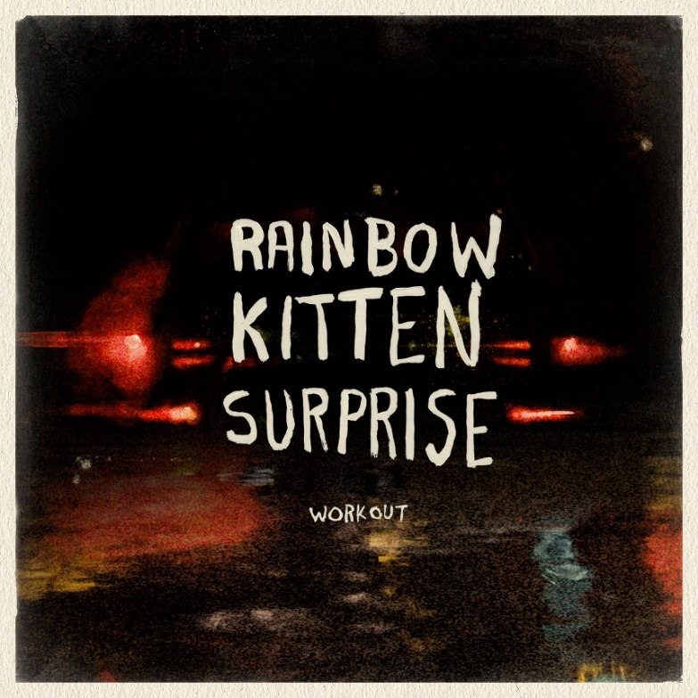
DOWNLOAD ASSETS HERE

Genre-defying, Nashville-based quintet and live sensations Rainbow Kitten Surprise have released the emotionally charged track “Work Out,” available everywhere now. Marking the band’s first new music in nearly two years, the song’s beautiful melody-line and effervescent vibe is a stark juxtaposition to its poignant lyrics about the difficult relationships – of all sorts – that people struggle with. “Work Out” is accompanied by a lyric video – handwritten by RKS frontperson Ela Melo – available to watch HERE.

“Work Out” arrives on the fourth anniversary of their breakout Elektra Records debut full length, “HOW TO: FRIEND, LOVE, FREEFALL,” featuring the RIAA-certified Gold hit “Its Called: Freefall.” Catapulting the band from an underground favorite shared by word of mouth to a national touring juggernaut, moving over 80,000 tickets, including selling out their first headline show at the iconic Red Rocks Amphitheater in a matter of minutes, the release also saw the band make multiple national television appearances highlighted by a debut performance on “The Late Late Show with Stephen Colbert.” A companion music video for “Work Out” is in post-production now.

Tomorrow, Rainbow Kitten Surprise kicks off their highly anticipated North American headline tour. Beginning at the Township Auditorium in Columbia, SC, on April 7th, most dates for the cross-country trek are already sold out, including back-to-back nights at The Caverns in Pelham, TN and a triumphant, two-night return to Red Rocks Amphitheater in Morrison, CO, which sold-out in a matter of minutes of being announced. Always a festival favorite, Rainbow Kitten Surprise top the lineups at Shaky Knees Festival in Atlanta, GA and Bottle Rock Festival in Napa, CA. Full tour itinerary listed below.

For all upcoming headline shows, Rainbow Kitten Surprise has again teamed up with PLUS1, ensuring $1 of every ticket sold will go to local food banks working to fight hunger and food insecurity in their communities. The band – who has worked with PLUS1 since 2019 – is expected to direct over $25,000 towards these organizations on this upcoming run alone.

ABOUT RAINBOW KITTEN SURPRISE:
As if channeling another dimension where genres simply don’t exist, Rainbow Kitten Surprise find harmony in unpredictability – weaving together lyrical poetry, hummable melodies, and a rush of instrumental eccentricities. Now boasting over 1 billion global streams across platforms, the band first began building their devoted fanbase with independent albums “SEVEN + MARY” (2013) and “RKS” (2015). Arriving in 2018, the band’s breakout full-length debut for Elektra, “HOW TO: FRIEND, LOVE, FREEFALL.” Produced by Grammy Award-winner Jay Joyce (Cage The Elephant, Sleeper Agent), the album featured RIAA-certified Gold single “It’s Called: Freefall”, earned widespread praise from Billboard, TIME, Vice, and NPR who described their sound as “…a mix of jam and indie and whatever else you can throw into the soup…very earnest, beautiful, political, loving rock n’ roll,” and saw the band make several national television appearances, including performances on “CBS This Morning Saturday,” “The Late Show with Stephen Colbert,” and PBS’s “Austin City Limits.” After gracing the bills of Bonnaroo, Lollapalooza, and Osheaga, to name a few, RKS moved 80,000 tickets of their own on their sold-out Friend, Love Freefall Tour earmarked by a packed night at Red Rocks Amphitheatre and three consecutive gigs in Athens, GA—as chronicled on their first official live album, “LIVE FROM ATHENS GEORGIA,” released in 2021. Most recently, two longtime fan-favorite tracks began to take off organically on TikTok, with “It’s Called: Freefall” and “Cocaine Jesus” experiencing massive upticks after user-created content on the platform went viral – resulting in over 11 million *weekly* streams for the band. The songs now boast 85 and 80 million streams, respectively.

Rainbow Kitten Surprise is: Ela Melo (lead vocals), Darrick “Bozzy” Keller (guitar, vocals), Ethan Goodpaster (lead guitar, vocals), Charlie Holt (bass, vocals), Jess Haney (drums)

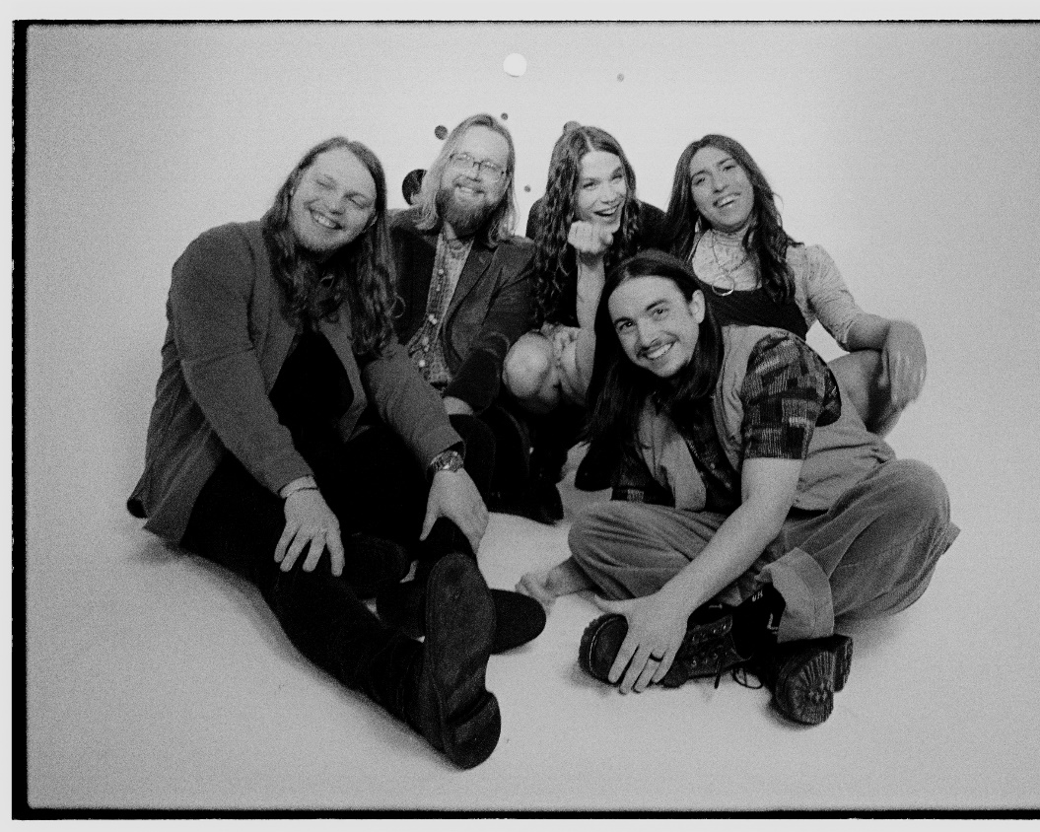
photo credit: Aubrey Denis; download HERE

RAINBOW KITTEN SURPRISE – UPCOMING LIVE DATES:
^ Flipturn supporting
# 99 Neighbors supporting
+ Briston Maroney supporting
* The Brook & The Bluff supporting
> Houndmouth supporting

APRIL
Thur, April 7th – Township Auditorium - Columbia, SC * sold-out
Fri, April 8th – The Caverns - Pelham, TN * sold-out
Sat, April 9th – The Caverns - Pelham, TN * sold-out
Mon, April 11th - JJ's Live - Fayetteville, AR * sold-out
Tue, April 12th - Hoyt Sherman Place - Theatre - Des Moines, IA * low tix
Thur, April 14th - The Admiral - Omaha, NE * sold-out
Fri, April 15th - Riverside Theater - Milwaukee, WI * sold-out
Sat, April 16th - PromoWest Pavilion at OVATION - Newport, KY *
Tue, April 19th - Roxian Theatre - McKees Rocks, PA * sold-out
Thur, April 21st - Harrisburg University at XL Live - Harrisburg, PA * sold-out
Fri, April 22nd – The Norva - Norfolk, VA * low tix
Sun, April 24th - Ting Pavilion - Charlottesville, VA ^ sold-out
Mon, April 25th - Knoxville Civic Auditorium - Knoxville, TN ^ sold-out
Tue, April 26th - Florida Theatre - Jacksonville, FL ^ low tix
Fri, Apr 29 – Shaky Knees Festival – Atlanta, GA

MAY
Fri, May 20th – The Van Buren – Phoenix, AZ #
Sun, May 22nd – Humphrey’s – San Diego, CA # sold-out
Sun, May 23rd – Humphrey’s – San Diego, CA # sold-out
Tues, May 24th – House of Blues Anaheim – Anaheim, CA # sold-out
Thur, May 26th – Brooklyn Bowl – Las Vegas, NV #
Fri, May 27th – Santa Barbara Bowl – Santa Barbara, CA #
Sat, May 28th – Bottle Rock Festival – Napa, CA

JULY
Fri, July 1st - The Woodlands Nature Reserve - Charleston, SC +
Sat, July 2nd - Riverfront Park - Live Oak Bank Pavilion - Wilmington, NC +
Sun, July 3rd - Rabbit Rabbit - Asheville, NC + sold-out
Tue, July 5th - Avondale Brewing Company - Birmingham, AL + sold-out
Tue, July 6th - Avondale Brewing Company - Birmingham, AL +
Fri, July 8th – Tulsa Theater – Tulsa, OK
Sat, July 9th - Whitewater Amphitheatre - New Braunfels, TX +
Mon, Jul 11 – Red Rocks Amphitheater – Morrison, CO + sold-out
Tue, Jul 12 – Red Rocks Amphitheater – Morrison, CO + sold-out
Thur, July 14th - VENUE TBA - Salt Lake City, UT > sold-out
Fri, July 15th - Idaho Botanical Garden - Boise, ID > sold-out
Sat, July 16th - KettleHouse Amphitheater - Bonner, MT > sold-out
Mon, July 18th - Marymoor Amphitheater - Redmond, WA >
Tue, July 19th – Orpheum - Vancouver, BC > sold-out
Wed, July 20th - McMenamins Edgefield - Troutdale, OR >

AUGUST
Fri, August 5th – Hinterland - Saint Charles, IA

For more ticket information and tour updates, please visit www.rksband.com/tour.

###

For more information, please visit:
RAINBOWKITTENSURPRISE.COM
FACEBOOK * TWITTER * INSTAGRAM * YOUTUBE * SPOTIFY

PRESS CONTACTS:
Glenn Fukushima | GlennFukushima@elektra.com
Libby Kober | Libby.Kober@atlanticrecords.com

