RACHEL CHINOURIRI RELEASES INTROSPECTIVE NEW SINGLE “ALL I EVER ASKED”

STREAM HERE | WATCH THE MUSIC VIDEO HERE
BREAKOUT ARTIST SIGNS TO ELEKTRA RECORDS

CHINOURIRI’S BALLAD “SO MY DARLING (ACOUSTIC)” QUICKLY BECOMES A VIRAL FAN FAVORITE, LAYING THE FOUNDATION FOR A LANDMARK 2022

CREDIT: Martina Martian
HI-RES AVAILABLE HERE

“...sounds beautiful and unbelievable” – NYLON
“...for all the exquisite sadness in her songwriting, Chinouriri is using darkness to help encourage listeners towards the light.” – NME
“Chinouriri plays with delicate vocal acrobatics akin to the likes of FKA twigs and SZA”
– The Line of Best Fit

“The way she sings of emotions, surrounded by shivers of synths and protected by percussion, it’s as if she’s trying to maintain the structures of dried flowers—as they wither with time, her delivery is undoubtedly more precious and precise.” – FLOOD
(March 11, 2022) – LOS ANGELES, CA – After a successful start to the year, breakout artist Rachel Chinouriri arrives with her latest single, “All I Ever Asked.” The new offering from the London by-way-of Zimbabwe alternative-indie-pop singer is a melodic, introspective song about not settling in a relationship. It was co-written by Chinouriri, Glenn Roberts, and Jamie Lloyd Taylor, and produced by Oli Bayston and Daniel Hylton-Nuamah. Earlier this week, “All I Ever Asked” was also named Clara Amfo’s Hottest Record on BBC Radio 1 in the U.K. Captured in Los Angeles, the Jake Erland-directed companion music video features Rachel traveling through lush and dreamy cityscapes. The track is available on all streaming platforms, with the official video available to view HERE.

“‘All I Ever Asked’ was inspired by a breakup my friend was going through, and it made me reflect on a similar situation I was going through too; the feeling of asking someone you love to respect you in the simplest form and realizing it’s the bare minimum. It’s also about realizing your own worth and not settling for someone who cannot be what you need,” Chinouriri explained about the new song.

Furthermore, Chinouriri has signed a worldwide deal with Atlas Artists / Parlophone, which includes Elektra Records in the United States – laying the foundation for a landmark year to come.

“All I Ever Asked” arrives on the heels of an incredible period of growth for Chinouriri. It follows her stunning ballad “So My Darling (Acoustic),” which has quickly become a viral fan-favorite, racking up 1M+ global streams per week since its release in January. The highly-anticipated song also inspired nearly 40k TikTok creations to the short snippet Chinouriri shared ahead of release. The spike in creations prompted the community of Black female creators across the U.S. to use the track as a soundtrack to their daily content.

Last fall, Chinouriri also unveiled her eight-track EP Four° In Winter, which elegantly showcased her graceful ability to melt genres together and evoke raw emotion through her lyrics. The EP featured singles “Darker Place”, “Give Me A Reason” and “Plain Jane” which showcased Chinouriri’s creative prowess with the accompanying video. In advance of the EP release, Chinouriri also sold out four headline shows at the iconic U.K. venue, St. Pancras Old Church.

Chinouriri is currently working on new original music - stay tuned for more coming soon.

RACHEL CHINOURIRI
“ALL I EVER ASKED”
AVAILABLE NOW
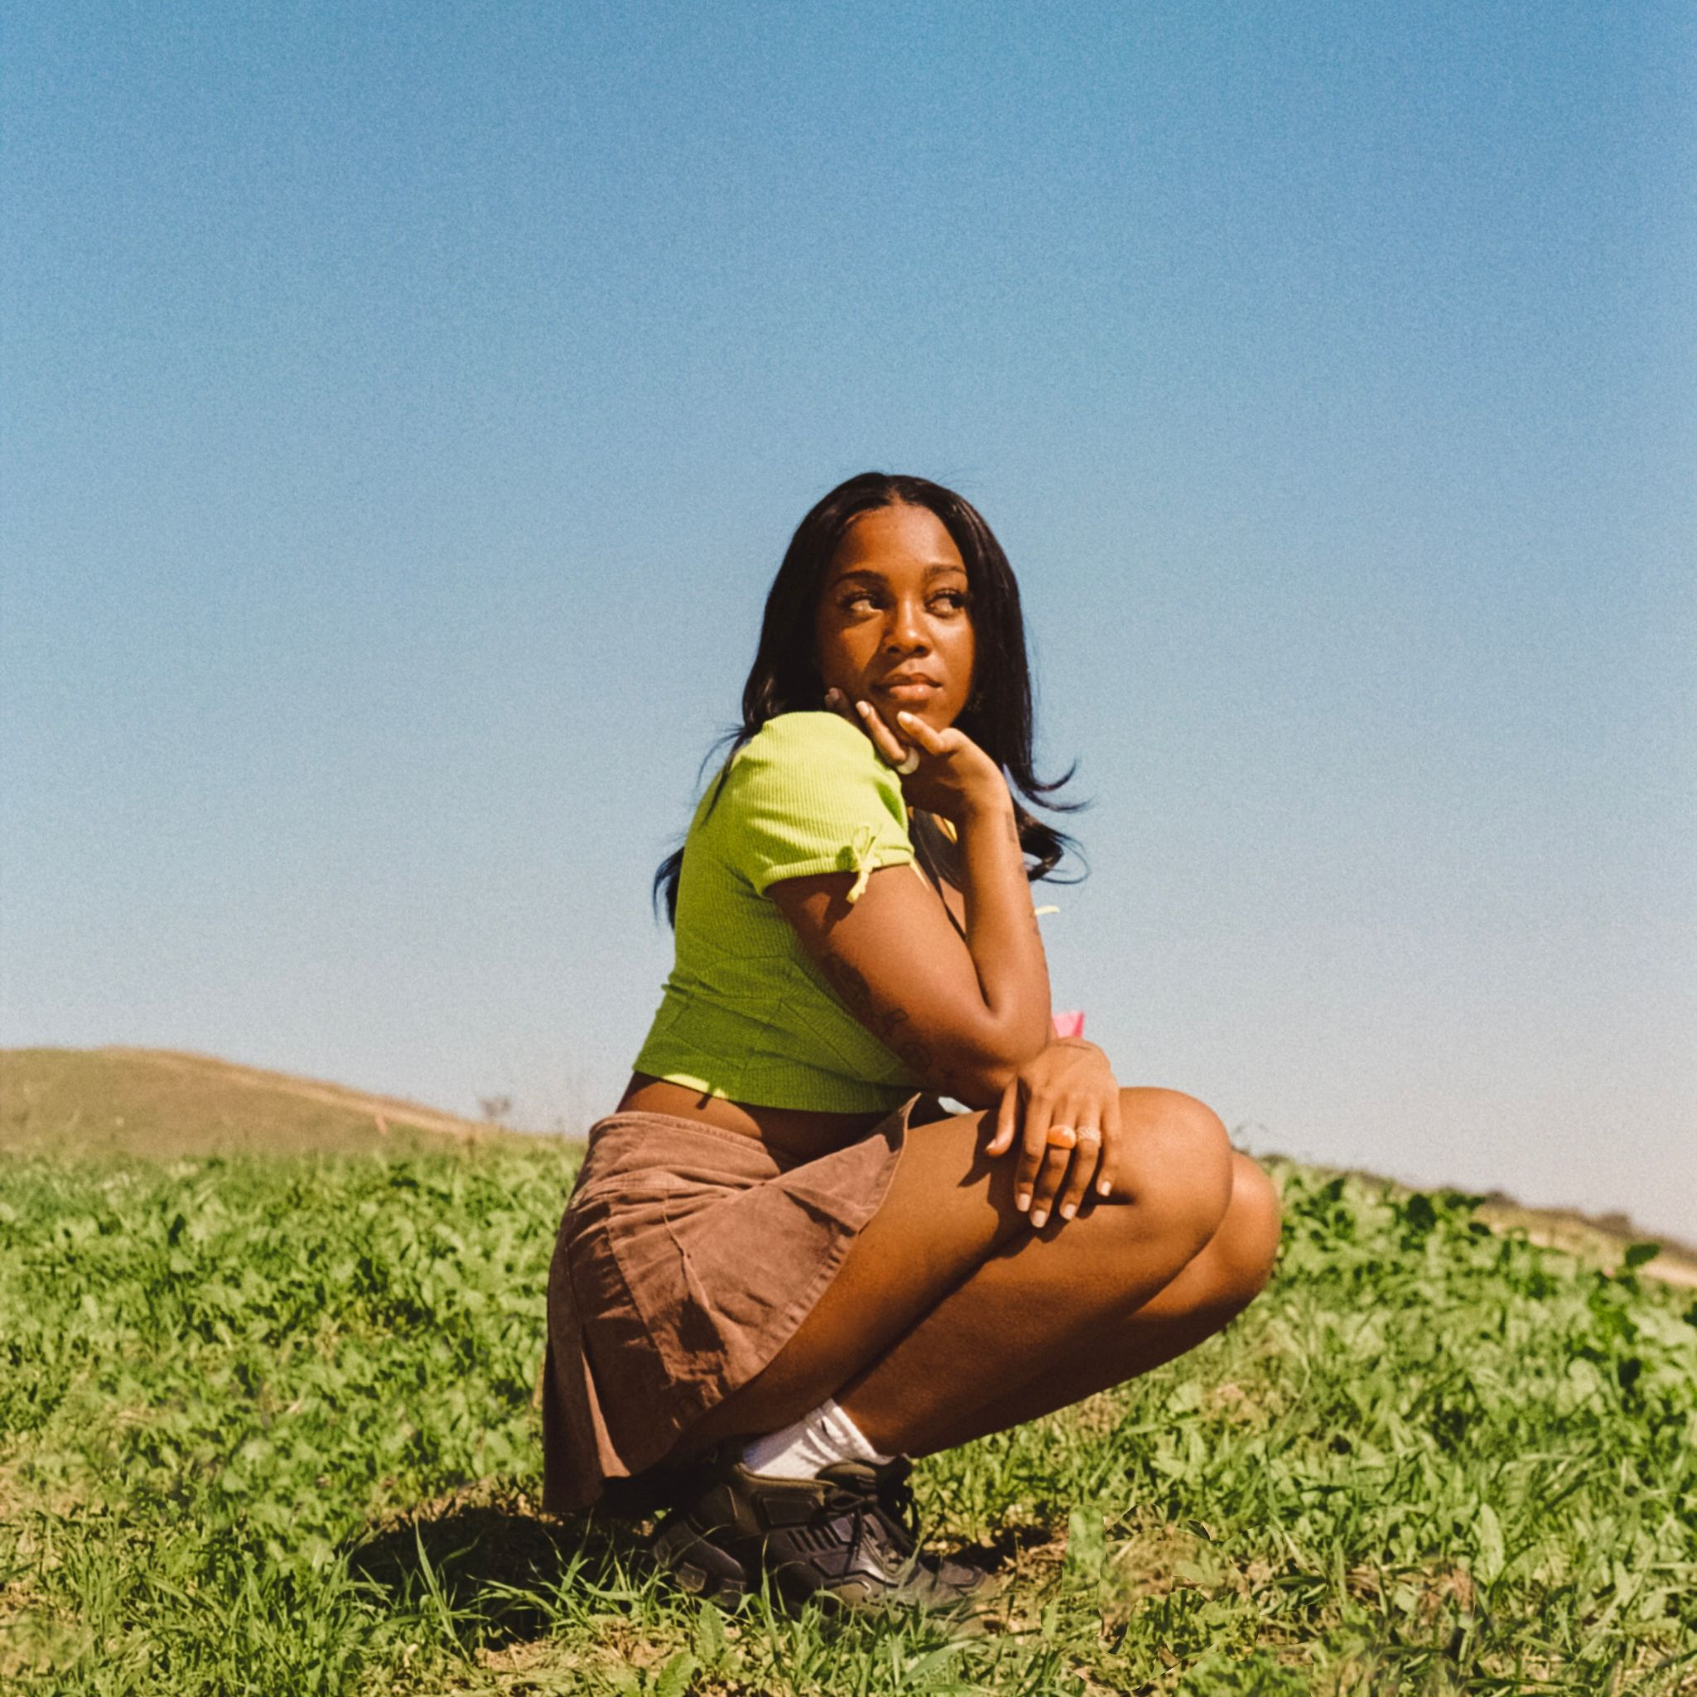
CREDIT: Martina Martian
HI-RES ARTWORK AVAILABLE HERE

FOLLOW RACHEL CHINOURIRI:
Instagram | Facebook | Twitter | TikTok | YouTube

# # #

MEDIA CONTACTS:
Nathalie Rubin & Sarah Goldstein
NathalieRubin@elektra.com | SarahGoldstein@elektra.com

