RIVAL SONS
ANNOUNCE PRESSURE AND TIME NORTH AMERICAN TOUR

FALL HEADLINE RUN TO CELEBRATE 10 YEAR ANNIVERSARY OF LANDMARK ALBUM

SPECIAL GUESTS DOROTHY & REIGNWOLF TO SUPPORT ON SELECT DATES

PRE-SALES BEGIN JULY 21ST AT 10:00AM LOCAL TIME
GENERAL ON SALE BEGINS JULY 23RD AT 10:00AM LOCAL TIME

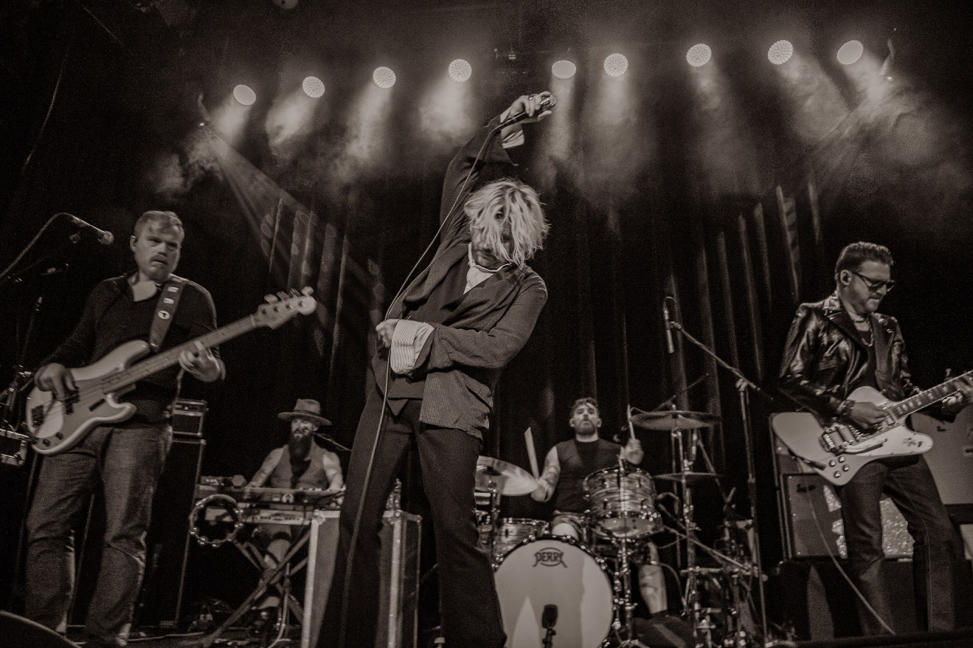
PHOTO CREDIT: RICK HORN

JULY 20, 2021 – 2x GRAMMY-nominated group Rival Sons will return to the road in North America on the Pressure and Time Tour this fall. The six-week headline run will see the band celebrating the 10th anniversary of their 2011 album, Pressure and Time, by performing the landmark long player live in its entirety. The tour kicks off on September 29th at Culture Room in Fort Lauderdale, FL, and includes stops at legendary venues such as the Ryman Auditorium in Nashville, the Riviera Theater in Chicago, The Warfield in San Francisco, The Wiltern in Los Angeles, and comes to a close on November 13th at House of Blues in Anaheim, CA [full itinerary below]. Most dates of the tour will feature support from Dorothy, with select dates supported by either Reignwolf or Myron Elkins. The official ticket pre-sale launches Wednesday July 21st at 10:00AM local time, while partner presales begin Thursday July 22nd at 10:00AM local time. General on-sale goes live Friday July 23rd at 10:00AM local time.

For the first time, Rival Sons will perform their critically acclaimed and cult favorite second full-length album, Pressure & Time, from top to bottom. Upon its arrival in 2011, Pressure and Time garnered the band worldwide recognition and has since amassed over 40 million-plus streams and garnered widespread praise with the BBC affirming it is “simply stuffed with rollicking tunes.”

Last month, Rival Sons lit up Southern California with a two-night livestream event, Rival Sons – “PAIR OF ACES” - Live from the historic Catalina Casino on Santa Catalina Island. They performed their debut LP, Before the Fire [2009], in its entirety on the first night and their self-titled EP, Rival Sons [2010], on the second.

Earlier this year, Rival Sons launched their very own label, Sacred Tongue Recordings, with distribution through Thirty Tigers. The band recently regained the master rights to several of their early releases and will reintroduce them to the world by first remastering their independent full-length debut LP, Before the Fire [2009], and self-titled EP Rival Sons [2010], on all DSPS, CD, and Vinyl - for the first time. Limited-edition vinyl variants are available for pre-order at www.sacredtonguerecordings.com. They’ve printed up an exclusive run of 1000 copies of both Before the Fire and Rival Sons. Before the Fire will come in an orange splatter variant, while the EP is available in a clear with gold splatter variant. There will also be indie retailer exclusive color-ways of each release in translucent orange and crystal clear, respectively. A repressing of Pressure and Time has not been announced but is expected in the coming months.

By looking back, Rival Sons also leap forward again as they continue working on more music and the follow-up to 2019’s FERAL ROOTS. FERAL ROOTS not only garnered a 2020 GRAMMY Award nomination in the category of “Best Rock Album,” but also yielded a GRAMMY nomination for “Best Rock Performance” for the top 10 rock track, “Too Bad,” and features the #1 rock radio single, “Do Your Worst.” Produced by multi GRAMMY Award-winner Dave Cobb at Nashville’s famed RCA Studio A, and the equally legendary Muscle Shoals Sound Studio in Muscle Shoals, AL, Rival Sons’ FERAL ROOTS is available now on all streaming platforms.

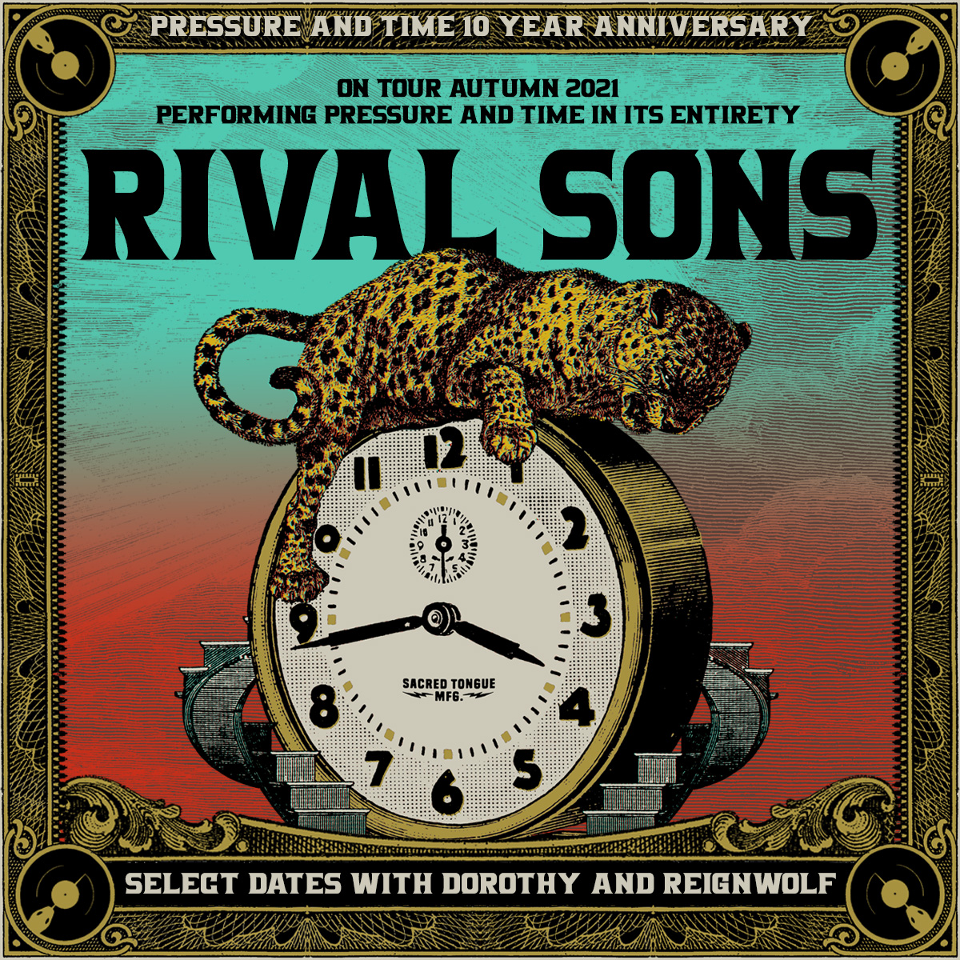
TOUR DATES:
Wed 09/29 - Ft. Lauderdale, FL - Culture Room+
Thu 09/30 - Orlando, FL - The Plaza Live+
Fri 10/1 - Panama City, FL - Sand Jam (Festival)
Sun 10/3 - Nashville, TN - Ryman Auditorium*
Tue 10/5 - Kansas City, MO - The Truman*
Fri 10/8 - Houston, TX - House of Blues*
Sat 10/9 - Dallas, TX - House of Blues*
Tue 10/12 - New Orleans, LA - House of Blues*
Wed 10/13 - Atlanta, GA - Buckhead Theatre*
Thu 10/14 - Charlotte, NC - The Underground*
Sat 10/16 -Detroit, MI - The Fillmore*
Sun 10/17 - Cleveland, OH - House of Blues*
Mon 10/18 - New York, NY - Webster Hall*
Wed 10/20 - Pittsburgh, PA - Mr. Smalls Theatre*
Fri 10/22 - Washington, DC - 9:30 Club*
Sat 10/23 - Philadelphia, PA - The Fillmore*
Sun 10/24 - Boston, MA - House of Blues*
Tue 10/26 - Toronto, ON - HISTORY*
Thu 10/28 - Chicago, IL - Riviera Theater*
Fri 10/29 - Minneapolis, MN - The Fillmore*
Sun 10/31 - Denver, CO - Ogden Theatre*
Mon 11/1 - Salt Lake City, UT - The Depot*
Thu 11/4 Boise, ID - Revolution Concert House* (w/ Halestorm)
Fri 11/5 - Spokane, WA - Knitting Factory*
Sun 11/7 - Vancouver, BC - The Orpheum*
Mon 11/8 - Seattle, WA - The Showbox*
Tue 11/9 - Portland, OR - Crystal Ballroom*
Thu 11/11 - San Francisco, CA - The Warfield^
Fri 11/12 - Los Angeles, CA - The Wiltern^
Sat 11/13 - Anaheim, CA - House of Blues^

support:
+Myron Elkins
*Dorothy
^Reignwolf

About Rival Sons:
Since their emergence in 2009, Rival Sons have quietly reignited and recharged rock ‘n’ roll with towering vocals, uncompromising riffs, and thunderous grooves. Following the independent release of their full-length debut Before The Fire, they were handpicked to perform alongside everyone from AC/DC to Black Sabbath. Working with longtime producer Dave Cobb, the band delivered a series of critically acclaimed albums—Pressure & Time [2011], Head Down [2012], Great Western Valkyrie [2014], and Hollow Bones [2016]—as they headlined sold out shows on multiple continents. 2019’s FERAL ROOTS broke new ground for the band. “Do Your Worst” shot to #1 on Rock Radio as their first chart-topper at the format. It also scored 40 million-plus streams and counting. They delivered an electrifying performance on The Late Late Show with James Corden and earned acclaim from Billboard, Rolling Stone, and many more. FERAL ROOTS also gathered a 2020 GRAMMY Award nomination for “Best Rock Album,” while the single “Too Bad” notched a nomination for “Best Rock Performance.” 2021 saw Rival Sons present their own label Sacred Tongue Recordings distributed by Thirty Tigers. Through and through, they embody everything a modern rock band should be and so much more.

# # #
CONNECT WITH RIVAL SONS
OFFICIAL SITE
FACEBOOK
TWITTER
INSTAGRAM
SPOTIFY
APPLE MUSIC

