FOR IMMEDIATE RELEASE
MARCH 25, 2021
SAD NIGHT DYNAMITE SHARES VIDEO FOR "KRUNK"

SELF-TITLED DEBUT MIXTAPE OUT NOW VIA ELEKTRA

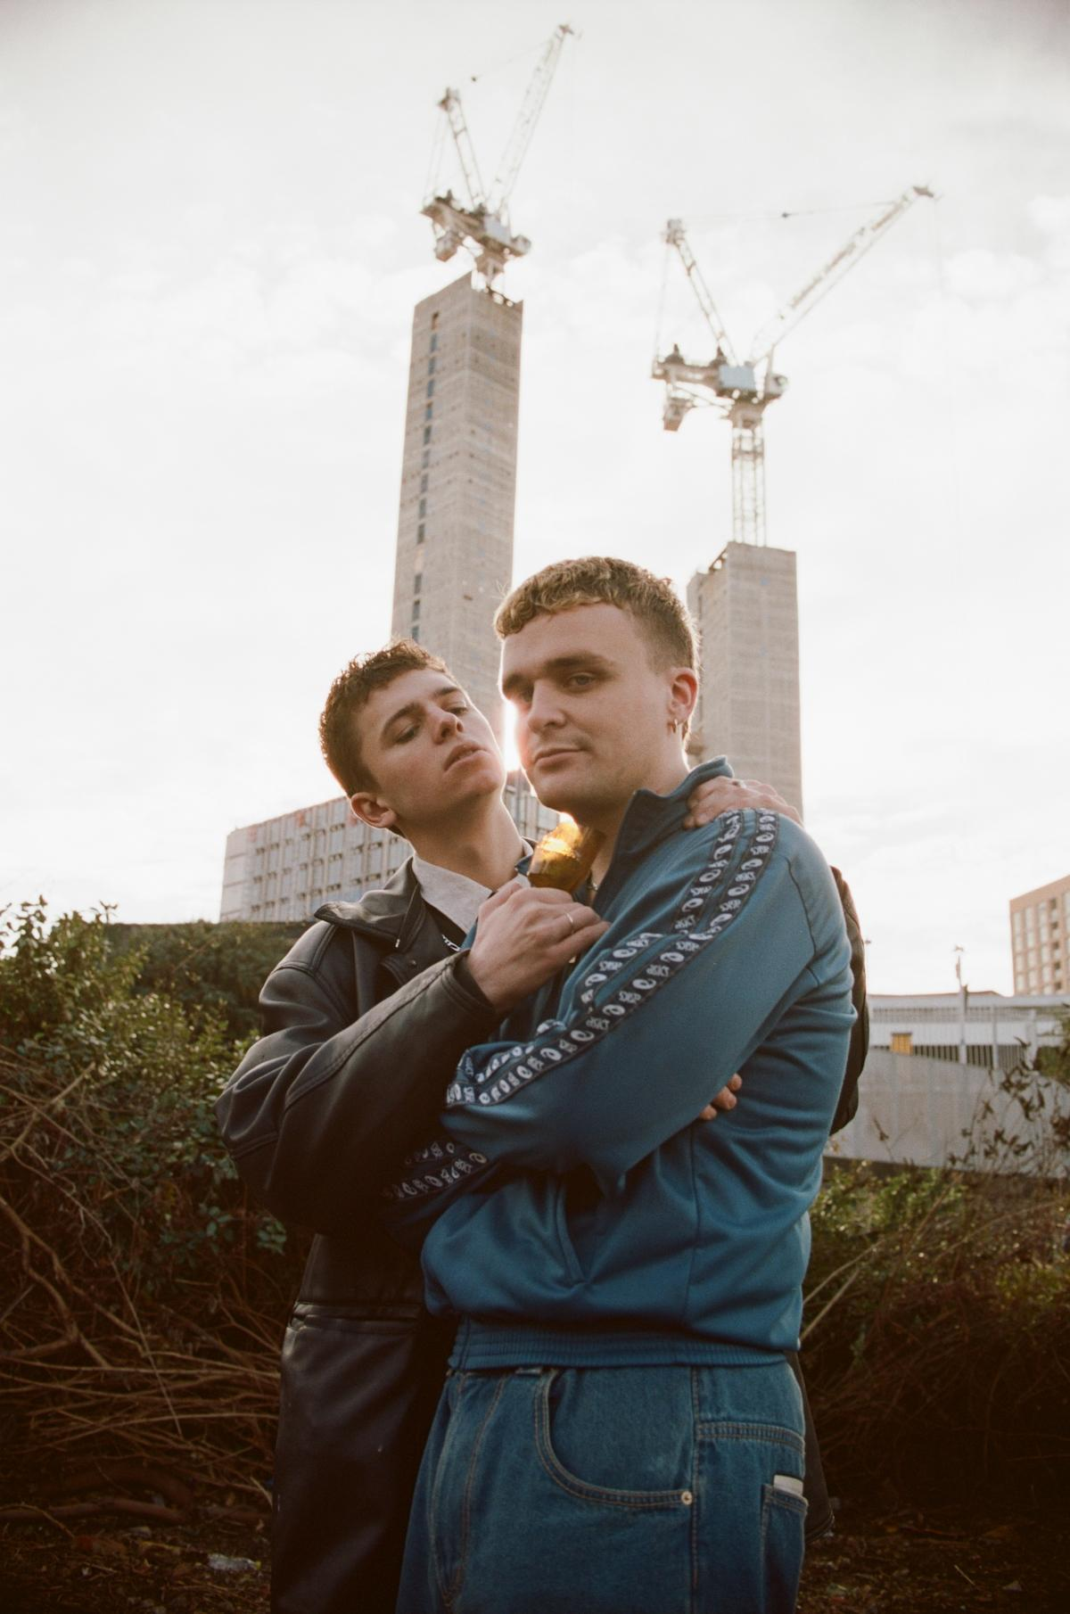

Sad Night Dynamite by Sirus F

"Krunk"
WATCH: https://youtu.be/EEd1tVAJFiU
LISTEN: https://sadnightdynamite.lnk.to/KrunkVideo

Sad Night Dynamite
LISTEN: ﻿https://sadnightdynamite.lnk.to/mixtape

What the press is saying about Sad Night Dynamite:

"unmistakably their own"
Billboard

"clear knack for injecting modern hip-hop with an evidently British sensibility"
CLASH

"Visceral and captivating"
COLORS

"Points to a career that should be long, fruitful and full of game-changing experimentation"
Complex

"A knack for experimentation and a unique set of skills"
Hypebeast

"a joy to behold"
The Line Of Best Fit

"A shadowy world to get lost in"
NME

Today, hotly-tipped duo Sad Night Dynamite are dropping the brilliant video for their latest single "Krunk." Taken from their self-titled debut mixtape, available now via Elektra, the band have picked up widespread acclaim plus support across Radio 1, Apple Music, 6Music, NTS and more for their idiosyncratic sound & visuals. Watch out for news of Sad Night Dynamite's first ever live shows coming soon.

Directed by Greg Hackett, "Krunk" is the kind of sinister and surreal storytelling that already feels like Sad Night Dynamite's own. A cinematic revenge-fantasy (and parody of the male ego), the track's effortless, Dr. Dre inspired beat is set against the recurring motif of Archie and Josh's latest (and strangest) journey in their white limo. "That visual is the centrepiece of the mixtape, and it represents us in a weird way," the boys said in conversation recently with NME. "You can hate it if you want, but once you get inside you can't help but love it."

"Krunk" is a key moment on Sad Night Dynamite's hugely-promising first mixtape, also available now. Equal parts light and shade, dystopia and fantasy, it's a project as much about the pleasures of getting lost as it is the at-times nightmarish world you dream of getting lost from. Epic first single "Icy Violence" - loosely set on a beach, but also based on a kidnapping - established the band's at times malevolent storytelling (its followup, "Killshot," was paired with a visual evoking the all-too-real reality of a surveillance state). Lead single "Smoke Hole" – and its stop-motion, hellish fairground of visual – was in itself about "getting lost in your own thoughts.” What emerges on Sad Night Dynamite is a band of boundless musical imagination: one as at ease with influences like The Avalanches or classic, Tarantino-esque cinema scores as they are the loaded atmosphere of London subculture. It also begins to introduce the two massive characters at the heart of it, Archie and Josh - a duo whose formative upbringing in Glastonbury saw them start the band whilst separated at university, and now make Sad Night Dynamite one of the UK's most exciting new bands.

Already, Sad Night Dynamite stand out in all the right ways for a breakthrough 2021. The band were spotted on socials in the studio late last year with FKA Twigs, as well as earning early shout outs from the likes of Gorillaz, Shy Girl, Ashnikko, Jeshi and Billy Walsh plus being named part of Reprezent Radio's Class of 2021. Continuing today with the visuals for "Krunk," Sad Night Dynamite are a band set to deliver a sound as explosive and evocative as their name implies - just when we need it the most.

About Elektra Music Group:
Elektra Music Group was launched in 2018 as a stand-alone music company within Warner Music Group. Its roots extend back to 1950, when Jac Holzman launched the iconic Elektra label in his college dorm room. Today, that same entrepreneurial, independent spirit is the driving force behind each of the unique labels that make up the core of the Elektra Music Group: Elektra, Fueled By Ramen, and Roadrunner. The company's adventurous, eclectic roster includes culture-defining artists such as Brandi Carlile, Coheed and Cambria, Fitz and the Tantrums, Gojira, The Highwomen, KALEO, Korn, Panic! At The Disco, Paramore, Slipknot, Tones And I, Twenty One Pilots, and others.

