FOR IMMEDIATE RELASE
OCTOBER 29, 2020

SAD NIGHT DYNAMITE SHARES NEW SONG AND VIDEO

WATCH "MOUNTAIN JACK" NOW

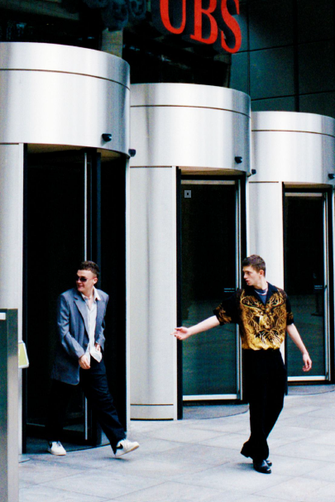
Sad Night Dynamite by Sirus F

"Mountain Jack"

WATCH: https://youtu.be/QbmcPiu_jZI

LISTEN: https://sadnightdynamite.lnk.to/MountainJack

What the press is saying about Sad Night Dynamite:

"Points to a career that should be long, fruitful and full of game-changing
experimentation"
Complex

"a knack for experimentation and a unique set of skills"
Hypebeast

"A creeping sense of foreboding and unease...it's difficult to pigeonhole their sound, but
that's what makes them so exciting"
District

Today, UK duo Sad Night Dynamite have dropped third track "Mountain Jack" - which
is available now via Elektra Records. This follows support across Radio 1, Apple Music
and NTS for the band's enigmatic first releases "Icy Violence" and " Killshot," with
"Mountain Jack" also teasing Sad Night Dynamite's first mixtape (due early next year)...
Equal parts light and shade, dystopia and fantasy, "Mountain Jack" is another
immersive window into Sad Night Dynamite and arrives with a visual directed by Will
Hooper (Dua Lipa, IDLES). Blending elements of G-Funk, Punk and genre-defying
modern pop, like much of Sad Night Dynamite's early material, it's as much about the
pleasures of getting lost as it is the at-times nightmarish world you dream of getting lost
from. “Mountain Jack was written at the top of a really, really high mountain," say the
boys. "I think the song is about being stretched in lots of different directions. Although
your body might be in a studio, your head is somewhere else. In this case up a
mountain.”

Barely in their twenties, Sad Night Dynamite draw together a complex mix of sounds
and storytelling. On their upcoming mixtape, you're as likely to hear a lifelong love of
hip-hop meld with classic British bands like The Specials as you are a pair just as
enamoured by fellow-crate-diggers like The Avalanches as they are the classic cinema
scores of Tarantino. All of this comes back to the charged, brother-like friendship of
Archie and Josh at the centre of it all: a duo whose formative (and slightly feral)
upbringing near Glastonbury eventually saw them start out Sad Night Dynamite online,
separated at university. Epic first single "Icy Violence" - loosely set on a beach, but also
based on a kidnapping - introduced their musical dream-world, which teeters on the
brink of nightmarishness. Its followup, "Killshot," married the atmospherics of UK rap
with a visual evoking the all-too-real reality of a surveillance state. What started out as a
surreal exercise in escapism has, for Sad Night Dynamite, become all the more
important as they work towards their first project. "We love artists who build something
bigger than themselves: songs to explore and be lived in."

Stay tuned for more from Sad Night Dynamite coming soon - a band set to keep
delivering a sound as explosive and evocative as their name implies, just when we
need it the most.

About Elektra Music Group:
Elektra Music Group was launched in 2018 as a stand-alone music company within
Warner Music Group. Its roots extend back to 1950, when Jac Holzman launched the
iconic Elektra label in his college dorm room. Today, that same entrepreneurial,
independent spirit is the driving force behind each of the unique labels that make up the
core of the Elektra Music Group: Elektra, Fueled By Ramen, and Roadrunner. The
company's adventurous, eclectic roster includes culture-defining artists such as Brandi
Carlile, Coheed and Cambria, Fitz and the Tantrums, Gojira, Kaleo, Korn, Panic! At The
Disco, Paramore, Slipknot, Sturgill Simpson, Tones and I, Twenty One Pilots, and
others.

