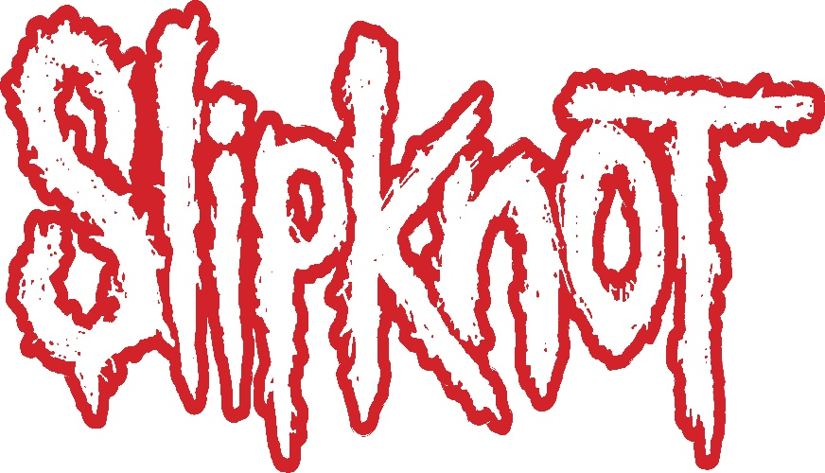

“It’s the uniqueness of the world that I live in that im so proud of,” says drummer and founding member Shawn “Clown” Crahan, aka #6. “And Slipknot is not just one gentleman’s imagination, it’s nine guys, dreaming together.”

“In Slipknot,” says vocalist and founding member Corey Taylor (#8), “everything is possible.”

Twenty years ago, nine guys from Des Moines, Iowa, shattered the scope of what was possible in metal. Slipknot’s music put blastbeats, massive breakdowns and brutal riffs alongside breakbeats and turntablism; punctuated hooky melodies with extreme vocals and percussive rap verses. On stage, bodies clad in numbered jumpsuits and horror film masks crashed into each other, eliciting mania from hungry crowds and drawing blood and breaking bones in the process. The world-building was pure imagination, but the stakes were real. Like the rotating titanium drum kit Clown famously Frankensteined together and put fifteen feet up on hydraulics, everything Slipknot did was maximalist and monstrous, completely unhinged and meticulously thought out. From the moment Slipknot appeared on an early afternoon stage at Ozzfest ‘99, it was clear they were like nothing people had ever seen and everything they never knew they needed. But where a similarly high-octane act might have burned out, in the years to come Slipknot has only proved an enduring commitment to hard work, constant evolution, their craft and their fans.

The all-in approach was necessary. Slipknot couldn’t afford to hold back when faced with an enemy they recognized as formidable: a creeping darkness that accompanies addiction and abuse, a seething rage and despair taking over those with few outlets to express it. It’s a darkness that Slipknot simultaneously embodied and destroyed, a darkness that has never quite left the American landscape but in 2019 seems to have become more powerful than ever. Fittingly, so has Slipknot.

Whatever the thing holding you back is—a dead-end job, family pressure, stifling gender expectations, a close-minded environment, or just plain not fitting in, Slipknot exists to blow it up. As a result, their fans (lovingly dubbed “maggots”) comprise a vast, fiercely loyal congregation. The Maggot is the kid on the bus with their hoodie up and their headphones in, the guy working the night shift at the gas station, AJ Soprano visiting his sister in college after being left alone with his toxic father, Princess Nokia getting pummeled by dodgeballs in gym class or owning her outsider power on A Girl Cried Red.

With We Are Not Your Kind, Slipknot’s first new album in five years, the band deliver when they are needed most. In an increasingly claustrophobic psychic landscape, We Are Not Your Kind brings back the violence, to meet the darkness blow for blow.

“Lyrically I’m drawing from a very personal place that I kind of kept to myself for a long time,” says Taylor. “Sharing this has let me move on from the hell I was in, and I’m hoping it will help people like myself. “We Are Not Your Kind” [has] really been the unspoken mantra of this band for several years. ‘We’ would mean anyone who has been judged, oppressed or beaten down for being who they are in this world. ‘Your’ just goes without saying, in this day and age.”

Slipknot’s creative strength and modern vision propelled We Are Not Your Kind to a #1 debut on the Billboard 200 this past August. The massive global audience surrounding the band drove the album to the top of the charts in the United Kingdom, Spain, Australia, Canada, Japan, Portugal, Ireland, Belgium, and Finland, with Top 3 debuts in Germany, France, Norway, Italy, Austria, Switzerland, The Netherlands, and New Zealand.

“With their latest studio album, Slipknot have released one of the strongest albums in their career,” remarked Consequence of Sound, with The Independent declaring, “The sheer ambition of We Are Not Your kind is just as staggering as their seminal record Iowa – the dynamic might be even better.” The Ringer professed, “Slipknot’s sixth album We Are Not Your Kind… furthers the argument that they’re the most important heavy band of their era,” while Kerrang! attested, “20 years since their debut, Slipknot are as bold, fearless and exhilarating as ever.” Vulture praised the LP for its “maelstrom of serrated riffs, warlike drums, and machine-gun poetry from Taylor,” and The UK’s NME put it simply: “The 'Knot's sixth album is an astonishing record.”

Slipknot’s career has surpassed countless career milestones. Globally, they boast 13 Platinum and 44 Gold albums, three of which peaked at #1 on Billboard (All Hope is Gone, .5 the Gray Chapter and We Are Not Your Kind), as well as several multi-platinum album and DVD releases. They have been nominated for ten Grammys and won one in 2006, in Best Metal Performance for “Before I Forget.” On top of that, they have amassed more than a dozen Kerrang! nominations and won seven Kerrang! Awards, in categories such as “Best International Band,” “Best Live Band,” and, simply, “Icon.”

Beyond formal acclaim, Slipknot’s success can be measured in sold out stadium shows, world tours, and dedicated fans who have shown their devotion by bringing the band members dead birds in jars or human femur bones to sign, fans who come up to the merch table show after show to tell the band they saved their lives.

In 2019, Slipknot consists of a separate DJ and sampler (Sid Wilson (#0) and Craig “133” Jones (#5), two percussionists (Shawn “Clown” Crahan (#6) and Jay Weinberg), along with two guitarists (Jim Root (#4), and Mick Thomson (#7), vocalist Corey Taylor (#8), and bassist Alessandro Venturella. The lineup has changed over time but when Slipknot formed in 1995 as a Des Moines supergroup, pulling in members from various bands in the scene to create the heaviest band in town, the vision was the same.

Their work ethic has been unparalleled from the get-go. When they got a Thursday night residency at a reggae bar they put up thousands of flyers, earning respect from the bar owner and threats of fines from the city. When they got a second stage slot on Ozzfest, they attacked it with a singular visceral intensity day after day. Behind the drum kegs, chopsaws, pyrotechnics, and stitches, there was a deep sense of invention and catharsis. It’s no surprise that Slipknot’s debut self-titled album, recorded to tape with Ross Robinson at the infamous Indigo Ranch (Korn, Soulfly, Machine Head) and released on Roadrunner, went platinum within three months of release—despite a lack of press, radio, or MTV support—on the strength of the reputation they built through relentless touring and hits like “Wait and Bleed,” “Eyeless,” and “Spit it Out.”

2001’s Iowa, Slipknot’s sophomore release, is still heralded as one of the greatest metal albums of all time, and certainly one of the most brutal. As nu-metal was jumping the shark, Slipknot went heavier and darker. Iowa unleashed an unyielding, destructive, death metal black mass through which no light would penetrate, immortalized in lines like “I want to slit your throat and fuck the wound” (“Disasterpiece”), “If you’re 555 / I’m 666” (“Heretic Anthem”), or simply “People=Shit.” Again panned across major distribution channels, this time by a post-9/11 radio landscape, it would nevertheless go to #3 on the Billboard charts and get across-the-board critical and fan acclaim.

Although Iowa was an artistic triumph, it marked a low point for many members of the band, who were struggling with drugs, self-harm, suicidal ideation, and family turmoil. Their next three albums would show both musical and personal growth. 2004’s Vol. 3 The Subliminal Verse expanded their vision and proved just what masterful musicians Slipknot really were. In many ways it was a departure—the band swapped Ross Robinson for Rick Rubin and explored more progressive, melodic, textured territory. The record included ghostly gothic love songs “Vermillion” and “Vermillion Pt.2” and ballads “Prelude” and “Circle,” which touched on Taylor’s fraught relationship with his father, but that doesn’t mean they pulled any punches. Subliminal Verses is also home to the aggressively militaristic “The Blister Exists,” the breakout hit “Duality,” and the industrial, open-hearted “Pulse of the Maggots”—a vow of devotion to the fans, who have always mattered to Slipknot above everything else.

2008’s All Hope is Gone and 2014’s .5: The Gray Chapter marked an ongoing progression: facing adversity through the music, experimenting, surviving sustainably for the long game, and evolving to take their places alongside career metal stalwarts such as Metallica and Iron Maiden. Founding member Paul Gray’s tragic death in 2010 dealt a huge blow to the band and cast all in doubt for a time. Ultimately, Paul was mourned, and then celebrated with the release of .5: The Gray Chapter. Through those years the band’s potency only increased, yielding some of their biggest songs (“Psychosocial,” “The Devil In I,” “Snuff,” and others).

“We as a band try as much as possible to be on the other side of whatever fence reality is trying to put up around us,” says Crahan. “’The way things are’ is not working. We roll the dice, try it another way, and see what the reward is for our expectations. I do believe we have created that space, out of Slipknot’s very own dream, or nightmare.”

