SLIPKNOT ANNOUNCE THE
KNOTFEST ROADSHOW 2022

Leg 1
Headlined by Slipknot
With Special Guests In This Moment and Jinjer
March 16th, 2022 - April 17, 2022

Leg 2
Headlined by Slipknot
With Special Guests Cypress Hill and Ho99o9
May 18th, 2022 - June 18th, 2022

Tickets And VIP Packages Go On General Sale At
10am Local on Friday, January 21st, 2022
KnotfestRoadshow.com

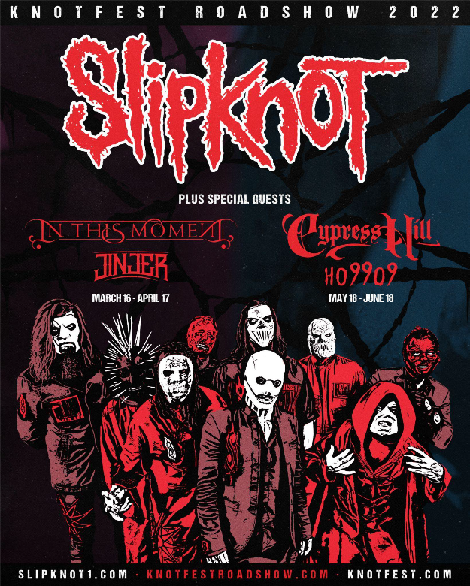

Tuesday, January 18, 2022 - Slipknot, one of the most thrilling and visceral musical collectives on the planet, are excited to announce the 2022 iteration of their infamous Knotfest Roadshow tour. The tour will take place over two legs, both headlined by Slipknot. The first leg will feature special guests In This Moment and Jinjer. The second leg will feature special guests Cypress Hill and Ho99o9. Tickets for all shows go on sale at 10am local time on Friday, January 21st from KnotfestRoadshow.com

The first leg of the 38 date tour, produced by Live Nation, kicks off in Fargo, ND on Wednesday, March 16th, 2022 and hits a further 17 cities before wrapping up in Vancouver, BC on Sunday, April 17, 2022. The second leg kicks off on Wednesday, May 18th, 2022 in University Park, PA and hits a further 17 cites before culminating on Sunday, June 18, 2022 in Chula Vista, CA. Full routing below.

Speaking on the new tour announcement, Slipknot’s clown shares “It feels so good to get back out on the road with our Culture. Get ready for a brand new experience. See you soon.”

Frontman, Corey Taylor adds: “Even with everything going on in the world right now, we’re still extremely excited to come back out in the states, with 2 different, exciting packages. Whether it’s In This Moment and Jinjer, or Cypress and Ho99o9, we pride ourselves in bringing our fans the epicenter of our music and art. Come celebrate with us and try to stay as safe as we will be.”

2021 marked a banner year for Slipknot. Making a triumphant return to the road, their Knotfest Roadshow 2021 tour sold out amphitheaters across the country, bookended with the record-breaking Knotfest Iowa and the biggest headline show of their career, Knotfest Los Angeles at Banc of California Stadium where they debut their first new music in two years - the furious ‘The Chapeltown Rag’ taken from the highly anticipated new Slipknot album, expected to release this year. In addition, they topped the bills of multiple, internationally renowned festivals including Riot Fest, Rocklahoma, Inkcarceration, Welcome To Rockville, and more.

Tickets for all Knotfest Roadshow dates go on sale at 10am local on Friday, January 21st, 2022 from
KnotfestRoadshow.com.

The tour will be part of Live Nation’s Live Stubs initiative which provides digital collectible NFT ticket stubs to ticket holders. Live Stubs will automatically be included with tickets purchased for the tour. Fans will also be able to view,share, gift, trade, and resell their live stubs on Livenation.com

Knotfest Roadshow 2022

LEG 1
Slipknot w/ In This Moment & Jinjer

Wed Mar 16 Fargo, ND FARGODOME
Fri Mar 18 Omaha, NE CHI Health Center
Sat Mar 19 Wichita, KS INTRUST Bank Arena
Tue Mar 22 Memphis, TN FedExForum
Wed Mar 23 Tulsa, OK BOK Center
Fri Mar 25 North Little Rock, AR Simmons Bank Arena
Sat Mar 26 Durant, OK Choctaw Grand Theater
Tue Mar 29 Birmingham, AL Legacy Arena at the BJCC
Wed Mar 30 N. Charleston, SC North Charleston Coliseum
Fri Apr 01 Greensboro, NC Greensboro Coliseum Complex
Sat Apr 02 Reading, PA Santander Arena
Mon Apr 04 Cleveland, OH Rocket Mortgage FieldHouse
Wed Apr 06 Green Bay, WI Resch Center
Thu Apr 07 Peoria, IL Peoria Civic Center
Sat Apr 09 Minneapolis, MN Target Center
Mon Apr 11 Winnipeg, MB Canada Life Centre
Tue Apr 12 Regina, SK Brandt Centre
Thu Apr 14 Saskatoon, SK SaskTel Centre
Fri Apr 15 Edmonton, AB Rogers Place
Sun Apr 17 Vancouver, BC Pepsi Live at Rogers Arena

LEG 2
Slipknot w/ Cypress Hill and Ho99o9

Wed May 18 University Park, PA Bryce Jordan Center
Fri May 20 Brooklyn, NY Barclays Center
Sat May 21 Providence, RI Dunkin' Donuts Center
Sun May 22 Manchester, NH SNHU Arena
Tue May 24 Albany, NY MVP Arena
Thu May 26 Montreal, QC Bell Centre
Sat May 28 Québec, QC Videotron Centre
Sun May 29 Ottawa, ON Canadian Tire Centre
Mon May 30 Toronto, ON Budweiser Stage
Wed Jun 01 Cincinnati, OH Heritage Bank Center
Thu Jun 02 Grand Rapids, MI Van Andel Arena
Sat Jun 04 East Troy, WI Alpine Valley Music Theatre
Sun Jun 05 Moline, IL TaxSlayer Center
Tue Jun 07 Bonner Springs, KS Azura Amphitheater
Thu Jun 09 Colorado Springs, CO The Broadmoor World Arena
Sat Jun 11 Nampa, ID Ford Idaho Center
Mon Jun 13 Seattle, WA Climate Pledge Arena
Tue Jun 14 Ridgefield, WA RV Inn Style Resorts Amphitheater
Fri Jun 17 Las Vegas, NV MGM Garden Arena
Sat Jun 18 Chula Vista, CA North Island Credit Union Amphitheatre

About Slipknot: Slipknot sit alongside musical institutions like Metallica and Iron Maiden, as one of a select few bands whose legacy is secured within heavy music's elite. The band emerged at the end of the 20th Century from the American mid-western town of Des Moines, IA and quickly established themselves as the most enigmatic, provocative and aggressive music collective of the modern era. 1999’s eponymous debut is widely viewed as a modern day classic and was honoured by Metal Hammer magazine as the ‘Best Debut of the Last 25 Years.’ The release racked up double RIAA platinum certification in the US, with many of Slipknot’s subsequent releases achieving platinum status both in the US and around the globe. To date, the band have been nominated for 10 Grammy Awards (winning in 2006 for ‘Before I Forget’), as well as scoring 12 Platinum and 41 Gold album certifications around the world and over 3.2 billion YouTube views and counting. Slipknot’s fanbase is as unwavering as it is ubiquitous - the band’s most recent studio album, 2019’s ‘We Are Not Your Kind’ debuted at #1 in the Official Album Charts of 12 countries around the world, including the US, UK, Australia, Canada and Mexico and in the Top 5 of an additional 12 countries including Germany, France and Sweden.

About Knotfest: Knotfest is Slipknot’s own self-curated, destination festival brand, currently held in four international locations; the US, Japan, Mexico and Colombia, with the inaugural Brazilian event set to happen in December 2021. Plans for the first UK event are still underway, having been postponed in 2019 by Covid-19 restrictions. Designed as an immersive, unforgettable, ‘dark carnival experience’, the event invites you into Slipknot’s apocalyptic underworld where stunning visuals, fire breathers and nightmarish creatures on stilts set the stage for an intoxicating and memorable weekend of live music.

About Live Nation Entertainment: Live Nation Entertainment (NYSE: LYV) is the world’s leading live entertainment company comprised of global market leaders: Ticketmaster, Live Nation Concerts, and Live Nation Sponsorship. For additional information, visit www.livenationentertainment.com.

About In This Moment
Since coming to life in 2005, gold-selling hard rock provocateurs In This Moment have presided over a diehard fan base under the watch of “mother” figure and frontwoman Maria Brink—joined by co-founder and lead guitarist Chris Howorth, bassist Travis Johnson, guitarist Randy Weitzel, and Kent Dimmel. As millions convened upon the group’s otherworldly and unforgettable concerts, they quietly emerged as one of the most influential and impactful bands of the 21st century. To date, the quintet have garnered two gold singles—“Blood” and “Whore”—and one gold album, Blood [2012]. The latter notably launched a trifecta of Top 25 entries on the Billboard Top 200 with Black Widow [2014] and Ritual [2017]. Bringing their total stream tally well past 200 million as of 2020, Ritual elevated them to new creative and
critical peaks as well. In a 4-out-of-5 star review, KERRANG! called it “their best vehicle to date” as Alternative Press claimed, “Maria Brink is the Lady Gaga of the metal world” and went on to add, “Ritual flourishes as the metal love child art-pop, gospel, Morrissey and Johnny Cash that the world didn’t know it needed until now.” Between selling out headline tours coast-to-coast, the group performed in arenas everywhere alongside Disturbed and appeared at countless festivals from Welcome To Rockville to Sonic Temple. Along the way, they assembled their seventh full-length, the aptly titled Mother [Roadrunner Records] with longtime trusted collaborator Kevin Churko [Ozzy Osbourne, Five Finger Death Punch]. Whereas Ritual hinted at a bluesy sonic sorcery, Mother breathes the activating mantra of an unbreakable spell, commenced on first single “The In-Between,” which was nominated for a “Best Metal
Performance” Grammy in 2020.

About Jinjer
In less than 12 years, four-piece progressive groove metal wrecking machine JINJER has taken the world by storm, emerging as one of the biggest burgeoning names within heavy metal and a rags-to-renown success story. Hailing from the war-torn province of Donetsk, Ukraine, the musical oddity has excelled against all odds since fleeing in 2014, never ceasing to push forward in an ever-changing musical landscape. Officially marking the start of the band with awe-inspiring vocalist Tatiana Shmayluk joining in 2010, the band launched with cult-embraced albums Inhale, Don't Breathe and Cloud Factory, before skyrocketing to fame and viral acclaim with the
game-changing single and video for “Pisces” from 2016’s breakout King Of Everything - which maintains its status as one of the most reacted-to metal videos on YouTube to this day. With their anticipated 2019 follow-up Micro and its groundbreaking successor Macro, JINJER climbed further - achieving massive benchmarks in international touring, charting, streaming and media recognition, while snatching radio #1’s at NACC and SiriusXM’s Devil’s Dozen in the US. After releasing their first live album Alive In Melbourne a year later (filmed just days before the pandemic hit in March 2020), JINJER triumphed again with their most personal offering yet, 2021’s Wallflowers. Boasting 20 international magazine covers, countless sold-out international tour dates and multi-millions of cross-platform streams on first singles “Vortex” and “Mediator” within just weeks, the album landed at #1 on both the US Billboard Top New Artist Album chart and Canada’s Hard Music album chart, #2 on
the US Hard Music album chart, and within the Top 10 in several additional countries. Wallflowers is a sonic pressure cooker of technical musicianship and emotional fury, and JINJER promises to bring this energy and more to the stage upon their return to North America in 2022.

About Cypress HIll: Three decades ago, B-Real, Sen Dog, and DJ Muggs sparked a trip that left popular culture stoned, stunned, and staggering in anticipation for more. Naming themselves after a local street in Los Angeles, Cypress Hill burst on the scene in 1991 with the release of their self-titled debut album. The singles “How I Could Just Kill a Man” and “The Phuncky Feel One” became underground hits, and the group’s public pro-marijuana stance earned them many fans among the alternative rock community. Cypress Hill followed their debut with Black Sunday in the summer of 1993, which debuted at #1 on Billboard’s Top 200, garnered three GRAMMY® Award nominations, and went triple platinum in the U.S. As a result, Cypress Hill became the first rap group to have two albums in the top 10 of the Billboard 200 charts at the same time and are the first Latino-American hip-hop group to achieve platinum and multi-platinum success. Since the release of Black Sunday, Cypress Hill have put out seven more albums including 2018’s critically acclaimed, Elephants on Acid. Cypress Hill made history once again in 2019 when the group was honored with their very own star on the Hollywood Walk of Fame. In 2021, Cypress Hill released “Champion Sound.” Produced by Black Milk, the single appears on the soundtrack of R.B.I Baseball 21 and is also the featured song for the band’s partnership with Montejo Cerveza. 2021 also saw Cypress Hill celebrate the 30th anniversary of their self-titled debut this year with a SONY reissue on vinyl, 7-inch box set, a reissue across all DSP’s that includes eight unreleased tracks, as well as a graphic novel and their very own STANCE sock. Cypress Hill continue to be busier than ever in 2022. The band will release a new album this spring and have already dropped three singles, “Champion Sound,” “Open Ya Mind,” and “Bye Bye.” Their “Hits From The Bong” documentary, which is part of Mass Appeal’s “Hip Hop 50” franchise in partnership with Showtime, will also be released this year.

About Ho99o9
Ho99o9 [HORROR] is a volatile conflagration of digital hardcore punk, gritty trap-infused hip hop, then cross-contaminated with explosive elements of industrial, electronic, metal, and noise. The experimental Avant-grarde project originated in New Jersey by Yeti Bones & theOGM, and is currently joined by drummer Billy Rymer of The Dillinger Escape Plan. Ho99o9 has built a cult-like following over the last decade, perpetually blazing around the globe laying waste with their legendary, visceral, live performances. Ho99o9’s completely unique and uncompromising style has created its own lane for the future of heavy, alternative music.

PLEASE SEND ALL TOUR ACCREDITATION REQUESTS TO ETER@COSANOSTRAPR.COM

For All Other Knotfest Roadshow Specific Media Enquiries
Charley Bezer, Cosa Nostra PR - charley@cosanostrapr.com

Slipknot Media Enquiries
Ross Anderson, Elektra Records - RossAnderson@elektra.com

In This Moment Media Enquiries
Amy Sciaretto, Atom Splitter PR - amy@atomsplitterpr.com

Jinjer Media Enquiries
Natalie Camillo, Napalm Records - natalie.camillo@napalmrecords.com

Cypress Hill Media Enquiries
Catie Monck, Primary Wave - cmonck@primarywave.com

Ho99o9 Media Enquiries
Ryan Cunnningham, Biz3 - ryanc@biz3.net

For Live Nation Concerts Enquiries
Monique Sowinski moniquesowinski@livenation.com

