SLIPKNOT RETURN WITH “THE CHAPELTOWN RAG”

FIRST NEW MUSIC IN TWO YEARS STREAMING NOW

FIRST-EVER LIVESTREAM BROADCASTS TONIGHT FROM KNOTFEST LOS ANGELES

AIRS 6:00PM PT / 9:00PM ET LIVE FROM BANC OF CALIFORNIA STADIUM IN LOS ANGELES, CA
TICKETS AVAILABLE AT KNOTFEST.VEEPS.COM

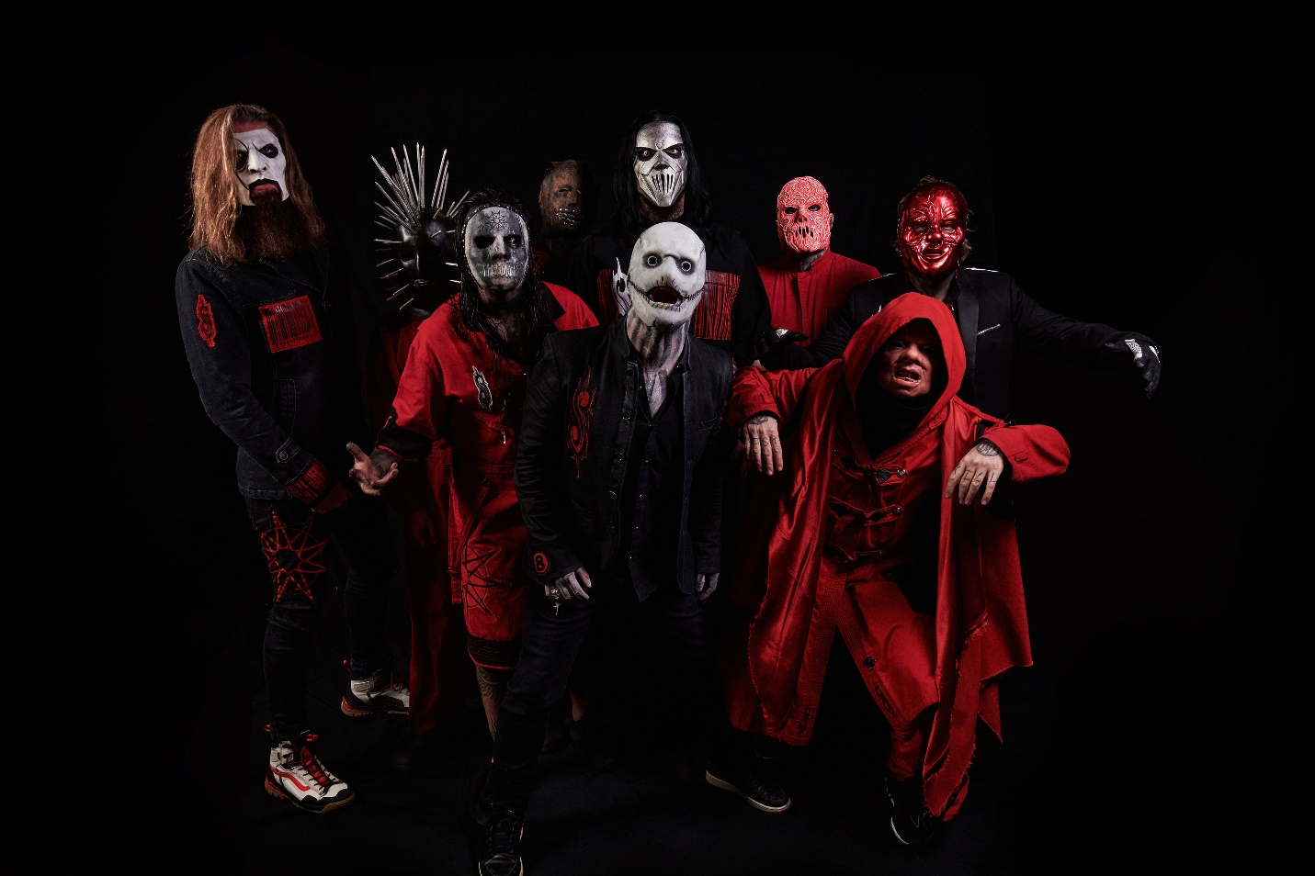
PHOTO CREDIT: ALEXANDER GAY

November 5, 2021 – GRAMMY Award-winning Iowan icons SLIPKNOT have returned today with “The Chapeltown Rag” - their first new music in two years. “The Chapeltown Rag” is available now on all streaming platforms and will be performed live for the first time ever tonight at SLIPKNOT’s KNOTFEST LOS ANGELES. The event will be livestreamed as it happens, giving fans access to both the studio version and SLIPKNOT’s live performance of “The Chapeltown Rag” within only hours [single artwork / livestream details below].

Recorded during recent sessions for a yet-to-be-announced new album, “The Chapeltown Rag” barrels forward with the speed of a derailed freight train and incisively eviscerates internet culture from the inside out with a scream, “WHEN EVERYTHING IS GOD ONLINE…NOTHING IS.”

SLIPKNOT vocalist Corey Taylor commented on “The Chapeltown Rag,” remarking “It’s a punisher man. It's classic Slipknot. And it's frenetic. But lyrically, it's coming from a point of talking about the various manipulations that can happen when social media meets media itself. And the different ways that these manipulations can try to pull us in different directions, in the fact that we're all becoming addicts to it, which is very, very dangerous.”

M. Shawn Crahan, better known as Clown from SLIPKNOT, added “‘The Chapeltown Rag’ facilitates a sort of mindset that you're going to like: it's along the barnburner side of things.”

Slipknot will debut “The Chapeltown Rag” live later tonight on their first-ever livestream from KNOTFEST LOS ANGELES at the Banc of California Stadium. Airing at 6:00PM PT / 9:00PM ET tonight, tickets for the livestream are available at knotfest.veeps.com with Knotfest Members eligible to purchase at a discounted price. Fans can experience the SLIPKNOT’s performance live and for a full 72 hours afterwards along with the select appearances from Killswitch Engage, FEVER 333, Code Orange, Vended and special guests Cherry Bombs. Check out the trailer for KNOTFEST LOS ANGELES HERE.

Just as forward-thinking as the music itself, SLIPKNOT heralded “The Chapeltown Rag” with an innovative rollout throughout the week. Unbeknownst to visitors, key lyrics from “The Chapeltown Rag” adorned www.knotfest.com —the band’s online hub for news, community, and the official fan club OT9. When users clicked on the lyrics, they landed on www.thechapeltownrag.com. Beckoning fans further down the rabbit hole, www.thechapeltownrag.com featured a series of nine eco-friendly NFTS minted under the user account desmoines515 and hosted on the WAX Blockchain. New digital assets were revealed daily throughout the week. When assembled, those assets granted the first look at the single artwork as well as a snippet of “The Chapeltown Rag.” Fans who collected all nine of the free-to-redeem tokens should stay tuned for various special redemption options and offerings throughout the next album cycle.

“SLIPKNOT has been at the cutting edge utilizing technology in new and creative ways to engage with their fans,” said Lee Jenkins, Product Manager for WAX, “and we are very excited that they chose WAX for this initiative that showcases a new way to utilize blockchain technology."

“The Chapeltown Rag” represents another high watermark in a banner year for SLIPKNOT. Making a triumphant return to the road, their KNOTFEST ROADSHOW sold out amphitheaters across the country bookended by the record-breaking KNOTFEST IOWA and now KNOTFEST LOS ANGELES. In addition, they topped the bills of festivals as diverse as Riot Fest, Rocklahoma, Inkcarceration, Welcome To Rockville, and more.

SLIPKNOT
“THE CHAPELTOWN RAG”
SINGLE ART

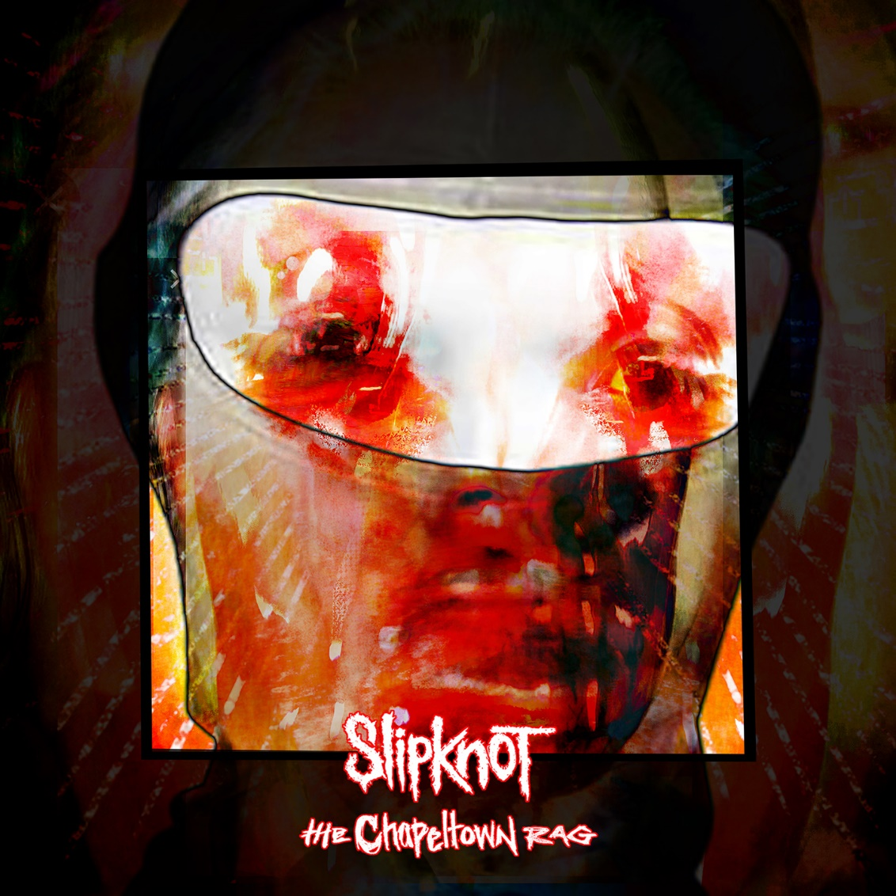

ABOUT SLIPKNOT:
There was never a band like Slipknot, and there will never be another. Like a spore out of the Midwest,
they’ve quietly bloomed into the most uncompromising, undeniable, and unique presence on the planet whose influence infects as it inspires. Since sowing the seeds for revolution in Iowa during 1999, these musical outliers have captured a GRAMMY Award, earned 15 platinum and gold certifications stateside, scored dozens of certifications worldwide, and generated north of 8.5 billion streams and 3.5 billion views—unprecedented for a rock act in this generation or any other. Rolling Stone cited the seminal platinum-selling 2001 Iowa among “The 100 Greatest Metal Albums of All Time,” while The Ringer attested, “They’re the most important heavy band of their era.” In addition to marking the group’s third consecutive #1 debut on the Billboard Top 200, their sixth full-length album, WE ARE NOT YOUR KIND, bowed at #1 in eleven countries worldwide in 2019. Selling out shows on multiple continents, they deliver an irreplicable multi-sensory experience on tour and through their own festival KNOTFEST. With their seventh album looming on the horizon for 2022, Slipknot are back, and nothing will be the same again.

For more information on SLIPKNOT, visit:
OFFICIAL WEBSITE |KNOTFEST | FACEBOOK | TWITTER | INSTAGRAM | YOUTUBE
APPLE MUSIC | SPOTIFY | AMAZON MUSIC

