FOR IMMEDIATE RELEASE
JULY 28, 2021

SAINT MOTEL ANNOUNCE ONE NIGHT ONLY FROM MACEDONIA:
‘THE ORIGINAL MOTION PICTURE SOUNDTRACK’ LIVE WITH ORCHESTRA

BAND TO BRING NEW ALBUM TO LIFE WITH NORTH MACEDONIA’S THE FAMES ORCHESTRA LED BY RENOWNED FILM COMPOSER DUKE BOJADZIEV

TICKETS FOR GLOBAL LIVESTREAM ON SALE NOW HERE

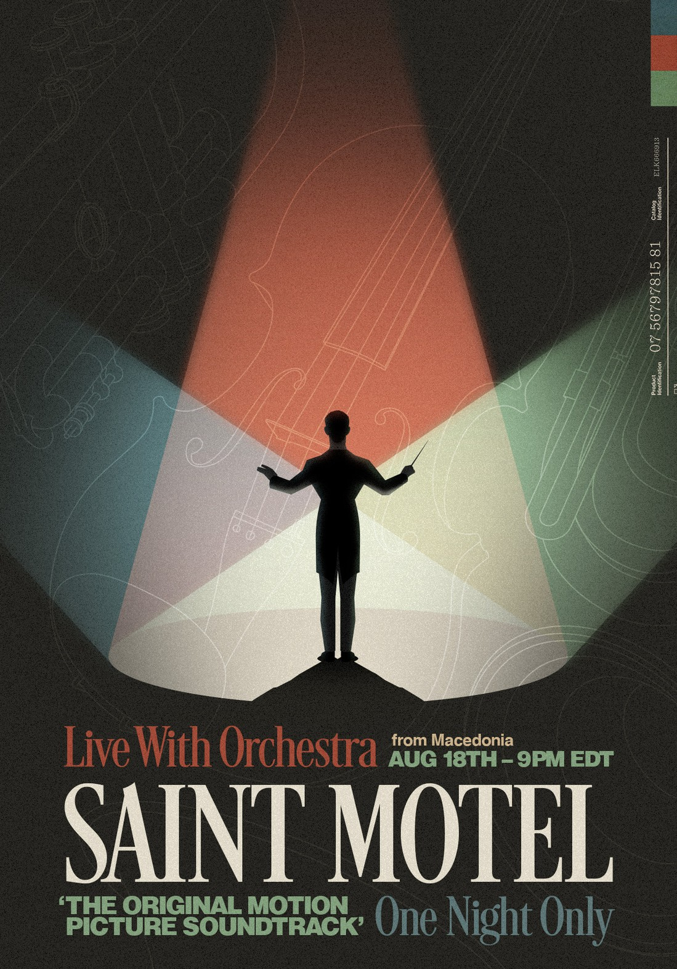

Elektra Recording group Saint Motel have announced plans to perform their brand new album The Original Motion Picture Soundtrack in its entirety, live with one of the world’s top orchestras, for the first and only time. Together with the Fames Orchestra of Macedonia and renowned film composer Duke Bojadziev, the band will play every song from the album, including film score transitions previously composed by Duke, live in the Macedonian capital of Skopje. Audiences from around the world can tune in on August 18 at 9:00pm EDT/6:00pm PDT via the DREAMSTAGE HD live stream platform. Tickets for the event are available now HERE. Watch a trailer for the show HERE.

"What an incredible way to perform The Original Motion Picture Soundtrack in the most thematically true way possible," shared Saint Motel frontman A/J Jackson. "Live with one of the best orchestras in the world and showcasing not only all the songs but the incredible film score transitions. It’s something truly special."

The Original Motion Picture Soundtrack was co-produced by Saint Motel frontman A/J Jackson and Grammy Award-winner Mark Needham (The Killers, Dolly Parton, Chris Isaac), and continues the Saint Motel custom of joyfully blurring genres, bringing in elements of everything from symphonic pop to big band. Connecting with Bojadziev, Saint Motel are able to take this soundtrack and create a true score to a fictional film, in a unique setting, providing fans a truly once-in-a-lifetime experience.

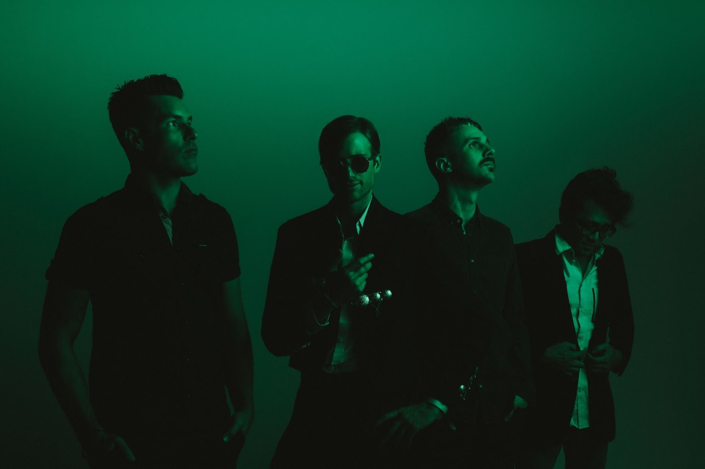
Photo credit: Catie Laffoon

About Saint Motel
Projecting pop hooks through an alternative lens with a flair for dramatic presentation, Saint Motel make music worthy of the big screen. Streamed and viewed over half-a-billion times, the platinum-selling Los Angeles quartet magnify this vision with immersive live experiences and one unpredictable move after another. The group initially came together at film school before introducing themselves on 2012’s Voyeur. Signing to Elektra Records, their 2014 My Type EP boasted both the gold-certified title track “My Type” and fan favorite “Cold Cold Man.” In 2016, saintmotelevision yielded the smash “Move.” Flipping the script once again, the musicians reimagined the record with a series of history-making first-of-their-kind innovations: an award-winning Virtual Reality version and an Augmented Reality version. In addition to unforgettable sets everywhere from Coachella and Lollapalooza to Bonnaroo, the boys lit up shows such as NBC’s TODAY, ABC’s Jimmy Kimmel Live!, and CBS’ The Late Late Show with James Corden, among others. In 2019, Saint Motel launched their most ambitious undertaking yet, unveiling their third full-length album in three parts. First up, they uncovered The Original Motion Picture Soundtrack Pt. 1 powered by the shimmy and shake of Alternative Top 15 lead single “Van Horn.” Between packing houses coast to coast on headline jaunts and earning acclaim from People, Billboard, and more, the four-piece rolled out Pt. 2 throughout 2020. Now, fans get the full picture of Saint Motel’s vision with the complete The Original Motion Picture Soundtrack studio album.

Saint Motel is: A/J Jackson (vocals), Aaron Sharp (guitar), Dak Lerdamornpong (bass), and Greg Erwin (drums).

CONNECT WITH SAINT MOTEL

WWW.SAINTMOTEL.COM
WWW.SAINTMOTEL.COM/NEWWORLD
TWITTER
FACEBOOK
YOUTUBE
INSTAGRAM

# # #

Saint Motel Press Contacts:
Glenn Fukushima (National)
818.238.6833
GlennFukushima@elektra.com

Collin Citron (National)
818.238.6314
CollinCitron@elektra.com

Sydney Worden (Tour/Online)
818.238.6834
SydneyWorden@elektra.com

