FOR IMMEDIATE RELEASE
MAY 14, 2021

SAINT MOTEL TO RELEASE NEW ALBUM THE ORIGINAL MOTION PICTURE SOUNDTRACK ON JUNE 25, 2021
PRE-ORDER NOW HERE

BAND SHARES BRAND NEW SINGLE “IT’S ALL HAPPENING”
LISTEN HERE

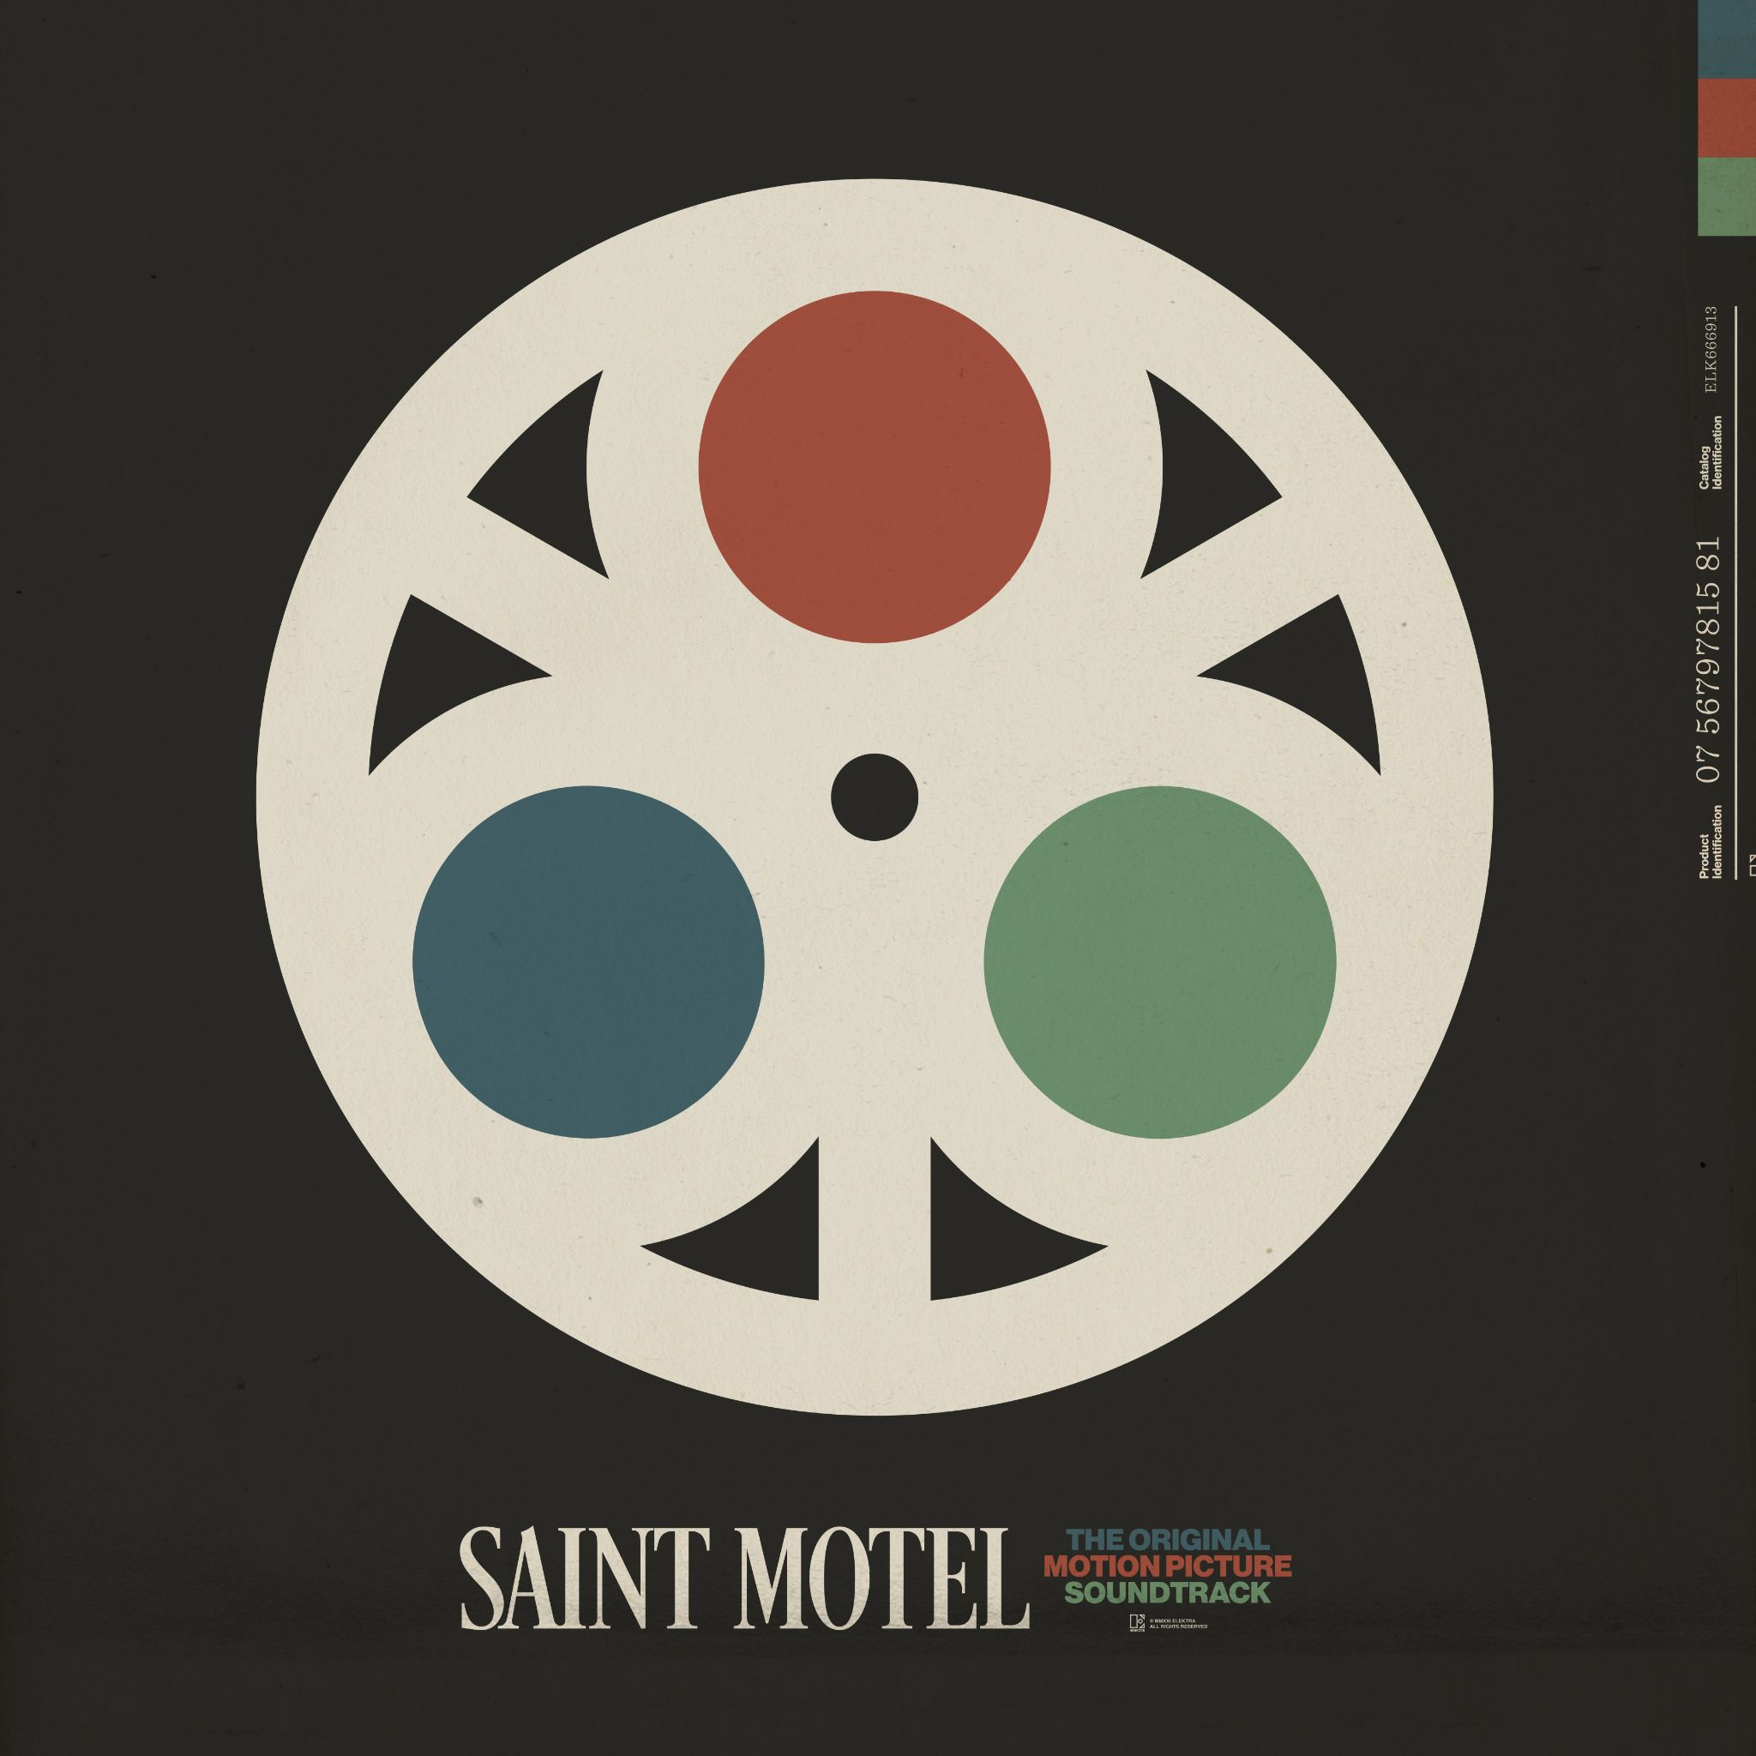

PRESS ASSETS HERE

Elektra recording group Saint Motel have announced they will release their much anticipated new album The Original Motion Picture Soundtrack on June 25, 2021. The album is available for pre-order starting today HERE. To herald the arrival of the record, the band has also shared a new single entitled “It’s All Happening”. The track is available to stream and download now HERE.

On The Original Motion Picture Soundtrack the Los Angeles-based band dreams up their own cinematic experience in album form, as its songs cycle through stories of love, danger, and impossible triumph. “We’d love it if it had the same effect as a great movie, where you feel a part of the adventure,” Saint Motel frontman A/J Jackson shared. “And just like the hero, you come out of the journey a new version of yourself, a version shaped by what you encountered along the way.”

The Original Motion Picture Soundtrack embodies an opulent sound true to its ambitious scope. Co-produced by frontman A/J Jackson and Grammy Award-winner Mark Needham (The Killers, Dolly Parton, Chris Isaac), the album continues the Saint Motel custom of joyfully blurring genres, bringing in elements of everything from symphonic pop to big band.

Audiences began experiencing the album with the release of a pair of EPs: The Original Motion Picture Soundtrack: Pt.1 and The Original Motion Picture Soundtrack Pt. 2. Among many highlights, “Van Horn” has amassed nearly 20 million streams, while the band performed it on ABC’s JIMMY KIMMEL LIVE! Receiving critical acclaim, DUJOUR described “Preach” as “a bop,” while American Songwriter poured over the album’s concept in an in-depth interview with A/J. Further looks came from Ladygunn, Hollywood Life, and more. Now, fans get the full picture of Saint Motel’s vision with the complete The Original Motion Picture Soundtrack studio album.

In the lead up to the album, Saint Motel made history as “the first band to open their own virtual metaverse” powered by Mozilla Hubs. The virtual world is designed as a motel with each room dedicated to a song on The Original Motion Picture Soundtrack. The quartet’s launch of “New World” welcomed fans to the virtual space where Jackson performed a live acoustic set. In this 3D VR chatroom enabled for all headsets and browsers, audiences can enter an exclusive, immersive environment to engage directly with the band through virtual meet-and-greets and intimate, live performances, consume exclusive video content, and much more. Additionally, it doubles as a space for fans to congregate and get to know each other. Saint Motel’s “New World” upholds what has become a tradition of engaging with groundbreaking technology for the guys. Visit www.saintmotel.com/newworld to explore the “New World.” In 2016, they dropped their Elektra full length debut saintmotelevision as the first-ever Virtual Reality album and first-ever Augmented Reality album and accompanied the record with the free saintmotel AR/VR app.

Stay tuned for more from Saint Motel soon.

The Original Motion Picture Soundtrack Tracklisting:
1. Old Soul
2. Sisters
3. Van Horn
4. Diane Mozart
5. Save Me
6. Make Me Feel Like
7. Slow Dance
8. Preach
9. A Good Song Never Dies
10. The Moment
11. Snake Charmer
12. Bullet
13. It’s All Happening
14. Origami
15. No Cares

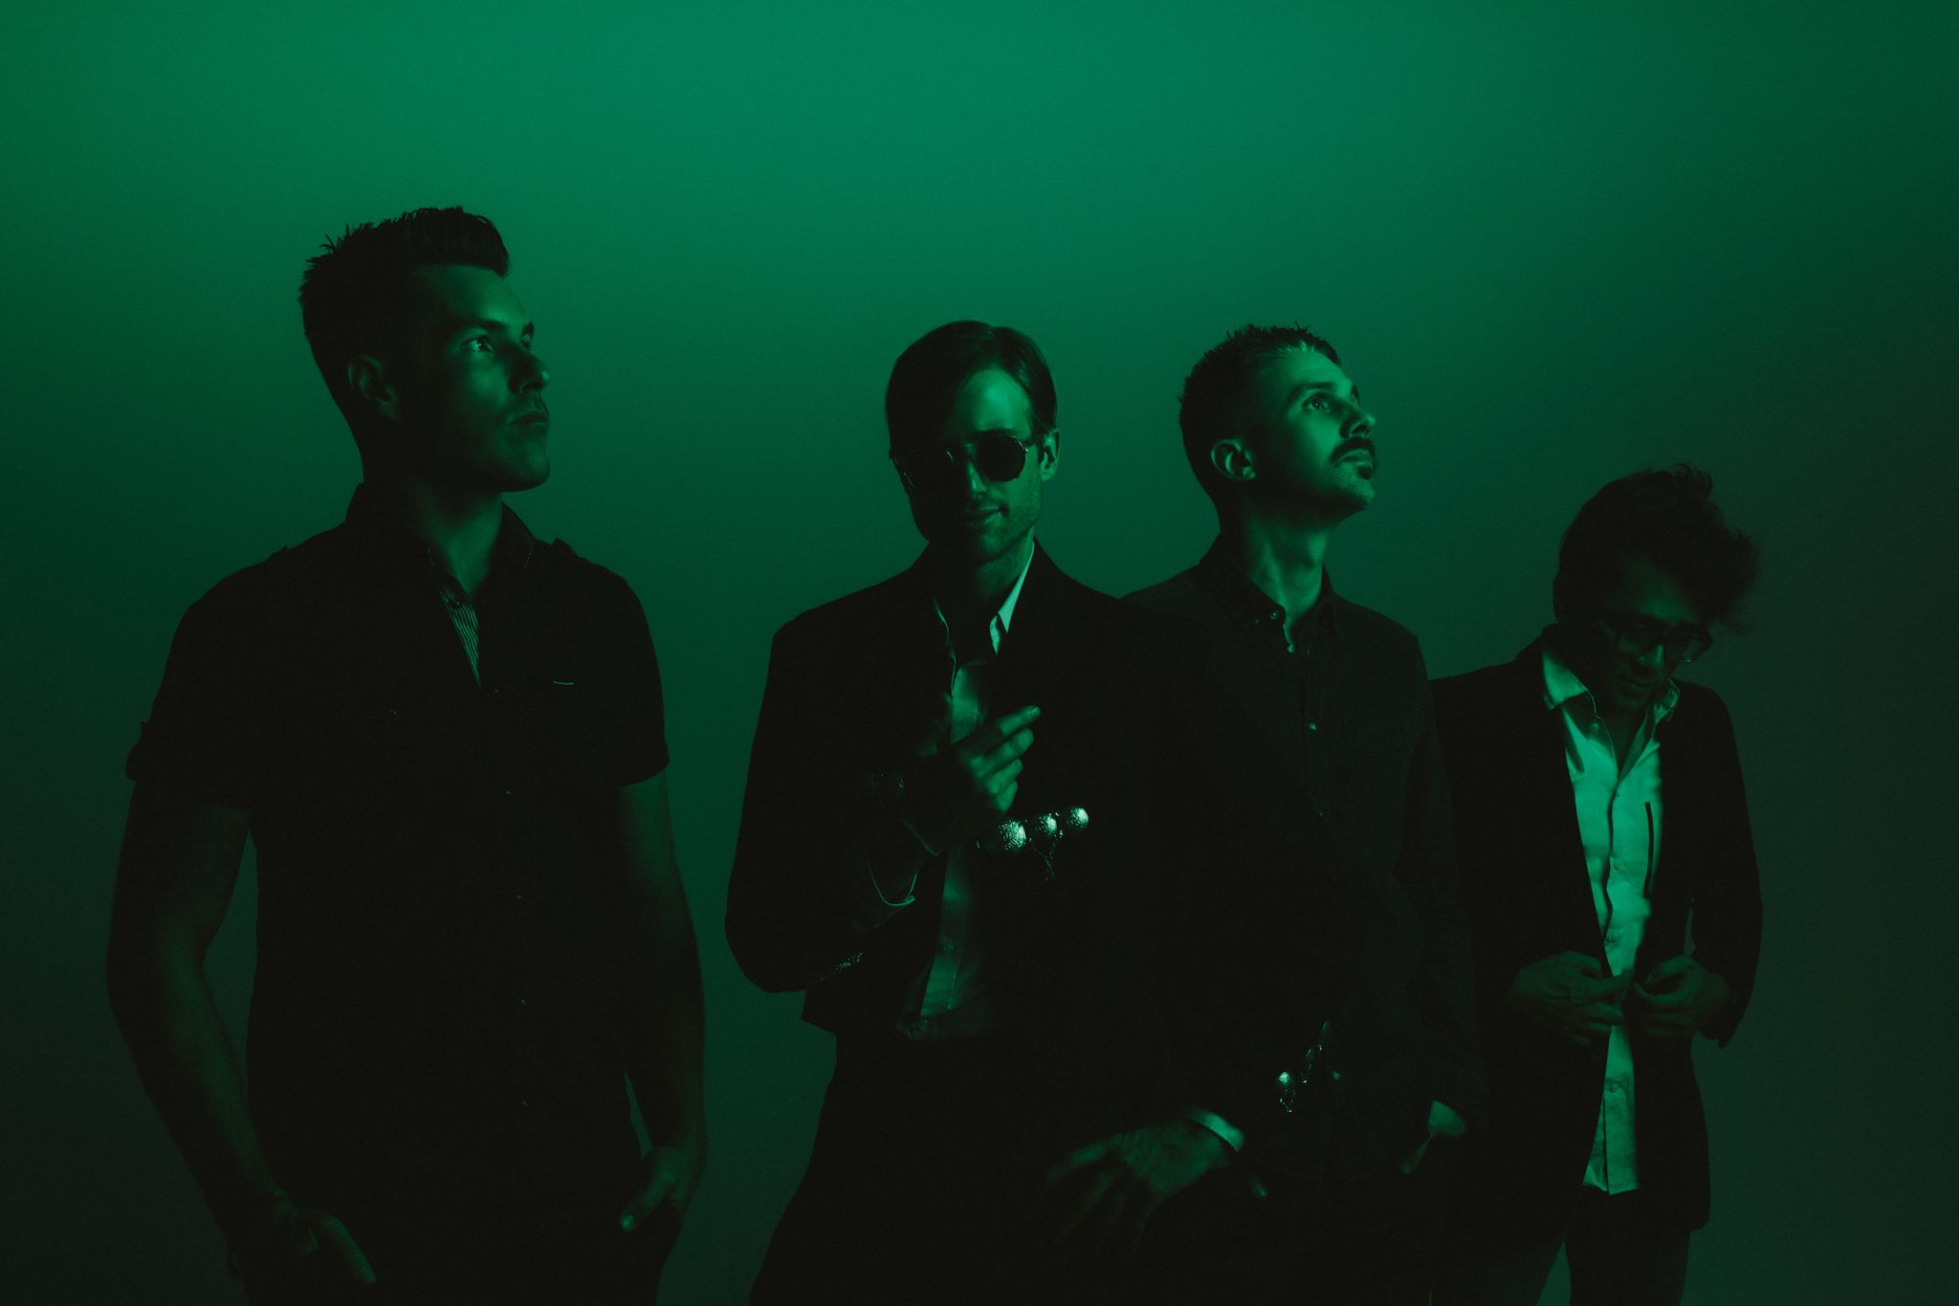
Photo credit: Catie Laffoon
*****

Projecting pop hooks through an alternative lens with a flair for dramatic presentation, Saint Motel make music worthy of the big screen. Streamed and viewed over half-a-billion times, the platinum-selling Los Angeles quartet magnify this vision with immersive live experiences and one unpredictable move after another. The group initially came together at film school before introducing themselves on 2012’s Voyeur. Signing to Elektra Records, their 2014 My Type EP boasted both the gold-certified title track “My Type” and fan favorite “Cold Cold Man.” In 2016, saintmotelevision yielded the smash “Move.” Flipping the script once again, the musicians reimagined the record with a series of history-making first-of-their-kind innovations: an award-winning Virtual Reality version and an Augmented Reality version. In 2019, Saint Motel launched their most ambitious undertaking yet, unveiling their third full-length album in three parts. First up, they uncovered The Original Motion Picture Soundtrack Pt. 1 powered by the shimmy and shake of Alternative Top 15 lead single “Van Horn.” Between packing houses coast to coast on headline jaunts and earning acclaim from People, Billboard, and more, the four-piece rolled out Pt. 2 throughout 2020. In addition to unforgettable sets everywhere from Coachella and Lollapalooza to Bonnaroo, the boys lit up shows such as NBC’s TODAY, ABC’s Jimmy Kimmel Live!, and CBS’ The Late Late Show with James Corden, among others.

Saint Motel is: A/J Jackson (vocals), Aaron Sharp (guitar), Dak Lerdamornpong (bass), and Greg Erwin (drums).

CONNECT WITH SAINT MOTEL

WWW.SAINTMOTEL.COM
WWW.SAINTMOTEL.COM/NEWWORLD
TWITTER
FACEBOOK
YOUTUBE
INSTAGRAM

# # #

PRESS CONTACT:

Glenn Fukushima (National)
818.238.6833
GlennFukushima@elektra.com

Collin Citron (National)
818.238.6314
CollinCitron@elektra.com

Sydney Worden (Tour/Online)
818.238.6834
SydneyWorden@elektra.com

