SAM RYDER DEBUTS NEW SINGLE “MORE”

OFFICIAL LYRIC VIDEO STREAMING NOW

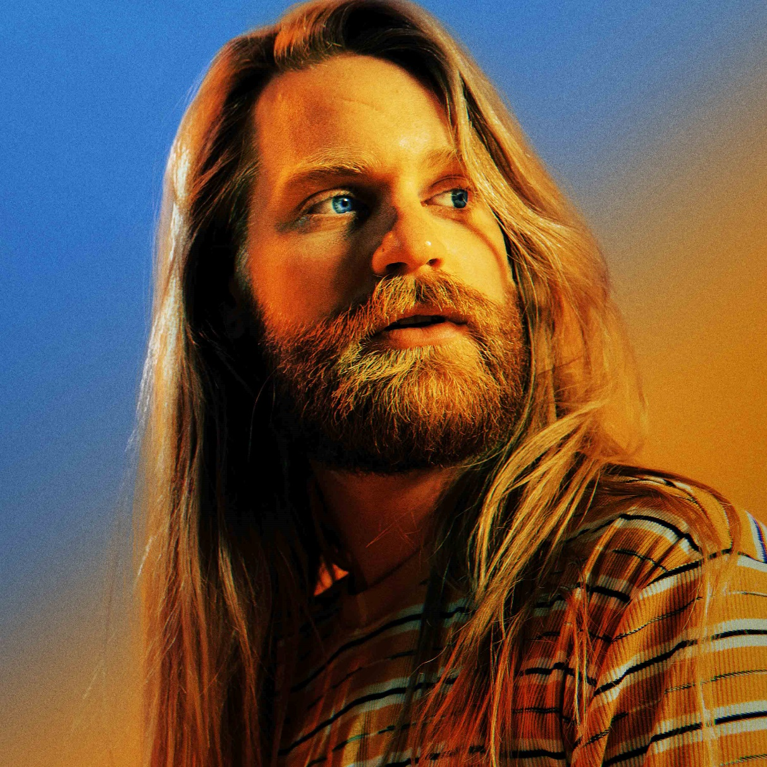

SEPTEMBER 3, 2021 – Sam Ryder has shared new single “More.” The track arrives alongside an official lyric video, which is streaming now on Sam’s official YouTube channel. Co-written with Wayne Hector (Nicki Minaj, Sigma) and Red Triangle (James Arthur, Little Mix, Charlie Puth), with production from Red Triangle and Freedo, “More” is available now on all streaming platforms via Parlophone Records/Elektra Records.

Sam’s unmistakeable vocals soar throughout the song as he passionately calls out for more of the things that truly matter in life. Commenting on the track’s inspiration, Sam added, "Life’s ornaments can distract us from life’s treasures... and that's what I wrote this song about.”

With over 30 million streams to date, “More” is the latest release from Sam, following singles “Whirlwind” and “Tiny Riot” which topped iTunes charts worldwide. Sam spent much of his adult life touring, writing and performing in bands before embarking on this new chapter as a solo artist. In March 2020 he uploaded the first of his now infamous covers which caught the attention of some famous fans (Justin Bieber, Sia, Alicia Keys and Elton John) – with compilations of his videos appearing on The Ellen Show, BBC’s Newsbeat and more. As the videos kept coming, so did the fans – with his socials currently standing at over 13 million.

SAM RYDER
“MORE”
AVAILABLE NOW
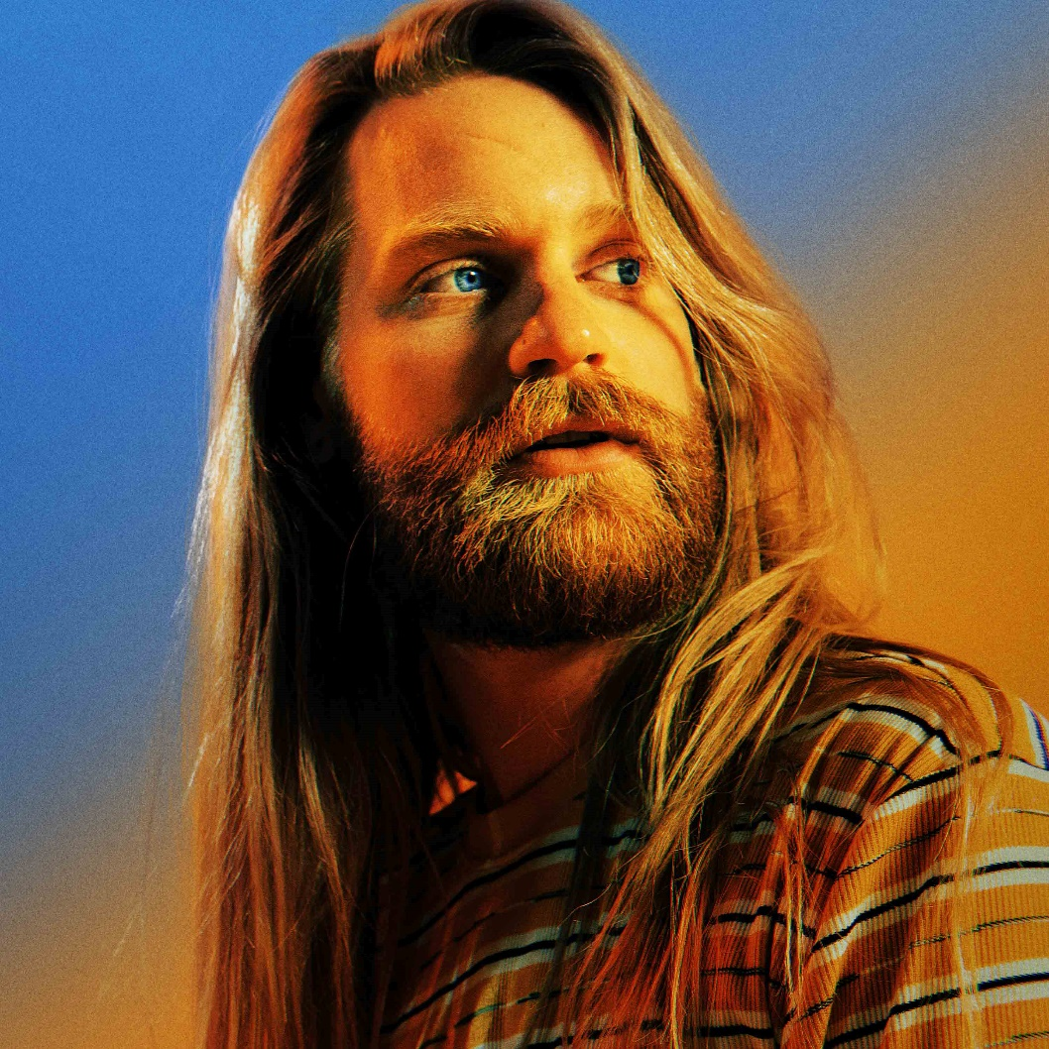

LINKS
TikTok | Instagram | Twitter | Facebook

For US press inquiries, contact:
Glenn Fukushima – glennfukushima@elektra.com
Sarah Goldstein – sarahgoldstein@elektra.com

